AGREEMENT TO SALE
_______________________________________________________________________
Project Name : 41 ELITE
Project Type : Residential
Building No. : “<<INTRODUCERBUILDING>>”
Floor No. : “08th Floor”
Apartment No. : “801”
Consideration : Rs. 56,58,715.00.
Survey No. : Survey No. 145/2A
Village : TATHAWADE, PUNE
Postal Code : 411033
MahaRERA Reg. No. : P52100027929 - ‘D’ Building
P52100027959 - ‘E’ Building
P52100027958 - ‘F’ building
Plan Sanction No. : B.P./TATHAWADE/13/2021,
DATED 23/03/2021
Date of Possession : 31.12.2023
Annexure-A : Certificate of Title
Annexure-B : 7/12 Extract of Land
Annexure-C1 : Layout of the Project
Annexure-C2 : Sanction Building Plan
Annexure-C3 : Open Space of Project
Annexure-D : Floor Plan of The Apartment
Annexure-E : Specification & Amenities of Apartment
Annexure-F : Certificate of Registration with MahaRERA
Annexure-G : Commencement Certificate
Annexure-H : Proposed Amalgamated Layout of the Project
_______________________________________________________________________

THIS AGREEMENT MADE AT PUNE ON THIS ______ DAY OF _____________________ IN THE YEAR 2021.

BETWEEN

M/S. KRISALA ENTERPRISES
[PAN: AASFK6219P]
A Partnership firm duly constitute under the relevant provisions of the Indian Partnership Act having its registered place of business at Survey No. 145/1B, Jeevan Nagar, Near Sharyu Toyota, Tathawade, Pune- 411033, Through Its Partner:

M/S. KRISALA INFRACON LLP
[PAN: AASFK3579Q]
Through Its Authorized Signatory;
MR. SAGAR OMPRAKASH AGARWAL
Age: About 31 Years, Occupation: Business
[PAN: AJXPA8908K]
RESIDING AT: 151 SHITLANAGAR, DEHUROAD, PUNE- 412101.

AND/OR

MR. TULSIDAS RATANSHIBHAI PATEL
Age: About 51 Years, Occupation: Business
[PAN: ADEPP0370M]

RESIDING AT: CELESTIAL CITY, PHASE-I, RAVET, PUNE-412101.

AND/OR

MR. MAHESH SHIVAJI RAUT
Age: About 29 Years, Occupation: Business
[PAN: BBFPR4294G]

RESIDING AT: PATIL WASTI, GAHUNJE ROAD, MAMURDI, DEHUROAD CONTONMENT, PUNE-412101.

Hereinafter referred to as "THE PROMOTER” / “DEVELOPER” / “BUILDER”/ “LANDOWNER” (Which the expression shall unless it be repugnant to the context or meaning thereof mean and include the said Partnership firm and its partners, their heirs, executors, administrators, agents and assignees) OF THE FIRST PART

AND

- LATE MR. SOPAN BALA PAWAR through his legal heirs-
- SMT. YASHODABAI SOPAN PAWAR
Age: 84 years, Occupation: Housewife,
[PAN: EAYPP7861L]/[AADHAR: 311831821925]

- MR. HANUMANT SOPAN PAWAR
Age: 62 years, Occupation: Agriculture,
[PAN: ANRPP7558E]/[AADHAR: 287851406611]

- MRS. JHAMABAI HANUMANT PAWAR
Age: 52years, Occupation: Housewife
[PAN: BNIPP0703P]/[AADHAR: 470295734763]

- MRS. JAYA RAMESH PAWAR
(For self and as guardian mother of No. 1e)
Age: 36 years, Occupation: Housewife
[PAN: BNAPP3523P]/[AADHAR: 946297141105]

- MASTER PRADYUMN RAMESH PAWAR
Age: 13 years, Occupation: Student

Nos. 1a) to e) Residing at: VILLAGE: TATHAWADE, TALUKA: MULSHI, DISTRICT: PUNE.

- MRS. SUREKHA PRAKASH MURHE alias MISS SUREKHA HANUMANT PAWAR
Age: 33 years, Occupation: Housewife
[PAN: CFJPM6463B]/[AADHAR: 555540129825]

Residing at: VILLAGE: KURULI, TALUKA: KHED, DISTRICT: PUNE.

- MR. TANAJI SOPAN PAWAR
Age: 60 years, Occupation: Agriculture
[PAN: BYAPP3460L]/[AADHAR: 233184142027]

- MRS. SHOBHA TANAJI PAWAR
Age: 49 years, Occupation: Housewife
[PAN: CAOPP9145D]/[AADHAR: 669756830788]

- MR. GANESH TANAJI PAWAR
Age: 23 years, Occupation: Agriculture
[PAN: DAWPP3005H]/[AADHAR: 762393841754]

Nos. 1g) to i) Residing at: VILLAGE: TATHAWADE, TALUKA: MULSHI, DISTRICT: PUNE.

- MRS. POONAM VISHAL BHISE alias MISS. POONAM TANAJI PAWAR
Age: 30 years, Occupation: Housewife
[PAN: BYGPB8184F]/[AADHAR: 251278640882]

Residing at: RAMNAGAR, VILLAGE: RAHATANI, TALUKA: HAVELI, DISTRICT: PUNE.

- MRS. POOJA VISHNU TANPURE alias MISS. POOJA TANAJI PAWAR
Age: 28 years, Occupation: Housewife
[PAN: BQCPT6439D]/[AADHAR: 621952715196]

Residing at: S. NO. 83, SHRIRAM COLONY, VILLAGE: DIGHI, TALUKA: HAVELI, DISTRICT: PUNE.

- MRS. AARTI YOGESH JADHAV alias MISS. AARTI TANAJI PAWAR
Age: 25 years, Occupation: Housewife
[PAN: BUKPJ1295H]/[AADHAR: 734722943165]

Residing at: VILLAGE: NERE, TALUKA: MULSHI, DISTRICT: PUNE.

Through Their Duly Appointed Power of Attorney Holder;

M/S. KRISALA ENTERPRISES
[PAN: AASFK6219P]
A Partnership firm duly constitute under the relevant provisions of the Indian Partnership Act having its registered place of business at Survey No. 145/1B, Jeevan Nagar, Near Sharyu Toyota, Tathawade, Pune- 411033, Through Its Partner:

M/S. KRISALA INFRACON LLP
[PAN: AASFK3579Q]
Through Its Authorized Signatory;
MR. SAGAR OMPRAKASH AGARWAL
Age: About 31 Years, Occupation: Business
[PAN: AJXPA8908K]
RESIDING AT: 151 SHITLANAGAR, DEHUROAD, PUNE- 412101.

AND/OR

MR. TULSIDAS RATANSHIBHAI PATEL
Age: About 51 Years, Occupation: Business
[PAN: ADEPP0370M]

RESIDING AT: CELESTIAL CITY, PHASE-I, RAVET, PUNE-412101.

AND/OR

MR. MAHESH SHIVAJI RAUT
Age: About 29 Years, Occupation: Business
[PAN: BBFPR4294G]

RESIDING AT: PATIL WASTI, GAHUNJE ROAD, MAMURDI, DEHUROAD CONTONMENT, PUNE-412101.

Hereinafter referred to as "LAND OWNERS” / “CONSENTING PARTY” (Which the expression shall unless it be repugnant to the context or meaning thereof mean and include the said Land Owners and their heirs, executors, administrators, agents and assignees) OF THE SECOND PART

AND

- MR. Shridhar Chandrakant Patki.

Age: 57Years, Occupation:
[PAN: ABVPP6742J] / [AADHAR: 286580784484]

RESIDING AT: Near Water Tank, Behind Gajanan Maharaj Mandir, Bhakti Construction, Eknath Nagar, Beed..

- ..

Age: Years, Occupation: . .
[PAN: . ] / [AADHAR: ]

RESIDING AT:

Hereinafter referred to as “THE ALLOTTEE”/“PURCHASER” (Which expression shall unless it be repugnant to the context or meaning thereof be deemed to mean and include the Allottee, his/her/their successors, heirs and permitted assignees alone so far as the obligations on the part of the Promoter is concerned) OF THE THIRD PART.

FOR AREA ADMEASURING 00H 32R OUT OF S. NO. 145/2A

WHEREAS the PROMOTER herein above referred is the owner of the land admeasuring about 00H 32R i.e. 3200 Square Meters out of Survey No. 145 Hissa No. 2A totally admeasuring about 00H 65.50R i.e. 6550 Square Meters situated at Gaon Mauje: Tathawade, Taluka: Mulshi, Jillah: Pune within the local limits of Pimpri Chinchwad Municipal Corporation and within the jurisdiction of Ld. Sub-Registrar of Assurances at Haveli. The Promoter has acquired the title of the said land from its previous owner Late Mr. Sopan Bala Pawar through his legal heirs vide Sale Deed dated 11/08/2020 which the Sale Deed is duly stamped and registered on 13/08/2020 at Haveli No. 14 at Serial No. 7990/2020. AND

FOR AREA ADMEASURING 00H 03R OUT OF S. NO. 145/2A

WHEREAS the land OWNERS herein above referred are the owners of all that piece and parcel of land admeasuring about 00H 03R i.e. 300 Square Meters out of Survey No. 145 Hissa No. 2A totally admeasuring about 00H 65.50R i.e. 6550 Square Meters situated at Gaon Mauje: Tathawade, Taluka: Mulshi, Jillah: Pune within the local limits of Pimpri Chinchwad Municipal Corporation and within the jurisdiction of Ld. Sub-Registrar of Assurances at Haveli,by virtue of the said land being their ancestral property. AND

WHEREAS the Party of the Second part entered in a “DEVELOPMENT AGREEMENT” [Serial No. 1851/2021 dated 01/02/2021 at Haveli No. 18] thereby entrusting the development rights of the land admeasuring area of 00H 03R bearing Survey Number 145 Hissa Number 2A situated at Gaon Mauje: Tathawade, Taluka: Mulshi, Jillah: Pune unto the Promoter herein on such terms and conditions as is enumerated in the said development agreement. The Party of the Second Part further executed and registered a Power of Attorney [Serial No. 1852/2021 dated 01/02/2021 at Haveli No. 18] under the said development agreement thereby appointing the Promoter herein to be their true and lawful attorney for the purpose of carrying out necessary activates for the development the said land. AND

WHEREAS, the Promoter herein is thus part owner and development rights holder of land 00H 35R i.e. 3500 Square Meters (consisting of area admeasuring about 00H 03R i.e. 300 Square Meters + 00H 32R i.e. 3200 Square Meters) out of total area admeasuring 00H 65.50R i.e. 6550 Square Meters of Survey No. 145 Hissa No. 2A situated at Gaon Mauje: Tathawade, Taluka: Mulshi, Jillah: Pune within the local limits of Pimpri Chinchwad Municipal Corporation and within the jurisdiction of Ld. Sub-Registrar of Assurances at Haveli as described at Schedule-A mentioned herein below and which the land is herein after referred to as the “said land/ said project land” and has all the rights and title for development of the said land. AND

WHEREAS for the purpose of getting the plan sanctioned from the Pimpri Chinchwad Municipal Corporation (‘PCMC’) for the said land, Promoter applied for sanction of layout to the Pimpri Chinchwad Municipal Corporation and accordingly Pimpri Chinchwad Municipal Corporation sanctioned layout plan for the said land vide sanctioned plan bearing No. B.P./Tathawade/92/2020, Dated 08/12/2020 which is revised by sanctioned plan bearing No. B.P./Tathawade/06/2021, Dated 03.03.2021, which is revised by sanctioned plan bearing No. B.P./Tathawade/13/2021, Dated 23.03.2021, thereby sanctioning building plan for the said land, which was also accompanied by the Work Commencement order bearing Commencement Certificate No. B.P./Tathawade/92/2020, Dated 08/12/2020 which is revised by sanctioned plan bearing No. B.P./Tathawade/06/2021, Dated 03.03.2021, which is revised by sanctioned plan bearing No. B.P./Tathawade/13/2021, Dated 23.03.2021. AND

WHEREAS The Hon'ble Tehsildar, Mulshi, Pune on the application of the Promoter herein granted permission to use the said land admeasuring 3500.00 Square Meters for non-agricultural purposes vide his order bearing No. जा. क्रं. 42ब एनए/ एसआर /01/2021, Dated 07/01/2021. AND

WHEREAS the Promoter has proposed to construct on the project land a scheme comprising of ownership Apartment (Residential), in the name of “41 ELITE-PHASE-II” [Herein after referred to as the “said project”] consisting of building/floors/units as tabled hereinbelow;

TOTAL POTENTIAL OF PROJECT
BUILDING NUMBER | OCCUPATION TYPE | NUMBER OF FLOORS | TOTAL NUMBER OF UNITS IN THE BUILDING/WING
D | Residential | Basement + Lower Parking Floor + Upper Parking Floor + 12 Floors | 60 (Residential Units)
E | Residential |  | 48 (Residential Units)
F | Residential |  | 60 (Residential Units)

(hereinafter referred to as the "Said Building/s" for the sake of brevity). AND

WHEREAS the Real Estate Regulatory Authority, Pune has granted registration to the Project proposed on the said land, vide registration for ‘D’ building bearing no. P52100027929, dated 16/01/2021, vide registration for ‘E’ building bearing no. P52100027959, dated 21/01/2021, vide registration for ‘F’ building bearing no. P52100027958, dated 21/01/2021, authenticated copy of the said registration is attached to this agreement at Annexure-F.

WHEREAS the Promoter has entered into a standard Agreement with M/s. Unusual Speaces, an Architect registered with the Council of Architects and such Agreement is as per the Agreement prescribed by the Council of Architects. However, the promoter herein has reserved the rights to change such Architect at any time if so desired by the promoter at its sole discretion. AND

WHEREAS the Promoter has appointed M/s. Hansal Parikh & Associates structural Engineer for the preparation of the structural design and drawings of the buildings and the Promoter accepts the professional supervision of the structural Engineer till the completion of the building/buildings. However, the promoter herein has reserved the rights to change such structural Engineer at any time if so desired by the promoter at its sole discretion. AND

WHEREAS the Promoter has accordingly commenced construction of the said building/s in accordance with the sanctioned plans. AND

WHEREAS by virtue of the recitals as mentioned herein above the Promoter has sole and exclusive right to sell the Apartment/s in the said building/s / said project constructed / to be constructed by the Promoter on the project land and to enter into Agreement/s with the allottee(s)/s of the Apartments and further to receive the sale consideration in respect thereof. AND

WHEREAS on demand from the allottee, the Promoter has given inspection to the Allottee of all the documents of title, Deeds and Documents, Orders, NA Orders, Sanctions, Registration Certificates, 7/12 Extracts, Title Search Report of the said land, commencement Certificate, Indemnity Bonds, Undertakings, relating to the project land and the plans, layouts, designs and specifications prepared by the Promoter's Architects, and of such other documents as are specified under the Real Estate (Regulation and Development) Act 2016 and Maharashtra Ownership of Flats Act 1963 (hereinafter both the Acts together are to be referred to as "the said Acts") and the Rules and Regulations made thereunder. AND

WHEREAS the Promoter has decided to form an Association of Apartments under Maharashtra Apartment Ownership Act, 1970 of all Apartment allottees of the buildings/project and have specifically informed the Allottee about its intention to do so and the Allottee has raised no any objection to the same. AND

WHEREAS on the request of the Promoter, the Allottee has carried out independent necessary search by appointing his/her/their own Advocate regarding the title and the nature of the title of the said land / proposed project. The Allottee has further visited the online site of the Real Estate Regulatory Authority and has apprised himself /herself/themselves about the details of the said project as disclosed and declared by the Promoter therein. The Allottee has / have satisfied himself / herself / themselves in respect of the marketable title of the Promoter in respect of the said land and also have verified the correctness and lawfulness of all the other documents produced for their inspection by the Promoter and thereafter have agreed to purchase the Apartment more particularly described in the “SCHEDULE-B” annexed herewith and delineated and demarcated in Red Color in Annexure-“D” annexed hereto. AND

WHEREAS the Allottee has read and understood all the terms and conditions of the deeds and documents concerning the title of the said land so also the Allottee has read and understood all the contents of the indemnity bonds/Undertakings, etc. given by the Promoter to the Hon’ble Collector, Pimpri-Chinchwad Municipal Corporation or any other authority and terms and conditions mentioned in Commencement certificate, NA Order and also the allottee has read and understood the terms and conditions thereof. AND

WHEREAS the Allottee is aware of the fact that the present scheme is Phase-I of the said project and the all the phases after they are fully developed shall form one Association of Apartments. Furthermore, the Allotee is aware of the fact that the plan of the phase II has been sanctioned by referring, indicating, showing the internal road of the Phase I of the project and further the allotee was also been made aware by the Promoter and that the allottee does not have any objection for the same. The Allottee is also aware that the Promoter has entered or will enter into similar and/or different and/or separate Agreements with several other intending allottees and/or Allottees, persons and parties in respect of other units in the said building/project. AND

WHEREAS the Allottee herein being desirous of purchasing an Apartment, applied to the Promoter for allotment of the Apartment No. “801”, on the 08th Floor in the Building No. “<<INTRODUCERBUILDING>>” of the project called “41 ELITE” to be constructed on the said land. Accordingly, in response to the application of the Allottee, the Purchaser/Allottee is offered by the Promoter an Apartment bearing No. “801” on the 08th Floor, in the Building No. “<<INTRODUCERBUILDING>>” of the project called “41 ELITE” (hereinafter referred to as “the said Apartment” / “the Said Flat”) being constructed AND

WHEREAS the authenticated copies of Certificate of Title issued by the attorney at law or advocate of the Promoter, extract of Village Forms VI and VII and XII, layout of the project, sanctioned building plan, Open space of the project, Floor Plan of the Apartment, Specification and amenities of Apartment and certificate of registration with RERA showing the nature of the title of the Promoter to the project land on which the Apartments are constructed or are to be constructed, approvals and registrations obtained, open space and amenities of the project as well as the apartment under sale has been annexed to this agreement at Annexure 'A' to Annexure 'G', respectively. AND

WHEREAS the Parties relying on the confirmations, representations and assurances of each other to faithfully abide by all the terms, conditions and stipulations contained in this Agreement and all applicable laws, are now willing to enter into this Agreement on the terms and conditions appearing hereinafter. AND

WHEREAS prior to the execution of these presents the Allottee has paid to the Promoter a sum of Rs. 5,94,171.00 (Rupees Five Lakh Ninety Four Thousand One Hundred Seventy One only ) including GST, being part/advance payment of the sale consideration of the Apartment agreed to be sold by the Promoter to the Allottee as advance payment or Application Fee (the payment and receipt whereof the Promoter both hereby admit and acknowledge) and the Allottee has agreed to pay to the Promoter the balance of the sale consideration in the manner hereinafter appearing. AND

WHEREAS under the said Acts the Promoter is required to execute a written Agreement for sale of said Apartment with the Allottee, being in fact these presents and also to register said Agreement under the Registration Act, 1908.

NOW THEREFOR, THIS AGREEMENT WITNESSETH AND IT IS HEREBY AGREED BY AND BETWEEN THE PARTIES HERETO AS FOLLOWS:

- The recitals mentioned herein above shall form part of this agreement and shall be binding upon the parties.

- Definitions: In this agreement, unless the context otherwise requires the words:

“carpet area”: means the net usable floor area of an apartment, excluding the area covered by the external walls, areas under services shafts, exclusive balcony appurtenant to the said Apartment for exclusive use of the Allottee or verandah area and exclusive open terrace area appurtenant to the said Apartment for exclusive use of the Allottee, but includes the area covered by the internal partition walls of the apartment.

“Common Area”: means The land under the buildings/phase/project, all community and commercial facilities, play area, lift, lift lobby, stair case, fire escape, exit of building, common entrance, the footings, RCC structures and main walls of the buildings, Staircase columns lift room in the building/s, Common sulage / Drainage / sumps, motors, fans, compressors, ducts, central services, Water, Electrical Lines, Power Backup / Common ground water storage tank and overhead tank, Electrical meters, wiring connected to common lights, lifts, pumps.

“Limited Common area”: means accommodation for watch and ward staff and for the lodging of community service personal, common top-terrace, common basement, common storage space, Partition walls between the two apartments shall be limited common property of the said two apartments.

FLOOR SPACE INDEX (FSI)
- The Promoter hereby declares that the Floor Space Index utilized for sanction of buildings (41 Elite - Building Nos. D, E and F) is as per the layout and building construction plans sanctioned by PCMC vide CC No. BP/Tathawade/92/2020, dated 08/12/2020, revised CC No. B.P./Tathawade/06/2021, Dated 03.03.2021 and revised CC No. B.P./Tathawade/13/2021, Dated 23.03.2021, and the Allottee has/have confirmed the same. The Allottee has/have given his/her/their irrevocable consent for the amalgamation of said land with adjacent property and to get the layout as well as building construction plans duly revised from time to time.

CONSTRUCTION IN ACCORDANCE WITH PLAN
- The Promoter shall construct the said building/s / project in accordance with the plans, designs and specifications as approved by the concerned local authority from time to time. Provided that the Promoter shall have to obtain prior consent in writing of the Allottee in respect of variations or modifications which may adversely affect the Apartment of the Allottee except any alteration or addition required by any Government authorities or due to change in law. Further, while sanctioning the said plans concerned local authority and/or Government has laid down certain terms, conditions, stipulations and restrictions which are to be observed and performed by the Promoter while developing the project land and the said building and upon due observance and performance of which only the completion or occupancy certificate in respect of the said building/s shall be granted by the concerned local authority. The Promoter shall obtain any further approvals as may be required under any law in force or any subsequent law affecting the development of the said project from the concerned authority, so also the Promoter shall obtain Building Completion Certificate or Occupancy Certificate of the said Building from the concerned authority after completion of the construction of the said building / said project.

FULL AND TRUE DISCLOSURE
- The Promoter has made full and true disclosure about the title, proposed plans concerning the said land and the said project to the Allottee. The Allottee having acquainted and satisfied himself/herself/themselves with all the facts and nature of rights of the Promoter has/have entered into this Agreement. The Allottee herein after shall not be entitled to challenge or question the title of the owner and the right of the Promoter to enter into this Agreement under any circumstances whatsoever.

NAME OF THE PROJECT
- The name of the Project shall be “41 ELITE”. The said name shall not be changed for any reason whatsoever without prior written consent of the promoter herein.

FUTURE SALE OF APARTMENT
- The Allottee hereby agrees to purchase from the Promoter and the Promoter hereby agrees to sell to the Allottee Apartment No. “801” admeasuring 68.25 Square Meters of carpet area, and Dry/Open Balcony of 8.99 located on the 08th Floor in the Building No. “<<INTRODUCERBUILDING>>” of the project called “41 ELITE” for the agreed consideration of Rs. 56,58,715.00 (RupeesFifty Six Lakh Fifty Eight Thousand Seven Hundred Fifteen only ) which the price is with discount / anti profiteering benefit on GST (the discount is the full and final benefit being given to the Purchaser by the Promoter and in the event that the Promoter receives any set-back / claim as against the GST paid on the inputs, the same shall not be required to be passed to the Purchaser and the same shall be considered to be part of the discount / anti profiteering benefit being offered by the Promoter to the Purchaser herein) and exclusive of stamp duty, LBT, registration fee and any other taxes levied by the Government. The Promoter and the Allottee have agreed that there shall be no any consideration payable by the Allottee to the Promoter on account of proportionate common areas and facilities so also limited common area appurtenant to the premises. The Promoter herein has allotted to the Allottee right of exclusive use of One Covered Car Parking and the allottee agrees that if for any reason it be held that allotment of the Car Park herein to the allottee gets cancelled then the allottee shall not be entitled to ask for refund of any amount or compensation as price herein agreed is only for the said Apartment and allotment is made Ex-Garcia for beneficial enjoyment of the same. The Promoter and the Allottee have agreed that there shall be no any consideration payable by the Allottee to the Promoter on account of parking allotment so also proportionate common areas and facilities so also limited common area appurtenant to the premises. The sale of the said Apartment is on the basis of carpet area only. The Allottee is aware that due to the skirting and variation in plaster, the carpet area varies. The variation may be approximately two to three percent. The Allottee consents for the same and is aware that the consideration being lump sum will not change.

DISCLOSURE REGARDING MANUFACTURER’S WARRANTY
- The Promoter specifically discloses that, the manufacturers of certain appliances, equipment’s, standard fittings, machineries including generator set for backup, STP (if any), electric pumps, waste management plants (if any), lifts, Gas line if any, security equipment’s if any, electronic equipment’s if any, Solar System if any, Gym equipment's if any, Garbage Chute, etc will be as per the warranty provided by the respective manufacturer / Supplier. The only warranty on those items is of the manufacturer’s warranty and the Promoter is in no way responsible for their performance or for any condition beyond the manufacturer’s warranty.

FIXTURES AND FITTINGS
- The fixtures and fittings with regard to the flooring and sanitary fittings and amenities with particular brand, or price range (if unbranded) to be provided by the Promoter in the said building and the Apartment as are set out in Annexure-'E', annexed hereto.

PAYMENT PLAN
- The Promoter and the Allottee has mutually agreed to the present payment plan based upon the milestone table hereinbelow. The Allottee has agreed to pay the consideration of Rs. 56,58,715.00 (Rupees Fifty Six Lakh Fifty Eight Thousand Seven Hundred Fifteen only , in following manner;

Sr. | Amount | Particulars
I | 5,65,871.50 | 10% at the time of Booking (inclusive of part/advance payment as mentioned herein above)
II | 5,65,871.50 | 10% at the of Agreement to Sale
III | 5,65,871.50 | 10% at the time of completion of plinth
IV | 2,82,935.75 | 5% at the time of completion of 1st Slab
V | 1,69,761.45 | 3% at the time of completion of 2nd Slab
VI | 1,69,761.45 | 3% at the time of completion of 3rd Slab
VII | 1,69,761.45 | 3% at the time of completion of 4th Slab
VIII | 1,69,761.45 | 3% at the time of completion of 5th Slab
IX | 1,69,761.45 | 3% at the time of completion of 6th Slab
X | 1,69,761.45 | 3% at the time of completion of 7th Slab
XI | 1,69,761.45 | 3% at the time of completion of 8th Slab
XII | 1,69,761.45 | 3% at the time of completion of 9th Slab
XIII | 1,69,761.45 | 3% at the time of completion of 10th Slab
XIV | 1,69,761.45 | 3% at the time of completion of 11th Slab
XV | 1,69,761.45 | 3% at the time of completion of 12th Slab
XVI | 1,69,761.45 | 3% at the time of completion of 13th Slab
XVII | 1,69,761.45 | 3% at the time of completion of 14th Slab
XVIII | 2,82,935.75 | 5% at the time of completion of brick work of the said Apartment
XIX | 2,82,935.75 | 5% at the time of completion of internal plaster (Gypsum) of the said Apartment
XX | 1,69,761.45 | 3% at the time of completion of Dado, toilet, kitchen tiling work of the said apartment
XXI | 2,82,935.75 | 5% at the time of completion of flooring tile works of the said apartment
XXII | 1,69,761.45 | 3% at the time of completion of window grill and kitchen otta work of the said apartment
XXIII | 2,82,935.75 | 5% at the time of handing over of the said possession of the said apartment
 | Rs. 56,58,715.00 | TOTAL CONSIDERATION (100%)

It is made clear and agreed by and between the parties hereto that the promoter shall not be bound to follow, chronological order of any of the stages of the above said construction stages/installments and that the Promoter shall be at complete liberty to choose the chronology of the respective stages of the construction. The Allottee agrees that the Promoter may merge or consolidate two or more installments in their discretion by simultaneously executing the contemplated work in the said installment. The consideration of the said Apartment is also arrived on the assurance of the Allottee to abide by the above payment schedule only and it will not be altered by the Allottee under any circumstances. The Allottee shall make all the payments to the Promoter by Demand Draft / Pay orders / Local Cheques payable at Pune only. If the Allottee makes the payment by outstation cheques then the date of payment shall be treated as and when the same is credited to the account of the Promoter and to the extent the said amount is credited by deducting the commission of the Bank/out station clearing charges. Payment of any installments if made in advance shall be adjusted to the installments as mentioned herein above. No interest shall be paid by the Promoter for such advance payments made by the Allottee or Housing Finance Companies/Banks, etc.

All payment under this agreement shall be made as per the demand note raised by the Promoter from time to time payable strictly in the following accounts:

Bank | Branch | Account No.
HDFC BANK LTD | NIGDI, PUNE | 50200054544372

- The Allottee authorizes the Promoter to adjust/appropriate all payments made by him/her under any head(s) of dues against lawful outstanding, if any, in his/her name as the Promoter may in its sole discretion deem fit and the Allottee undertakes not to object/demand/direct the Promoter to adjust his payments in any manner.

TIME OF ESSENCE
- Time is essence for the Promoter as well as the Allottee. The Promoter shall abide by the time schedule for completing the project and handing over the Apartment to the Allottee and the common areas to the association of the allottees after receiving the occupancy certificate or the completion certificate or both, as the case may be. Similarly, the Allottee shall make timely payments of the instalment and other dues payable by him/her and meeting the other obligations under the Agreement subject to the simultaneous completion of construction by the Promoter as provided in clause 1 (c) herein above which is herein after referred to as the “Payment Plan”.

INTEREST ON DELAYED PAYMENT
- It is hereby specifically agreed that the time for payment as specified above is of the utmost essence to this agreement and on failure of the Allottee to pay the same on due dates, it shall be deemed that the Allottee has committed breach of this agreement and the Promoter shall be entitled to take such action as they are entitled to take in case of breach/default of this agreement, including termination of this agreement. Without prejudice to the right of the Promoter to take action for breach arising out of delay in payment of the installments on the due date, the Allottee shall be bound and liable to pay interest as specified under the rules formed under the said Act, with quarterly rests on all amounts which become due and payable by the Allottee to the Promoter till the date of actual payment. Provided that tender of the principal amounts and interest or tender of the interest and expenses on delay thereof shall not itself be considered as waiver of the right of the Promoter under this Agreement, nor shall be construed as condonation by Promoter on such delay. The amount of interest shall be calculated after completion of the said apartment and the Allottee has agreed to pay the same before possession of the said apartment without fail. It is pertinent to mention that the payment shall be made within a period of 7 days from the date of receipt of demand letter. Furthermore if the allottee fails to pay the amount within the specified time, then the promoter shall be liable to claim 24 % interest per annum and/or an amount equivalent to 2 % above the existing S.B.I MCLR and 18% GST shall also be applicable upon the due payment from the date of demand letter till the actual payment.

TAXES AND ITS PAYMENT
- The Total Negotiated Price is with discount / anti profiteering benefit on GST (the discount is the full and final benefit being given to the Purchaser by the Promoter and in the event that the Promoter receives any set-back / claim as against the GST paid on the inputs, the same shall not be required to be passed to the Purchaser and the same shall be considered to be part of the discount / anti profiteering benefit being offered by the Promoter to the Purchaser herein) and excludes Taxes (consisting of tax paid or payable by the Promoter by way of stamp duty, LBT, registration fee and Cess or any other similar taxes which may be levied, in connection with the construction of and carrying out the Project payable by the Promoter) up to the date of handing over the possession of the Apartment. It is agreed between the Promoter and the Allottee that all such taxes/duties/registration fees shall be paid by the Allottee separately as and when demanded by the Promoter within 07 days of such demand being made in writing.

- It is agreed by and between the Promoter and the Allottee that, in case of failure of the Allottee to pay the Government dues as mentioned hereinabove, if the Promoter is subjected to any penal interest by the concerned government authorities then the Allottee shall be duty bound to reimbursed the same to the Promoter. Further, the Allottee agrees to pay to the Promoter, interest as specified in the Rule, on the taxes and penalty, which become payable by the Allottee to the Promoter under the terms of this Agreement from the date the said amount is paid by the Promoter to the concern government authorities. It is agreed that, the Promoter shall have the right to claim such amount along with other claims of compensation/losses/burden undergone/undertaken by the Promoter. It is further agreed that there shall always be a charge / lien on the said apartment in favour of the Promoter against the amount payable by the Allotee to the Promoter towards the Service Tax / VAT and / or any other tax, duty, charge, premium, levies, cess, surcharge, penalties etc. relating to this transaction.

ESCALATIONS
- The Total Price is escalation-free, save and except escalations/increases, due to increase on account of development charges payable to the competent authority and/or any other increase in charges which may be levied or imposed by the competent authority Local Bodies/Government from time to time. The Promoter undertakes and agrees that while raising a demand on the Allottee for increase in development charges, cost, or levies imposed by the competent authorities etc., the Promoter shall enclose the said notification/order/rule/regulation published/issued in that behalf to that effect along with the demand letter being issued to the Allottee, which shall only be applicable on subsequent payments.

- If at any time, after execution of this agreement the Central Government / State Government / Local authority / Revenue Authority / any other authority / any court / Judicial authority / quasi-judicial authority by way of any Statute / rule / regulation / notification / order / judgment /executive power etc. levies any tax /duty / charges / premium / levies / cess / surcharge / demands / welfare fund or any fund /betterment tax/ sales tax / transfer tax / turnover tax / works contract tax / service tax, VAT, penalties etcetera and put in force or shall be in force prospectively or retrospectively, in respect of the said apartment or the construction for execution of the said agreement or other document registered or the transaction herein, shall exclusively be borne and paid (and if the same is paid by the Promoter then reimbursed) by the Allottee. The Allottee hereby indemnifies the Promoter from all such levies, cost and consequences.

OBSERVATION OF CONDITIONS IMPOSED BY LOCAL AUTHORITY
- The Promoter hereby agrees to observe, perform and comply with all the terms, conditions, stipulations and restrictions if any, which may have been imposed by the concerned local authority at the time of sanctioning the said plans or thereafter and shall, before handing over possession of the Apartment to the Allottee, obtain from the concerned local authority occupancy and/or completion certificates in respect of the Apartment.

- It is hereby agreed that subject to the terms of this agreement, the Allottee shall observe and perform and comply with all terms and conditions, stipulations, restrictions, if any, which have been or which may be imposed by the local authority, State and/or Central government including Environment Department etc. at the time of sanctioning/revision of the plans or at the time of granting completion certificate. The Allottee shall not be entitled to claim possession of the said Apartment until the completion certificate in respect of the said apartment is received from the Pimpri-Chinchwad Municipal Corporation and the Allottee pays all dues, advances, deposits, etc. payable under this agreement in respect of the said Apartment to the Promoter and has signed the possession documents, bonds, receipts, etc. After receipt of the completion certificate from Pimpri-Chinchwad Municipal Corporation the Promoter shall be absolved from or any liability in case any addition and/or alteration to the Apartment/building by the Allottee, any damage to the building by accident, any tampering with the geometrical sections of the building, lack of maintenance by the Allottee/association, any event of force majeure and any act of God.

TERMINATION OF AGREEMENT
- On the allottee committing three default in payment on the due dates, of the instalments or any other amounts due and payable of the Allottee committing breach of any terms and conditions of this agreement, the Promoter shall in its sole discretion be entitled to terminate this Agreement. Provided always that the power of termination herein before contained shall not be exercised by the Promoter unless and until the Promoter has given to the Allottee fifteen days prior notice in writing of the Promoter’s intention to terminate this agreement and of the specific breach or breaches of the terms and conditions in respect whereof it is intended to terminate this agreement and default shall have been made by the Allottee in remedying such breach or breaches within fifteen days after such notice. After a period of fifteen days from the date of this notice, if even part of the dues remains unpaid, the agreement shall be terminated. The Allottee has irrevocably agreed to the same.

- It is agreed between the parties that upon termination of this Agreement, the Promoter shall within 30 days of such termination make a demand Draft/Cheque of the balance amount, if any, out of the installments of the consideration which the Allottee might have till then paid to the Promoter, without any interest and only after deducting GST Amount and agreed liquidated damages of Rs.1,00,000/- [Rupees One Lakh Only]. After making the Demand Draft/Cheque of the balance amount the Promoter shall inform the Allottee about the same calling upon him to collect the Demand Draft/Cheque from the Promoter. It is further agreed that the balance amount, if any, shall be paid by the promoter to the Allottee after resale of the said Apartment in the manner of receipt of consideration from new Allottee. The Allottee shall have no claim except for repayment of the amount payable as mentioned above. The Allottee hereby agrees that in that event all of his/her/their rights in the said Apartment shall stand extinguished and no separate cancellation deed, its execution and registration will be required. The information letter sent by the promoter calling upon the Allottee to collect the Balance amount will in itself be considered as the cancellation of this agreement in toto. The promoter shall be entitled to resale the said Apartment and/or dispose of or otherwise alienate the same in any other manner as the Promoter in its sole discretion thinks fit. The Allottee agrees to the same.
- The Allottee is also made aware that depending upon various promises and assurances given by the Allottee, the promoter has incurred and shall incur the expenditure and will make commitments to the third parties. In event of cancellation of the agreements by the Allottee for any reason whatsoever, the promoter in addition and without prejudice to other remedies and rights and towards reimbursements and damages, shall suffer great loss and hardship and work may be affected. Therefore, in the event of this agreement being cancelled by the Allottee for any reason whatsoever, the promoter shall be entitled to retain, withhold and forfeit agreed liquidated damages of Rs.1,00,000/- [Rupees One Lakh Only] and GST Amount, from and out of the amount until then paid by the Allottee to the promoter and then the promoter shall be liable to repay only the balance amount (if any) from the amount received by the promoter on resale of the said Apartment. In this case reduction in price of the Apartment will be considered as damages/loss of the promoter in addition to the loss and expenses.

POSSESSION
- The Promoter shall give possession of the Apartment to the Allottee on or before 31/12/2023 If the Promoter fails or neglects to give possession of the Apartment to the Allottee on account of reasons beyond his control and of his agents by the aforesaid date then the Promoter shall be liable on demand to refund to the Allottee the amounts already received by him in respect of the Apartment with interest at the same rate as may mentioned in the rules from the date the Promoter received the sum till the date the amounts and interest thereon is repaid. Provided that the Promoter shall be entitled to reasonable extension of time for giving delivery of Apartment on the aforesaid date, if the completion of building in which the Apartment is to be situated is delayed on account of:

- war, civil commotion or act of God;

- any notice, order, rule, notification of the Government and/or other public or competent authority/court or any Decree / Order of any Court/tribunal/authority.

- Non-availability of steel, cement, other building material, water, electric supply or drainage line etc.

- Any stay or injunction order from any Court/forum/statutory body.

- Pendency of any litigation of any nature effecting the construction or furbishing.

- Delay or default in payment of any installment or dues by the Apartment Allottee. (This is without prejudice to the right of the Promoter under Clause 11, 12 & 13 above).

- Delay by Local Authority in issuing or granting necessary Completion Certificate or Occupation Certificate.

- Any other circumstances beyond the control of the Promoter or force majeure.

- Changes in any rules, regulations, bye laws of various statutory bodies and authorities from time to time affecting the development and the project.

- Delay in grant of any NOC/ permission/ license/ connection installment of any services such as elevators, electricity and water connections and meters to the scheme/ Apartment/ road etc. or completion certificate from any appropriate authority.

PROCEDURE FOR TAKING POSSESSION
- The Promoter, upon obtaining the occupancy certificate from the competent authority and the payment made by the Allottee as per the agreement shall offer in writing the possession of the Apartment, to the Allottee in terms of this Agreement to be taken within 3 (three months from the date of issue of such notice and the Promoter shall give possession of the Apartment to the Allottee. The Promoter agrees and undertakes to indemnify the Allottee in case of failure of fulfilment of any of the provisions, formalities, documentation on part of the Promoter. The Allottee agree(s) to pay the maintenance charges as determined by the Promoter or association of allottees, as the case may be. The Promoter on its behalf shall offer the possession to the Allottee in writing within 7 days of receiving the occupancy certificate of the Project.

- The Allottee shall take possession of the Apartment within 15 days of the written notice from the promoter to the Allottee intimating that the said Apartments are ready for use and occupancy:

- Failure of Allottee to take Possession of Apartment: Upon receiving a written intimation from the Promoter, the Allottee shall take possession of the Apartment from the Promoter by executing necessary indemnities, undertakings and such other documentation as prescribed in this Agreement, and the Promoter shall give possession of the Apartment to the allottee. In case the Allottee fails to take possession within the time provided herein the such Allottee shall continue to be liable to pay maintenance charges as applicable.

- Furthermore, it is agreed by the Allottee that, once the notice is issued by the Promoter calling for taking possession, the Allottee shall come forward and take the possession, failing which, the Allottee shall be liable to pay the MSEB Bill, Property tax and Maintenance charges of the said Apartment from the date of issuance of such notice.

FORMATION OF APARTMENT CONDOMINUIM AND CONVEYANCE
- In accordance with the provisions of Maharashtra Ownership of Flats Act, 1963, a separate association of apartment owners including the bye laws of the proposed association of apartment’s owners of the project/building shall be formed and if required by the Promoter the Allottee shall sign all necessary documents. Further, no objection shall be taken by the Allottee if any changes or modifications are made in the draft bye-laws if the same are required to be made by the Promoter as per their commitments to various persons, allottees and or any other competent authority as the case maybe. This condition is the essence of the agreement. It is communicated to and agreed by and between the parties that the Promoter shall form Apartment Condominium of for the said project and the Allottee shall not raise any objection to the same on any ground whatsoever.

- Unless prevented by the circumstances beyond the control of the Promoter, it is agreed that the said land along with the building/s constructed or to be constructed thereon, shall be subjected to the provisions of Maharashtra Apartment Ownership Act, 1970, and the Apartment will be conveyed by the Promoter herein on or before 31/12/2025 subjected to receipt of entire amount and all dues from all allottees including maintenance charge, outgoing, stamp duty, registration fee, service tax, any other government dues.

- At the time of registration of conveyance or Lease of the structure of the building or wing of the building, the Allottee shall pay to the Promoter, the Allottees' share of stamp duty and registration charges payable, by the said Apartment Condominium on such conveyance or lease or any document or instrument of transfer in respect of the structure of the said Building /wing of the building. At the time of registration of conveyance or Lease of the project land, the Allottee shall pay to the Promoter, the Allottees' share of stamp duty and registration charges payable, by the said Apex Body or Federation on such conveyance or lease or any document or instrument of transfer in respect of the structure of the said land to be executed in favour of the Apex Body or Federation.

- This agreement shall be construed as a Declaration by the Allottee as provided under Maharashtra Apartment Ownership Act, 1970 read with Maharashtra Apartment Ownership Rules 1972 thereby submitting their Apartments to the provisions of the said act.

- In case the law applicable to these present with respect to the formation of Association of Apartment owners is changed with retrospective and which shall adversely affect the obligation of the Promoter under this agreement with respect to formation of association of Apartment allottees then in that case the changes so made in the Law having retrospective effect shall not apply to this agreement and the obligation on part of the Promoter in respect to the formation of Association shall be followed as laid down under this agreement.

- The conveyance and/or Declaration u/s 2 of the Maharashtra Apartment Ownership Act, 1970 shall be subject to exclusive, limited common rights of the flat allottee and commitments of the Promoter. The Promoter shall be entitled to amend/frame the bye laws, rules, etc. of the association as per terms of this agreement and also with a view to maintain decorum, beautification of the buildings, open grounds and common amenities, etc. The Promoter in its absolute discretion and at its option may execute and register such conveyance even before the aforesaid stipulated period.

DEFECT LIABILITY
- If within a period of five years from the date of handing over the Apartment to the Allottee, the Allottee brings to the notice of the Promoter any structural defect in the Apartment or the building in which the Apartment are situated or any defects on account of workmanship, quality or provision of service, then, wherever possible such defects shall be rectified by the Promoter at his own cost and in case it is not possible to rectify such defects, then the Allottee shall be entitled to receive from the Promoter, compensation for such defect in the manner as provided under the Act. The word defect here means only defect on account of workmanship, quality or provision of service caused on account of willful neglect on part of the Promoter and shall not mean defects caused by normal wear and tear, negligent use of apartment by the allottee, vagaries of nature etc.

- It is agreed that the described liability period under the Act shall be deemed to have commenced after expiry of 15 days from the date on which the Promoter has given the necessary intimation for possession to the Allottee or actual date of possession whichever is earlier. Provided further, it is agreed that the Allottee shall not carry out any alterations of whatsoever nature in the said apartment or in the fittings therein, in particular it is hereby agreed that the Allottee shall not make any alterations in any of the RCC structure, fittings, pipes, water supply connections or any other erection in the bathroom, kitchen, toilet, WC, terrace, etc. If any of such works are carried out or any heavy load are stored in the said Apartment, balcony, terrace etc., any liability including the defect liability automatically shall become void & the Allottee alone shall be responsible for it. Further the Allottee will be liable for paying damages, if any, to the Allottee/Owner/User of apartment below or any affected apartment. If due to the Allottees or any other Allottees act or negligence, the Allottees apartment is damaged, the repairs shall be carried out by the party responsible for such an act and the Promoter shall not be liable for the same.

USE OF APARTMENT
- The Allottee shall use the Apartment or any part thereof or permit the same to be used for purpose of Residential only.

MAINTAINENCE
- Within 15 days after notice in writing is given by the Promoter to the Allottee that the Apartment is ready for use and occupancy, the Allottee shall be liable to pay the proportionate share (i.e. in proportion to the carpet area of the Apartment) of outgoings in respect of the project land and Building/s namely local taxes, betterment charges or such other levies by the concerned local authority and/or Government water charges, insurance, common lights, repairs and salaries of clerks bill collectors, chowkidars, sweepers and all other expenses necessary and incidental to the management and maintenance of the project land and building/s. Until the Society or Limited Company is formed and the said structure of the building/s or wings is transferred to it, the Allottee shall pay to the Promoter such proportionate share of outgoings as may be determined.

- Furthermore, the Allottee agrees and confirms that, if the maintenance amount paid by the Allottee is used or utilised before the period of 24 months then the Allottee shall pay an additional maintenance amount as and which be decided by the Promoter. The Allottee shall pay the said additional maintenance amount to the Promoter within a period of 15 days from the date of notice of payment of additional maintenance amount. Failing which, the said additional maintenance amount shall be recoverable as dues from the Allottee.

- The Allottee further agrees that till the Allottee's share is so determined the Allottee shall pay to the Promoter provisional monthly contribution of Rs.2.5/- + GST [Rupees Two Point Five Only Plus GST] per Square Feet per month of Saleable area including the balcony/terrace area towards one time advance maintenance for 24 [Twenty Four] Months towards the outgoings at the time of possession. The Promoter shall maintain a separate account in respect of sums received by the Promoter from the Allottee as maintenance and shall utilize the amounts only for the purposes for which they have been received.

- The amounts so paid by the Allottee to the Promoter shall not carry any interest and remain with the Promoter until a conveyance/assignment of lease of the structure of the building or wing is executed in favour of the Apartment Condominium. On such conveyance/assignment of lease being executed for the structure of the building or wing the aforesaid deposits (less deduction provided for in this Agreement) shall be paid over by the Promoter to the Society or the Limited Company, as the case may be.

- The Allottee has agreed that the monthly maintenance will start from the date of first intimation letter given to any of the Allottee in the said Scheme that the said apartment is ready for Possession.

- The maintenance shall include the outgoings in respect of the said land and building/buildings namely local taxes, betterment charges or such other levies by the concerned local authority and/or Government, Water charges, Insurance, Common Lights, repairs, and salaries of clerks, bill collectors, Chowkidars, sweepers and all other expenses necessary and incidental to the Management and maintenance of the said land and building/s.

- That after expiry of the initial period of 24 [Twenty Four] Months and until the Association of Apartment Owners is formed and registered and the said land and building/s or the administration of the building/s is handed over or transferred to it, the Apartment Allottee/s further agrees that till the Apartment Allottee’s share is so determined the apartment Allottee herein shall pay to the Promoter or to such person as may be nominated by the Promoter provisional monthly contribution as decided by the promoter from time to time. The amounts so paid by the allottee/s shall not carry any interest and remain with the Promoter or the concerned person as the case may be until a conveyance is executed in favour of the unit allottees as aforesaid. During the continuance of the scheme the maintenance charges paid by the Allottee after occupying the apartment agreed to be sold to him or interest accrued from the deposit paid by him is never sufficient to cover the expenses of maintenance of the common areas and facilities since there are some unsold apartments from whom charges cannot be collected. If any dues or over expenses are incurred for aforesaid purposes, the same shall be proportionately paid by the Apartment Allottee/s to the Promoters or concerned person prior to the final conveyance deed as aforesaid. The Apartment Allottee /s undertake/s to pay such provisional monthly contribution and such proportionate share of outgoings regularly on the 5th day of each and every month in advance and shall not withhold the same for any reason whatsoever. The Apartment Allottee herein has specifically agreed to pay his contribution for running and maintaining the lifts/elevators (if provided in the said building) irrespective of the floor on which the Apartment is located and also irrespective of the use of the lifts/elevators by the Apartment Allottee. The Promoter is not liable to give any account of the expenses incurred for the aforesaid purposes.

- The Promoter at its discretion and option shall be entitled to enter into agreement with any person / company / agency for maintenance of the common areas and facilities for months or years with a view to ensure cleanliness thereof. Even after formation of Association the Allottee and Association shall be bound by the said contract.

REPRESENTATIONS AND WARRANTIES OF THE PROMOTER
- The Promoter to the best of his knowledge and information, hereby represents and warrants to the Allottee as follows:

    - The Promoter has clear and marketable title with respect to the project land; as declared in the title report annexed to this agreement and has the requisite rights to carry out development upon the project land and also has actual, physical and legal possession of the project land for the implementation of the Project;

    - The Promoter has lawful rights and requisite approvals from the competent Authorities to carry out development of the Project and shall obtain requisite approvals from time to time to complete the development of the project;

    - There are no encumbrances upon the project land or the Project except those disclosed in the title report;

    - There are no litigations pending before any Court of law with respect to the project land or Project except those disclosed in the title report;

    - All approvals, licenses and permits issued by the competent authorities with respect to the Project, project land and said building/wing are valid and subsisting and have been obtained by following due process of law. Further, all approvals, licenses and permits to be issued by the competent authorities with respect to the Project, project land and said building/wing shall be obtained by following due process of law and the Promoter has been and shall, at all times, remain to be in compliance with all applicable laws in relation to the Project, project land, Building/wing and common areas;

    - The Promoter has the right to enter into this Agreement and has not committed or omitted to perform any act or thing, whereby the right, title and interest of the Allottee created herein, may prejudicially be affected;

    - The Promoter has not entered into any agreement for sale and/or development agreement or any other agreement / arrangement with any person or party with respect to the project land, including the Project and the said Apartment which will, in any manner, affect the rights of Allottee under this Agreement;
    - The Promoter confirms that the Promoter is not restricted in any manner whatsoever from selling the said [Apartment/Plot]to the Allottee in the manner contemplated in this Agreement;

    - At the time of execution of the conveyance deed of the structure to the association of allottees the Promoter shall handover lawful, vacant, peaceful, physical possession of the common areas of the Structure to the Association of the Allottees;

    - The Promoter has duly paid and shall continue to pay and discharge undisputed governmental dues, rates, charges and taxes and other monies, levies, impositions, premiums, damages and/or penalties and other outgoings, whatsoever, payable with respect to the said project to the competent Authorities;

    - No notice from the Government or any other local body or authority or any legislative enactment, government ordinance, order, notification (including any notice for acquisition or requisition of the said property) has been received or served upon the Promoter in respect of the project land and/or the Project except those disclosed in the title report.

REPRESENTATIONS AND WARRANTIES OF THE ALLOTTEE
- The Allottee/s or himself/themselves with intention to bring all persons into whosoever hands the Apartment may come, hereby covenants with the Promoter as follows:

      - To maintain the Apartment at the Allottee's own cost in good and tenantable repair and condition from the date that of possession of the Apartment is taken and shall not do or suffer to be done anything in or to the building in which the Apartment is situated which may be against the rules, regulations or bye-laws or change/alter or make addition in or to the building in which the Apartment is situated and the Apartment itself or any part thereof without the consent of the local authorities, if required.

      - Not to store in the Apartment any goods which are of hazardous, combustible or dangerous nature or are so heavy as to damage the construction or structure of the building in which the Apartment is situated or storing of which goods is objected to by the concerned local or other authority and shall take care while carrying heavy packages which may damage or likely to damage the staircases, common passages or any other structure of the building in which the Apartment is situated, including entrances of the building in which the Apartment is situated and in case any damage is caused to the building in which the Apartment is situated or the Apartment on account of negligence or default of the Allottee in this behalf, the Allottee shall be liable for the consequences of the breach.
      - To carry out at his own cost all internal repairs to the said Apartment and maintain the Apartment in the same condition, state and order in which it was delivered by the Promoter to the Allottee and shall not do or suffer to be done anything in or to the building in which the Apartment is situated or the Apartment which may be contrary to the rules and regulations and bye-laws of the concerned local authority or other public authority. In the event of the Allottee committing any act in contravention of the above provision, the Allottee shall be responsible and liable for the consequences thereof to the concerned local authority and/or other public authority.

      - Not to demolish or cause to be demolished the Apartment or any part thereof, nor at any time make or cause to be made any addition or alteration of whatever nature in or to the Apartment or any part thereof, nor any alteration in the elevation and outside colour scheme of the building in which the Apartment is situated and shall keep the portion, sewers, drains and pipes in the Apartment and the appurtenances thereto in good tenantable repair and condition, and in particular, so as to support shelter and protect the other parts of the building in which the Apartment is situated and shall not chisel or in any other manner cause damage to columns, beams, walls, slabs or RCC, Pardis or other structural members in the Apartment without the prior written permission of the Promoter and/or the Society or the Limited Company.

      - Not to do or permit to be done any act or thing which may render void or voidable any insurance of the project land and the building in which the Apartment is situated or any part thereof or whereby any increased premium shall become payable in respect of the insurance.

      - Not to throw dirt, rubbish, rags, garbage or other refuse or permit the same to be thrown from the said Apartment in the compound or any portion of the project land and the building in which the Apartment is situated.

      - Pay to the Promoter within fifteen days of demand by the Promoter, his share of security deposit demanded by the concerned local authority or Government or giving water, electricity or any other service connection to the building in which the Apartment is situated.

      - To bear and pay increase in local taxes, water charges, insurance and such other levies, if any, which are imposed by the concerned local authority and/or Government and/or other public authority, on account of change of user of the Apartment by the Allottee for any purposes other than for purpose for which it is sold.

      - The Allottee shall not let, sub-let, transfer, assign or part with interest or benefit factor of this Agreement or part with the possession of the Apartment until all the dues payable by the Allottee to the Promoter under this Agreement are fully paid up.

      - The Allottee affirms and declares that the Allottee herein shall not Rent, Lease or Let the said Apartment to any unmarried person / Bachelor / College Student without prior written consent of the Promoter/Builder and/or Proposed Apartment Condominium/Housing Society. If the Allottee yet Rents / Leases / Let the said Apartment to any unmarried /Bachelor / College Student and if any damage, nuisance is caused then the Allottee shall bear all the expenses, damages occurred and/or due to which if any one suffers due to the overt act or any damages occurred to the Apartment Condominium/Society or its property then the Allottee shall be solely held responsible.

      - The Allottee shall observe and perform all the rules and regulations which the Apartment Condominium may adopt at its inception and the additions, alterations or amendments thereof that may be made from time to time for protection and maintenance of the said building and the Apartments therein and for the observance and performance of the Building Rules, Regulations and Bye-laws for the time being of the concerned local authority and of Government and other public bodies. The Allottee shall also observe and perform all the stipulations and conditions laid down by the Society/Limited Company/Apex Body/Federation regarding the occupancy and use of the Apartment in the Building and shall pay and contribute regularly and punctually towards the taxes, expenses or other out-goings in accordance with the terms of this Agreement.

      - Till a conveyance of the structure of the building in which Apartment is situated is executed in favour of Society/Limited Society, the Allottee shall permit the Promoter and their surveyors and agents, with or without workmen and others, at all reasonable times, to enter into and upon the said buildings or any part thereof to view and examine the state and condition thereof.

      - Till a conveyance of the project land on which the building in which Apartment is situated is executed in favour of Apex Body or Federation, the Allottee shall permit the Promoter and their surveyors and agents, with or without workmen and others, at all reasonable times, to enter into and upon the project land or any part thereof to view and examine the state and condition thereof.

      - Not to make any changes, in the elevation such as, enclosures and terraces, dry balconies, additions of grills, etc., except or without the prior permission of the project architect.

      - The Allottee is hereby prohibited from altering, obstructing the external and internal structure of the building constructed as per the sanctioned plan.

      - It is specifically understood that the matters related to service providers such as security services, managerial services& other service appointed by the Promoter for the Association of Owners is entirely the responsibility & liability of the Association. The Apartment Association has to handle all the financial and other matters with such service providers and the Promoter shall not be financially liable towards the Association and/ or the service providers.

      - As the Promoter will be applying to the concerned authorities for giving separate water connections for buildings and electricity meters and connections for the said Apartment of the Allottee, if there is delay in obtaining the water and electricity connections from the concerned department then in that case the Promoter may provide electrical connections / water supply /power supply/ generator supply through any other temporary arrangements because of which if there is any improper / in sufficient/ irregular supply of water / electricity the Promoter shall not be held responsible for the same and the Allottee hereby consents for any temporary arrangement that may be made in the said interim period. The Allottee shall pay for the proportionate charges as demanded, determined and decided by the promoter and service tax (as applicable) thereon. Until receipt of this amount from the Allottee, the Promoter shall be entitled to temporarily deduct any dues of such proportion or entire charges payable by the Allottee for the above from the outgoings/maintenance charges for which the Allottee hereby gives his consent. The Promoter is entitled to demand charges for such temporary arrangement in advance, for 12 months, before giving possession of the said Apartment.

      - The Promoter further specifically discloses that, in case of delay or rejection for new separate water connection or improper/insufficient water supply, the Promoter shall organize a survey at the said land from an expert organization and shall construct bore wells, if possible, and install pumps and lay down a water pipeline up to the storage tanks provided and further from such storage tanks to each apartment/flat in the various buildings.

      - The Promoter has specifically disclosed that despite the aforesaid efforts on the part of the Promoter, if the water supply at the said project is found insufficient, additional required water will have to be procured by the occupants/Purchaser/Allottee/s at their own cost, collectively through the Association or the Apex Body as the case may be and shall not take any objection regarding this matter and shall keep Local Authority/Sanctioning Authority/ Promoter indemnified at all times. The Allottee/s further agrees to bear the costs so incurred proportionate to the water consumed by them or as may be decided by the Association or Apex Body from time to time. The Promoter further discloses that, the Promoter will only create suitable infrastructure for treatment of this raw water, which will treat the water as per domestic and drinking consumption standards.

      - Till a separate electric meter or a water meter is installed/allotted by the MSECDL and any other authority, the allottee herein hereby agrees to bear and pay punctually the amounts and charges of the common electric and water meter and also the expenses for the maintenance of the common areas and facilities in proportion to the area of his/her Apartment.

RESTRICTED AREAS AND FACILITIES
- The areas described in definition clause herein above state common areas and facilities and which shall be for the more beneficial use and enjoyment in common with other Allottee’s. The Allottee shall have no exclusive claim whatsoever in the same including all lobbies, staircases, lifts, which will always remain the property of the association and the same shall be for the common use for of all the Apartment allottees.

- The areas described in definition clause herein above state limited common areas and facilities and which shall be for the purpose of facilitating services required for the common maintenance of the Apartment/building/scheme. The Allottee shall have no exclusive claim whatsoever in the same will always remain the property of the association and the same shall be used for of the purposes as decided by the Apartment Condominium from time to time.

- The Allottee shall not raise any objection in the matter of allotment or sale or remaining Apartment etc. in the said land on the ground of nuisance, annoyance or inconvenience or any other reason what so ever from any profession, trade or business, etc. that has been or will be permitted by law or by local authority.

- The Allottees shall have no claim save and except in respect of the said Apartment hereby agreed to be sold in to him/her/them and all common amenities, areas and facilities as described in Schedule-C herein below will remain the property of the Promoter until the said land and building/s is/are transferred to an Association of Apartment Owners. Significant risks and rewards of ownership and effective control of Apartment shall be deemed to have been transferred on delivery of possession though ownership and effective control of scheme shall remain with Promoter.

- The Allottee hereby gives his consent and has no objection for the use of the remaining units wholly or in parts any other purpose as may be permitted by the Promoter in accordance with laws.

RIGHT OF ALLOTMENT OF CAR PARKING / GARAGES
- It is hereby agreed that the Promoter has the exclusive right of allotment of the different parking spaces or garages to one or more person/s of their choice and such person/s may not be the Apartment holders and realize sale and other proceeds there from to its benefits. Covered/Open Scooter and Car parks are not the common areas and each car/scooter park will be allotted to specific Allottee/s by the Promoter as per his choice and discretion.

- The Allottee/s is given the right of exclusive use of one stilt/podium/basement/ open car park and the Allottee/s also agrees that if for any reason it be held that allotment of the Car Park herein to the Allottee/s gets cancelled then the Allottee/s shall not be entitled to ask for refund of any amount or compensation as price herein agreed is only for the Apartment and allotment is made ex-gracia for beneficial enjoyment of the same. The Allottee/s further agrees that he will not challenge any allotment of any parking space made by the Promoter to any other Allottee/s.

TRANSFER OF PROJECT
- The Promoter shall have right to transfer the project to any third party /entity subjected to due compliance of the conditions as laid down under Section 15 of The Real Estate Act, 2016.

SPECIAL COVENANTS
- Nothing contained in this Agreement is intended to be nor shall be construed as a grant, demise or assignment in law, of the said Apartments or of the said Plot and Building or any part thereof. The Allottee shall have no claim save and except in respect of the Apartment hereby agreed to be sold to him and all open spaces, parking spaces, lobbies, staircases, terraces recreation spaces, will remain the property of the Promoter until the said structure of the building is transferred to the Society/Limited Company or other body and until the project land is transferred to the Apex Body /Federation as hereinbefore mentioned.

- The Allottee is made aware of by the Promoter and the Allottee undertakes to maintain and run Sewage Treatment Plant (STP) / Waste Water Recycling Plant / Rain Water Harvesting / Solar Water Heating System / Water Pumps / Fire Fighting System / any other system, if provided, water recycling units located/or to be located in the present scheme from the date of handover of management of the Apartment Condominium to the Managing committee thereof in conformity with the rules and regulation governing the operation of such plant. The Allottee together with the Apartment Condominium thus formed shall keep the Promoter/PCMC indemnified from any liability arising out of non-functioning or violation of law pertaining to the Sewage Treatment Plant/Waste Water Recycling Plant/Rain Water Harvesting located at the present scheme.

- All rights of water, drainage, water course, light and other easement and quasi or reputed easements and rights of adjoining land Owner/s and their prospective members affecting the same and to any liability to repair or contribute to the repair of roads, ways, passages, sewers, drains, gutters, fences and other like matters. The Promoter shall not be required to show the creation of or define or apportion any burden.

- All the covenants and conditions ensuring for the benefit of the said person / s as contained in the Agreement / s made between them and / or the Promoter, the said Order / s passed under the Ceiling Act, Order of Layout and / or sub-division relating to the said land, Order of conversion and all terms and conditions stipulated by the Promoter in respect of the common areas and facilities and amenities to be provided for the benefits of the said land or any part / s thereof.

- For the aforesaid purpose and all purposes of and incidental thereto, and / or for the more beneficial and optimum use and enjoyment of the various portions of the said land and / or any part / s thereof of the Promoter in such manner as may be desired by the Promoter, the Promoter shall be entitled to grant, over, upon or in respect of any portion/s of the said land, all such rights, benefits, privileges, easements etc. including right of way, right of draw from or connect to all drains, sewers, water, electricity, telephone connections and/or installations and other service in the said land and/or any part/s thereof right of use and enjoyment of all amenities and facilities provided and/or agreed to be provided in the said land and/or any part/s thereof for the more beneficial and optimum use and enjoyment of the same in such manner as may be desired by the Promoter. The Promoter shall, if they so desires, be also at liberty to form and incorporate one ultimate body hereinafter referred to in respect of the said land and/or any part/s thereof subject to the same being permissible by the DEVELOPMENT CONTROLLING AUTHORITY and authorities concerned and the Allottee/s hereby irrevocably consent/s to the same. The term ultimate body shall be accordingly construed wherever such construction is permissible in relation to said term.

- It being made expressly clear that the ultimate body’s transfer deed/s in respect of the said land viz. the said land and/or any part/s thereof with building thereon shall contain such provision which shall be accordingly framed and the burden thereof shall run with the said land shall be binding upon all the persons who are the holders of their respective Apartment/s comprised in the said land as the Promoter may reasonably require for giving effect to and/or enforcing the said restriction covenants and stipulations.

- It is hereby recorded that the consideration factor arrived at between the parties hereto under these presents is suitably priced keeping into consideration the rights and obligations reserved and vested into each and therefore the Allottee/s shall have no right or remedy to defer or deny any obligation imposed on him/her/them since he/she/they has/have availed of the benefit factor of such obligation by reduction in the consideration hereunder.

- Any natural calamity or manmade occurrences which could not have been envisaged while designing the building for which the building is not designed any act that is detrimental to the building as a whole.

- The Promoter shall have a first charge and/lien on the said apartment in respect of any amount payable by the Allottee/s under the terms and conditions of this Agreement.
- It is hereby made clear that the furniture layout, colour scheme, specifications, amenities and facilities, elevation treatment, trees, garden, lawns, etc. shown in the pamphlets, brochures, literature, films, hoardings, websites, and other promotional media are shown only for the sake of advertisement and the same are not binding on the Promoter to provide unless specifically mentioned and agreed in this agreement and subject to his right/s and discretion to make changes in the same. The balconies as shown in the sanctioned plan may be enclosed at the Promoter’s discretion.

- It is specifically agreed between the Promoter & Allottee/s that the Allottee/s has absolute right on the said apartment. The Allottee/s has limited/common rights on the amenities which are specifically mentioned in the Schedule-C of the said agreement. The Purchaser/s can be granted limited/ common rights (if any) other than that as mentioned in Schedule-C as and when decided by the Promoter from time to time.

- The Allottee shall under no condition raise any objection/dispute or resort to any legal process to disrupt or stop right of way/easementary rights/ Right to share amenities of the scheme/any other privilege/rights granted by the promoter herein to any individual/society/apartment condominium / partnership firm / proprietorship firm /company /body-corporate /sister concern.

- The Promoter has made the Allottee aware that the present scheme is if effected by the BRTS route and hence as per the development control rules of the PCMC, the Promoter is required to hand over parking space to the PCMC. The said parking space shall be handed over by the Promoter to the PCMC in said building of the present scheme. The Allottee undertakes not to raise any objection to the same and further to abide by the rules and regulations of PCMC under which the present development permission is granted.

- The Party of the First has informed the Allottee and the Allottee herein is aware that this is the Phase-II development of the present project and that on the completion of the present Phase, the present scheme / project land / said land and shall form part of the final scheme / said project and shall be included/amalgamated with the Phase I of the present scheme. The Allottee herein has given its irrevocable consent for the same. There shall not be any requirements on part of the Promoter to seek any further consent from the Allottee with regards to the same and the consent given herein shall be treated as specific and informed consent.

- Further, the Allottee is aware that the amenities as proposed in the scheme 41 ELITE shall be treated in common with the additional units/ floors / wings / buildings so developed on the amalgamated land and the Allottee has understood the same and have given its irrevocable consent for such future amalgamation and development of additional structure and use of the amenities as proposed by the existing unit occupiers of Phase I of the present scheme or the future unit occupiers of the additional structure. The Allottee has also been informed that the number of floors in the existing building may vary by the way of addition of floors at the sole discretion of the Promoter herein. The Allottee herein has given its irrevocable consent for the same. There shall not be any requirements on part of the Promoter to seek any further consent from the Allottee with regards to the same and the consent given herein shall be treated as specific and informed consent.

- The Party of the First herein is in talks and/or finalized negotiation with owners of land bearing Survey number 149 (P) & 145 (P) located at Village: Tathawade, Taluka: Mulshi, District: Pune which the lands are located adjacent to the said land / project land. The said acquisition of land bearing Survey number 149 (P) & 145 (P) could not be completed at the time of sanction of the plans for the present project land and therefore is not included in the sanctioned plan and will be included in future in the present scheme / project land / said land and shall form part of the final scheme / said project. The final scheme / said project is planned considering the adjacent land which is to be incorporated in the sanctioned scheme once the acquisition thereof is complete. The present scheme / project land / said land is planned considering the adjacent land which is to be incorporated in the sanctioned scheme once the acquisition thereof is complete. The Party of the First Part specifically disclosed that the present project will be implemented in phases.

RIGHT TO MORTGAGE
- It is hereby expressly agreed between the parties hereto that the Promoter shall be entitled to borrow construction loan, at his own cost and risk, from any person or party including any banking/financial institutions and for that purpose to mortgage the said land/building/s and /or the entire construction work put up or to be put up (excluding the apartment under sale by these presents) thereon or any part thereof and such charge shall be cleared by the Promoter before conveyance to the allottee. However; it is clarified that after the Promoter executes this Agreement he/she/they/it shall not mortgage or create a charge on the Apartment and if any such mortgage or charge is made or created then notwithstanding anything contained in any other law for the time being in force, such mortgage or charge shall not affect the right and interest of the Allottee who has taken or agreed to take such Apartment.

BINDING EFFECT
- Forwarding this Agreement to the Allottee by the Promoter does not create a binding obligation on the part of the Promoter or the Allottee until, firstly, the Allottee signs and delivers this Agreement with all the schedules along with the payments due as stipulated in the Payment Plan within 30 (thirty) days from the date of receipt by the Allottee and secondly, appears for registration of the same before the concerned Sub- Registrar as and when intimated by the Promoter. If the Allottee(s) fails to execute and deliver to the Promoter this Agreement within 30 (thirty) days from the date of its receipt by the Allottee and/or appear before the Sub-Registrar for its registration as and when intimated by the Promoter, then the Promoter shall serve a notice to the Allottee for rectifying the default, which if not rectified within 15 (fifteen) days from the date of its receipt by the Allottee, application of the Allottee shall be treated as cancelled and all sums deposited by the Allottee in connection therewith including the booking amount shall be returned to the Allottee without any interest or compensation whatsoever.

ENTIRE AGREEMENT
- This Agreement, along with its schedules and annexures, constitutes the entire Agreement between the Parties with respect to the subject matter hereof and supersedes/annuls any and all understandings, any other agreements, allotment letter, correspondences, arrangements whether written or oral, if any, between the Parties in regard to the said apartment/plot/building, as the case may be.

RIGHT TO AMEND
- This Agreement may only be amended through written consent of the Parties.

PROVISIONS OF THIS AGREEMENT APPLICABLE TO ALLOTTEE / SUBSEQUENT ALLOTTEES
- It is clearly understood and so agreed by and between the Parties hereto that all the provisions contained herein and the obligations arising hereunder in respect of the Project shall equally be applicable to and enforceable against any subsequent Allottees of the [Apartment/Plot], in case of a transfer, as the said obligations go along with the Apartment for all intents and purposes.

SEVERABILITY
- If any provision of this Agreement shall be determined to be void or unenforceable under the Act or the Rules and Regulations made thereunder or under other applicable laws, such provisions of the Agreement shall be deemed amended or deleted in so far as reasonably inconsistent with the purpose of this Agreement and to the extent necessary to conform to Act or the Rules and Regulations made thereunder or the applicable law, as the case may be, and the remaining provisions of this Agreement shall remain valid and enforceable as applicable at the time of execution of this Agreement.

METHOD OF CALCULATION OF PROPORTIONATE SHARE WHEREVER REFERRED TO IN THE AGREEMENT
- Wherever in this Agreement it is stipulated that the Allottee has to make any payment, in common with other Allottee(s) in Project, the same shall be in proportion to the carpet area of the Apartment to the total carpet area of all the Apartments in the Project.

FURTHER ASSURANCES
- Both Parties agree that they shall execute, acknowledge and deliver to the other such instruments and take such other actions, in additions to the instruments and actions specifically provided for herein, as may be reasonably required in order to effectuate the provisions of this Agreement or of any transaction contemplated herein or to confirm or perfect any right to be created or transferred hereunder or pursuant to any such transaction.

PLACE OF EXECUTION
- The execution of this Agreement shall be complete only upon its execution by the Promoter through its authorized signatory at the Promoter’s Office, or at some other place, which may be mutually agreed between the Promoter and the Allottee, in 04 months after the Agreement is duly executed by the Allottee and the Promoter or simultaneously with the execution the said Agreement shall be registered at the office of the Sub-Registrar. Hence this Agreement shall be deemed to have been executed at PUNE.

- The Allottee and/or Promoter shall present this Agreement at the proper registration office of registration within the time limit prescribed by the Registration Act and the Promoter will attend such office and admit execution thereof.

SERVICE OF NOTICE
- That all notices to be served on the Allottee and the Promoter as contemplated by this Agreement shall be deemed to have been duly served if sent to the Allottee or the Promoter by Registered Post A.D and notified Email ID/Under Certificate of Posting at their respective as mentioned herein below

FOR PROMOTER:
M/S. KRISALA ENTERPRISES
Office at 151, Prakash Provision Store, Shitalanagar, Dehuroad, Pune – 412101, Through Its Partner:
- M/S. KRISALA INFRACON LLP
Through Its Authorized Signatory;
MR. SAGAR OMPRAKASH AGARWAL
RESIDING AT: 151 SHITLANAGAR, DEHUROAD, PUNE 412101

- MR. TULSIDAS RATANSHIBHAI PATEL
RESIDING AT: CELESTIAL CITY, PHASE-I, RAVET, PUNE-412101.

- MR. MAHESH SHIVAJI RAUT
RESIDING AT: PATIL WASTI, GAHUNJE ROAD, MAMURDI, DEHUROAD CONTONMENT, PUNE-412101.

FOR ALLOTEE:

- MR. Shridhar Chandrakant Patki.
RESIDING AT: Near Water Tank, Behind Gajanan Maharaj Mandir, Bhakti Construction, Eknath Nagar, Beed..

- ..
RESIDING AT:

- It shall be the duty of the Allottee and the promoter to inform each other of any change in address subsequent to the execution of this Agreement in the above address by Registered Post failing which all communications and letters posted at the above address shall be deemed to have been received by the promoter or the Allottee, as the case may be.

JOINT ALLOTTEES
- That in case there are Joint Allottees all communications shall be sent by the Promoter to the Allottee whose name appears first and at the address given by him/her which shall for all intents and purposes to consider as properly served on all the Allottees.

STAMP DUTY AND REGISTRATION
- The consideration of the said agreement between the Promoter and the Allottee/s herein is as per the prevailing market rate in the subject locality. This agreement is executed by the parties hereto under the Maharashtra Ownership Flats Act, 1963, Maharashtra Apartment Ownership Act, 1970 and The Real Estate (Regulation and Development) Act, 2016 and the stamp duty for this transaction is payable as per the Bombay Stamp Act, 1958, Schedule-1, Article 25 (d). The Allottee herein has paid stamp duty at the rate of 4% of the agreed consideration and Allottee herein has paid 1% Levy Surcharge (LBT) under section 149A of the Maharashtra Municipal Corporation Act (Bom. LIX of 1949) and shall pay appropriate registration fees and expenses. The parties hereto shall be entitled to get the aforesaid stamp duty, adjusted, livable on the conveyance, which is to be executed by the Promoter/Owners herein in favor of the Allottee/s herein. If any additional stamp duty or other charges are required to be paid at the time of conveyance the same shall be paid by the Allottee alone. The parties are aware that the government of state of Maharashtra proposed to increase the stamp duty as levied on the registration of Agreement to Sale from current 7% of the value (5% stamp duty + 1% LBT +1% Metro Rail) to 8% or higher. In case there is any requirement to pay any additional stamp duty either at the time of registration of these presents or at the time of execution and registration of Deed of Apartment or conveyance deed in favour of apartment, the same shall be borne by the Allottee herein. In case the Allottee failed to pay the same the Promoter and the third party shall be under no liability to execute the Deed of Apartment/conveyance and the Promoter/Third Party shall be absolved of all the liability as cast upon them under Maharashtra Ownership of Flats Act. It is also agreed that in case there is any increase in the registration charges the same shall be borne by the Allottee herein.

- The Allottee herein has agreed to purchase the said Apartment as on investor as laid down in Article 5(2) of the Bombay Stamp Act 1958 & hence it is entitled to adjust the stamp duty to the agreement against the duty payable to the agreement by the Allottee herein to the subsequent Allottee as per provision of the said clause Article 5(2).

DISPUTE & JURISDICTION
- Any dispute between parties shall be settled amicably.

- Further in case the dispute remains unresolved then in that case Parties to this agreement submit to the exclusive jurisdiction of Real Estate Regulatory Authority at Pune / Competent Authority as provided under The Real Estate Act 2016 / Maharashtra Ownership of Flats Act 1963 will have exclusive jurisdiction to try and entertain the dispute.

GOVERNING LAW
- That the rights and obligations of the parties under or arising out of this Agreement shall be construed and enforced in accordance with the laws of India for the time being in force and the Real Estate Regulatory Authority will have the jurisdiction for this Agreement

WAIVER
- Any delay tolerated or indulgence shown or omission on the part of the Promoter in enforcing the terms of this Agreement, or any forbearance or giving of time to the Allottee by the Promoter shall not be construed as the waiver on the part of the Promoter of any breach or non-compliance of any of the terms and conditions, by the Allottee nor shall the same in any manner prejudice the rights of the Promoter.

DECLARATION BY ALLOTTEE
- The Allottee/s declares hereby that he/ she/ they has/ have read and fully understood and agreed to the contents of this agreement and thereafter the same has been executed by the Allottee/s.

INTERPRETATION:
- The section headings in this Agreement are for convenient reference only and shall be given no substantive or interpretive effect.

- Use of singular shall include the plural and vice versa and any one gender includes the other gender.

- All the dates and periods shall be determined by reference to the Gregorian calendar.

- Reference to any party to this agreement includes his/her/its heirs, executors, administrators, successors and permitted assigns.

SCHEDULE-A
[DESCRIPTION OF THE SAID LAND]

ALL THE PIECE AND PARCEL OF land admeasuring about 00H 35R i.e. 3500 Square Meters (consisting of area admeasuring about 00H 03R i.e. 300 Square Meters + 00H 32R i.e. 3200 Square Meters) out of total area admeasuring 00H 65.50R i.e. 6550 Square Meters of Survey No. 145 Hissa No. 2A situated at Gaon Mauje: Tathawade, Taluka: Mulshi, Jillah: Pune within the local limits of Pimpri Chinchwad Municipal Corporation and within the jurisdiction of Ld. Sub-Registrar of Assurances at Haveli and which is bounded as under:

On or towards East : By Survey No.145/2B (Part)
On or towards West : By Survey No.149 (Part)
On or towards North : By remaining part of Survey No. 145/2A.
On or towards South : By Survey NO.145/2B (Part)

Together with all rights, liberties, easements, privileges, hereditaments and appurtenances thereto.

SCHEDULE-B
[DESCRIPTION OF THE APARTMENT]

Apartment No. : “801”
Floor No. : “08th Floor”
Building No. : “<<INTRODUCERBUILDING>>”
Scheme/Project : “41 ELITE”
Carpet Area : 68.25 Square Meters

OTHERS
[EX GRATIA: AREA ALLOTTED FOR EXCLUSIVE USE]

Dry/Open Balcony Area : 8.99 Square Meters
Allotted Parking Space : One Covered Car Parking

IN WITNESS WHEREOF THE PARTIES HERETO HAVE HERE UNTO SET AND SUBSCRIBED THEIR RESPECTIVE HANDS AND SEALS ON THE DAY, MONTH AND THE YEARS HEREIN ABOVE WRITTEN.

PHOTO | Left Hand Thumb Impression | SIGNED, SEALED AND DELIVERED BY THE WITHIN  NAMED PROMOTER/LANDOWNER i.e. M/S. KRISALA ENTERPRISES [Also As Power of Attorney Holder of CONSENTING PARTY] Through Its Partner;  Sign……………………………………….  M/S. KRISALA INFRACON LLP, Through Its Partner; MR. SAGAR OMPRAKASH AGARWAL
PHOTO | Left Hand Thumb Impress  ion | SIGNED, SEALED AND DELIVERED BY THE WITHIN NAMED ALLOTTEE/S  Sign……………………………………….  Shridhar Chandrakant Patki  Sign……………………………………  .
WITNESS NO. 01;  Sign_________________________  Mr. ……………………………………  R/at: …………………………………… |  |  | WITNESS NO. 02;  Sign_________________________  Mr. ……………………………………  R/at: ……………………………………

SCHEDULE-C

COMMON AREAS AND FACILITIES

- COMMON AREAS

- The land under the buildings.
- The footings, RCC structures and main walls of the buildings.
- Staircase, columns and lift as with lift room in/on/above the building/s.
- Common ground, water storage tank and overhead tank.
- Electrical meters, wiring connected to common lights, lifts, pumps, solar water heating system.

- LIMITED COMMON AREAS AND FACILITIES:

- Partition walls between the two tenements/flats/units shall be limited common property of the said two tenements/flats/units.
- The parking areas on/under stilts/ marginal open spaces/ side margins/podium/ basements and portions thereof may be allotted for exclusive use of the specific tenements/flats/units by the Promoter as per his discretion or retained by it.
- Other exclusive and limited common area and facilities as mentioned in the agreement.
- All areas which are not covered under aforesaid head common areas and facilities are restricted areas and facilities.
- Land around building and open areas.
- Terrace on the top of Building including the self-contained lift room
- Passage leading to top terrace from the last floor.

ANNEXURE-A
[CERTIFICATE OF TITLE]

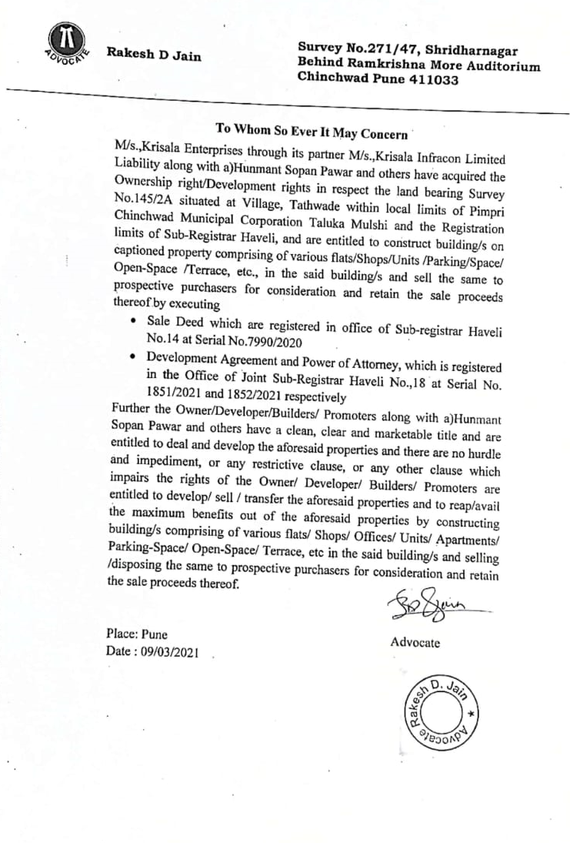
ANNEXURE-B
[7/12 EXTRACT OF LAND]
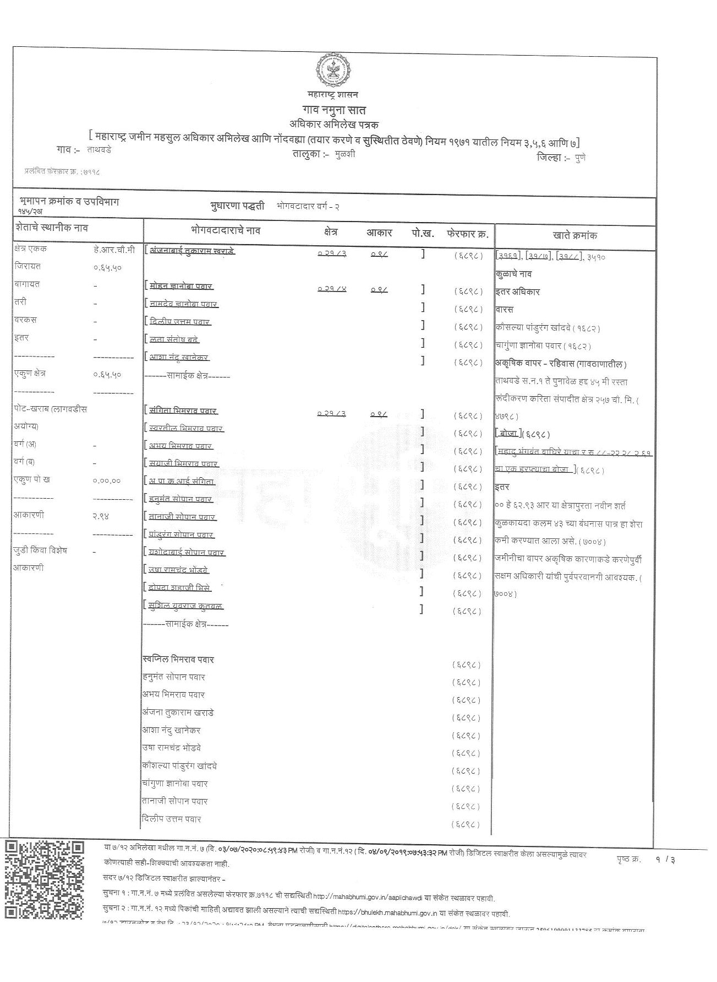
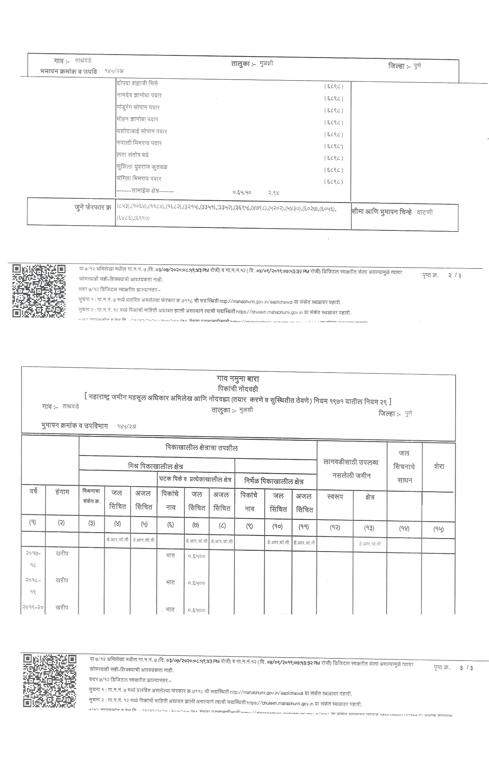

ANNEXURE-C1
[LAY OUT OF THE PROJECT]

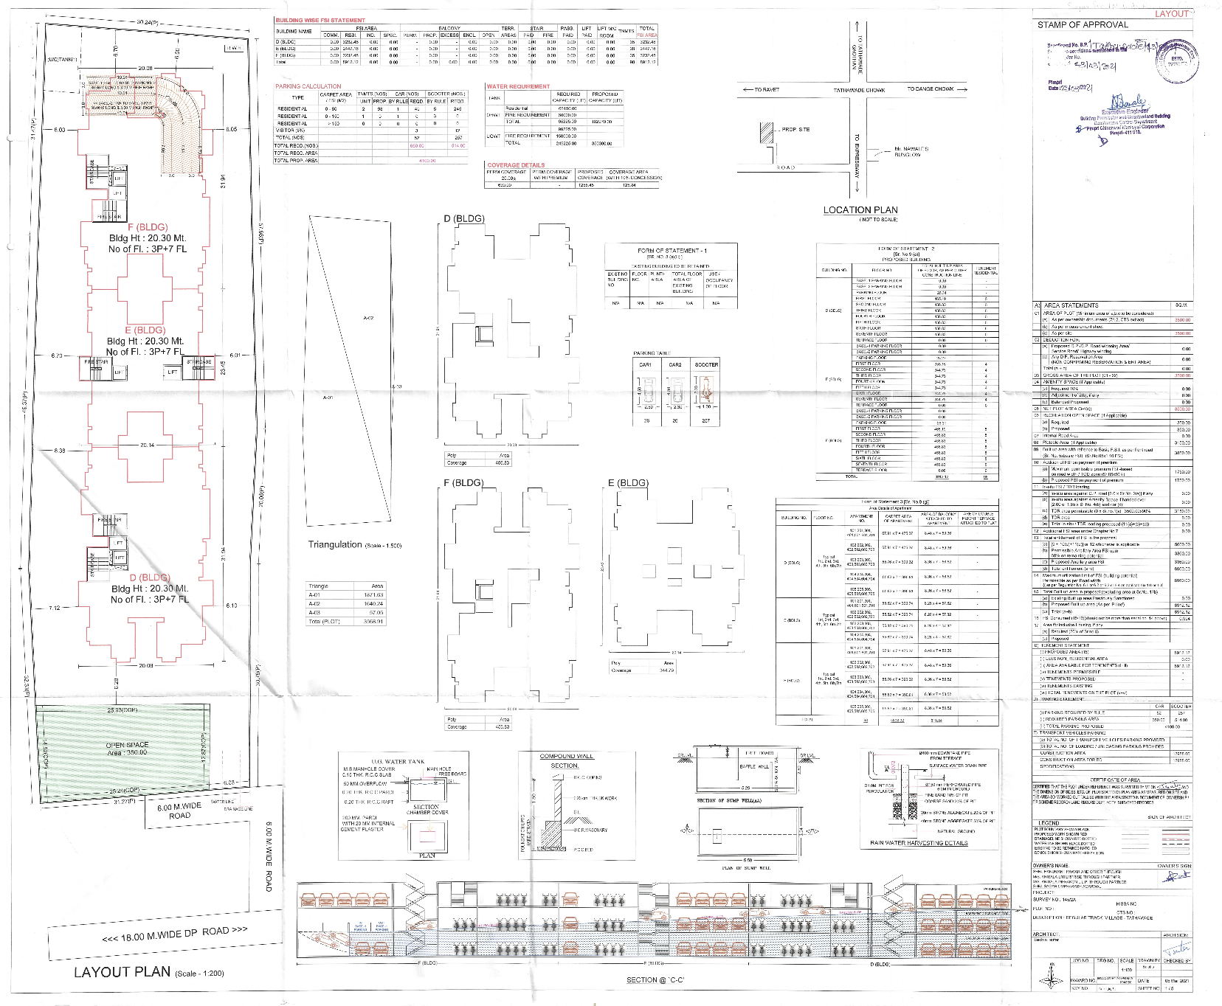

ANNEXURE-C2 + C3
[BUILDING PLAN MAP + OPEN SPACE MAP OF PROJECT]

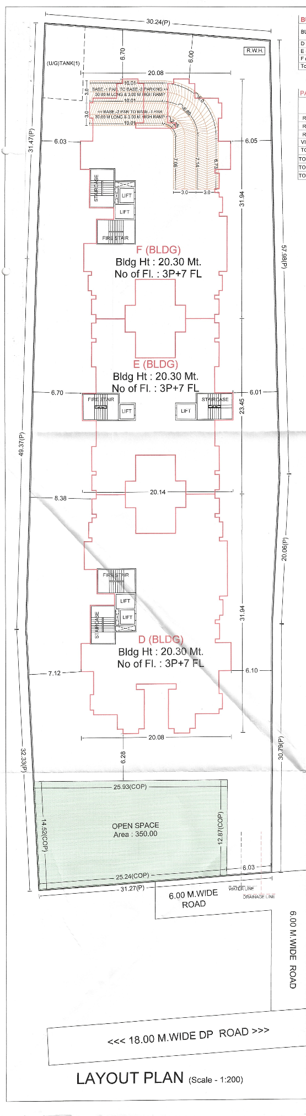
ANNEXURE-D
[FLOOR PLAN OF THE APARTMENT]

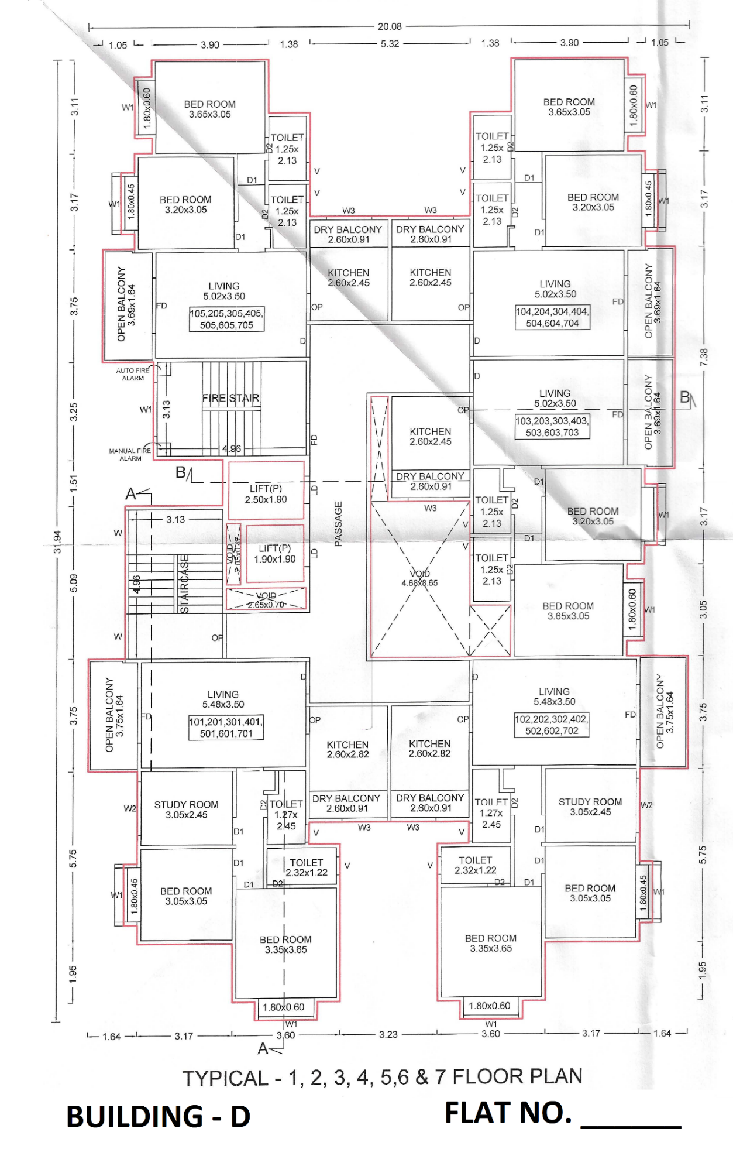

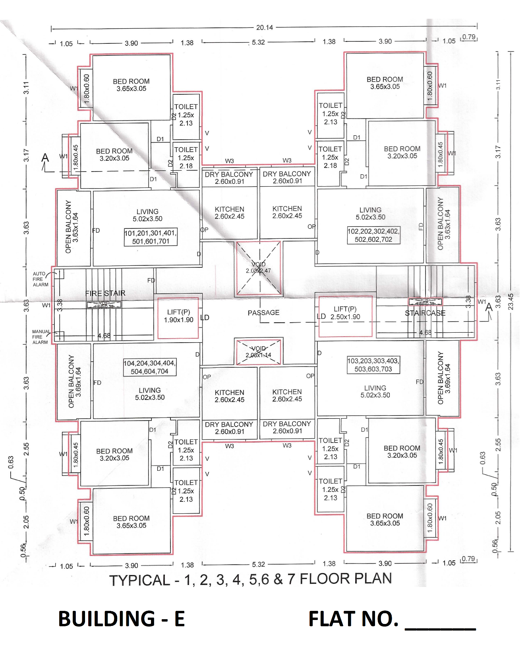

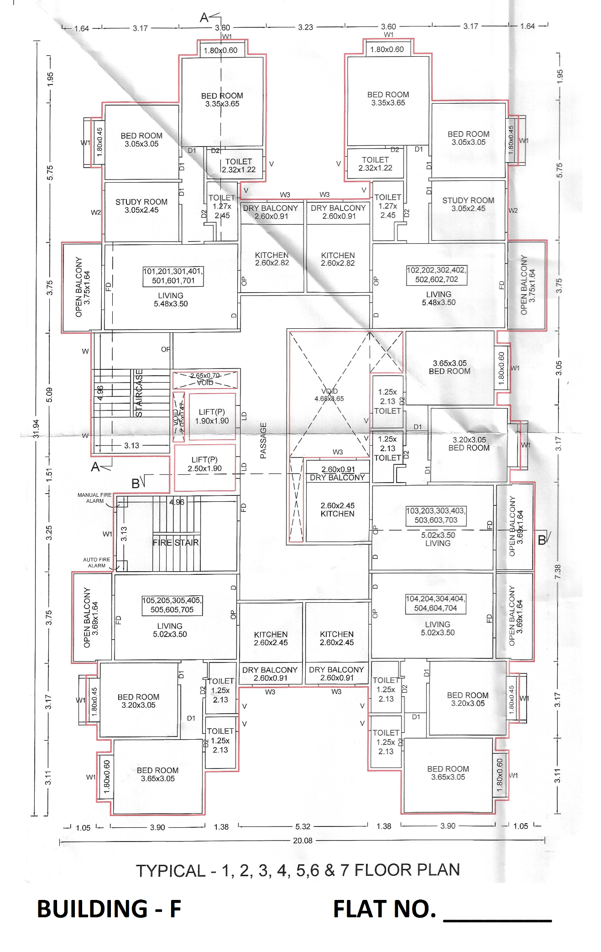
ANNEXURE-E
(SPECIFICATION OF THE APARTMENT AND COMMON AMENITIES)
AMENITIES
SWIMMING POOL | GARDEN AREA
CHINDREN’S PLAY AREA | CHESS COURT
SENIOR CITIZEN’S ALLEY | ROCK CLIMBING AND ADVENTUROUS WALL
OPEN GYM | SIT OUT / CABANAS
INDORR GAMES | DESIGNER ENTRANCE LOBBY
DESIGNER MAIN ENTRANCE GATE | WALKING TRACK
MULTIPURPOSE LAWN, BADMINTON AND FOOTSAL | BBQ ZONE
GARBAGE CHUTE | LOFT FOR INVERTER AND STORAGE
YOGA MEDITATION AREA | CLUB LOUNGE
FULLY EQUIPPED GYM | PRESENTATION ROOM
COFFEE TABLES | DANCE FLOOR
WASH ROOMS | PROVISION FOR MUSIC SYSTEM
CHARGING POINTS | A TODDLERS SAFE ZONE
AUTOMATION
GAS LEAK DETECTOR | PANIC BUTTON IN PARENTS BED & BATHROOM
SIP VIDEO DOOR PHONE | CCTV CAMERA
VISITOR’S MANAGEMENT APP
GREEN FEATURES
RAIN WATER HARVESTING | SOLAR WATER HEATERS
SAFETY AND SECURITY
FIRE FIGHTING SYSTEM | POWER BACKUP FOR COMMON AREAS
CCTV SURVEILLANCE

STRUCTURE
RCC FRAMED STRUCTURE | EARTHQUAKE RESISTANT STRUCTURE
TILES
DADO TILES IN WASHROOM AND ABOVE KITCHEN PLATFORM
FLOORING
800 X 800 VERTIFIED TILES IN BEDROOMS, LIVING ROOMS AND KITCHEN | ANTI-SKID FLOOR TILES IN WASHROOM, TOILET & TERRACE
PAINT
INTERNAL OBD PAINT | SUPERIOR QUALITY EXTERNAL PAINT
KITCHEN
CLOSED KITCHEN FOR PRIVACY AND BETTER STORAGE SPACE | GRANITE KITCHEN COUNTER TOP WITH STAINLESS STEEL SINK
ADDITIONAL SS SINK IN DRY BALCONY FRO DRY AND CLEAN KITCHEN PLATFORM | PROVISION FOR WATER PURIFIER
GLAZED TILES ABOVE THE PLATFORM | ELECTRICAL POINTS AS PER ELECTRICAL LAYOUT
WALL BETWEEN KITCHEN AND DRY BALCONY FOR SEPARATE WET AND DRY AREAS | BREAKFAST COUNTER WITH GRANITE TOP TO AVOID CONGESTION.
BEDROOM
BOTH SIDE LAMINATED FLUSH DOORS | AC PROVISION IN MASTER BEDROOM
ALL ELECTRIC POINTS AS PER ELECTRICAL PAYOUT

TERRACE
SLIDING DOOE FOR THE BALCONY TO SAVE BALCONY SPACE | SS RAILING WITH TOUGHENED GLASS
GRANITE COUNTER PROVIDED WITH CHARGING POINT FOR LAPTOP | 600 X 600 TILES FOR FLOORING TO GIVE A SPECIOUS LOOK
NATUAL SUNLIGHT IN EVERY CORNER OF THE FLAT | TOUGHENED GLASS IN TERRACE TO ENSURE
SAFETY AD GLASS IN TERRACE TO ENSURE | ANTI-SKID TILES FOR SAFETY IN RAINY SEASON
CHARGING POINT
DRY BALCONY
SS SINK WITH GRANITE PLATFORM | ELECTRICAL POINTS FOR WASHING MACHINE
WINDOWS
3 TRACK POWDER COATED ALUMINIUM SLIDING WINDOW WITH GRANITE SILL | MS SAFETY GRILL
LOUVERED VENTILATORS IN BAHROOM
DOORS
BOTH SIDES LAMINATED FLUSH DOORS | WOODEN LAMINATED DOOR FRAME ON MAIN DOOR & BEDROOM DOOR
WOODEN LAMINATED MAIN DOOR & BEDROOM DOOR | ALL DOORS FITTINGS WITH BRASS/STAINLESS FINISH
PLUMBING
INTELLIDENT PUBLING WITH CONCEALED PIPES | SANITARY AND BATH FITTINGS
JAGUAR OR EQUIVALENT MAKE BATH FITTINGS | GEYSER PROVISION IN ONE BEDROOM
WASHROOM
GRANITE DOOR FRAME WITH BOTH SIDE LAMINATED FLUSH DOORS | CPVC PLUMBING AND SANITARY WAVE
GLAZED TILES UPTO 7’ HEIGHT | EXHAUST FAN PROVISION AND ELECTRIC BOILER POINT
SOLAR WATER HEATER IN MASTER TOILET
ELECTRICALS
CONCEALED FIRE RETARDANT LOW SMOKE COPPER WIRES CIRCUIT BREAKER | TV AND TELEPHONE POINTS IN LIVING AND ONE BEDROOM
MODULAR SWITCHES | SPLIT AC PROVISION IN ONE BEDROOM
EXHAUST FAN PROVISION IN ONE BEDROOM | FRIDGE, OVEN AND FOOD PROCESSOR POINTS IN KITCHEN
PROVISION FOR EXHAUST FANS IN KITCHEN AND WASHROOM
LIVING ROOM
DECORATIVE NAME PLATE AT THE MAIN DOOR | DESIGNER MAIN DOOR WITH ELEGANT HANDLE
TWO WAY SWITCHES FOR LIGHT AND FAN FOR LIVING ROOM | RIGHT AT THE ENTRANCE
BEDROOM
BEDROOMS ARE CLUBBED TOGETHER AND LOCATED IN MORE PRIVATE AREA OF THE HOUSE | TWO SIDE WALLS FOR FLEXIBILITY IN ARRANGEMENT OF FURNITURE
TWO WAY SWITCHES FOR LIGHT AND FAN AT THE DOOR AND NEAR THE BED | PROVISION FOR AC POINT
PROVISION FOR TV AND INTERNET POINTS | CHARGING POINT NEAR BED
COMMON AREAS
LEAD FREE NON-FRAMMABLE PAINT | ISI MARK BRANDED CABLES
LOBBY AREA TO AVOID CONGESTION AT THE BEDROOM ENTRANCE | SAFETY GRILLS FOR WINDOWS FROM OUTSIDE
ANNEXURE-F
Certificate of Registration with MahaRERA
BUILDING - D
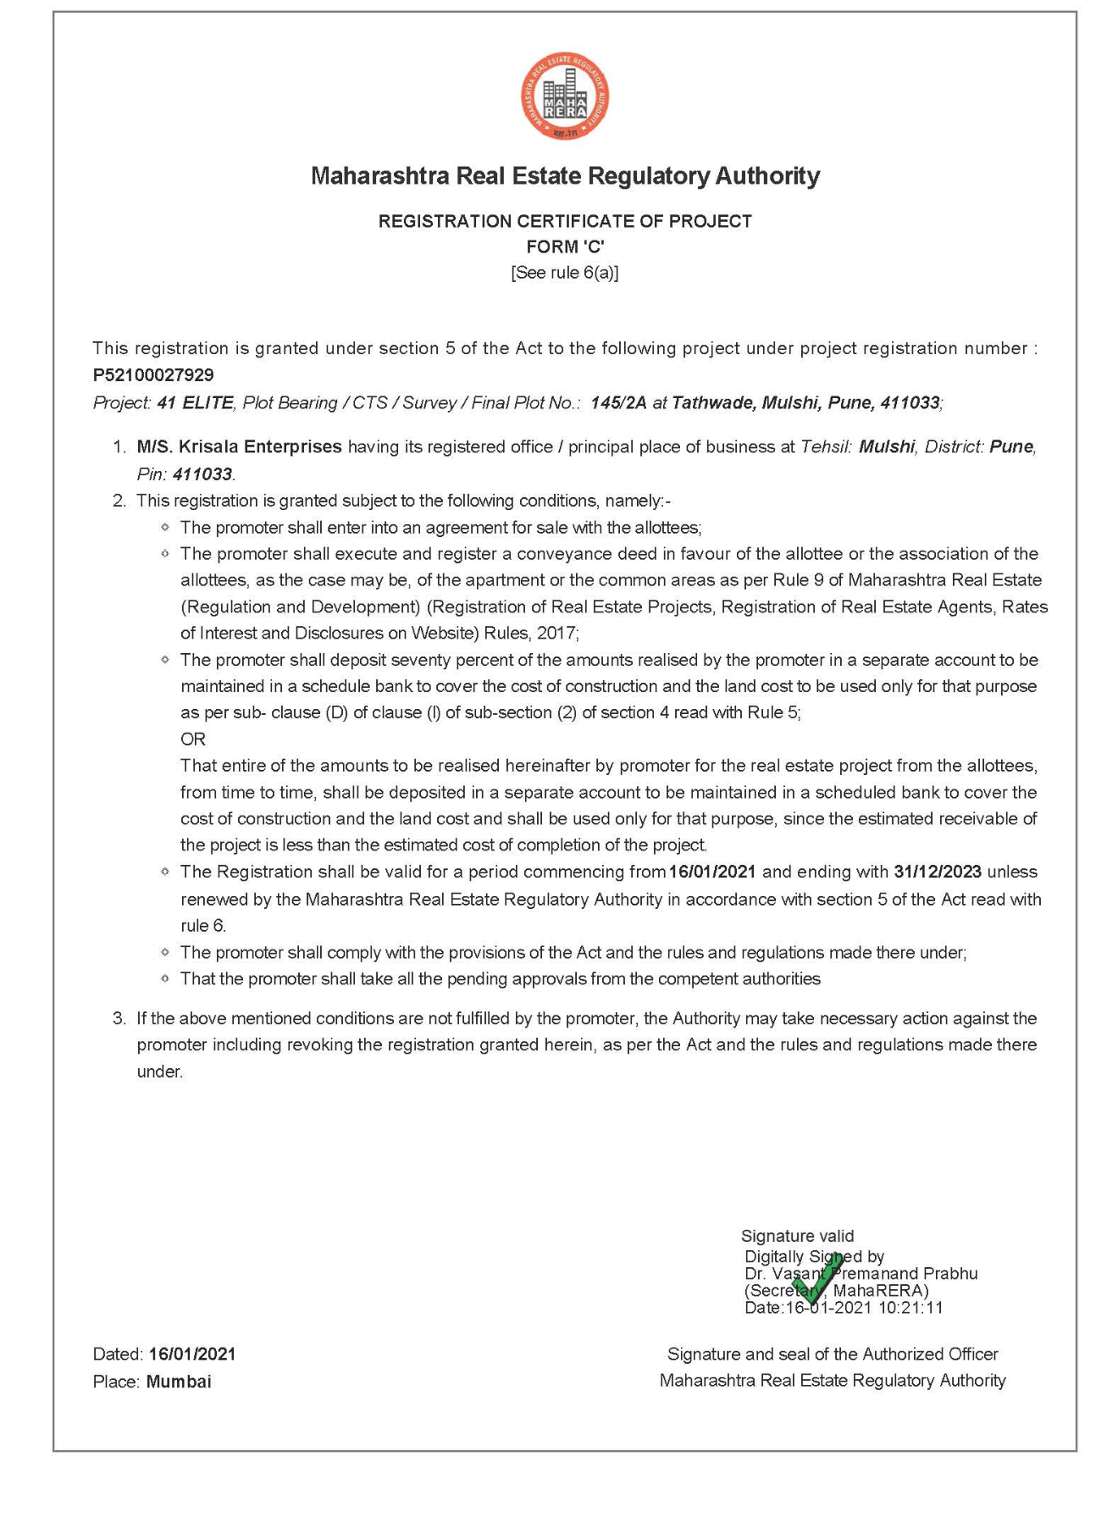

Certificate of Registration with MahaRERA
BUILDING – E

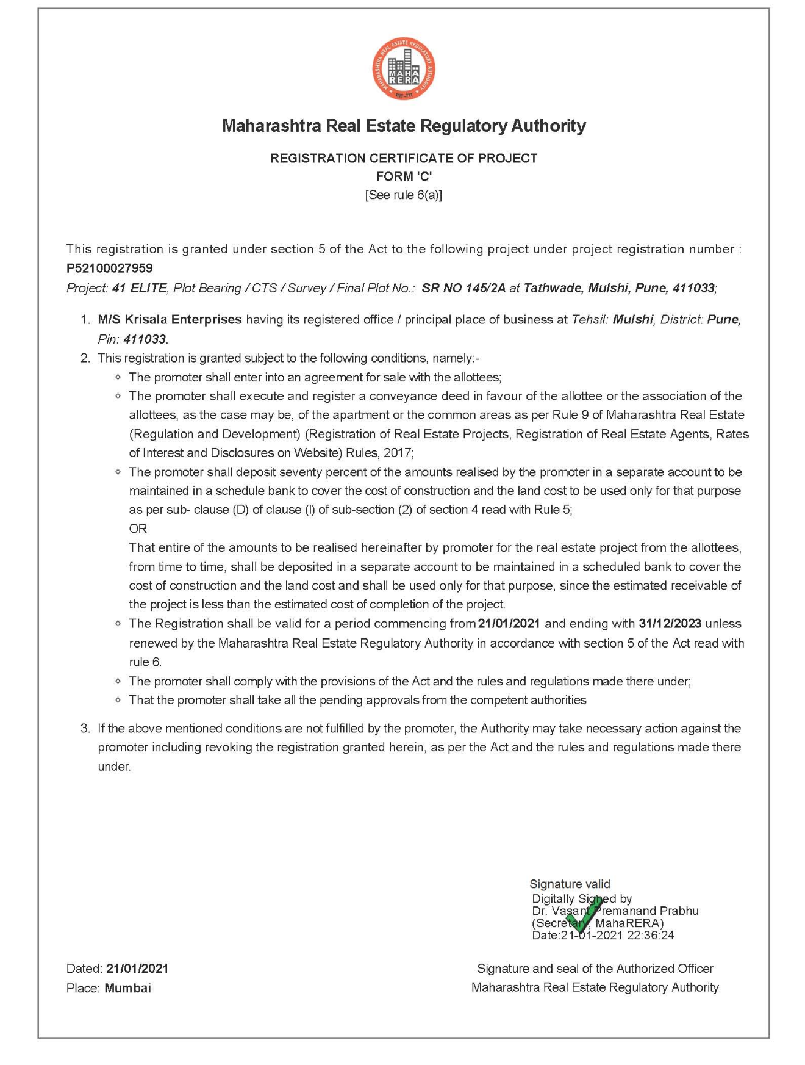

Certificate of Registration with MahaRERA
BUILDING – F

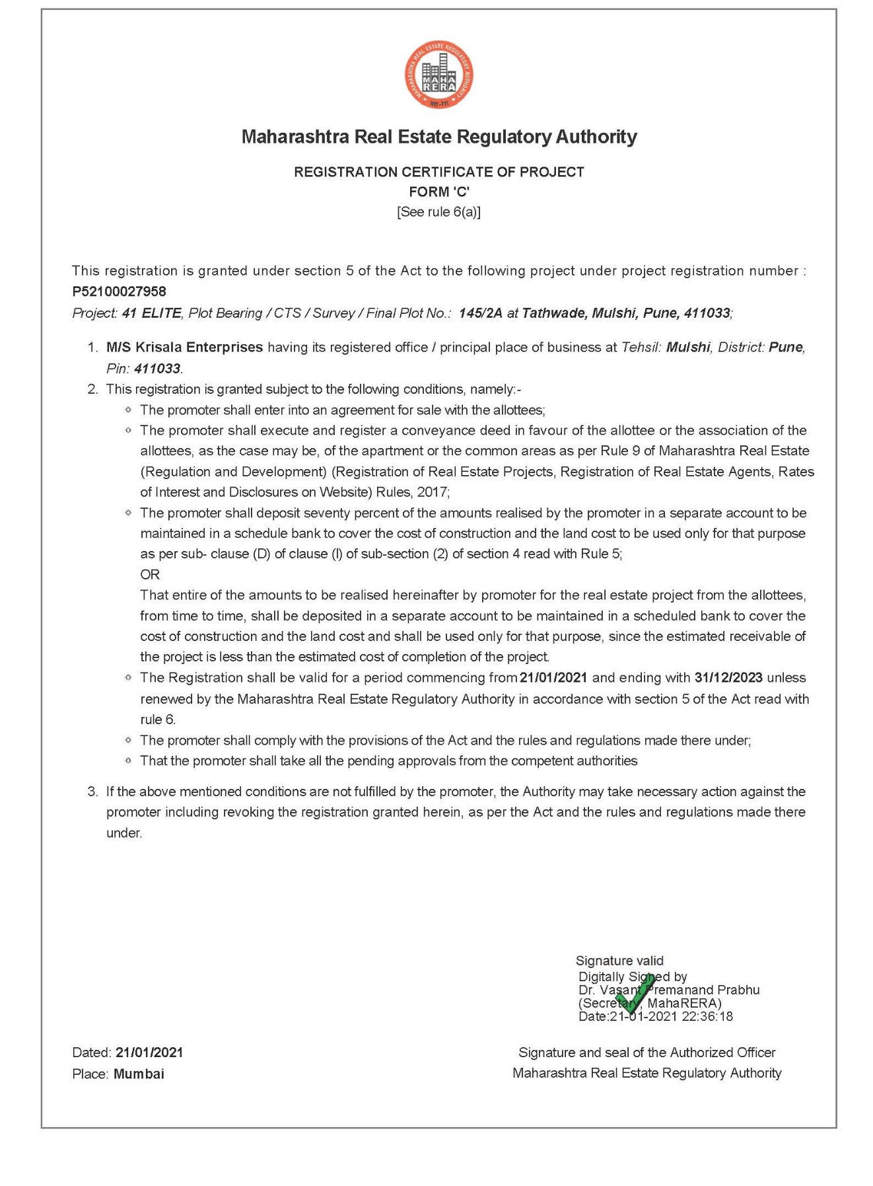

ANNEXURE-G
COMMENCEMENT CERTIFICATE
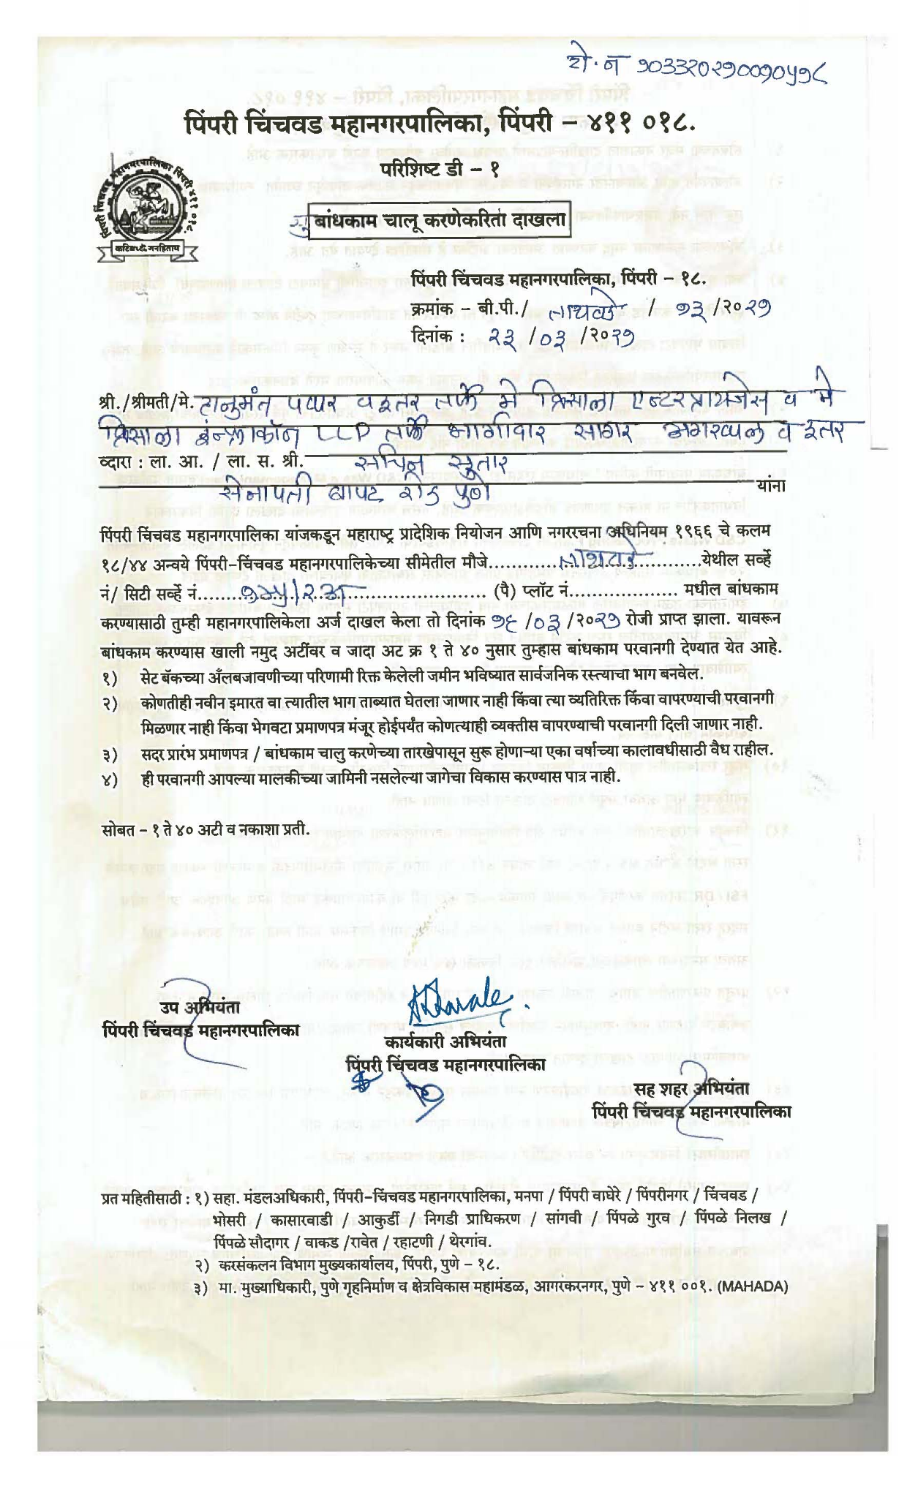
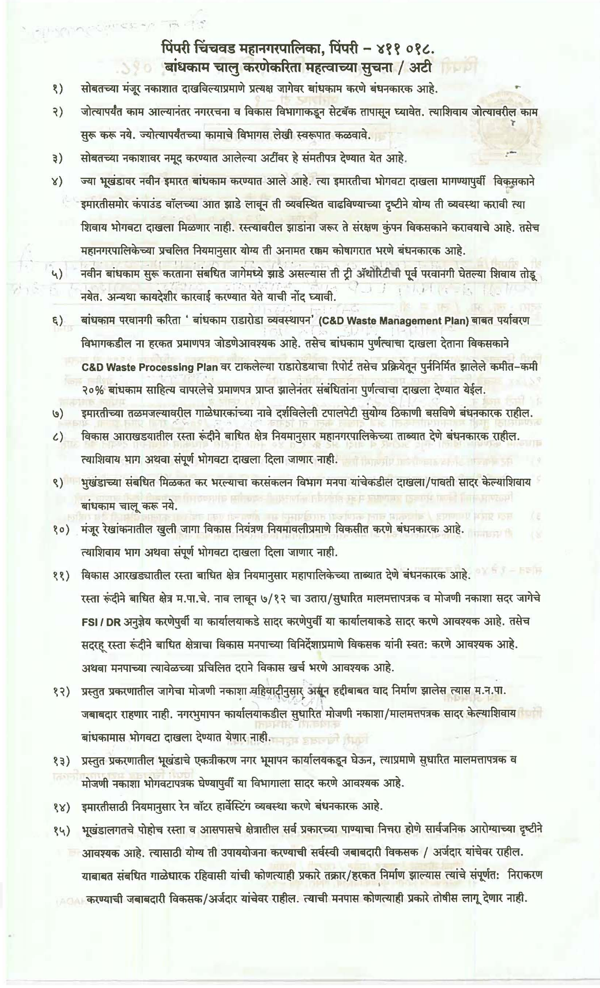
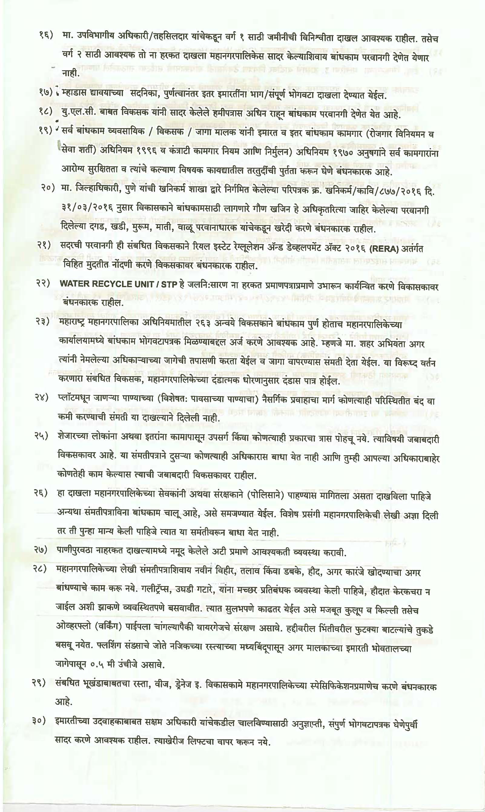
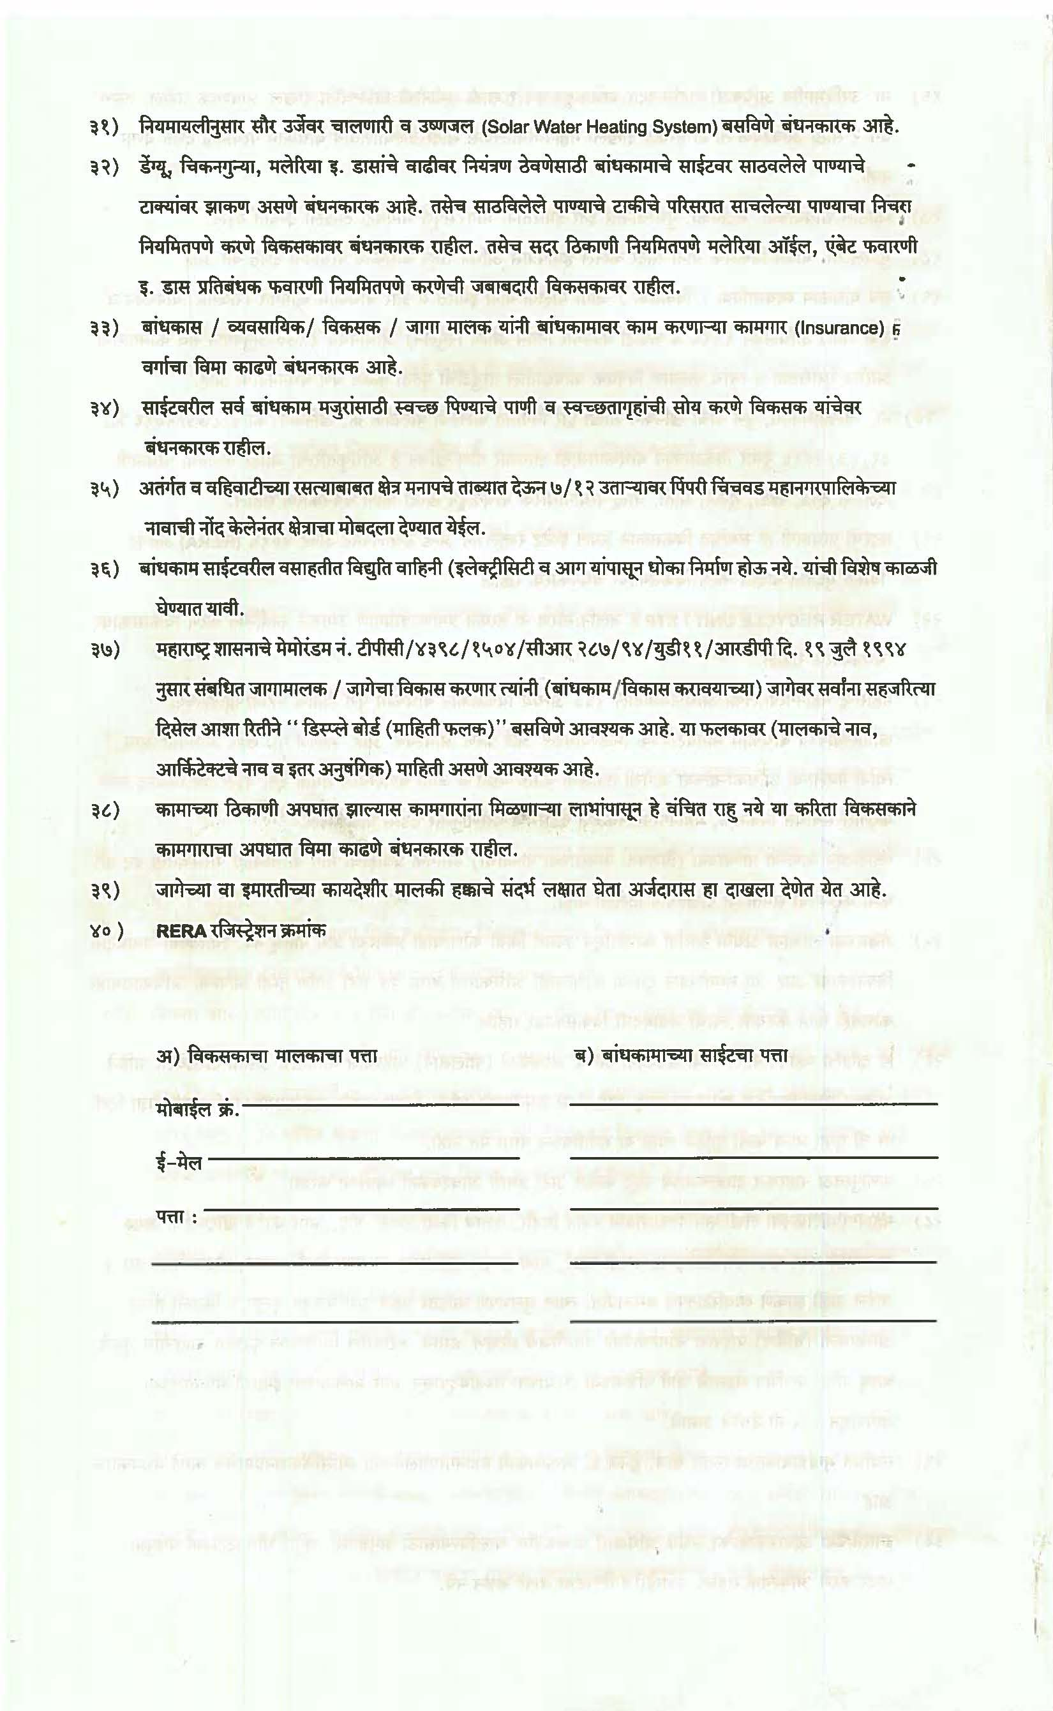
ANNEXURE-H
PROPOSED AMALGAMATED LAYOUT OF THE PROJECT

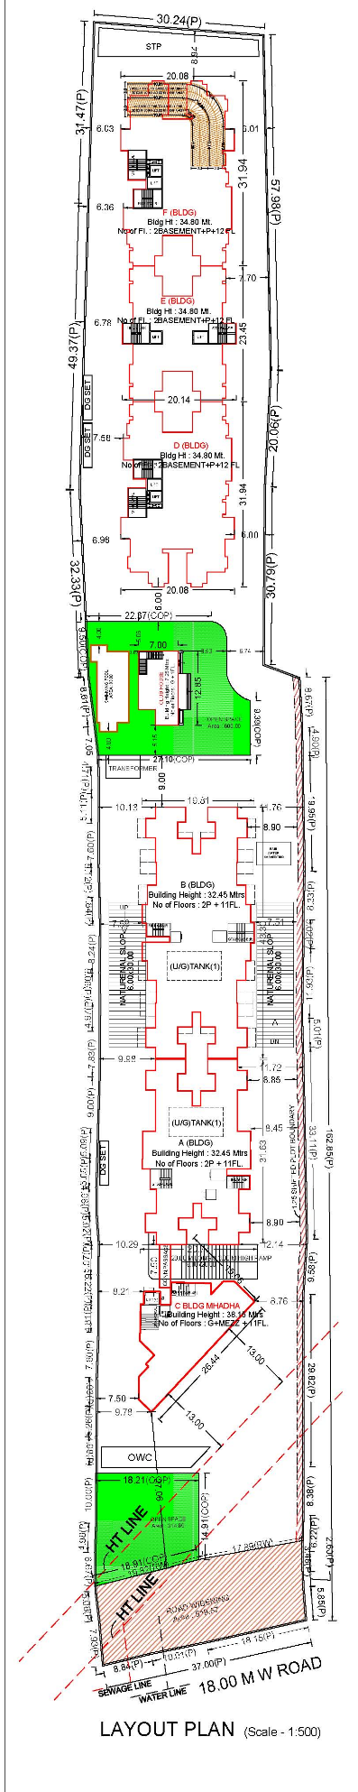
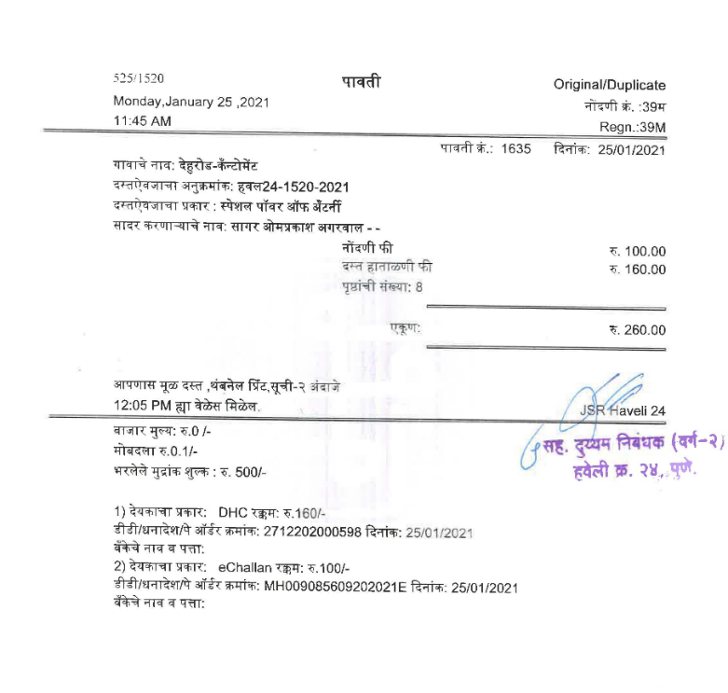

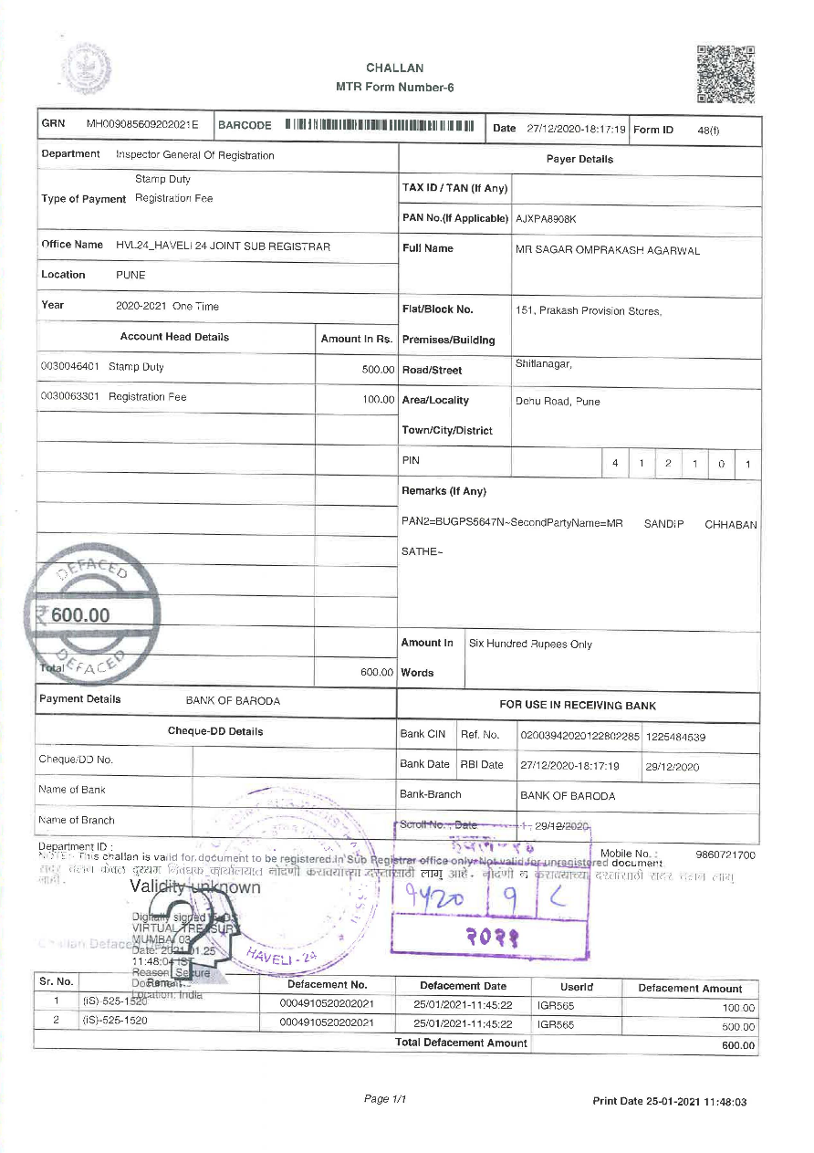

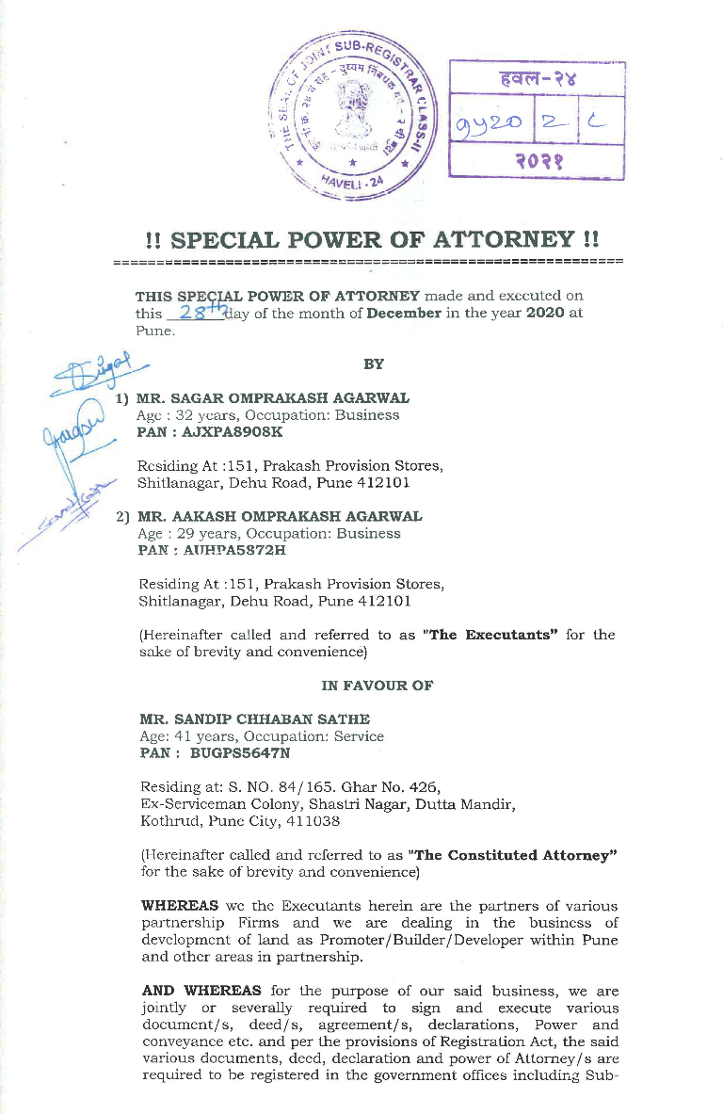
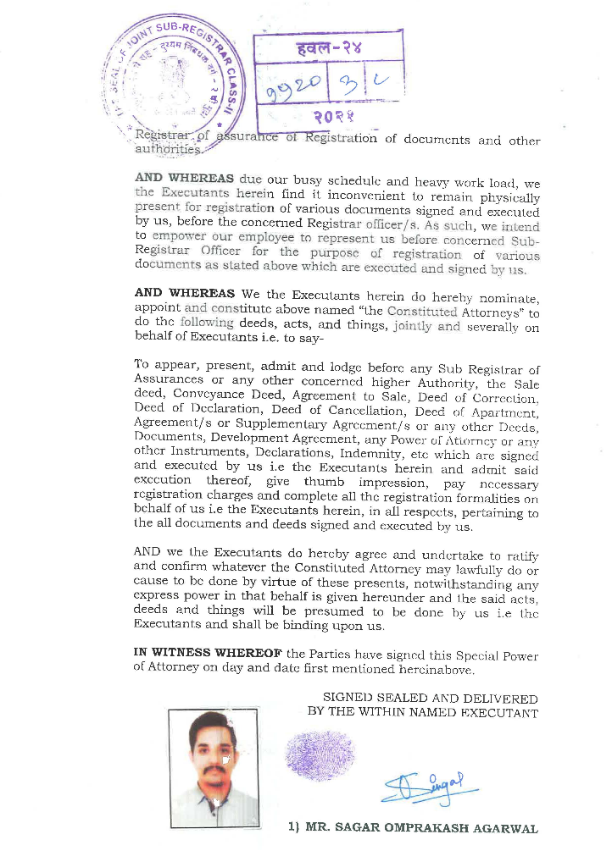

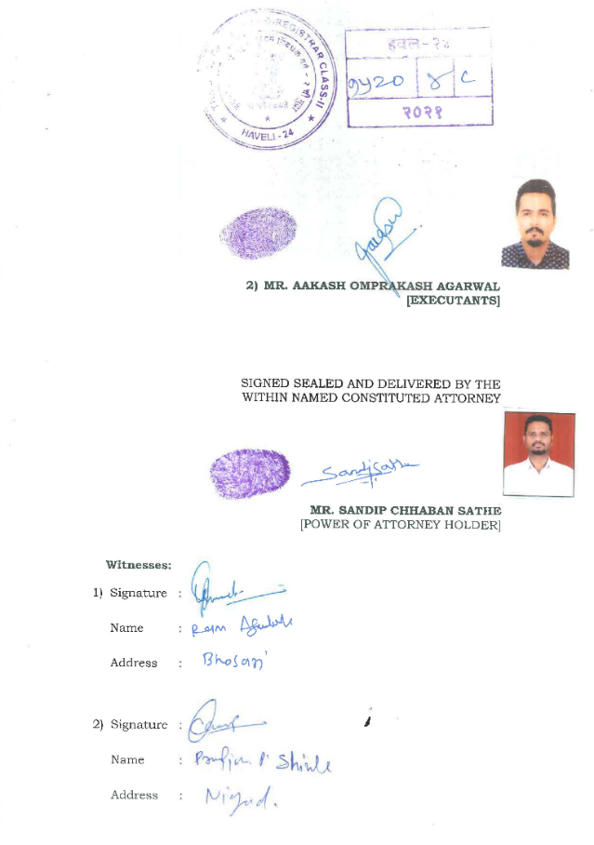
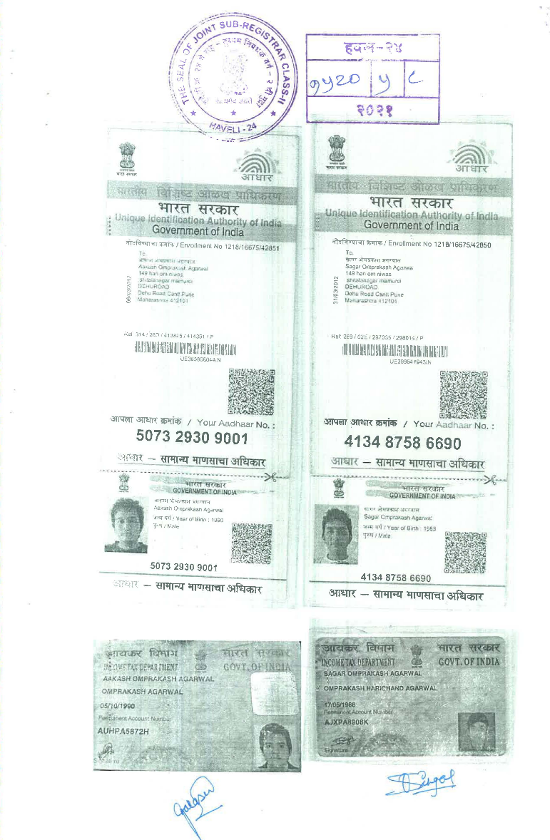
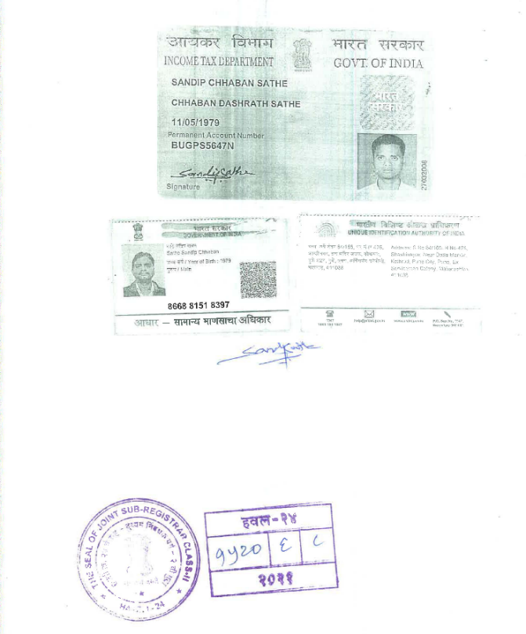

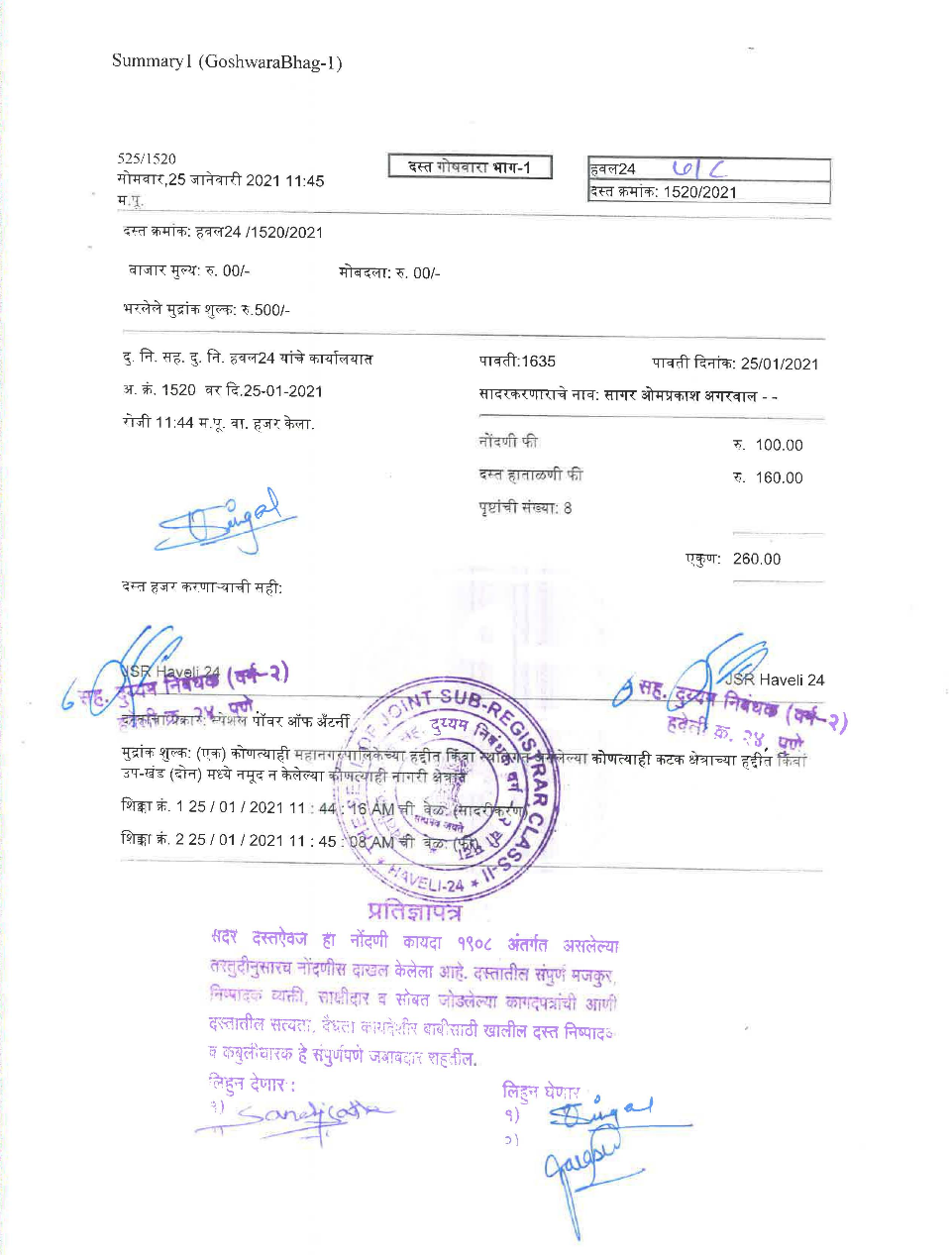

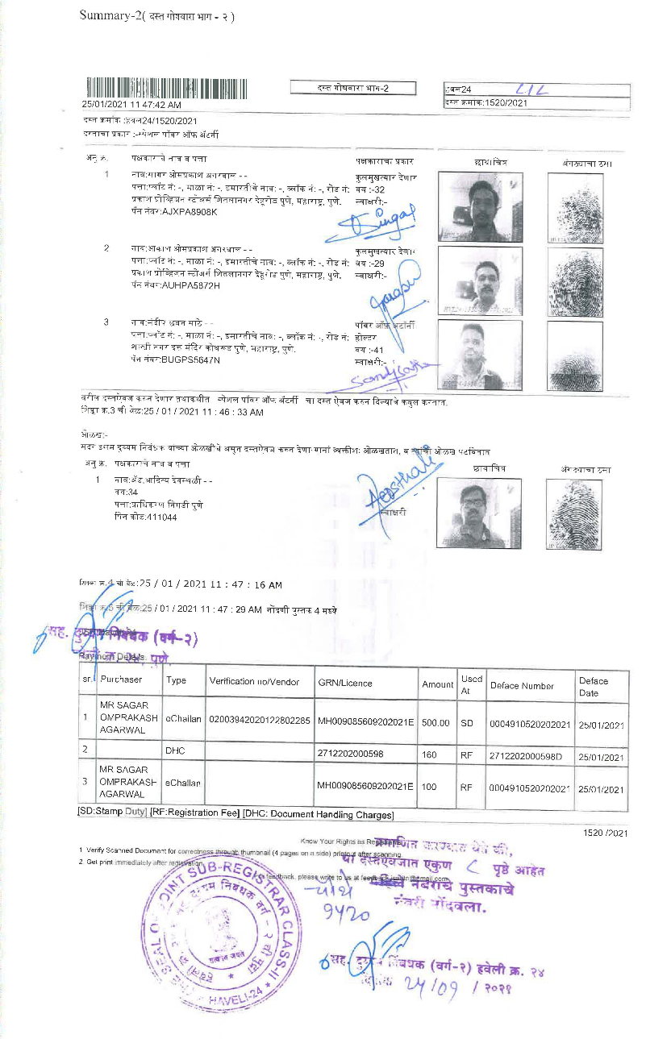

D E C L A R A T I O N

M/S. KRISALA ENTERPRISES through its Partner, do hereby state and declare that I have presented document in the office of Sub-Registrar, Haveli for registration. I state that Mr. Hanumant Sopan Pawar and others have executed Power of Attorney, which are duly registered in the office of Sub Registrar Haveli No. 18, at Serial No.1852/2021 on 01.02.2021 our favour. The said Power of Attorney is not cancelled. I state that the executants of the said Power of Attorney is not dead. The said Power of Attorney is perfectly valid and I am authorized to do the aforesaid act. I state that if the present declaration is found to be false, I am aware that I am liable to be punished under Section 82 of the Registration Act 1908.

MR. SAGAR O. AGARWAL
DECLARANT

D E C L A R A T I O N

Mr. Sandip C. Sathe, do hereby state and declare that I have presented document in the office of Sub-Registrar, Haveli for registration. I state that Mr. Sagar Omprakash Agarwal has executed Special Power of Attorney, which are duly registered in the office of Sub Registrar Haveli No. 24, at Serial No.1520/2021 on 25.01.2021 in my favour. The said Special Power of Attorney is not cancelled. I state that the executant of the said Special Power of Attorney is not dead. The said Special Power of Attorney is perfectly valid and I am authorized to do the aforesaid act. I state that if the present declaration is found to be false, I am aware that I am liable to be punished under Section 82 of the Registration Act 1908.

MR. SANDIP C. SATHE
DECLARANT

PAN CARD OF THE PROMOTER/ALLOTTEE


