ARTICLES OF AGREEMENT

THIS AGREEMENT is made and executed at Pune on this_____ day of
___________in the year 2021.

BETWEEN

M/S. WONDER SKYLINE LLP, a Limited Liability Partnership firm duly constituted and registered under the provisions of the Limited Liability Partnership Act, 2008, PAN: AAHFE9448F, having its Registered Office at: 334, Market yard, Pune - 411037, District Pune.
Through its Designated Partners:
- Mr. Manoj Vijaykumar Agarwal, Age: Adult, Occupation: Business, (PAN No.: ADAPA7232R)
- Mr. Aakash Omprakash Agarwal, Age: Adult, Occupation: BUSINESS, PAN No.: AUHPA5872H)
- Mr. Anuj Agarwal, Age: Adult, Occupation: BUSINESS, (PAN No.: AKWPA2478G)
Hereinafter referred to or called as "the Promoters" (which expression unless repugnant to the context or meaning thereof shall mean and include the said partnership firm, it’s a present partner/s, partner/s who may continue/ s as the partner of the firm and person/ s who may be admitted as the partner of the firm on reconstitution of the firm and the dissolution of the firm right, and obligation, under this agreement to whom allotted and partner/ s heirs, executors, administrators, but does not include the partner/s who ceases to be the partner of the said firm and his/her theirs, executors, representatives, administrators, and permitted assigns).
….. PARTY OF THE FIRST PART

AND

Mr. Mahadev Dalvi, Age: 46 Years, Occupation: Salaried (PAN No. ALDPD8566E/Aadhar Card No. 893505853676, residing at G-11 Suvarna Nagari, Near Relainace Petrol pump At post- Saswad

Mr.. Age: Years, Occupation: . [PAN: . ] / [AADHAR: ] Residing At:

(Hereinafter called and referred to as, "the Purchaser / s" (which expression shall unless repugnant to the context or meaning thereof shall mean and include the Purchaser/s and include his / her / their respective heirs, executors, representatives, administrators and permitted assigns etc.

....PARTY OF THE SECOND PART

AND

M/S. KUMAR BEHARAY RATHI, (PAN – AAAFK6677K) a partnership firm duly registered under the provisions of the Indian Partnerships Act, 1932 having its Registered Office at – 10th Floor, CTS no. 29, Bund Garden Road, Pune 411 001 by the hand of its partner, SHRI. LALITKUMAR KESARIMAL JAIN, hereinafter referred to as “Consenting Party No. 1/KBR” (which expression shall unless it be repugnant to the context or meaning thereof be deemed to mean and include the partners for the time being of the said firm, the survivors or survivor of them and the heirs, executors and administrators of such last survivors)
--- PARTY OF THE THIRD PART;
AND

- Mr. Madhav Narayan Paranjape, age about 67 years, Occupation: Medical Practitioner.
- Mrs. Mohini Madhav Paranjape, age about 58 years, Occupation household.
- Mr. Rajiv Madhav Paranjape, age about 31 years, Occupation Business.
- Mr. Anapla Rajiv Paranjape, age about 25 years, Occupation household.
- Master Kunal Rajiv Paranjape, age about 4 years, Occupation Nil, minor, through his natural guardian and father Mr. Rajiv Madhav Paranjape.
All the above (1) to (5) are residing at 1396, Sadashiv Peth, Pune-411030.
- Mrs. Radha alias Medha Raju Raje, age about 30 years, Occupation Household, residing at 26, Navketan Co-operative Housing Society, Kothrud, Pune.
- Smt. Sumatibai Moreshwar Paranjape, age about 75 years, Occupation Household and Medical Practitioner.
- Mr. Yashwant Moreshwar Paranjape, age about 60 years, Occupation Business.
- Mrs. Prabha Yashwant Paranjape, age about 53 years, Occupation Household through her constituted Attorney Holder Shri. Yashwant Moreshwar Paranjape.
- Mr. Sanjiv Yashwant Paranjape, age about 32 years, Occupation Business, through his constituted attorney holder Shri. Yashwant Moreshwar Paranjape.
- Mrs. Shubhada Sanjiv Paranjape, age about 25 years, Occupation Household through her constituted attorney holder Shri. Yashwant Moreshwar Paranjape.
- Mr. Ajay Yashwant Paranjape, age about 24 years, Occupation Student.
- Mr. Dhananjay Yashwant Paranjape, age about 20 years, Occupation Student.
All above (6) to (13) are residing at 1398, Sadashiv Peth, Pune-411030.
- Smt. Shila Vishwanath Gokhale, age about 50 years, Occupation Household, residing at Sanjeevan Hospital, Ghole Road, Pune- 411005

through Substituted Power of Attorney holder (pursuant to Power of Attorney dated 10/11/1987 and Substituted Power of Attorney dated 09/02/2004 registered on 12/02/2004 at the office of Sub Registrar of Assurances Haveli No. 10 Pune ) Shri. Lalitkumar Kesarimal Jain as Partner of M/s KUMAR BEHARAY RATHI, Age – 57 years, Occupation – BUSINESS , having office at:- BUND GARDEN ROAD, Tal. HAVELI, Dist. Pune, having Office address at: 10th Floor, CTS no. 29, Bund Garden Road Pune – 411001

(Hereinafter referred to as, "the Consenting Party No. 2 / Owners" (which expression shall unless repugnant to the context or meaning thereof shall mean and include his / her / their heirs, executors, attorney holder, representatives, administrators and assigns etc.)
....PARTY OF THE FOURTH PART

RECITALS:
WHEREAS, All that piece and parcel of land admeasuring 4000 sq. mtrs. of slum declared land i.e. area sanctioned for “K” building which now as per current possession is 3523.86 sq.mtrs. in the plan approved by the Pune Municipal Corporation out of the whole area of the land i.e. 34810 Sq. Mtrs. bearing Survey No. 224, Hissa No. 2/1, 2/2 and Survey No. 226A Hissa No. 1/1, 1/2, 1/3, 1/4 and 1/5 of Village - Hadapsar, Taluka -Haveli, District - Pune, situated within the Revenue jurisdiction of the Office of Sub-registrar of Assurances, Taluka - Haveli, District - Pune duly stands in the names of the Consenting Parties as herein mentioned (hereinafter referred to as the "said land" and more particularly described in the Schedule I hereunder);

AND WHEREAS, as per Mutation Entry No. 1997 dated 24 October 1929 Mr. Narayan Mahadev Paranjape had applied for confirming the boundaries of Survey No. 226 (A) and Survey No. 224 and Survey No. 266. While deciding the boundaries difference were found in the forest easementary area and as per the order respective authorities corrections had been done with respect to the land bearing Survey No. 226A/1 and 226A/2;

AND WHEREAS, Mr. Narayan Mahadev Paranjape, who died intestate on 08.03.1929 was succeeded by his legal heirs i.e. his widowed wife Mrs. Laxmibai Narayan Paranjape, and his two sons namely Mr. Moreshwar Narayan Paranjape and Mr. Madhav Narayan Paranjape. Consequently, names of Mr. Moreshwar Narayan Paranjape alone was recorded on the Village Form No. VII, and XII of the revenue records of Survey No. 226A/1;

AND WHEREAS, vide a Partition Deed dated 02.01.1941, executed and duly registered at Sr. No. 538 in the office of Jt. Sub Registrar of Assurances, Haveli No. 1, Pune, all ancestral properties of Mr. Narayan Mahadev Paranjape, were partitioned. As per the said Partition Deed, the scheduled property transferred to the joint share of Mr. Moreshwar Narayan Paranjape, Mr. Yashwant Moreshwar Paranjape, Mr. Madhav Narayan Paranjape and Mrs. Laxmibai Naryan Paranjape. Ms. Laxmibai Narayan Paranjape died intestate in the year 1948;

AND WHEREAS, a Deed of Partition dated 28.03.1961 was executed and was duly registered at Serial No. 453 in the office of Jt. Sub Registrar of Assurances Haveli I, Pune by and between Mr. Moreshwar Narayan Paranjape, his son, Mr. Yashwant Moershwar Paranjape and his grandson Mr. Sanjiv Yashwant Paranjape, whereby their collective share in the scheduled property was partitioned by metes and bounds. This Deed of Partition was not recorded in the Village Form No. VII and XII of the revenue records of the scheduled property. This Deed of Partition dated 28.03.1961 was not effected and their collective undivided one-half share in the said lands continued to be held by them jointly.

AND WHEREAS, as per Mutation Entry No. 4519 dated 13.12.1963 it appears that as per Section 23 of Bombay Tenancy Act, land of Mr. Moreshwar Narayan Paranjape in the other rights column Mr. Maruti Ganpati Kadam’s name was recorded on form No.VII and XII of Survey No. 266, Survey No. 224 and 226A/1.

AND WHEREAS, as per Mutation Entry No. 6988 dated 22.05.1969 it appears that under the Maharashtra State Government Rule for Weight Measurement Act, 1958 and Indian Currency Act, 1955 a notification of rights in village register of the Additional District Inspector of Land Assessment is noted on Form No. VII and XII of all the above mentioned properties;

AND WHEREAS, as per Mutation Entry No. 8696 dated 12.01.1977, it appears that Mr. Moreshwar Narayan Paranjape died on 26.11.1970 leaving behind his last Will and Testament dated 29.03.1961. Vide the said Will he bequeathed his undivided share in Survey No. 224 and 226 A-1 of Hadapsar, Pune to his son namely Mr. Yashwant Moreshwar Paranjape. Consequently, names of Mr. Yashwant Moreshwar Paranjape, widowed wife Smt. Sumatibai Moreshwar Paranjape, Mr. Madhav Narayan Paranjape and daughter Mrs. Sheila Vishwanath Gokhale were recorded in the other rights of column. Some dispute arose between Mr. Yashwant Moreshwar Paranjape widowed wife Smt. Sumatibai Moreshwar Paranjape, and married daughter Mrs. Sheila Vishwanath Gokhale;

AND WHEREAS, as per Mutation Entry No. 9544 dated 28.08.1980 it appears that in the year 1980 Mr. Maruti Ganpat Kadam who was protected tenant in the portions out of the said lands bearing Survey No. 224 and 226 A-1 Hadapsar Pune who filed the proceedings under the provisions of Section 32 G of the Bombay Tenancy and Agricultural Lands Act, 1948. In the said matter the land owners and the tenants went up to the High Court, Mumbai. After that both the parties have decided to settle the dispute amicably and it was declared that a portion admeasuring 2 Hectares=15 Ares out of total land admeasuring 03 Hectares=18 Ares of Survey No. 224, Hadapsar was declared to be purchased by the said tenant i.e. Mr. Maruti Ganpati Kadam. The portion admeasuring 02 Hectares=15 Ares allotted to Mr. Maruti Ganpati Kadam was numbered as Hissa No. 1 of Survey No. 224, Hadapsar while the portion admeasuring 01 Hectares = 03 Ares which was in the name of the land owners was assigned Hissa No. 2 of Survey No. 224 Hadapsar, Pune;

AND WHEREAS, as per order of Hon’ble Upper Tahasildar Haveli bearing No.Tahap/459/80 dated 12.07.1980 and as stated in the order dated 31.05.1975 in case No. 32G/Hadapsar 228/63 of Sec. 32 G Bombay Tenancy Act as per the compromise done before the Hon’ble High Court, Mumbai, in order to hand over the possession of the lands to the respective owners dates were given to the Mandal Adhikari from time to time but on the given dates the possession was not handed over to the owners. But the respective land owners took the possession of the land at their level as per the order of Hon’ble High Court as per the compromise. Hence letter has been sent to the Talathi on 12.05.1980 and 20.05.1980 in order to make the necessary change in the Revenue records. Consequently, name of Mr. Maruti Ganpati Kadam as a tenant had been deleted from other rights column;

AND WHEREAS, Smt. Laxmibai Marutrao Kadam had filed Special Civil Suit No. 684/1983 against Mr. Moreshwar Narayan Paranjape and others seeking specific performance of an Agreement dated 21.02.1975 allegedly executed by Mr. Moreshwar Paranjape and others in her favour in respect of the lands bearing Survey No. 224 and 226A-1 Hadapsar, Pune. In the said matter amicable settlement took place and Hon’ble Civil Judge, Senior Division, Pune vide its Decree dated 05.01.1988 disposed off the Suit by giving direction to execute and register one or more Sale Deeds/Conveyance of the suit property in the name of nominee of M/s. Kumar Beharay Rathi;

AND WHEREAS, all the disputes settled amicably and hence Smt. Sumatibai Narayan Paranjape, Mr. Yashwant Moreshwar Paranjape and Mrs. Sheila Vishwanath Gokhale executed a Family Settlement on 29.09.1987 in which each of them had agreed to hold and enjoy their respective undivided shares in the said lands. As per the family settlement Deed Smt. Sumatibai Moreshwar Paranjape holds 4/18th share, Mr. Yashwant Moreshwar Paranjape holds 4/18thshare and Mrs. Sheila Vishwanath Gokhale holds 1/18th share;

AND WHEREAS, Mr. Madhav Narayan Paranjape, Mrs. Mohini Madhav Paranjape and Mr. Rajiv Madhav Paranjape executed a Deed of Partition dated 17.01.1974 and as per the said Partition Deed Mr. Madhav Narayan Paranjape got 1/10th Share in the Survey No. 224 Hissa No. 2 and Survey No. 226 A, Hissa No. 1, Hadapsar, Pune and Mrs. Mohini Madhav Paranjape. Mr. Madhav Narayan Paranjape and other executed power of Attorney to and in favour of Mr. Ramkumar Hiralal Rathi and Mr. Vimal Kumar Jain the partners and nominees of the M/s. Kumar BeharayRathi. Vide Deed of Partition dated 11.01.1988 Mr. Yashwant Moreshwar Paranjape and other with the consent of M/s Kumar Beharay Rathi partitioned the said land bearing Survey No. 224 Hissa No. 2 and Survey No. 226 A, Hissa No.1, Hadapsar, Pune by metes and bounds which is registered in the office of Sub Registrar Haveli No. II;

AND WHEREAS, each holder were assigned the following Hissa Nos.-
- S. No. 224 Hissa No. 2/1 admeasuring 3844.4 sq. mtrs. owned by Mr. Yashwant Moreshwar Paranjape, Smt. Prabha, Mr. Sanjeev, Mr. Ajay, Mr. Dhananjay Yashwant Paranjape, Mrs. Subhadra Sanjeev Paranjape.
- S. No. 224 Hissa No. 2/2 admeasuring 6755.6 sq. mtrs. owned by Smt. Sumatibai Moreshwar Paranjape.
- S. No. 226A Hissa No. 1/1 admeasuring 10470.00 sq. mtrs. owned by Mr. Madhav Narayan Paranjape and Mrs. Mohini Madhav Paranjape.
- S. No. 226 A Hissa No. 1/2 admeasuring 6890.00 sq. mtrs. owned by Mr. Raju Madhavrao Paranjape, Mrs. Alpana Raju Paranjape, Mr. Kunal Raju Paranjape.
- S. No. 226 A Hissa No.1/3 admeasuring 1000.00 sq. mtrs. owned by Smt. Sumatibai Moreshwar Paranjape.
- S. No. 226 A Hissa No. 1/4 admeasuring 3911.2 sq. mtrs. owned by Mr. Yashwant Moreshwar Paranjape, Smt. Prabha Yashwant Paranjape, Mr. Sanjeev Yashwant Paranjape, Mrs. Subhadra Sanjeev Paranjape, Mr. Ajay Yashwant Paranjape and Mr. Dhananjay Yashwant Paranjape.
- S. No. 226 A Hissa No. 1/5 admeasuring 1938.8 sq. mtrs. owned by Mrs. ShilaVishwanathGokhale.
Consequently, the effect of the said partition was duly recorded on the form no VII and XII vide.

AND WHEREAS, that Mr. Vimal Jain had given written application that partition of Survey No. 224/2 and Survey No. 226/A/1 Hadapsar was already partitioned vide registered Partition Deed as the effect of partition was duly recorded on Form No. VII, and XII vide Mutation Entry No. 12372 but some area of said Survey No. is remaining in the share of Mr. Madhav Paranjape and hence Correction Deed was executed and Index II of the Correction was produced on record and following names were duly recorded on the form No. VII, and XII Mr. Yashwant Moreshwar Paranjape, Smt. Sumatibai Moreshwar Paranjape, Mr. Madhav Narayan Paranjape, Mrs. Mohini Madhav Paranjape, Mr. Rajiv Madhav Paranjape, Mrs. Alpana Rajiv Paranjape, Mr. Kunal Rajiv Paranjape, Smt. Sumatibai Moreshwar Paranjape, Mrs. Prabha Yashwant Paranjape, Mr. Raju Yashwant Paranjape, Mrs. Sunanda Raju Paranjape, Mr. Ajay Yashwant Paranjape, Mr. Dhananjay Yashwant Paranjape, Mrs. Sheila Vishwanath Gokhale, Mr. Sanjiv Yashwant Paranjape, Mrs, Subhadha Sanjiv Paranjape;

AND WHEREAS, Mrs. Ranjana Balasaheb Kotwal and 32 others filed a Special Civil Suit No 928/2004 before the Civil Court Senior Division Pune against M/s. Kumar Builders and 8 others had filed the suit for declaration and perpetual Injunction. Plaint rejected and suit dismissed on 19.01.2015. Mrs. Ranjanan Balasaheb Kotwal and 32 others had filed an Appeal (bearing No 71 of 2015) before the Hon’ble District Court against the Judgment and order dated 19.01.2015 of the Small Cause Court, Pune. The said Appeal is dismissed on 06.09.2017. It appears that Mrs. Ranjana Balasaheb Kotwal and others had filed second Appeal No. 380/2018 against the order dated 06.09.2017 in the Civil Appeal No. 71/2015 against M/s Kumar Builders which is due for Pre-Admission;

AND WHEREAS, a portion out of the said land bearing Survey No. 226A-1, Hadapsar was declared to be a Slum Area under the provisions of the Maharashtra Slum Areas (improvement, Clearance and Re-Development) Act, 1971. Hence, development of the said portion out of the said land shall be governed by the provisions of the Maharashtra Slum Areas (improvement, Clearance and Re-Development) Act, 1971;

AND WHEREAS, Vide Agreement of Development dated 10.11.1987 registered at Serial No. 14841 in the office of Sub Registrar Haveli No. 1, Pune, Mr. Madhav Narayan Paranjape and others granted development rights with respect to Survey No. 224 HissaNo. 2 and Survey No. 226A Hissa No. 1, Hadapsar to and in favour of M/s. Kumar Beharay Rathi (“said Development Agreement”);

AND WHEREAS, M/s. Kumar Beharay Rathi applied to the Pune Municipal Corporation and got the building layout sanctioned with respect to the larger portion of the land vide its Commencement Certificate bearing No. D.P.O./8902/VI/71 dated 22.01.2004;

AND WHEREAS, Smt. Sumatibai Moreshwar Paranjape and others filed returns or statements with the Additional Collector and Competent Authority, Pune Urban Agglomeration in respect of their holdings of vacant Urban Land, including the said lands, as prescribed under the provisions of Sec. 6 (1) of the said Act;

AND WHEREAS, the proceedings under the provisions of section 8 and in revision under Section 34 of the Urban Land (Ceiling and Regulation) Act, 1976 was duly held by the said Additional Collector and Competent Authority, Pune Urban Agglomeration and by the Government of Maharashtra, Housing and Special Assistance Department and vide the order dated 07.04.1992 passed in revision under Section 34 of the said Act by the Secretary, Housing and Special Assistance Department, Government of Maharashtra set aside the earlier orders passed by the Competent Authority, Pune Urban Agglomeration and remanded the ULC Cases for reconsideration on merits. Vide a Corrigendum issued on 01.10.1992 the said Competent Authority declared the said lands as retainable in the hands of the said holders thereof;

AND WHEREAS, the said property is being developed as Slum rehabilitation under Section 3 (A) of Maharashtra Slum (Improvement, Clearance and Redevelopment) Act, 1971 and necessary permit from the Slum Rehabilitation Authority (SRA) under Regulation 33 (10) DCR- 1991 for the development of the said Property and/or the portion thereof in accordance with the applicable law and/or DCR has been obtained;

AND WHEREAS, vide order dated 11.07.2003 bearing No PRH/NA/SR/56/III/2003 the office of Collector, District Pune permitted conversion of user of a portion admeasuring 10600 sq. mtrs. out of the land bearing Survey No. 224 Hissa Nos. 2/1 and 2/2, Hadapsar, Pune to “residential” under the provisions of Section 44 of the Maharashtra Land Revenue Code, 1966;
AND WHEREAS, an Agreement dated 27/07/2021 (hereinafter referred to as the "said Agreement") has been executed by the M/s. Kumar Beheray Rathi(KBR) in favour of the Promoters herein, to carry out the construction and development of all that piece and parcel of land adm. 4000 sq. mtrs. Of slum declared land i.e. Area sanctioned for “K” Building which now as per current possession is 3523.86 sq. Mtrs. in the plan approved by Pune Municipal Corporation out of the whole area of the land i.e. 34810 sq. mtrs. Bearing Survey No. 224/2/1 and 224/2/2 and Survey No. 226A Hissa No. 1/1, ½,1/3,1/4,1/5 of Village Hadapsar, Taluka Haveli, District Pune, (the said land area admeasuring 3523.86 sq. Mtrs. is hereinafter referred to as the said land) and thereby authorizing and empowering the Promoters to sell the flats/shops/offices / parkings / terraces / tenements / gardens / godowns / etc. to proposed purchaser(s) entirely at the responsibility of Promoters in accordance with the terms and conditions contained in the said Agreement particularly regarding the proceeds of Sale to be shared between the KBR and the Promoters in the ratio mentioned in the "Said Agreement "
The said Agreement dated 27/07/2021 is registered in the office of the Sub-Registrar, Haveli No. 23, Pune, at Serial No. 13238/2021 on 28/07/2021. The Consenting Parties are not responsible for actions, suits, costs, charges, expenses, damages fines, penalties etc. resulting from any act or omission or any default or delay of compliance or breach on the part of Promoters in developing the said Land in terms of rules regulations, terms and conditions of breach contracts with any Government Agencies, office of Collector of Pune, local bodies or third parties. Promoters shall obtain comprehensive insurance including third party liability insurance. Notwithstanding anything contained in the present Agreement, the terms of the said Agreement dated 27/07/2021 dated shall be valid, subsisting and binding on the parties hereto and shall supersede this Agreement in case of any conflict in interpretation.
“Kumar Builders” is used in advertising material and collaterals for Branding purposes only. “Kumar Beharay Rathi as firm is the only material party to the agreement.
AND WHEREAS, by virtue of the said Agreement the Promoters have full and exclusive rights to sell the flats / shops / offices / parkings / terraces / tenements / garden / godowns / etc. in the building(s) to be constructed by the Promoter on the said properties and to enter into agreements with the proposed purchasers of the flats / shops / offices / parkings / terraces / tenements / garden / godowns / etc. and receive the consideration amount in respect thereof subject to the terms of the said Agreement ;
AND WHEREAS, the Promoter herein has obtained the Commencement Certificate dated 30/08/2021 bearing no. 192/1416/2021. And prepared the layout and building plans over the said land and as per the plan sanctioned by the Pune Municipal Corporation (hereinafter referred to as "the said plans");
AND WHEREAS, while sanctioning the said plans, the concerned local authority and/or Government has laid down certain terms, conditions, stipulations and restrictions which are to be observed and performed by the Promoter while developing the said land and upon due observance performance of which only, the completion and occupation certificates in respect of the said buildings may be granted by the concerned local authority;
AND WHEREAS, the Purchaser and the Promoter had read and understood all the contents of terms and condition mentioned in Commencement Certificate and NA Order and agree that this Agreement is subject to the said terms and are also binding on the Purchasers and the Promoter.
AND WHEREAS, in view of the above permissions and sanctions, the Promoter has now decided to carry out and construct a Project consisting of residential flats / shops / offices / parkings / terraces / tenements / garden / godowns / etc. under the name and style of
‘41 CITY HUB’ (“said project”) in and upon the said land and sell the individual units / flats / shops / offices / parkings / terraces / tenements / garden / godowns / etc. to various purchaser/s for suitable consideration under Section 5 of Real Estate (Regulation and Development) Act, 2016 (hereinafter referred to as “RERA”).
AND WHEREAS, the Promoter has entered into a standard Agreement with Architect ‘CUBIX ARCHITECTS ASSOCIATES’ (“said Architect”) who is registered with the Council of Architects and such agreement is as per the agreement prescribed by the Council of Architects and the Promoter has appointed MAYUR ANAND AKHADE (“said Structural Engineer”) for the preparation of the structural design and drawings of the said buildings. The Promoter has accepted the professional supervision of the said Architects and the said Structural Engineer till the completion of the said project;
AND WHEREAS, the Promoter has accordingly commenced construction of the said building/s in and upon the said land in accordance with the said sanctioned building plans and permissions under the name and style of ‘Junaid Sayyed’
AND WHEREAS, the Promoter has registered the said project under the provisions of RERA with the Real Estate Regulatory Authority registered at No. P52100030903 dated 29/09/2021. The Promoter proposes to sell / allot the units / flats / shops / offices and also rights of exclusive use pertaining to terrace / garage appurtenant or adjoining to certain units in the said building/s on ownership basis and is entering into a separate agreement for sale / allotment of such premises with various purchasers on similar terms and conditions subject to such modification as may be desirable by the Promoter with a view that ultimately all such purchasers together shall form and incorporate a Co-operative Housing Society or an Apartment Condominium or Limited Company as the Promoters may decide.
AND WHEREAS, the Purchaser is desirous of purchasing a unit in the said project and approached the Promoter for purchasing the unit bearing no. 422 on the 04th Floor floor in the said project (hereinafter referred to as “said Unit” and more particularly described in the Schedule II given here under).
AND WHEREAS, the Purchasers demanded from the Promoter and the Promoter has given for inspection to the Purchasers all the documents of title relating to the said land, and the plans/s, designs and specifications, in respect of the said Unit to be purchased by the Purchaser, prepared by the aforesaid Architects of the Promoter and such other documents as are specified under the Maharashtra Ownership Flats (Regulation of the promotion of Construction, Sale, Management and Transfer) Act, 1963, (hereinafter referred to as ''the said act'') and the rules made hereunder.
AND WHEREAS, the copy of the (i)Title Certificate issued by the Advocate of Promoter / Builder, (ii) copy of the 7/12 Extract showing the nature of the title to the said land on which the flats/shops/offices etc. are constructed or are to be constructed, (iii) the copy of the plans and specification (iv) the copy of Commencement Certificate and (v) Non- Agriculture Order in respect of the flats/shops/offices etc. agreed to be purchased by the Purchaser and approved by the concerned local Authority have been annexed hereto as ANNEXURE - A, B, C , D, E respectively hereto.
AND WHEREAS, after the Purchasers enquiry, the Promoter provided and handed over to the Purchasers the copies of all documents necessary for verification of title and requested the Purchaser to carry out independent necessary search by appointing his/her/their - Advocate and to ask any queries he/she/they had regarding the title and the nature of the title and the Purchaser has satisfied himself/herself/themselves about the marketable title of the Consenting Parties and development rights of the Promoter in respect of the said land. Accordingly, the Purchasers shall not be entitled to raise any objections regarding the title what so ever at any point of time in future.
AND WHEREAS, the Purchaser herein has represented, assured and declared to the Promoter that he/she is not debarred or disentitled from acquiring the said Unit under the provisions of the Maharashtra Co-operative Societies Act, 1960 and the Rules made thereunder;
AND WHEREAS, the Purchaser is aware of the fact that the Promoter has entered into or will enter into similar and/or separate agreement/s with several other person/s and / or party/ ies in respect of the other units etc., to be constructed on the said land.
AND WHEREAS, relying upon the said application, declaration and agreement, the Promoter agreed to sell to the Purchaser the said Unit at the price and on the terms and condition hereinafter appearing.
AND WHEREAS, under Section 13 of RERA the Promoter is required to execute a written agreement for sale of said unit with the Purchaser, hence, in fact being these presents and also to register this Agreement under the Registration Act, 1908.
NOW THEREFORE THIS AGREEMENT WITNESSES AND IT IS HEREBY AGREED, CONFIRMED AND DECLARED BY AND BETWEEN THE PARTIES HERETO AS FOLLOWS:
- All the piece and parcel of the Unit bearing no. 422 in Wing “K”, admeasuring 196.55 sq. ft. i.e. 18.26 sq. meters (Carpet area), along with enclosed balcony admeasuring 0.00 sq. ft. i.e. 0.00 sq.mtrs. (Carpet area), Store admeasuring 0.00 sq. ft. i.e. 0.00 sq. mtrs., Mezzanine admeasuring 0.00 sq. ft. i.e. 0.00 sq.mtrs., for total Carpet area admeasuring 197.00 sq. ft. i.e. 18.30 sq.mtrs, on 04th Floor floor, in the project known as ’41 City Hub’ constructed upon the landed property mentioned in Schedule I. which is more particularly shown delineated in red colour boundary line in Annexure ‘F’ annexed hereto, at or for total consideration of Rs. 33,22,227.00/- (Rupees Thirty Three Lakh Twenty Two Thousand Two Hundred Twenty Seven only Only) (“said consideration”) including the price of the common areas and facilities, appurtenant to the said Unit.

- The nature, extent and description of the common areas and facilities are more particularly described in the Schedule - III written hereunder and the Promoter has agreed to provide the amenities in the said Unit which are more particularly described in the Annexure "G" written hereto. The Purchaser agrees not to question or challenge the said consideration.

- The Purchaser shall pay to the Promoter the said consideration of Rs 33,22,227.00/- ( Rupees Thirty Three Lakh Twenty Two Thousand Two Hundred Twenty Seven only only) in the following manner:
PAYMENT SCHEDULE:
Sr. No. | Percentage | Description
1 | 10% | At the time of Booking (inclusive of part / advance payment as mentioned herein above)
2 | 10% | At the time of Execution of Agreement to sale
3 | 5% | At the time Completion of Basement Raft
4 | 5% | At the time Completion of Basement (Slab 1)
5 | 5% | At the time Completion of Basement (Slab2)
6 | 5% | At the time Completion of Ground Parking
7 | 5% | At the time Completion of floor 1 (Slab 4)
8 | 5% | At the time Completion of floor 2 (Slab 5)
9 | 5% | At the time Completion of floor 3 (Slab 6)
10 | 5% | At the time Completion of floor 4 (Slab 7)
11 | 5% | At the time Completion of floor 5 (Slab 8)
12 | 5% | At the time Completion of floor 6 (Slab 9)
13 | 5% | At the time Completion of floor 7 (Slab 10)
14 | 5% | At the time Completion of floor 9 (Slab 12)
15 | 5% | At the time Completion of Top Terrace (Slab 14)
16 | 5% | At the time Completion of Brick Work (Said Unit)
17 | 5% | At the time Completion of Flooring Tiles (Said Unit)
18 | 5% | At the time of Possession (Said Unit)Or Completion certificate whichever is earlier.
 | 100% | Total Consideration (100%)

  - The Purchaser herein shall pay the aforesaid consideration to the Promoter herein on the due date within 15 (fifteen) days from the date of intimation/demand from the Promoter calling upon the Purchaser to make the payment of due installment, payment in time is essence of the contract, if the Purchaser fails to make the payment of the installment in time to the Promoter, then the Promoter shall be entitled to charge interest @24% p.a.for all delayed payments, till realization and payment of each said delayed amount.

  - All Agreements for Sale of Flats in the present Project shall be executed by Promoters herein as the “Promoter” while KBR and Consenting Party Number 2 are having only party as person having interest in Land and have joined in present Agreement as Consenting Parties as per agreement executed between the Promoter and Consenting party No. 1 dated 27/07/2021 and registered in the office of the Sub-Registrar, Haveli No. 23, Pune, at Serial No. 13238/2021 on 28/07/2021. The Purchaser has taken note of the same and undertakes not to hold KBR, Consenting Party No.2 or Kumar builders Responsible for any aspect of the transaction.

  - The said consideration above excludes taxes (consisting of tax paid or payable by the Promoter by way of Value Added Tax, Service Tax, GST and Cess or any other similar taxes which may be levied, in connection with the construction of and carrying out the Project payable by the Promoter) up to the date of handing over the possession of the said Unit.

  - It has been agreed between all the parties to these presents that all the payments to be made by the Purchasers or his Banker for and on behalf of the Purchaser shall be made by RTGS or DD or by Local A/c Payee cheques drawn in favour of M/s WONDER SKYLINE LLP COLLECTION ACCOUNT, KOTAK MAHINDRA BANK, IFSC KKBK0001771, SWARGATE, PUNE Branch, Pune bearing bank Account No.0845426867, payable at Pune.

  - If applicable, the tax deduction at source (TDS) under the Income Tax laws shall be deducted by the Purchaser on the consideration payable to the Promoter and the same shall be deposited by the Purchaser to the concerned authority within the time period stipulated under law and the Purchaser shall provide proper evidence thereof to the Promoter within 60 (sixty) days of such deduction. If such deposit of TDS is not made by the Purchaser to the concerned authority or proper evidence thereof is not provided to the Promoter, then the same shall be treated as default on the part of the Purchaser under this Agreement and the amount thereof shall be treated as outstanding

- Construction as per Approved Plans :
  - The Promoter shall in phases construct the said buildings on the said land in accordance with the plans, designs and specification approved by the concerned local authority and which have been seen and approved by the Purchaser with only such variations and modification as the Promoter may consider necessary with approval of KBR and the local authorities or as may be required by the concerned local authority / the Government authority to be made in them or any of them.
  - However, the Purchaser shall not object the Promoter for making reasonable changes in revising the layout, plans, designs, specifications and amenities including the plans of the building in which the said unit is situated for any number of times as per requirements of the Promoter, due to additional FSI available or otherwise and for completing the development in phases as per the Promoter’s discretion.
  - The Purchaser hereby irrevocably consents and authorizes the Promoter to carry out such alteration, modifications in the sanctioned plan/s of the said buildings as the Promoter in its sole discretion think fit and proper and such modifications and alterations which are necessary in pursuance of law, rules, regulations, order of the local authority or Government or any officer of any local authority. Provided that the Promoters shall in writing intimate the Purchasers of such alterations and modifications adversely affecting the construction of the said Unit hereby agreed to be sold.

- Observance of all conditions imposed by local authorities:
The Promoter hereby agrees to observe, perform and comply with all the terms and conditions, stipulations and restrictions, if any, which may have been imposed by the concerned local authority when obtaining the occupation and / or completion certificates in respect of the said unit.

- F. S. I. :
  - The Promoter hereby declares that as per existing rules the Floor Space Index (FSI) available in respect of the said land is as per the Development Control Rules (D.C. Rules). The Purchaser consents and authorizes the Promoter to float FSI of any other property i.e. TDR in the said project and on the building in which the said Unit is situated by revising the building plans as the Promoter may deem fit and sell additionally constructed FSI to any persons of their choice. The Purchaser approves and consents for the Promoter disposing of the premises constructed in a similar manner as part of the said project and receiving the sale proceeds and inducting the prospective purchasers of the said floated FSI to the membership on the Co-operative Society or ultimate organization to be formed. The residual and further available F.A.R. (F.S.I.) in respect of the said land or the layout not consumed and/or available till the execution of the final Deed of Conveyance of the said land will be available to the Promoter and if any additional FSI is available and claimed by the Promoter, The Promoters and KBR Jointly shall be entitled to construct additional Units etc. upon the said land and dispose off the same in a similar manner and get the layout and building plans changed and revised suitably, phase -wise or otherwise for which consent of the Purchaser shall be deemed to have been given, and the Society whether registered and / or proposed, or the Purchaser shall not demand any share or compensation in any circumstances from the Promoter.

  - Provided the Promoter shall obtain prior written consent of the Purchasers if such revision to the layout or building plans adversely affect the construction of the said Unit hereby agreed to be sold. Subject to the above the Purchaser hereby gives his irrevocable consent and authorizes the Promoters for doing all acts and things necessary and signing on his behalf before all semi-government, government and Municipal and local authorities, etc. for the above purposes. For this reason, the plans annexed to this Agreement are tentative and the Purchaser consents for changing of the record plan by the Promoter till the execution of the Sale Deed.

- Disclosure as to title :
Promoter hereby agrees that it shall, before handing over possession of the said Unit to the Purchaser and in any event before execution of the conveyance of the said land in favor of a corporate body (hereinafter referred to as “the Society” / “the Limited Company” or “Apartment Condominium”) to be formed by the purchasers of units in the building / s to be constructed on the said land make full and true disclosure of the nature of their title to the said land as well as encumbrances, if any, including any right, title, interest or claim of any party in or over the said land, and shall, as far as practicable, shall strive to ensure to its reasonable efforts that the said lands is free from all encumbrances and that the original owners have absolute, clear and marketable title to the said land so as to enable them to convey to the said Society / Limited Company such absolute, clear and marketable title on the execution of the conveyance of the said land by the owners / Promoter in favor of the said Society / Limited Company. At any stage, during the implementation of the said project, the Promoter shall be at liberty to sell, assign or transfer or otherwise deal with their right, title and interest in the said land or building/s to be constructed thereon provided that the same does not in any way affect or prejudice the rights granted in favor of the Purchaser in respect of the said Unit agreed to be purchased by him / her in terms of this Agreement. Having acquainted and satisfied himself / herself /themselves with all the facts and rights of Promoter regarding the said land, the Purchaser shall at no time be entitled to challenge or question the title of the Consenting party or the rights of the Promoter in respect of the said land or construction thereon.

- Termination on default in payment and breach of conditions:
8.1 Time for payment of each installment and other dues in terms hereof is of the essence of the contract (being subject to clause 3 in the present Agreement). On the Purchaser committing default in payment on the due date of any amount due and payable by the Purchaser to the Promoter under this Agreement (including his / her proportionate share of taxes levied by the concerned local authority and other outgoings) and / or on the Purchaser committing a breach of any of the terms and conditions herein contained, the Promoter shall be entitled at his own option to terminate this Agreement.
8.2 Provided always that the right of termination hereinbefore contained shall not be exercised by the Promoter unless and until the Promoter shall have given to the Purchaser fifteen (15) days prior notice in writing of his intention to terminate this Agreement and of the specific breach or breaches of terms and conditions in respect of which it is intended to terminate the Agreement, and default shall have been made by the Purchaser in remedying such breach or breaches within a reasonable time after giving of such notice provided that upon the termination of this agreement as aforesaid the Promoter shall be entitled to forfeit the earnest money which will be an amount equal to 5% of the Agreement value, and shall refund the remaining amount paid by the Purchaser in installments within 1 (one) month of termination of this Agreement. In the event of delay in returning the remaining installments to the Purchasers, the Promoter shall be liable to pay interest @ 9% (nine per cent)per annum or 2% above SBI’s highest MCLR whichever is higher after the expiry of the above mentioned 1 (one) month delay in issuance of any reminder/s or notices from the Promoter shall not be considered as a waiver of Promoter’s absolute right to terminate this agreement.
8.3 However, the Promoter shall not be liable to pay to the Purchaser any interest on the amount so refunded; and upon the termination of this Agreement for default of the Purchaser i.e. after the expiry of 15 (fifteen) days’ notice period the Promoter shall be at liberty to dispose off the said Unit to any other person or third party as the Promoter deems fit and at such price, as the Promoter may in his absolute discretion think fit without any hindrance or objection from the Purchaser who shall be deemed to have given his consent for such resale.

- Payment in due time is essence of the Contract:
It is hereby agreed that, time for the payment as specified above in clause no. 3 and elsewhere in this agreement is the essence of the contract and on failure of the Purchaser to pay the same on due dates, shall be deemed that the Purchaser has committed breach of condition of this agreement and the Promoter herein shall be entitled to take such action as the Promoter are entitled to take in case of breach of any condition of this agreement, including termination of this agreement.

- Amenities provided:
The fixtures, fittings, specifications and amenities to be provided by the Promoter in the said building and the said Unit are only those that are set out in Schedule - III and Annexure “G” annexed hereto. Whatever design, elevation, layout, tress lawns colour scheme etc. shown in the brochure and pamphlet are only for aesthetic value and advertisement and the Promoters are not bound to provide the same. The Promoter shall be entitled to grant rights of exclusive use of all or any of the limited common areas and facilities enumerated and set out in the schedules/Annexures to any of the Unit purchasers as the Promoter any determine and such area or facility so reserved for exclusive use by that purchaser shall not be a restricted facility and area for the other Unit purchasers and shall be available for use and enjoyment to the concerned Unit Purchaser to the exclusion of the other Unit purchasers.

- Possession and delay / failure to give possession on due date:
11.1 The Promoter shall handover possession of the said Unit to the Purchaser on 30.11.2024 subject to timely extensions granted by RERA which shall be made known to Purchaser with prior written intimation, furthermore subject to the Purchaser fulfilling his /her part of the Agreement. If the Promoter fails or neglects to handover possession of the said Unit to the Purchaser on account of reasons beyond his control and of his agents by the aforesaid date, or within the period mentioned under Section 8 of the Maharashtra Ownership Flats Act, 1963, then the Promoter shall be liable, on-demand to refund to the Purchasers the amount already received by the Promoter in respect of the said Unit/s with simple interest @ 9% (nine per cent) or 2% above SBI’s highest MCLR whichever is higher per annum, in installments, from the date the Promoter received the said sum till the date the amount and interest are repaid. Till the entire amount and interest thereon are refunded by the Promoter to the Purchaser, there shall, subject to the prior encumbrance, if any, be a charge on the said Unit.

11.2 Further, if the promoter fails to complete or is unable to give possession of the said Unit (a) in accordance with the terms of this Agreement, or as the case may be, duly completed by the date specified therein; or (b) due to discontinuance of his business as a Promoter / Developer on account of suspension or revocation of the registration under RERA or for any other reason, the Promoter shall be liable to pay on demand to the Purchasers, in case the Purchasers wishes to withdraw from the said Project, without prejudice to any other remedy available, to return the amount received by him in respect of said Unit, with interest @ 9% p.a (nine per cent per annum) or 2% above SBI’s highest MCLR or the interest rate over the loan that purchaser had to incur, whichever is more. Provided that wherein the Purchasers do not intend to withdraw from the project, then the Purchaser shall be paid, by the Promoter, interest @ 8.65% (eight-point sixty-five) or the interest rate over the loan that purchaser had to incur, whichever is more for every month of delay, till the handing over of the possession by the Promoter.
Provided that the Promoter shall be entitled to reasonable extension of time for giving delivery and possession of said Unit on the aforesaid date, and status quo shall be maintained the completion of the building in which the unit is to be situated is delayed on account of :-
    - Non availability of steel, cement, other building material, water or electric supply, labor problems etc.
    - War, Civil Commotion or act of god.
    - Any notice, order, rule, notification of the Government and / or other public or competent authority including the authorities under the Urban Land (Ceiling & Regulation) Act, 1976, Collector, or any disputes or matters relating to the property pending final determination by the Courts or any other authorities.
    - Changes in any rules, regulations & byelaws of various statutory bodies and authorities from time to time then affecting the development and the project.
    - Delay in grant of any NOC / Permission / License Connection / Installation of any services such as lifts, electricity & water connections and meters to the scheme / unit road, NOC etc.
    - Delay in possession in case of Lockdown due to Pandemic or any other reason /situation

- Defects or unauthorized change in unit:
12.1 The Purchaser shall take possession of the unit within fifteen (15) days of the Promoter giving written notice to the Purchaser intimating that the said Unit is ready for use and occupation provided however that the Purchaser has observed and complied with the terms of this Agreement and paid the said consideration amount being paid in full or/in consonance with Clause no. 3 mentioned elsewhere in the present Agreement, and other dues and deposits as mentioned herein.

12.2 Provided that if within a period of 5 years (Sixty Months) from the date of possession, the Purchaser brings to the notice of the Promoter any material defect in the said Unit or building in which the unit is situated or the material used thereon or any unauthorized change in the construction of the said building, then wherever possible such defects or unauthorized changes shall be rectified by the Promoter at its own cost. The word ‘defect’ shall mean only defects in RCC work and/or manufacturing defects caused on account of willful neglect of the Promoter themselves and shall not include defects caused by normal wear and tear, negligent use of the premises by the Purchaser, abnormal temperature fluctuations, heavy rains and weather conditions etc.

12.3 It is further made clear that the Purchaser shall not carry out any alterations in the said or the amenities / fittings provided therein, pipes, water supply connections, tiling, bathroom renovations which may result in seepage of water and the defect liability of the Promoter shall automatically cease and become void if any such work is carried out by the Purchaser.

- Purposes of the said Units / garages / parking space :
The Purchasers shall use the said Unit or any part thereof or permit the same to be used only for the purpose allowed as per plan sanctioned by the local authority. The Purchaser shall use the garage or parking space only for the purpose of keeping or parking his / her own vehicle and shall park his vehicle in the specific parking allotted to him / her and shall not disturb the parking facilities allotted to the other purchasers or claim any rights on the un-allotted parking space/s.

- Formation of one or more Society or Apartment Condominium or Limited Company:
Within one (1) year from all the units in building ‘K’ or the last unit being sold or whichever is later, in the said project being disposed off by the Promoter, the Purchaser along with other purchasers of the units in the building ‘K’ after Completion of the entire building ‘K’, shall join in forming and registering the Society or a Limited Company or Apartment Condominium or any other body to be known by such name as the Promoter may decide and for this purpose and also from time to time sign and execute the application for registration and / or membership and other papers and documents necessary for the formation and the registration of the Society or Limited Company or Apartment Condominium and for becoming a member thereof including the bye-laws of the proposed society, and shall duly fill in, sign and return to the Promoter within 15 days of the same being forwarded by the Promoter to the Purchaser, so as to enable the Promoter to register the organization of the unit purchasers. The Promoter shall have the right and discretion to form one or more Societies under Maharashtra Co-operative Societies Act, 1960 or subject the scheme to Maharashtra Apartment Ownership Act, 1970 (which ever applicable) by giving one or more declaration to that effect. The Purchasers shall not be entitled to take any objection/s if any changes or modifications are made in the draft bye-laws or the Memorandum and / or Article of Association, as may be required by the Registrar of Co-operative Societies or the Registrar of the Companies, as the case may be, or any other competent authority.

- Conveyance to Society / Limited Company / Apartment Owners:
The Promoter shall, only after completion of the entire project in all respects and obtaining completion certificate and after all the units being occupied by the individual unit purchasers as aforesaid, but in any case within one (1) year from the date of completion of the construction work of the last building or sale of the last Unit or receiving all dues from all the Purchasers, whichever is later, caused to be transferred to the Society or Limited Company all the right, title and the interest of the original owners / Promoters and/or the owners in the aliquot part of the said land together with the building/s by obtaining or executing the necessary conveyance/s of the said land or phase wise part/s thereof (or to the extent as may be permitted by the authorities) and the said building/s in favor of such Society or Limited Company or Apartment Owners as the case may be and such conveyance/s shall be in keeping with the terms and provision of this Agreement. However, for the sake of the convenience and better management, the society or organization of the purchasers may be registered earlier and the Promoter shall not be held responsible if the conveyance/s is delayed on part of the Society and its members or apartment owners including the Purchaser.

- Outgoings and proportionate contributions :
On a notice in writing or by electronic media being given by the Promoter to the Purchaser that the unit is ready for use and occupation, the Purchaser shall w. e. f. the date of occupation certificate of the said Unit issued by the municipal authorities or local authorities or from the date of possession by the Purchaser whichever is earliest, be liable to bear and pay all expenses necessary and incidental to the management and maintenance of the said buildings. Until an Association of Apartment Owners / Society is formed and registered and the said property and building/s or the administration of the building/s is handed over or transferred to it, the Purchasers further agree that till the Unit purchaser's share is so determined the purchasers herein shall pay to the Promoter or to such person as may be nominated by the Promoter provisional contribution of lump sum or one time as mentioned towards the outgoings, maintenance charge, proportionate expenses and M.S.E.D.C.L. Light Bill / water deposits, incidental expenses and proportionate charges for a one year period or such increased amount/s as and when called upon to do so. The said contribution along with increased amount/s shall be paid to the Promoter within a period of fifteen (15) days from date of such demand.

- Stamp duty and registration charges :
The Purchaser shall pay the stamp duty and registration charges payable on the conveyance, which is to be executed by the Promoter and the Owners herein in favor of the Purchasers herein Till the final Conveyance/s of the said land and building/s is executed this amount shall remain with the Promoter and shall be adjusted accordingly on the final conveyance of the said Unit to the Purchasers. The Purchaser further undertakes to pay any additional difference in stamp duty or registration fees or taxes that may arise due to change in government rules and laws till final conveyance deed is executed and regarding the same.

- Covenants as to use and maintenance of Unit by the Purchaser:
The Purchaser for him / herself and with the intention to being all persons into whosoever hands the Unit may come, hereby covenant with the Promoter as follows:-
  - To maintain the said Unit at the Purchaser’s own cost in good tenantable repair and condition from the date the possession of the said Unit and not to do or cause to be done anything in or to the building in which the said Unit is situated, staircase or any passage which may be against the rules, regulations or bylaws of the concerned local or any other authority or change/alter or make addition in or to the building in which the said Unit is situated and the said Unit itself or any part thereof.
  - Not to store in the said Unit any goods which are of hazardous, combustible or dangerous nature or are so heavy as to damage the construction or structure of the building in which the said Unit is situated or storing of which goods is objected to by the concerned local or other authority and shall not carry or cause to be carried heavy packages to the upper floors which may be damage or are likely to damage the staircase, common passages or any other structure of the building in which the said Unit is situated. Any damage caused to the building in which the unit is situated or the unit on account of negligence or default of the Purchaser in this behalf shall be made good by him / her and the unit Purchaser shall be responsible and liable for the consequences arising therefrom.
  - To carry at his own cost all internal repairs to the said unit after the expiry of the 12 (twelve) months of the possession as mentioned in clause 15 and maintain the said Unit in the same condition, state and order in which it was delivered by the Promoter to the Purchaser and not to do or cause to be done anything in or to the building in which the said Unit is situated or the unit which may be detrimental to the rules regulations and bye-laws of the concerned local authority or other public authority. And in the event of the Purchaser committing any act in contravention of the above provision, the Purchaser alone shall be responsible and liable for the consequences thereof and to the concerned local authority and / or other public authority.
  - Not to demolish or cause to be demolished the unit or any part thereof, not at any time make or cause to be made any addition or alteration of whatever nature in or to the unit or any part thereof, or any alteration in the elevation and outside colour scheme of the building in which the said Unit is situated and shall keep the portions, sewers, drains, pipes in the unit and appurtenances thereto in good tenantable repair and condition, and in particular, so as to support shelter and protect the other parts of the building in which the unit is situated and shall not chisel or in any other manner cause damage to column, beams, walls, slabs or R.C.C., pardis or other structural members in the unit without the prior written permission of the Promoter and / or the Society or the Limited Company.
  - Not to do or permit to be done any not or thing which may render void or voidable any insurance of the said land and the building in which the said Unit is situated or any part thereof or whereby any increased premium shall become payable in respect of the insurance.
  - Not to throw dirt, rubbish, rags, garbage or other refuse or permit the same to be thrown from the said Unit in the compound or any portion of the said land and the building in which the unit is situated.
  - Pay to the Promoter within ten (10) days of demand by the Promoter, his / her share of the security deposit when demanded by the concerned local authority or Government for giving water, electricity or any other service connections to the building in which the unit is situated.
  - To bear and pay any increase in local taxes, water charges, insurance and such other levies, if any, which are imposed by the concerned local authority and / or Government and / or public authority, on account of change of user of the said Unit by the unit Purchaser viz. or on any other account user for any purposes other than for residential purposes.
  - The Purchaser shall not let, sublet, transfer, assign or part with the possession of the said Unit until all the dues payable by the Purchaser to the Promoter are fully paid and subject to the condition that the Purchaser is not guilty of breach of any terms or is not guilty for non-observance of any terms and conditions of this Agreement and until the Purchaser has obtained prior consent in writing of the Promoter.
  - The Purchaser shall observe and perform all the obligations under the rules and regulations which the society or the limited company may adopt at its inceptions and as it may be in force from time to time for protection and maintenance of the said buildings and the units therein, and shall be responsible for the observance and performance of the building rules, regulations and bye-laws for the time being of the concerned local authority and the Government and other public bodies. The Purchaser shall also observe and perform all the stipulations and conditions laid down by the society / limited company regarding the occupation and use of the said Unit and the building and shall pay and contribute regularly and punctually towards the taxes, expenses or other outgoings in accordance with the terms of this agreement.
  - The Purchaser shall at all reasonable times permit the Promoter and their surveyors and agents, with or without workmen and others, at all reasonable times, to enter into and upon the said land and buildings or any part thereof to view and examine the state and condition thereof.
  - Any obstruction, objection, nuisance, etc. created or caused by the Purchaser shall forthwith be removed as asked for by the Promoter, society / association or any members thereof suffering inconvenience on account of such cause.
  - Not to obstruct the development work for any reason and in any way.
  - In the event of the Promoter carrying out any work of additions and/or alterations as per instructions of the Purchaser to keep the Promoter harmless and indemnified from all or any actions if taken by any person or authority or incidentals thereof. The Promoter shall not be bound to obtain completion/occupation certificate as per such additions or alterations which work shall be done by the Purchasers at their own costs and risk.
  - If the Purchasers shall desire to fit grill/s to the balconies and/or windows then they shall do so at their own costs only as per the designs and specifications approved by the Promoter. The Purchaser shall not fit any grills or enclose the car parking space allotted for their exclusive use.
  - The visitors of the Purchasers will not be entitled to park their vehicles within the compound wall of the entire scheme/project.
  - The Purchaser shall not change the use without prior written permission of the Promoter or Association as the case may be.

- No grant till conveyance :
Nothing contained in this Agreement is intended to be nor shall be constructed as a grant, demise or assignment in law of the said Unit or of the said lands and building or any part thereof. The Purchaser shall have no claim save and except in respect of the said Unit hereby agreed to be sold to him and all open spaces, parking spaces, lobbies, roads, staircases, terraces, recreation spaces etc. Rights unless specifically allocate to any person/s will remain the property of the Promoter until the sale deed of the said land and buildings is transferred to the society/limited company as hereinafter mentioned. The Promoter shall till the execution of the final conveyance be entitled at his discretion to declare such areas or facilities as restricted, common, limited or reserved and cause changes therein or allot any of the same to any person/s for such extra charge as they may deem fit for which the Purchaser hereby irrevocably consents and shall not object.

- Forbearance not to be construed as waiver :
No forbearance or delay in exercising or non-exercising by either party of any of its rights under or in connection with this Agreement shall operate as a waiver of that right and no waiver of any such rights or of any breach of any term of this Agreement will be deemed to be a continuing waiver or a waiver of any other right or of any later breach.

- Payment of Stamp Duty and Registration Fee:
The charges towards stamp duty and Registration of this Agreement shall be borne by the Purchaser. The Promoter shall present this Agreement at the proper registration office for registration within the time limit prescribed by the registration act and on intimation, the Purchaser will attend such office and admit execution thereof.

- Payment of Stamp Duty and Registration charges on conveyance :
At the time of registration of conveyance the Purchaser shall pay to the Promoter, the Purchasers' share of stamp duty and registration charges payable, by the said Society or Apartment Association such conveyance or lease or any document or instrument of transfer in respect of the structure of the said building.

- Unit Purchasers address for service of notice :
All notices to be served on the Purchasers as contemplated by this Agreement shall be deemed to have been duly served if sent to the unit Purchaser, by courier / registered post / under certificate of posting / ordinary post at his / her address first hereinabove mentioned.

- Use of Terraces & Open spaces / gardens :
It is also understood and agreed by and between the parties hereto that apart from the attached terrace space mentioned in Schedule II hereinbelow, the terrace space or open space / s in the layout or in front of or side areas adjacent to the unit / s in the said building, if any, shall not be enclosed by the Purchaser till the permission in writing is obtained from the concerned local authority and the Promoter or the society, or limited company as the case may be, as some of the Units in the said project/building/s are designed to be as terrace/garden Units/ units for aesthetics space or side areas or road rights shall not vest in the Purchaser or society as the case may be till the specific and exclusive rights of that particular terrace or open space or side areas of the unit have been allocated to him / her under this Agreement. The rights of exclusive use of terraces and open garden / spaces areas / parking areas specifically allocated to the particular unit holder shall exclusively be used by the concerned unit holder and the same shall be a restricted area for any other unit holder. For this purpose these terms are not included in the common areas and facilities provided for all the purchaser but are restricted in use and also that the Promoter having incurred costs for making provision of the same by way of fixing chequered tiles, construction of WBM road, laying RCC slab and / or stilts for covering parking areas, landscaping, marking etc. is entitled to recover his costs by selling exclusive rights for use of such parking space / garden, open area / terrace etc. for which the purchaser consents irrevocably. The Purchaser shall be entitled to erect TV Antennas only at such places as the Promoter shall allow. Dish antennas shall specifically not be erected without the prior written consent of the Promoter. The Purchaser shall not have any grievances as regards internal road / s which can only be completed after all the buildings in the scheme are duly constructed. All un-allotted terraces / parking spaces or open garden / spaces / areas etc. shall remain exclusively owned by the Promoter unless specifically allotted to any unit Purchaser and the unit Purchaser shall not object and consent to the promoter for allotting or using the same in any manner as they may deem fit. The Purchaser consent and has no objection for the Promoter exclusively retaining an and / or constructing upon the compulsory open space from the said layout of the said properties if permissible as they may in their absolute discretion deem fit and the Purchaser shall not have any right, claim or interest in the construction made thereon by the promoter if any.
The Promoter shall be entitled to sell or otherwise dispose off the right to put up hoardings and or advertisement / s in any part of the said lands and / or on the buildings being constructed thereon.

- Parking:
25.1 It is made well aware by the Promoter to the Purchaser that there will be four floors designated for the parking area constructed in the said project. Three floors i.e. Basement 1, Basement 2 and Lower ground floor will be designated as private parking area (Mechanized parking) and allotted as per the promoter’s discretion. Third floor will be designated for common parking area (Puzzle Parking). which will be allotted to the Purchasers purchasing units which would be more than 600 sq. ft. saleable area and this allotment will be made on first come first serve basis. In addition, access to the third floor parking area in said Project will be through a car lift.

25.2 It is made well aware by the Promoter to the Purchaser that if further required the Promoter will provide Valet Parking services. The contract for the operation of this service being provided will be awarded to a reputed agency, the contract for providing such services will be executed between the Promoter and any third party providing the relevant services.
- If any damage caused to the vehicle while providing valet services by the agency, the liability will be solely borne by the agency and not by the Promoter.
- In case if there is any theft caused or disputes with respect to ownership of the vehicle, the liability with respect to the same will be borne by the vehicle owner himself. No liability with respect to the same shall accrue on the Promoter.
25.3 It is made well aware by the Promoter to the Purchaser that for the said Project in which said Unit is proposed to be situated, will be provided with sufficient capacity Mechanized Parking System below the building. This Parking system is proposed to be erected and developed by the Promoters as per the rules and regulations prescribed by the Development Authority. The Promoter has appointed a reputed manufacturer and erector of such Mechanized Parking System. The Mechanized Parking System can be erected, assembled and fitted by the manufacturers at their own responsibility and efforts through their own staff and workers, as per prescribed norms, good quality and prescribed standards and shall be made available/made operational for actual use to the Purchaser, after getting required Authentication/approval/permissions from the designated Competent Authority. The maintenance charge with respect to the mechanized parking is as per annexure H. The management and maintenance of Mechanized Parking System with the manufacturer shall be in force with Promoter till formation of Society/Legal Entity for the subject Project or part project. Immediately after formation of the Apartment Association/Society and/or after formation of the Ad - HOC Body/ Management Body for the said Apartment association/Society, the same shall enter in an Annual Maintenance Contract (AMC) with said manufacturer, immediately within 15 days. After expiration of such 15 days, the Promoter shall be deemed to be absolved from such AMC and responsibility and the Apartment Association/Society shall be solely responsible to manage and maintain the Mechanized Parking - System at their own cost, responsibility and risks, without making the Promoter anyway liable or responsible for the same. The Purchaser has acknowledged that after commencing the use of the said Mechanized Parking System, he/she/they shall pay his/her/their respective share of its management and maintenance cost, irrespective of the location of the floor of the said unit or frequency of use of the Mechanized Parking System. The Purchasers, who have been allotted the usage of the Mechanized Parking System shall not deny in any event paying the said charges, for the reasons, whatsoever, as the same shall be provided to facilitate the entire Project building and for common use of Purchasers and in that use no discrimination is kept or reserved. The Mechanized Parking System shall be used by all the Purchasers who have been allotted the parking from Building as a common Use/ Facility. The Mechanized Car Parking Slot shall be used subject to following conditions:
- The Mechanized Car Parking System shall be provided by the Promoters below the Project Building ‘’ and shall be completed subject to timely payments from the Purchaser under this Agreement . This Mechanized Car Parking System lot shall be having independent __ levels metal structure over ground level and below project building, commonly known as puzzle parking. The structure can be revised by the Promoter, considering the use requirements from the Project, but such revision shall not affect or disturb the rights and entitlements Purchasers, who acquired rights of use.

- The said Mechanized Car Parking Slot Spaces will be on an unnumbered, non - reserved basis and allotment rights will be as per the discretion of the Promoter and also shall be subject to such reasonable rules and regulations as may be in effect, prepared by the Promoter and operators and thereafter by the AD-HOC Committee of the proposed Society/Apartment Association/Legal Entity for the use of the parking areas from time to time.

- The retrieval time of slots shall be between 2 to 5 minutes, or as may be taken after starting its actual working/operations by the operators.

- In case of downtime, if a system problem occurs, then help line number of service provider shall be provided. The Engineers of service providers shall be available on working days or as actual time may be taken by the operators and service providers.

- The said Mechanized Car Parking system is motorized structure and therefore manual retrieval of end user is not possible. The Promoter shall not be having any active part in erection, operation or maintenance of said Mechanized Parking System and they have given a contract to Manufacturer of said Mechanized Parking System. It is sole and absolute responsibility of said manufacturer to erect, operate and maintain said system as per prescribed norms and requirements. The Promoter or any person on behalf of promoter, excluding the AMC Contractor, shall not held liable or responsible for any damage or accident or mishap, if happens while using said Mechanized Parking System.

- No Purchaser shall be allotted any specific Parking Slot Number from the entire Parking System. Only those Purchasers shall be having right to use Parking Slot, who acquired specific rights under this Agreement, and shall be provided with the right to use one Parking Slot from the Mechanized Parking System. The Purchaser shall be solely liable to pay the monthly maintenance and management charges to the operator, without any delay or demure. If any Purchaser wish to use said Parking System without getting Allotment under this Agreement, the same can be used on daily charge basis, subject to availability, and upon payment of applicable charges, as may be applicable and decided by the operator of the system.
The Promoter has all the rights to modify/amend this clause as per the sole discretion.
- Pent Units:
The Unit No. 6 in the said Project will be constructed as Pent Unit which will include terrace area admeasuring 39.13 sq. mtrs. The Unit No. 7 in the said Project will be constructed as Pent Unit which will include terrace area admeasuring 39.13 sq. mtrs. The Unit No. 8 in the said Project will be constructed as Pent Unit which will include terrace area admeasuring 59.03 sq. mtrs. The Purchasers of the Pent Units will have ownership rights on the terrace area. The entrance to the terrace area will be provided from the Pent Unit itself. Other Unit Purchasers would have no ownership rights over the terrace area of the Pent Unit. The said clause is subject to sanction or promoter’s discretion.
- Bulk deals :
A part of Terrace area has been kept reserved for Purchasers who will purchase the said Units in Bulk for the commercial purposes. The other Purchasers will have no common rights over the usage of the terrace area. The ownership right with respect to common passage area in case of bulk deals by Purchaser/s, may be allotted at the sole discretion of the Promoter.

- Provisions of Laws :
This Agreement shall always be subject to the provisions of the RERA, Maharashtra Ownership Flat’s (Regulation of the Promotion of Construction, Sale, Management and Transfer) Act, 1963, the Maharashtra Apartment Ownership Act, 1970/ Maharashtra Co-operative Societies Act, 1960, and the Rules made there under and amendments thereto.

- Payment of other Taxes :
The Purchaser shall be liable to pay all and any other taxes such as service tax, VAT and other taxes as are or as may be levied by the State or Central Government or any other authority before or after the possession of the said Unit as and when such taxes become due and such payment in proportion to the area of the said Unit to be purchased by the Purchasers shall be effected within reasonable time, and the Purchaser shall exclusively be liable for any delay in payment thereof.

- Consent to represent Purchaser :
30.1 The Purchaser hereby irrevocably consents and authorizes the Promoter to represent him / her in all matters regarding property tax assessment and reassessment before the municipal authorities and decisions taken by the Promoter in this regard shall be binding on the Purchaser. The Promoter may till the execution of the final conveyance represent the Purchaser and his / her interest and give consent, NOC and do all necessary things in all departments of the Municipal Corporation, Collectorate, Road, Water, Wing / Building tax assessment department, Government and Semi Government Departments, M.S.E.D.C.L., U.L.C. Officials etc. on behalf of the Purchaser and the same shall stand ratified and confirmed by the Purchaser.

30.2 The unit Purchaser hereby authorizes and allows the Promoter to represent him / her for applying to concerned authorities and departments for separate water and electricity matters, and / or changing the position of roads, open spaces, parking lots, other common amenities, staircases, lobbies, underground / overhead tanks, transformers, garbage, dust-bin, septic tank, sewage line, water lines etc. As per their requirement and will not take any objection for the same.

30.3 The Purchaser consents and authorizes the promoter to utilize and take connections for water, electricity, sewage or drainage lines and other conveniences in the said scheme / building / s as and when they require to do so for carrying on further development.

30.3 The Purchaser is also aware that, if the Promoter have not consumed the full FSI or revision on plans is required as per Promoter opinion then the revised plans will be submitted as per their requirement and they will be entitled to change the entire plans and layout subject to the said Agreement by and between Promoters and KBR . Also, they may increase number of units and floors in the building/s in which the Purchaser has booked his Unit or any other building/s and / or construct upon the open space in the layout as per the requirement of the Promoter. The Promoter is allowed to change the elevation and plans for any number of times upto execution of the sale deed/s of all buildings, including the building wherein the Purchaser has booked his Unit and the unit Purchaser will not take any objection for the same. The Purchaser hereby gives consent to the Promoter for representing him / her for doing the same. The Purchaser consents and agrees for the Promoter raising finance for and in the course of completing the development and construction work on the said properties by creating charge / mortgage thereof or any part there from, to any person / s or instructions as the Promoter may deem fit or require. The Promoters shall be entitled to create Mortgage on the Flats / Units in the said Project coming to its share in favour of any Bank / Financial Institution as security for due repayment of any Project Finance availed of by the Promoters. However, the Promoters shall not be entitled to create Mortgage on the said Land or on in respect of KBR’s Premises.
30.4 In future, if there is any increase in FSI upto sale deed, Promoter shall have the sole rights to claim utilize, develop and dispose off the same in a similar manner subject to the said Agreement between the Promoters and KBR and Purchaser will not ask for any compensation for the same and the Promoter is authorized to submit the plans and sign on behalf of Purchaser if his / her signatures are required for this purpose.

30.5 The Promoter is allowed to make suitable and necessary representations and changes in all Government, semi Government or any other departments to execute the scheme property as they may deem fit. All activities done by Promoter will be binding on the Purchaser and he / she will not take any objection for the same.

- Representation and Warranties of the Promoter:
The Promoter hereby represents and warrants to the Purchaser as follows:
  - The Promoter herein state that, the Promoter has clear and marketable title with respect to the project land; as declared in the title certificate annexed to this agreement and has the requisite rights to carry out development upon the project land and also has actual, physical and legal possession of the project land for the implementation of the Project;
  - The Promoter has lawful rights and requisite approvals from the competent Authorities to carry out development of the Project and shall obtain requisite approvals from time to time to complete the development of the project;
  - There are no encumbrances upon the project land or the Project except those disclosed in this Agreement.
  - All approvals, licenses and permits issued by the competent authorities with respect to the Project, project land and said building are valid and subsisting and have been obtained by following due process of law. Further, all approvals, licenses and permits to be issued by the competent authorities with respect to the Project, project land and said building shall be obtained by following due process of law and the Promoter has been and shall, at all times, remain to be in compliance with all applicable laws in relation to the Project, project land, Building/wing and common areas;
  - The Promoter has the right to enter into this Agreement and has not committed or omitted to perform any act or thing, whereby the right, title and interest of the Purchaser created herein, may prejudicially be affected;
  - The Promoter has not entered into any agreement for sale and/or development agreement or any other agreement / arrangement with any person or party with respect to the project land, including the Project and the said unit which will, in any manner, affect the rights of Purchaser under this Agreement;
  - The Promoter confirms that the Promoter is not restricted in any manner whatsoever from selling the said Unit to the Purchaser in the manner contemplated in this Agreement;
  - At the time of execution of the conveyance deed of the structure to the Society of Purchasers the Promoter shall handover lawful, vacant, peaceful, physical possession of the common areas of the Structure to the Society of the Purchasers, as stated hereto before.
  - The Promoter has duly paid and shall continue to pay and discharge undisputed governmental dues, rates, charges and taxes and other monies, levies, impositions, premiums, damages and/or penalties and other outgoings, whatsoever, payable with respect to the said project to the competent Authorities till completion;
  - No notice from the Government or any other local body or authority or any legislative enactment, government ordinance, order, notification (including any notice for acquisition or requisition of the said land) has been received or served upon the Promoter in respect of the project land and/or the Project except those disclosed in the title report.

- Covenants as to use and maintenance of the unit by the Purchaser:
  - To maintain the Unit at the Purchasers own cost in good and tenantable repair and condition from the date that of possession of the Unit is taken and shall not do or suffer to be done anything in or to the building in which the Unit is situated which may be against the rules, regulations or byelaws or change/alter or make addition in or to the building in which the Unit is situated and the Apartment itself or any part thereof without the consent of the local authorities, if required.
  - Not to store in the Unit any goods which are of hazardous, combustible or dangerous nature or are so heavy as to damage the construction or structure of the building in which the Unit is situated or storing of which goods is objected to by the concerned local or other authority and shall take care while carrying heavy packages which may damage or likely to damage the staircases, common passages or any other structure of the building in which the Unit is situated, including entrances of the building in which the Unit is situated and in case any damage is caused to the building in which the Unit is situated or the Unit on account of negligence or default of the Purchaser in this behalf, the Purchaser shall be liable for the consequences of the breach.
  - To carry out at his own cost all internal repairs to the said Unit and maintain the Unit in the same condition, state and order in which it was delivered by the Promoter to the Purchaser and shall not do or suffer to be done anything in or to the building in which the Unit is situated or the Unit which may be contrary to the rules and regulations and bye-laws of the concerned local authority or other public authority. In the event of the Purchaser committing any act in contravention of the above provision, the Purchaser shall be responsible and liable for the consequences thereof to the concerned local authority and/or other public authority.
  - Not to demolish or cause to be demolished the Apartment or any part thereof, nor at any time make or cause to be made any addition or alteration of whatever nature in or to the Apartment or any part thereof, nor any alteration in the elevation and outside colour scheme of the building in which the Apartment is situated and shall keep the portion, sewers, drains and pipes in the Apartment and the appurtenances thereto in good tenantable repair and condition, and in particular, so as to support shelter and protect the other parts of the building in which the Apartment is situated and shall not chisel or in any other manner cause damage to columns, beams, walls, slabs or RCC, Pardis or other structural members in the Apartment without the prior written permission of the Promoter and/or the Society or the Limited Company.
  - Not to do or permit to be done any act or thing which may render void or voidable any insurance of the project land and the building in which the Unit is situated or any part thereof or whereby any increased premium shall become payable in respect of the insurance.
  - Not to throw dirt, rubbish, rags, garbage or other refuse or permit the same to be thrown from the said Unit in the compound or any portion of the project land and the building in which the Unit is situated.
  - To bear and pay increase in local taxes, water charges, insurance and such other levies, if any, which are imposed by the concerned local authority and/or Government and/or other public authority, on account of change of user of the Unit by the Purchaser for any purposes other than for purpose for which it is sold.
  - Till a conveyance of the structure of the building in which Unit is situated is executed in favour of Society/Apartment Association, the Purchaser shall permit the Promoter and their surveyors and agents, with or without workmen and others, at all reasonable times, to enter into and upon the said buildings or any part thereof to view and examine the state and condition thereof.
  - Till a conveyance of the project land on which the building in which Unit is situated is executed in favour of the Society/Apartment Association, the Purchaser shall permit the Promoter and their surveyors and agents, with or without workmen and others, at all reasonable times, to enter into and upon the project land or any part thereof to view and examine the state and condition thereof.
- Right to dispose of premises constructed on terrace :
The Promoter may allow the display of advertisements and hoarding sites on the said building and derive an appropriate income therefrom in the Promoter’s own rights after the Conveyance Deed. The terraces on the building and / or attached to any units or premises which are not exclusively allotted to any particular purchaser shall always belong to the Promoter and they shall be entitled to deal with and dispose off rights pertaining thereof in such manner as they may deem fit. In the event of the Promoter obtaining permission from the Municipal Corporation for construction of any type of premises on the terrace, then the Promoter shall be entitled to deal with and dispose off in any manner whatsoever such premises constructed by them to such person or persons or parties at such rate and on such terms and conditions as the Promoter, may deem fit. The Promoter shall be entitled in that event to allot the entire terrace to the buyers of such premises constructed on the terrace. The Purchaser shall have no objection to the said Society accepting the buyers of the premises that may be constructed on the terrace as its member / s. In the event of any water shortage tank being constructed on the terrace of the said building or lifts being installed for the benefit and use of the various holders of unit or other premises then the Promoter / Society shall be entitled to depute its representative to go to the terrace for the regular check-up and upkeep, maintenance and repairing the tanks and lifts at all reasonable time as may be mutually agreed to between the Promoter and the buyer of terrace premises. The Unit Purchasers prior to the conveyance deed cannot advertise or engage in any personal branding in the premises of the said Project.
- Electricity and Water Supply :
That in case there is any liability of installing the meters, cables or transformers or any other additional and incidental charges levied by the M.S.E.D.C.L. such as ORCS / SLC and other M.S.E.D.C.L. deposits, installations, consultation and service charges of meter sanction, cables up to individual meters, feeder pillars, bus-bar, laying cable and its pipeline, transformer plinth, LT room, construction, cable inspection charges, consultation charges etc. from time to time for getting proper electricity supply whether in the premises where the building / s and unit is situated or outside, including common meter the same shall be proportionately borne by the Purchaser and shall be paid to the Promoter within eight (8) days from such intimation. Whatever electric meter deposit and expenses and monthly electricity bills due will be paid by the Purchaser to the Promoter on demand. Due to any reason if the electrical work is delayed and proper supply is not available to the Purchaser, in the interim period, for the Purchaser / s convenience a few temporary meters will be availed for which the Purchaser shall have no complaints. As the Promoter will be applying to the concerned authorities for giving separate water and electricity meters and as authority holder of the Purchaser, if there is any delay in obtaining separate water and M.S.E.D.C.L. Supply connections from the concerned department due to which or if there is improper supply of water the Promoter shall not be held responsible for the same and the Purchaser consents for any temporary arrangements that may be made in the interim period. The Purchaser shall pay the proportionate charges as demanded, determined and decided by the Promoter. The Promoter shall be entitled to deduct any dues of such proportionate or entire charges payable by the Purchaser for the above from the society deposit, maintenance deposit or M.S.E.D.C.L. Deposit accounts for which the Purchaser hereby gives consent.

- Promoter to have charge till all amounts paid :
That the Promoter shall have necessary lien and first charge on the unit for all amounts that the Purchaser is liable to pay to the Promoter under this Agreement and the Promoter shall be entitled to recover and receive the same from the Purchaser and shall be entitled to withhold giving possession subject to the payment thereof and of the other liabilities relating to taxation or otherwise.

- Change in Area or Additions :
If any change in the area, walls site plan or room, portion of unit etc. are required to be made before handing over possession by the Promoter to the Purchaser, due to peculiar site condition, or as per the direction of the municipal corporation or any other state, central or local authority, or on account of utilizing the remaining or additional F.S.I. if any, or if the Promoter may so deem necessary and convenient the Promoter shall have deemed to have given his / her consent. Provided the Promoter shall obtain prior written consent of the Purchasers if such alteration adversely affects the construction of the said Unit hereby agreed to be sold unless the same is to be done as per the direction of Municipal Corporation or any other state, central or local authority. In such an event if there is any change in the area of the premises of the Purchaser the Promoter shall calculate the price of the premises based on its saleable area by the agreed rate and accordingly the price to be paid will be adjusted. The Purchaser shall allow the dry duct to be opened with a view to clean the same.

- Purchaser not to claim partition of share :
The Promoter will be entitled to make alterations or modifications in the places, structures, floors or buildings and to amalgamate it with the adjoining property / properties or vice-versa or to subdivide the same and this exclusive right of the Promoter shall not be objected to by the Purchaser for whatsoever reasons. The Purchaser shall not be entitled to claim partition in his / her / their share in the said land and building and the same shall always remain undivided and impartible. The Purchaser shall not be entitled to carry out any external changes, modifications, alterations which will affect the external elevation of the buildings without the written consent of the Promoter and / or their architect.

- Use of Unit :
38.1 The Purchaser shall use the said Unit for the purpose for which it is given as sanctioned by the municipal and respective authorities and the Purchaser shall be answerable and responsible for any deviation in use of the same. The Purchaser is entitled only to the Unit hereby agreed to be sold to him and shall not use any open space, passage etc. un-authoritatively for such purpose that may cause inconvenience or is objected to by the society / association or any of its members and also by the Promoter till the final conveyance.
38.2 Notwithstanding anything contained herein, the Purchaser/s shall not be entitled to use the said Unit or permit the same to be used for massage center, gambling house/lodging/boarding, lottery center, liquor shop, meat/mutton/chicken shop, flour mill or any illegal or immoral purpose. The Purchaser/s hereby declare/s and confirm/s that he has agreed to the aforesaid restrictions for the users of the said Unit and undertakes to abide by the same.
- Set Back Compensation :
The Promoter alone shall be entitled to claim and receive compensation for any portion of the land / building that may be notified for set back and claim the FSI, benefits and compensation available for areas under reservation for community center, D. P. Road / s prior to the final conveyance in favour of the proposed Society / Apartment Condominium / Limited Company subject aforesaid Agreement dated 27/07/2021 between the Consenting party No.1 i.e. KBR and the Promoter.

- Consent by the Consenting Parties :
The Consenting party No.1 i.e. KBR has joined this Agreement as the party of the third part and has given their formal consent for this Agreement for the consideration and upon the terms and conditions as stated in their aforesaid Agreement dated 27/07/2021 with the Promoter.

- Maintenance :
41.1 The Purchaser is liable to pay an amount of Rs. 7/sq.feet+ GST (as applicable) on saleable area as the maintenance of the said project per month for 24 months in lump sum at the time of possession, the Purchaser may be liable to bear the maintenance charges post 24 months after possession uptill the management is handed over to the society. The Purchaser shall abide by the rules and by-laws framed by the Promoter, who will be the administrator, and supervisor of common services (lifts, corridors, passages, staircases, roads, recreational facilities, gardens, drainage, water supply, electricity and other services and property of common enjoyment) There will be 10% Management fee charged on the total expenses. If the Purchaser ever fails to pay maintenance charges for the said Unit, the Promoter shall be entitled to disconnect and stop providing all or any services to the schedule Unit including water, electricity, etc. The Purchaser shall pay Rs. 100/sq. ft. on saleable area, by way of deposit in favor of the Promoter towards the corpus fund at the time of taking possession.

41.2 The list of services included in Maintenance charges provided in detail in the ‘Annexure H’. The Promoter will look over the maintenance for a period of 2 years or more, if management is not handed over to the society. The Purchasers have to pay the maintenance after 2 years to the Promoter @Rs. 7 /sq.ft. (saleable area) every month along with GST as applicable.

- Entire Agreement:
  - This Agreement, along with its schedules and annexures, constitutes the entire Agreement between the Parties with respect to the subject matter hereof and supersedes any and all understandings, any other agreements, allotment letter, correspondences, arrangements whether written or oral, if any, between the Parties in regard to the said unit.
  - Notwithstanding anything contained in the present Agreement, the terms of the said Agreement dated 27/07/2021 dated shall be valid, subsisting and binding on the parties hereto and shall supersede this Agreement in case of any conflict in interpretation.

- Right To Amend:
This Agreement may only be amended through written consent of the Parties.

- Severability:
If any provision of this Agreement shall be determined to be void or unenforceable under any Act or Rules and Regulations made thereunder or under other applicable laws, such provisions of the Agreement shall be deemed amended or deleted in so far as reasonably inconsistent with the purpose of this Agreement and to the extent necessary to conform to Act or the Rules and Regulations made thereunder or the applicable law, as the case may be, and the remaining provisions of this Agreement shall remain valid and enforceable as applicable at the time of execution of this Agreement.

- Dispute Resolution:
Any dispute between parties shall be settled amicably. In case of failure to settled the dispute amicably, which shall be referred to the MahaRERA Authority as per the provisions of the Real Estate (Regulation and Development) Act, 2016, Rules and Regulations, thereunder.

- Force Majeure:
Neither Party will be liable for any failure or delay in performing an obligation under this Agreement that is due to any of the following causes, to the extent beyond its reasonable control: acts of God, accident, riots, war, terrorist act, epidemic, pandemic, quarantine, civil commotion, breakdown of communication facilities, breakdown of web host, breakdown of internet service provider, natural catastrophes, governmental acts or omissions, changes in laws or regulations, national strikes, fire, explosion, generalized lack of availability of raw materials or energy.
SCHEDULE – I
(Description of the said land)

All that piece and parcel of land admeasuring 4000 sq. mtrs of slum declared land i.e. area sanctioned for building “K” which now as per current possession is 3523.86 sq. meters in the plan approved by Pune Municipal Corporation out of the whole area of the land i.e. 34810 sq. mtrs. bearing Survey No. 224, Hissa No. 2/1, 2/2 and Survey No. 226A Hissa No. 1/1, 1/2, 1/3, 1/4 and 1/5 of Village Hadapsar, Taluka Haveli, District Pune, situated within the Revenue jurisdiction of the Office of Sub-registrar of Assurances of Taluka Haveli, District Pune and within the administrative limits of Pune Municipal Corporation and is bounded as under;
On or towards North : Part of S. No. 226 (A2 and B1 Building)
On or towards East : D. P. Road
On or towards West : P. M. T. Bus Depot (Gadital)
On or towards South : Pune - Solapur Highway

SCHEDULE – II
(Description of the said Unit)
All the piece and parcel of the Unit bearing no. 422 in Wing “K”, admeasuring 196.55 sq. ft. i.e. 18.26 sq. meters (Carpet area), along with enclosed balcony admeasuring 0.00 sq. ft. i.e. 0.00 sq.mtrs. (Carpet area), Store admeasuring 0.00 sq. ft. i.e. 0.00 sq. mtrs., Mezzanine admeasuring 0.00 sq. ft. i.e. 0.00 sq.mtrs., for total Carpet area admeasuring 197.00 sq. ft. i.e. 18.30 sq.mtrs, on 04th Floor floor, in the project known as ’41 City Hub’ constructed upon the landed property mentioned in Schedule I.
SCHEDULE – III
(Common Areas and Facilities)

- Common Areas and Facilities:
- Glass Facades for Natural Ventilation
- Automatic Escalators for Shopping Floors
- Rolling Shutters for Shops
- Provision for ODU (Outdoor Units)
- Lifestyle Elevation
- MDU Provider
- 3 Automatic Lifts for 13 Passengers and 1 Automatic Lift for 8 Passengers
- Conference Room in every alternative Lobby
- Provisions for breakout Space/Café/Canteen for Owners and Employees on the Rooftop
- LED & Spotlights on the Top
- Intercom for All Offices
- Fiber Optic Cables for Fast Internal Connectivity

- Specifications:
- Structure - Earthquake Resistance – RCC Frame Structure, Internal Partition Wall in ACC Blocks with Gypsum Finish.
- Paint – Superior quality internal Paints.
- Flooring – Anti-Skid flooring for Washroom area, Verified tile flooring, Vitrified Double Charge 2’X2’, as Per Selection.
- Plumbing – Plumbing with Concealed Pipes, Branded Sanitary and CP fittings
- Electrical – One Electrical Distribution box at every Shop and Office. DG Backup (MSEB Permissible load)
- Parking –
- 4 floors designated Parking area.
- 2 dedicated Car lifts with 24 hour Generator Backup.
- Dedicated space for 2 wheeler Parking.
- Parking Managing System.

IN WITNESS WHEREOF parties hereinabove named have set their respective hands and signed this Agreement for sale at Pune in the presence of attesting witness, signing as such on the day first above written.

SIGNED, SEALED AND DELIVERED
by within Promoter

M/S. WONDER SKYLINE LLP
Through its Designated Partners

Name | Sign | Thumb | Photo
Mr. Manoj Vijaykumar Agarwal

Mr. Anuj Agarwal

Mr. Aakash Omprakash Agarwal

SIGNED, SEALED AND DELIVERED
by within Purchaser
Name | Sign | Thumb | Photo
Mr. / Mrs. Mahadev Dalvi
Mr. / Mrs.

SIGNED, SEALED AND DELIVERED
by M/S. KUMAR BEHARAY RATHI, by the hand of its partner, SHRI. LALITKUMAR KESARIMAL JAIN
within Consenting Party No. 1 :
Name | Sign | Thumb | Photo
M/S. KUMAR BEHARAY RATHI through authorised Partner Mr. Lalit Kumar Kesarimal Jain

SIGNED, SEALED AND DELIVERED
by within Consenting Parties No.2:
- Mr. Madhav Narayan Paranjape,
- Mrs. Mohini Madhav Paranjape,
- Mr. Rajiv Madhav Paranjape,
- Mr. Anapla Rajiv Paranjape,
- Master Kunal Rajiv Paranjape,
- Mrs. RadhaalliasMedhaRajuRaje,
- Smt. SumatibaiMoreshwarParanjape,
- Mr. YashwantMoreshwarParanjape,.
- Mrs. Prabha Yashwant Paranjape,
- Mr. Sanjiv Yashwant Paranjape,
- Mrs. ShubhadaSanjivParanjape,
- Mr. Ajay Yashwant Paranjape,
- Mr. Dhananjay Yashwant Paranjape,
- Smt. ShilaVishwanathGokhale,

Through their duly constituted Power of Attorney

M/S. Kumar Beharay Rathi
Name | Sign | Thumb | Photo
Mr. Lalit Kumar Kesarimal Jain

IN THE PRESENCE OF:-

1) Signature :
Name :
Address :

2) Signature :
Name :
Address :

ANNEXURE –A
Title Certificate
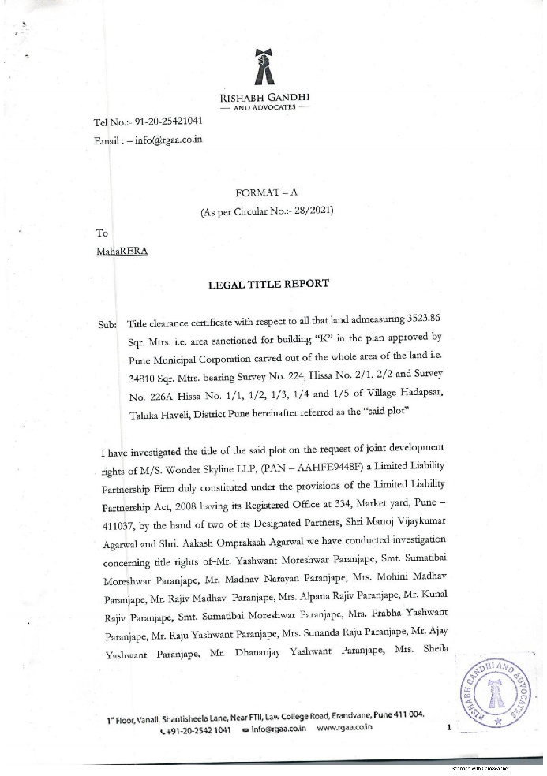
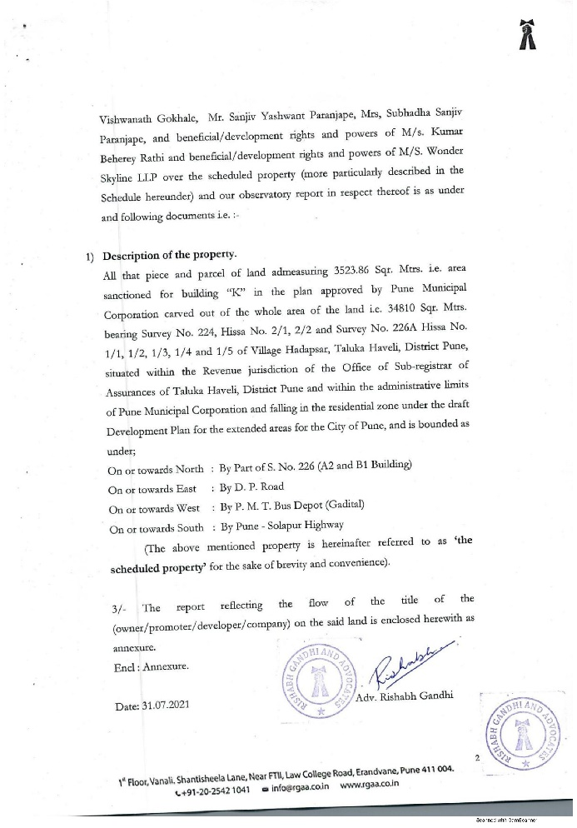
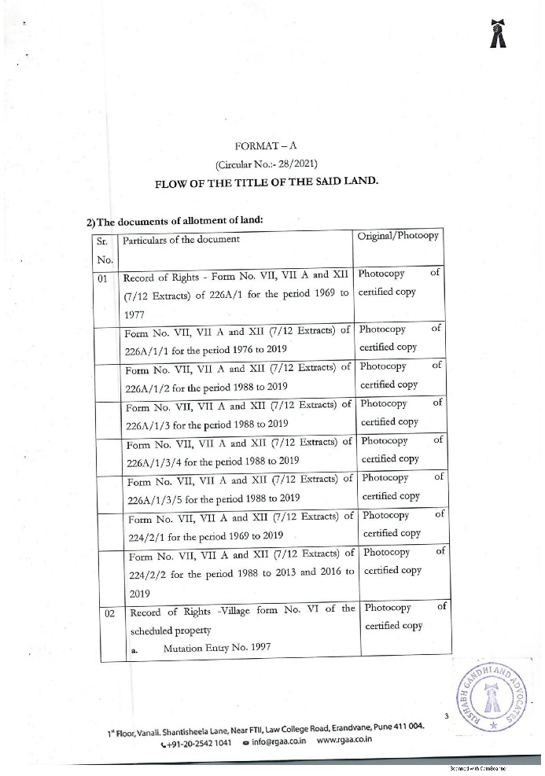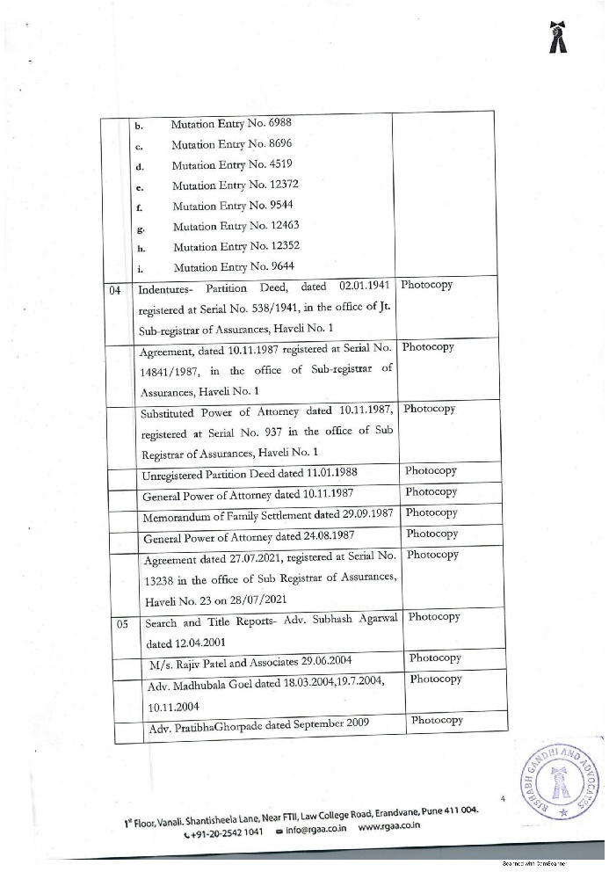
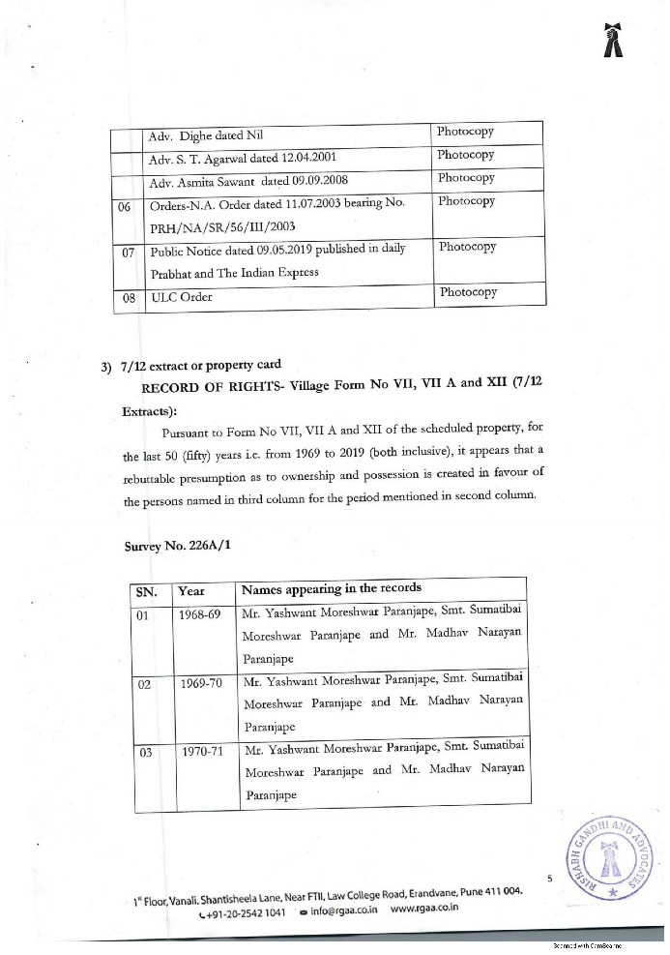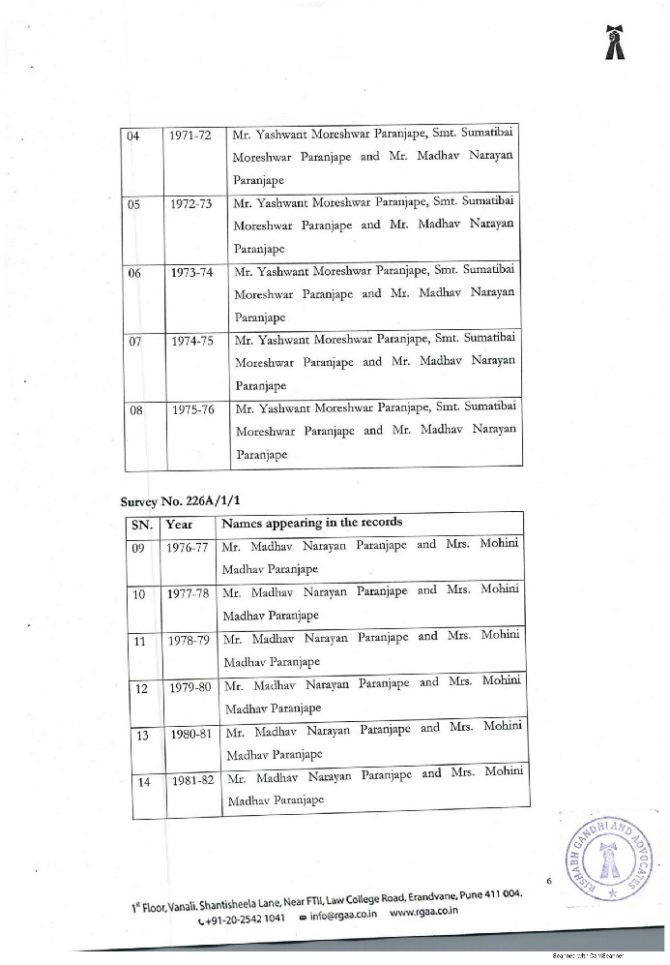
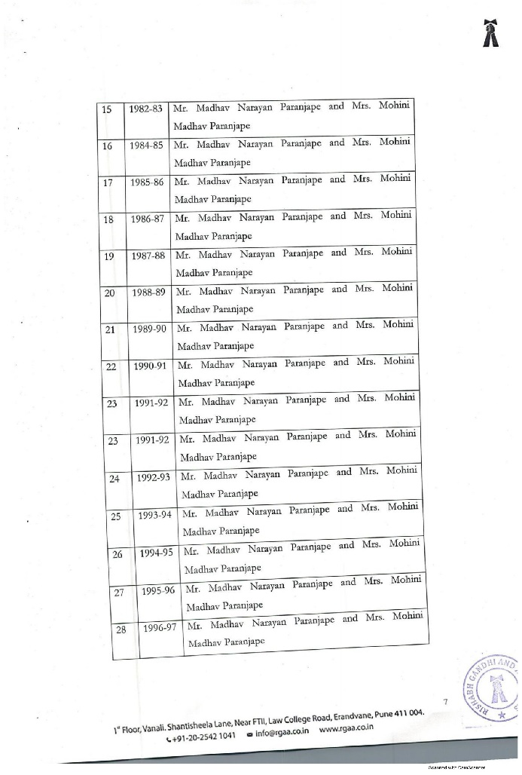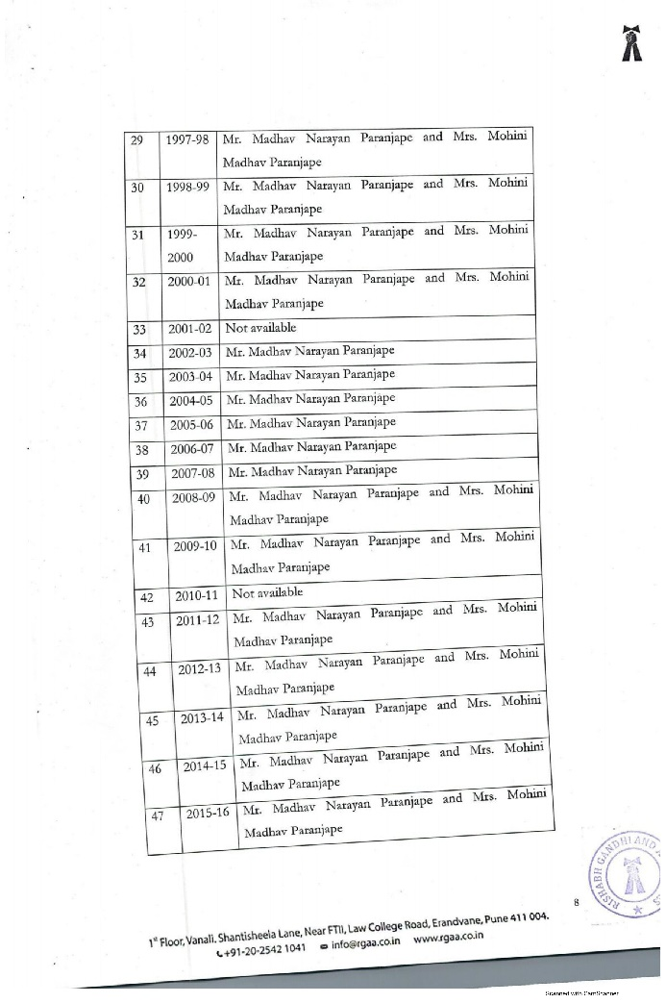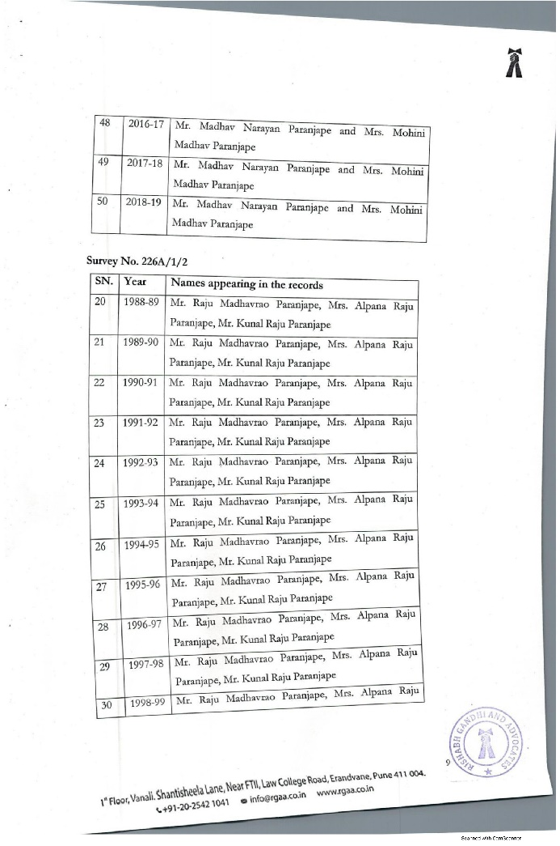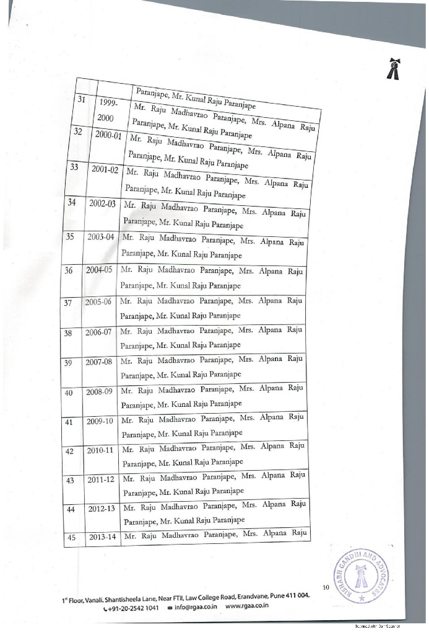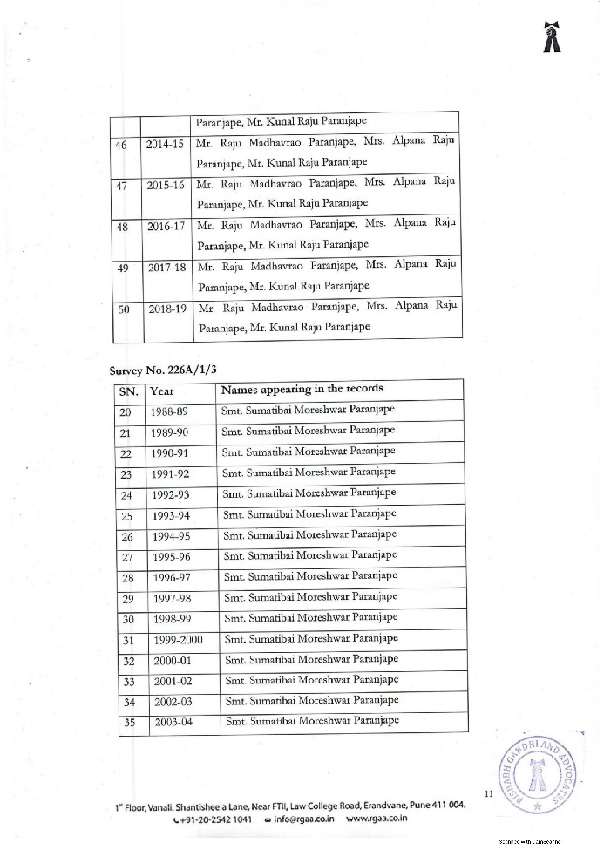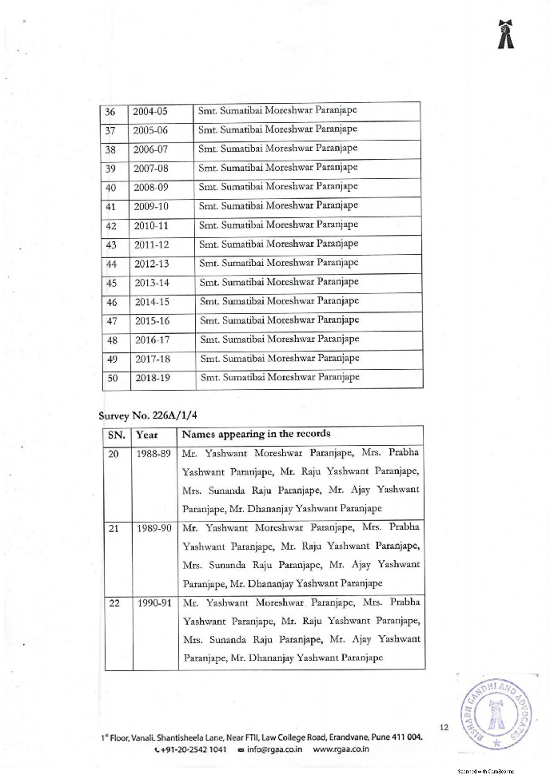.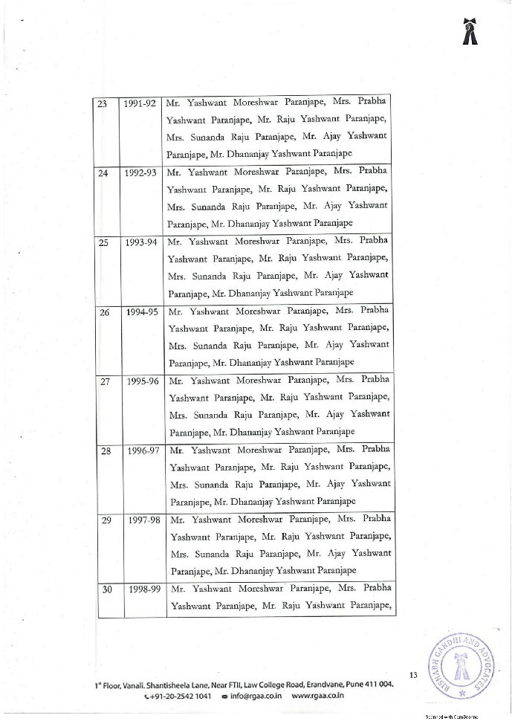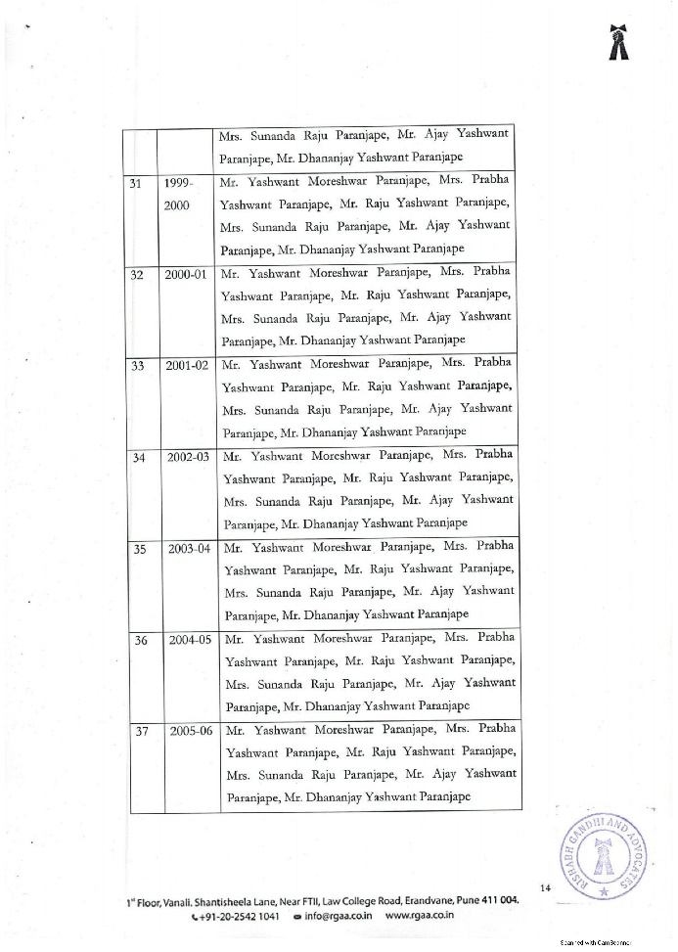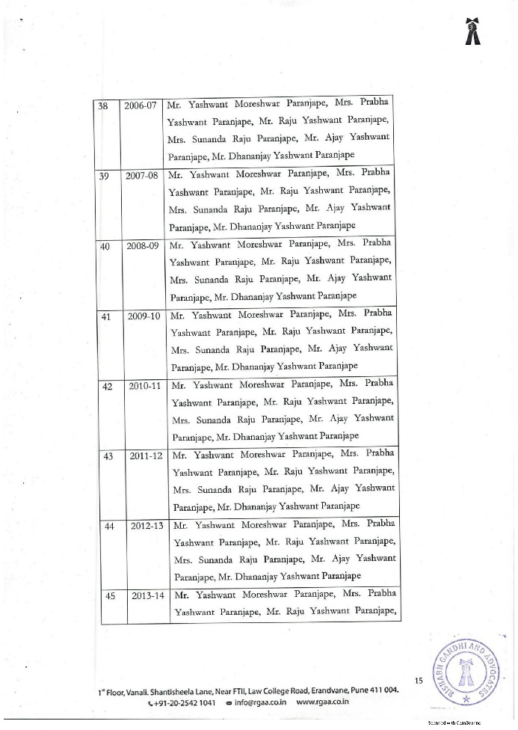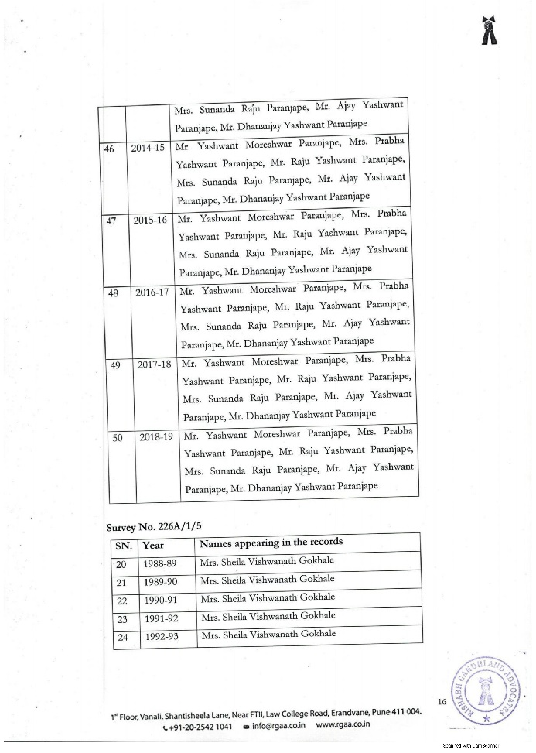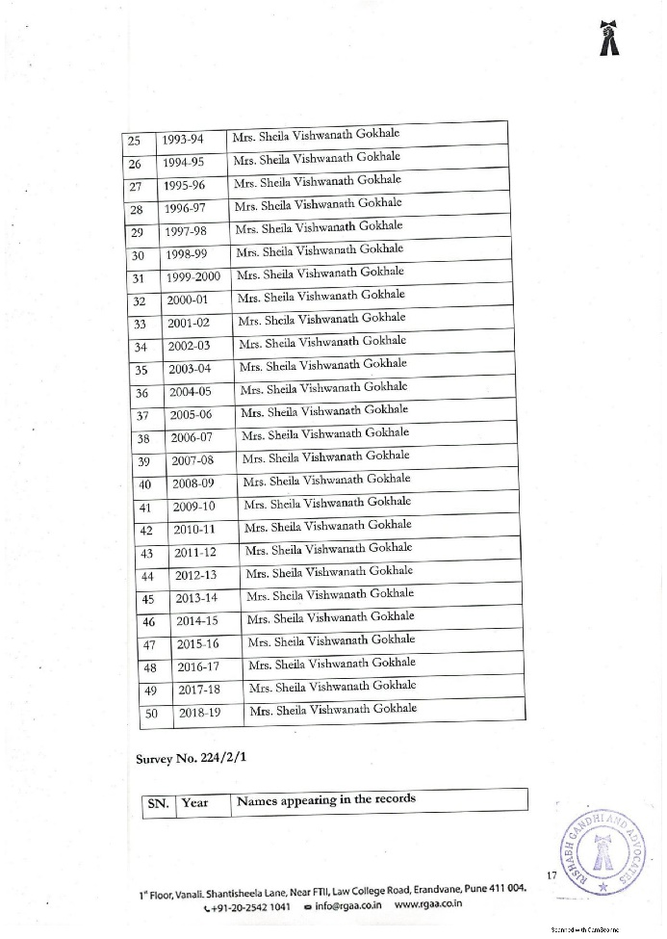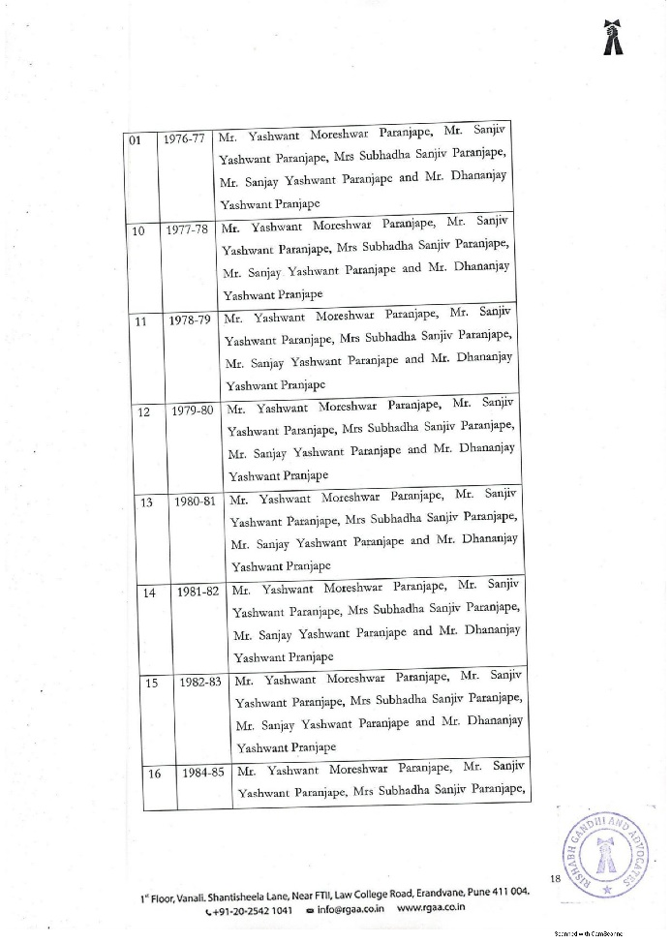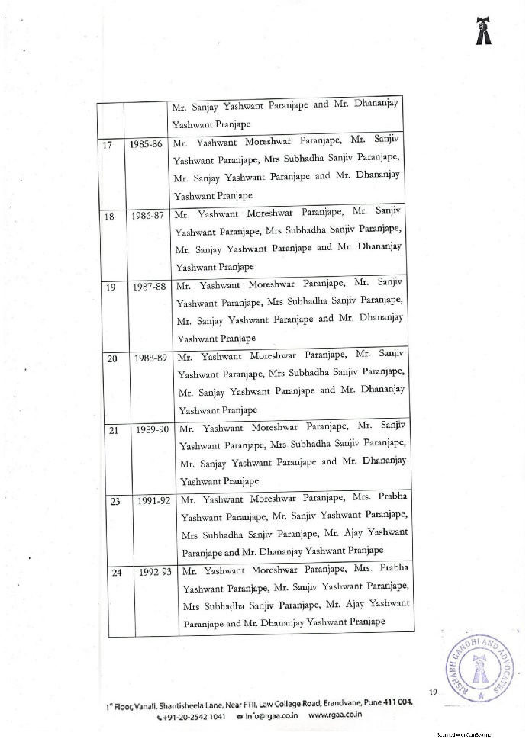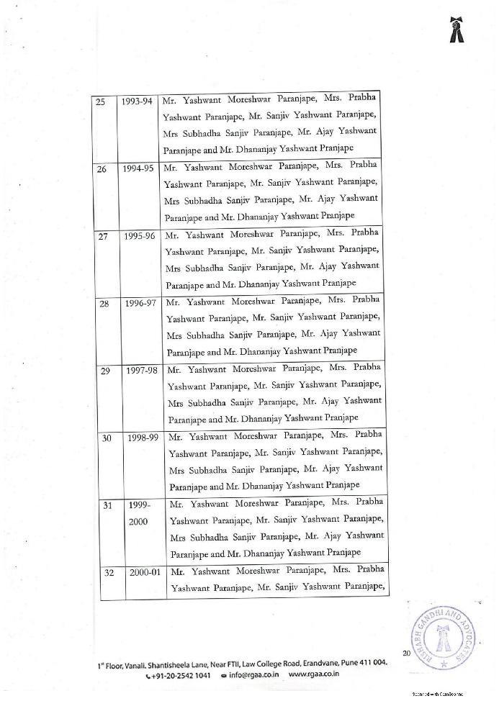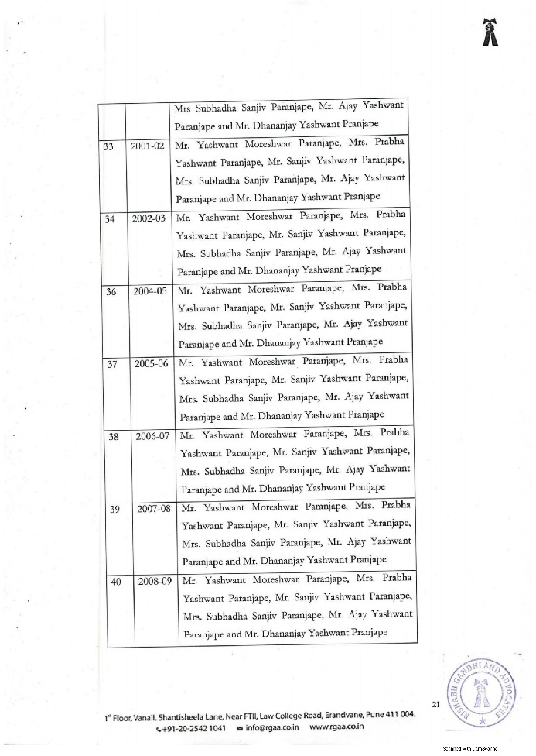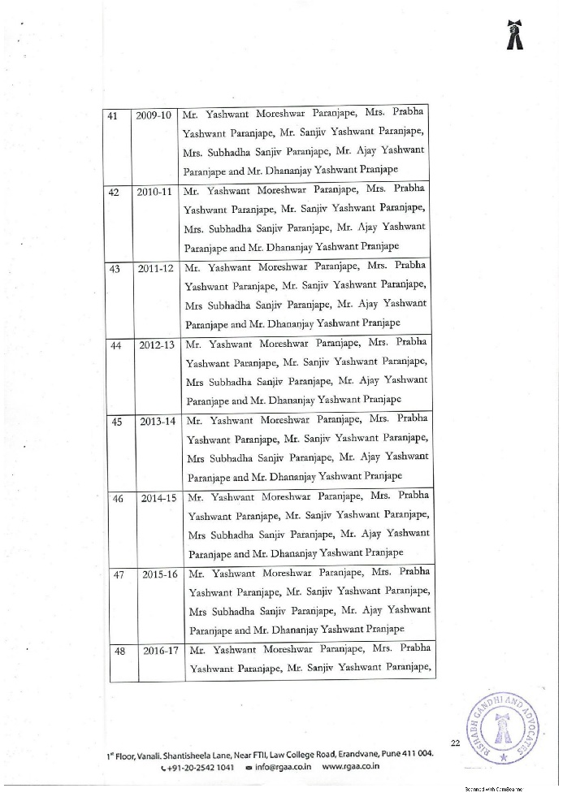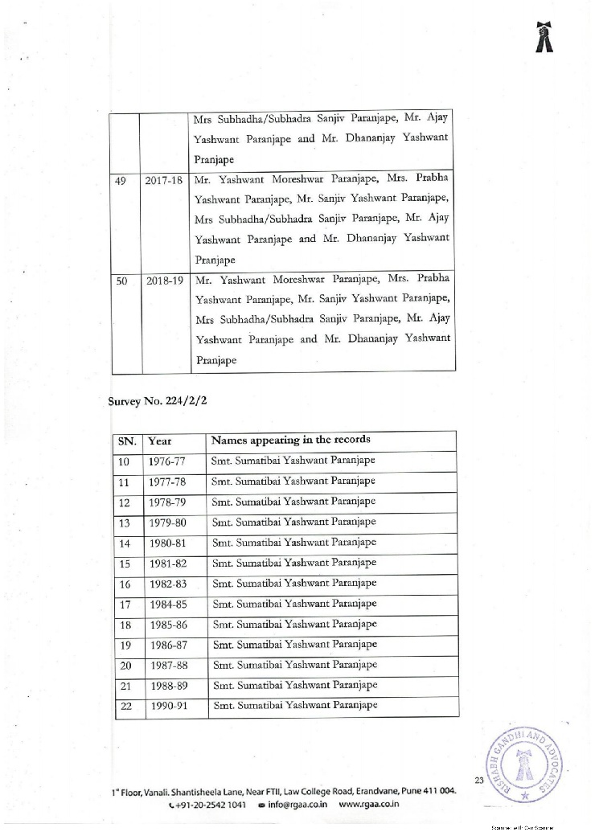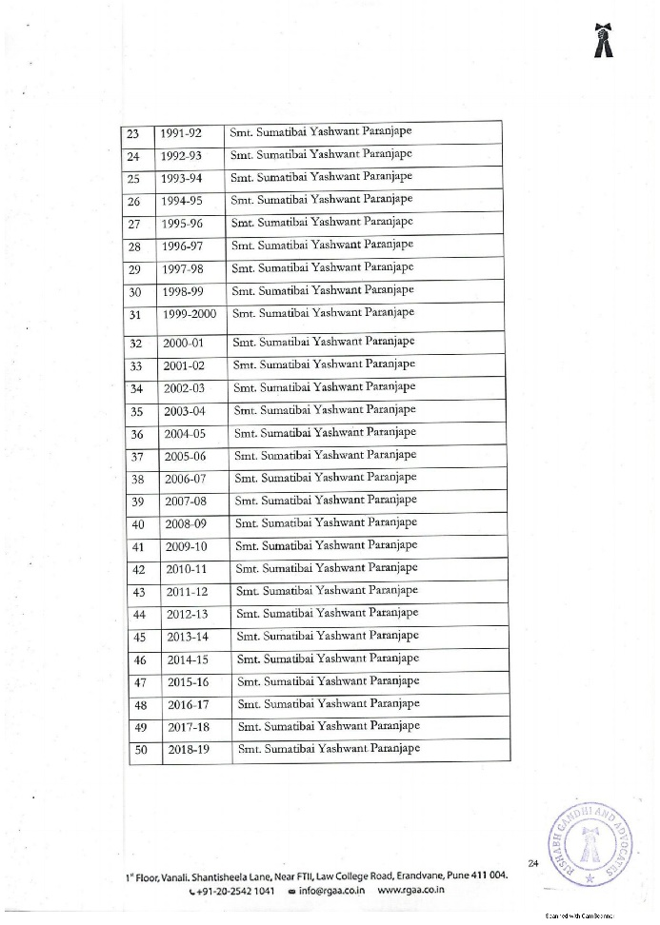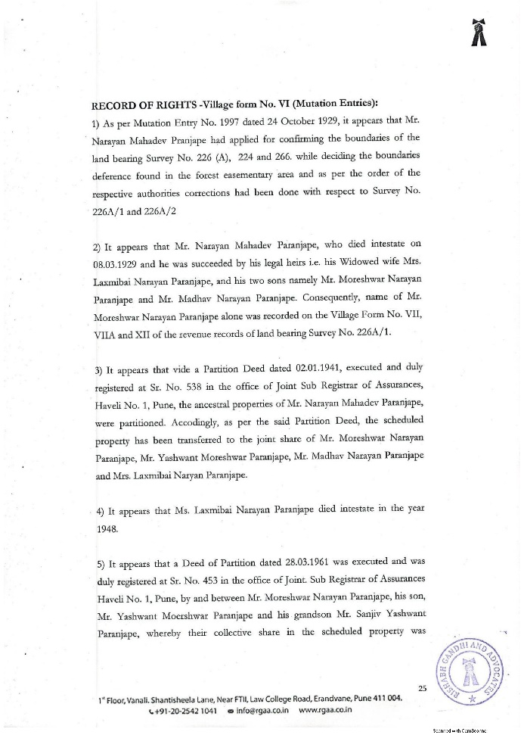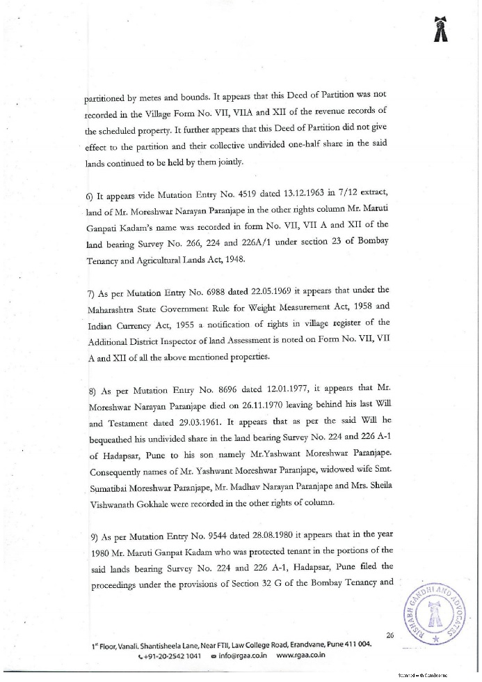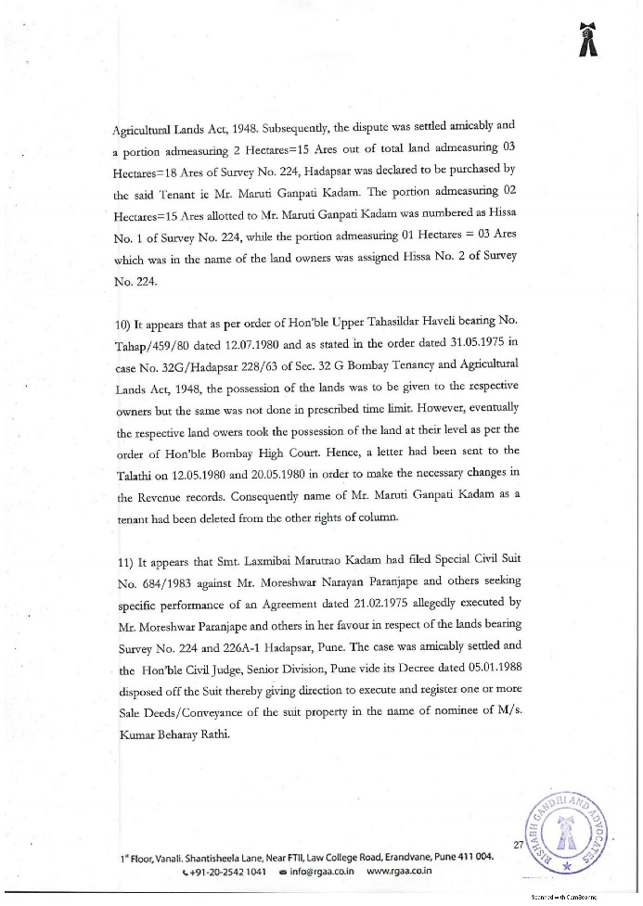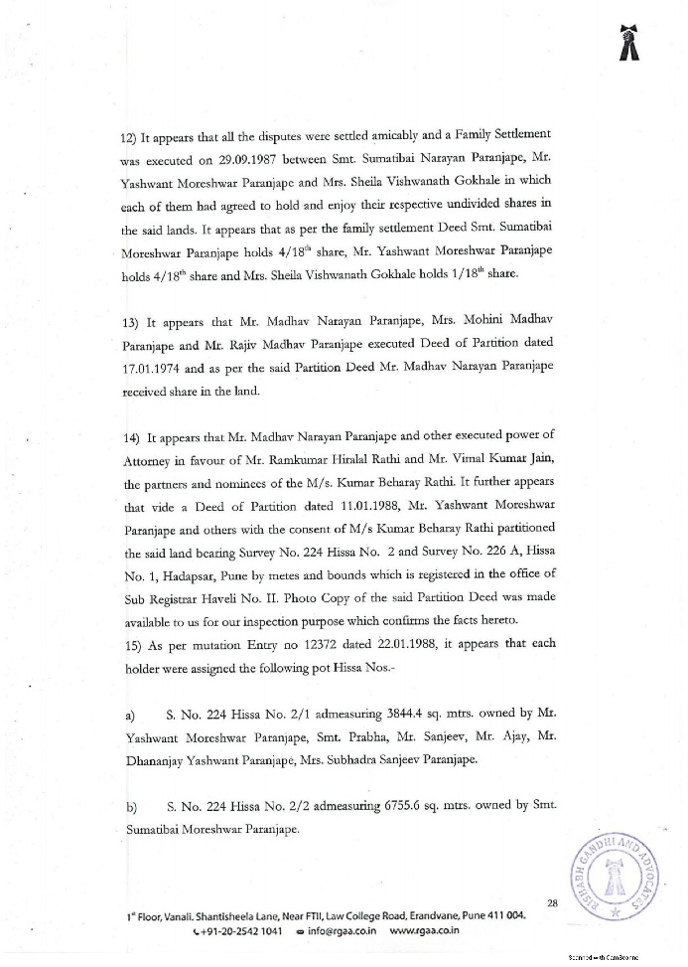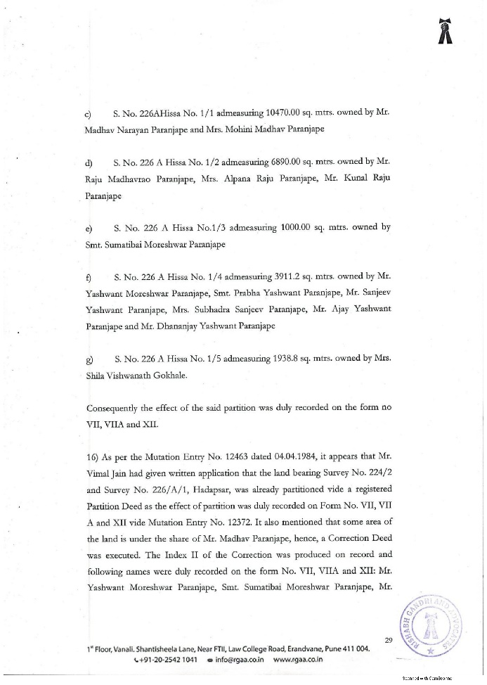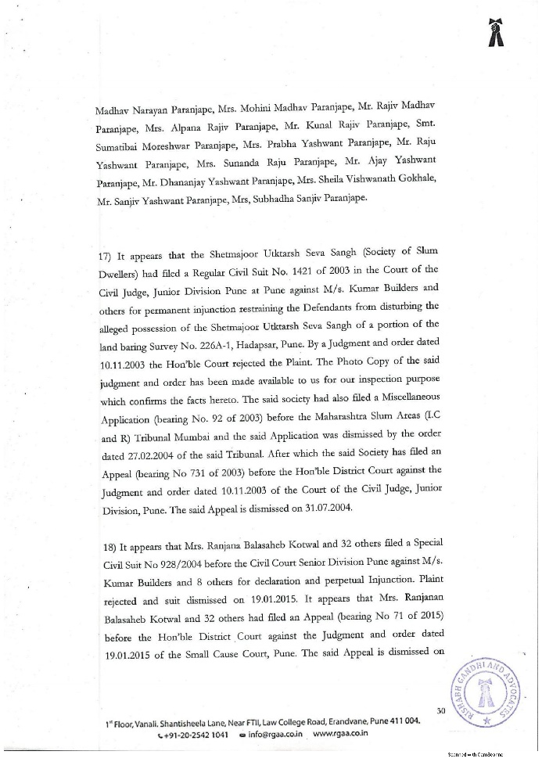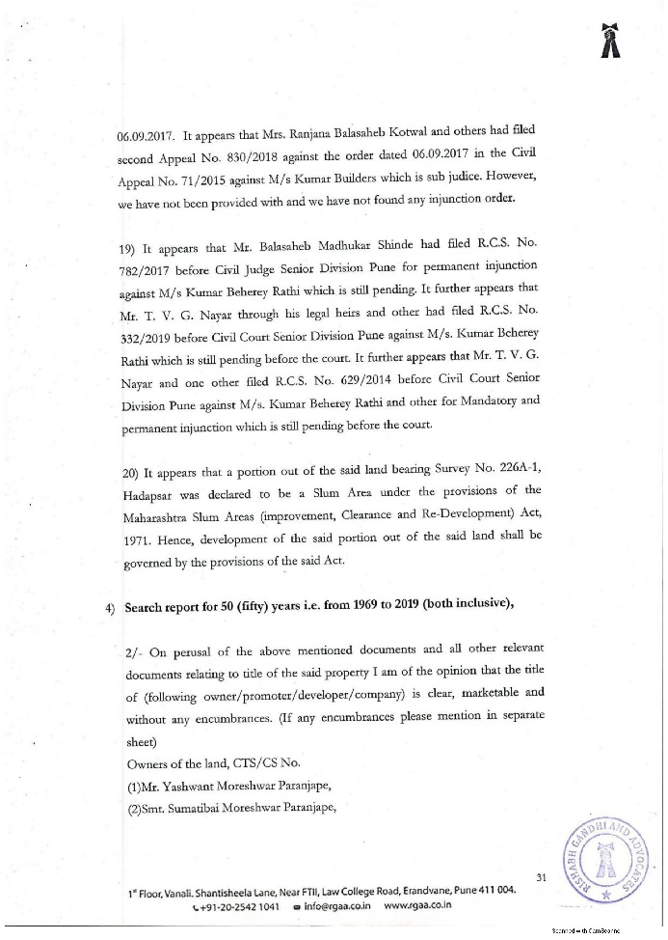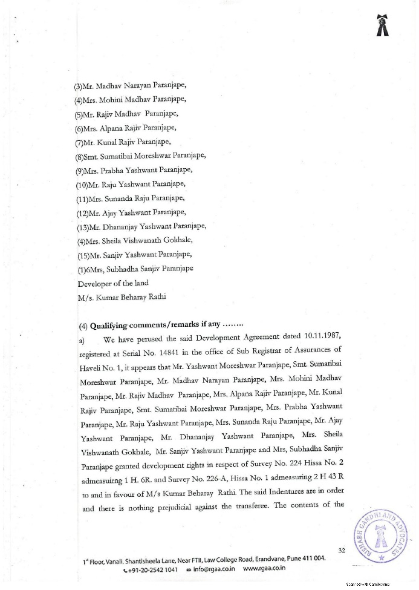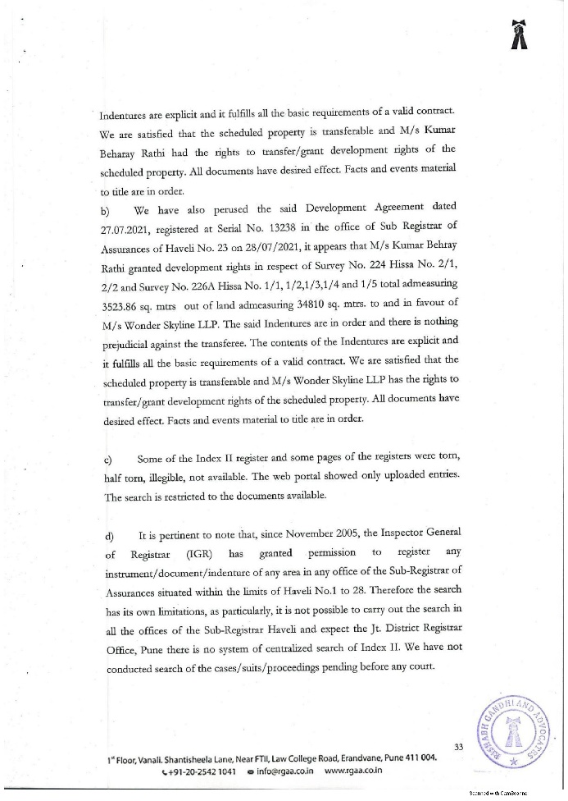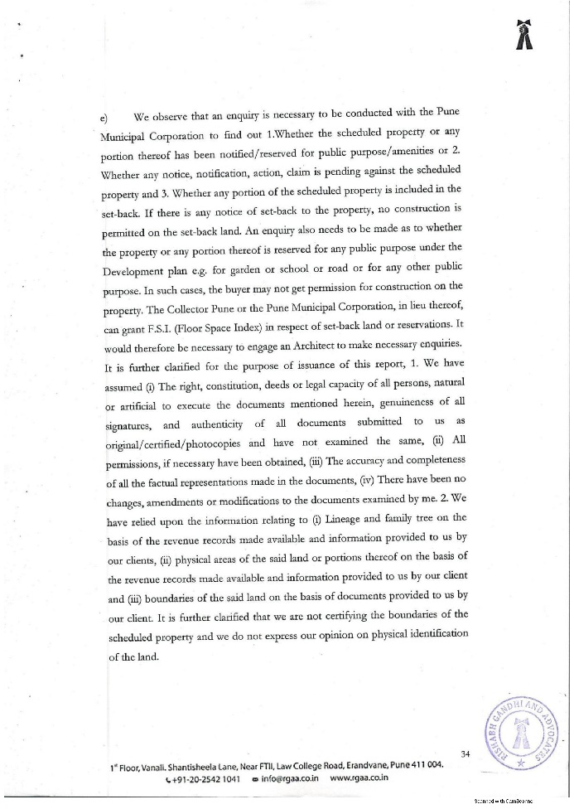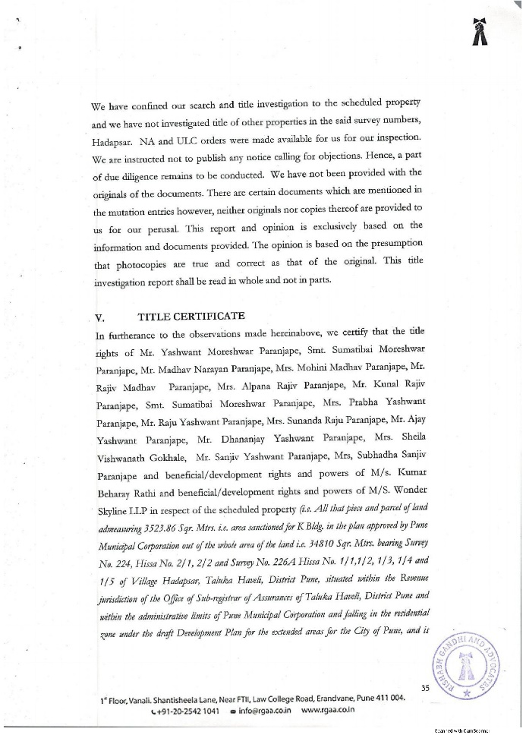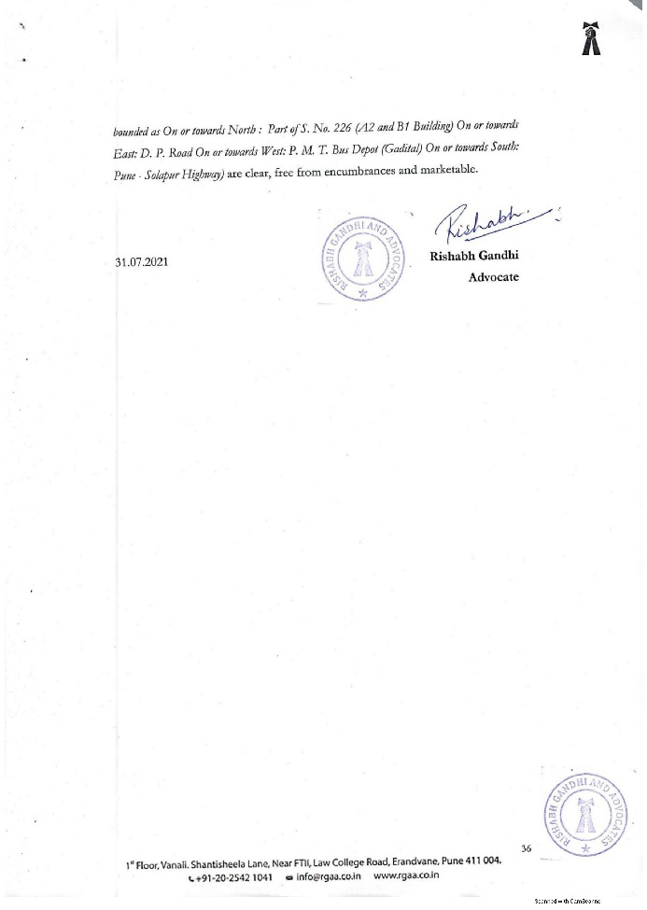

ANNEXURE –B
7/12 Extract
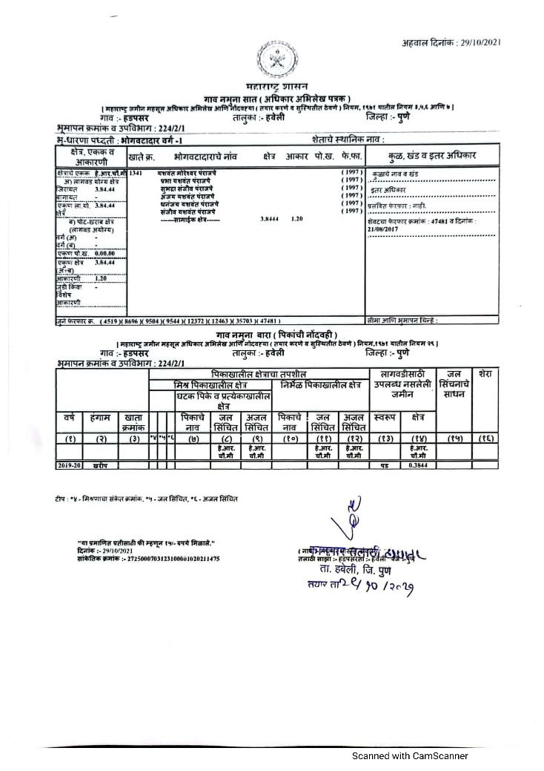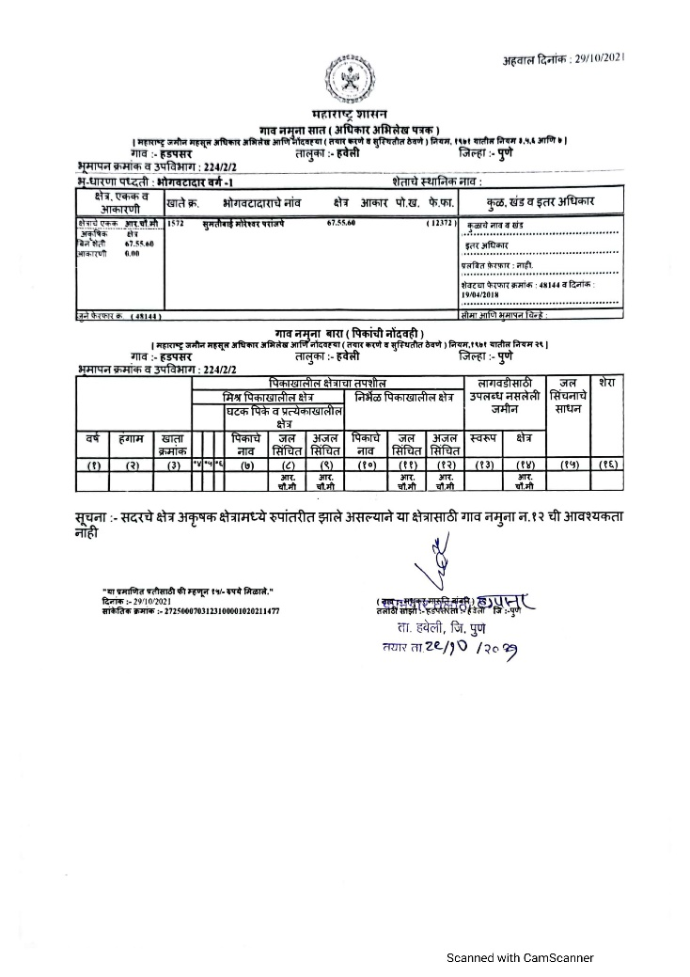
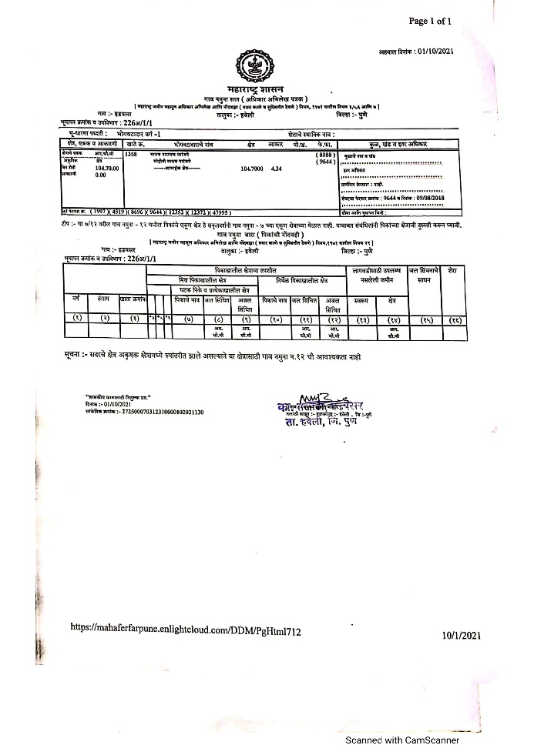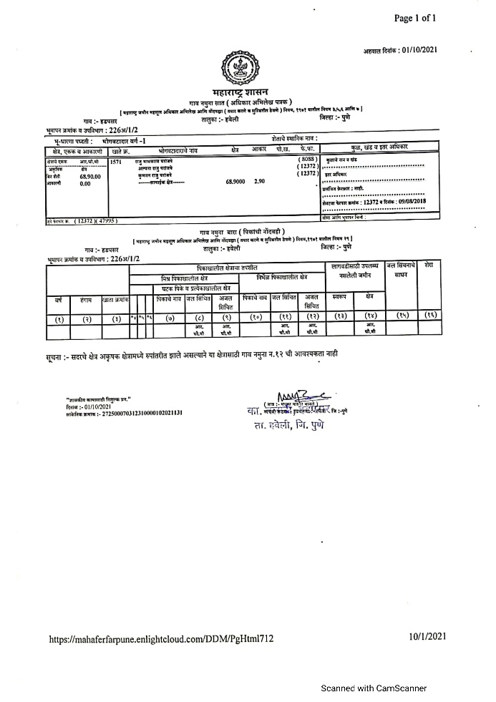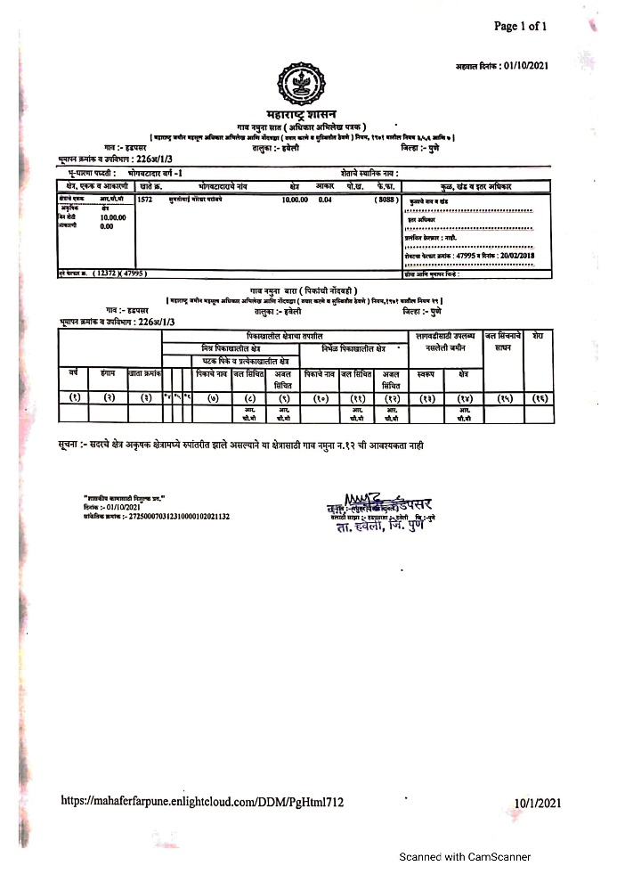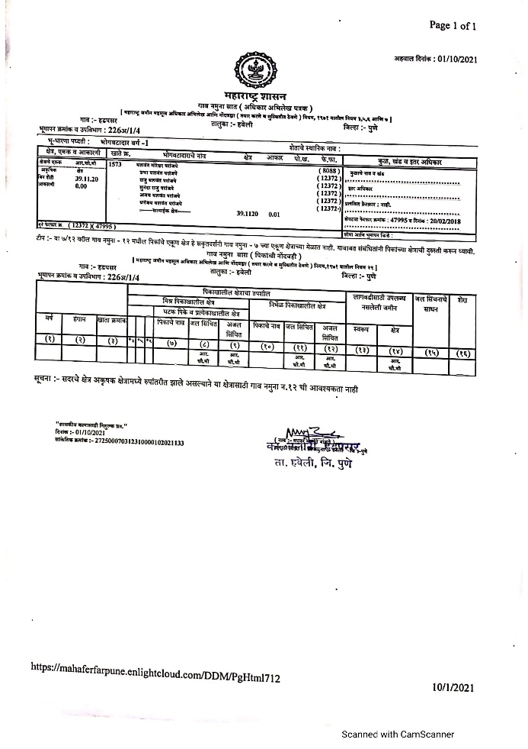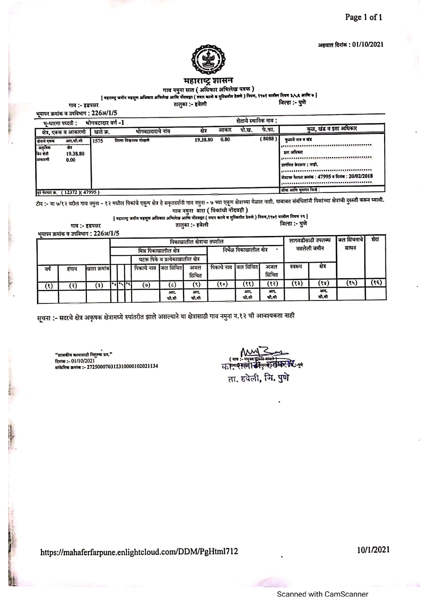

ANNEXURE –C
Sanctioned plans
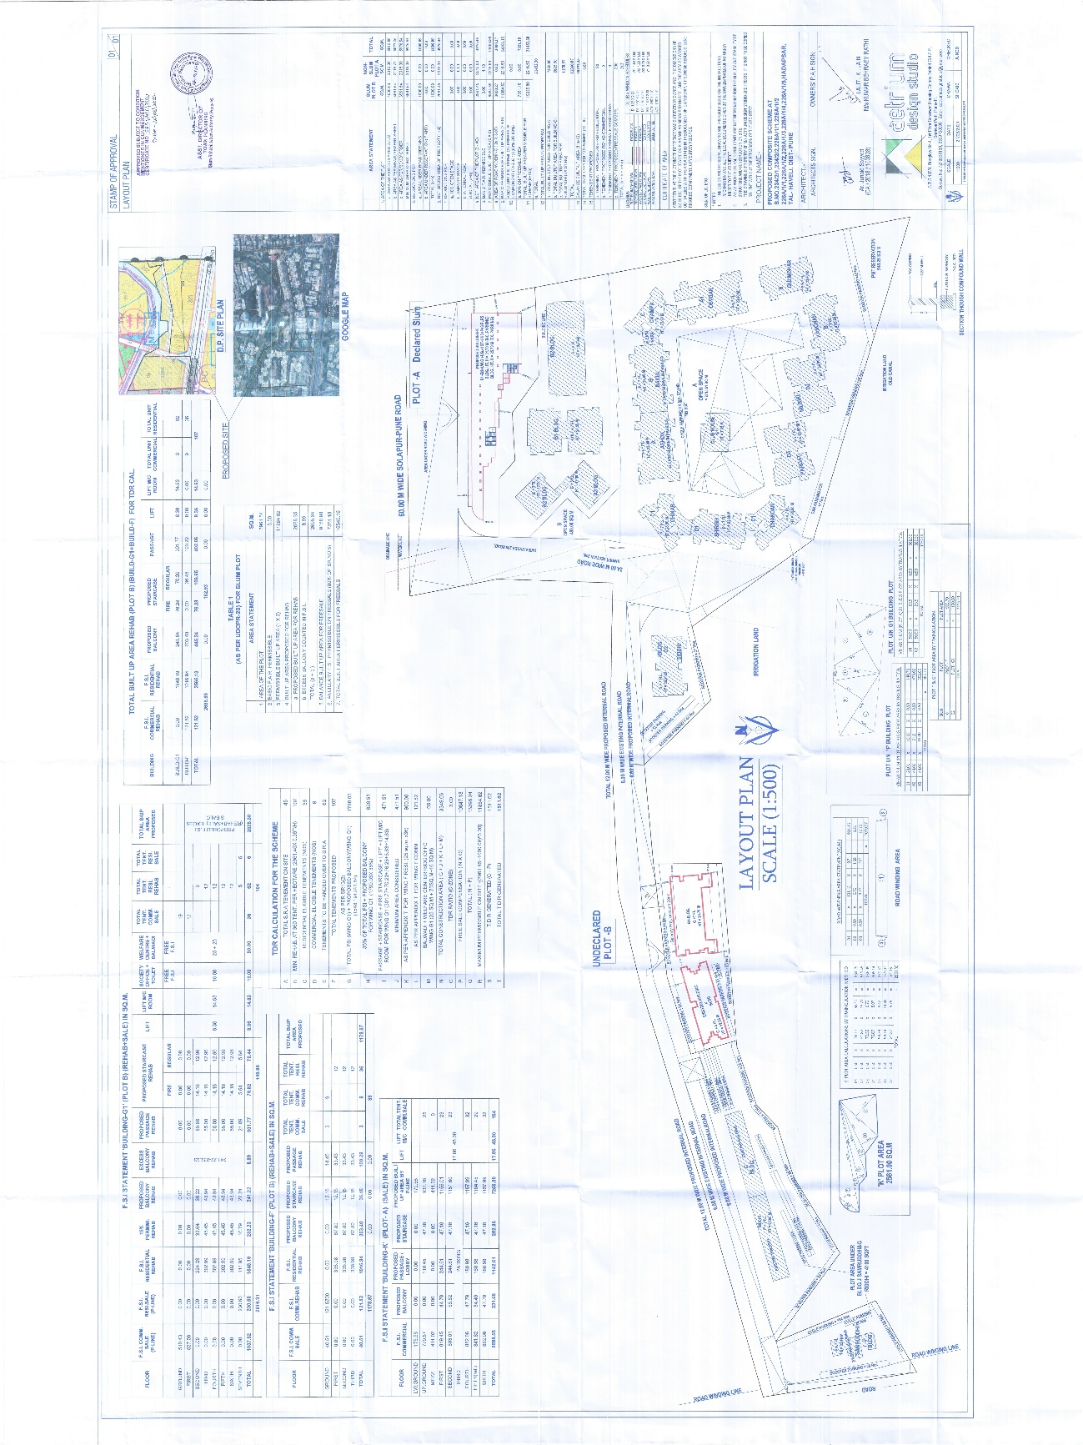

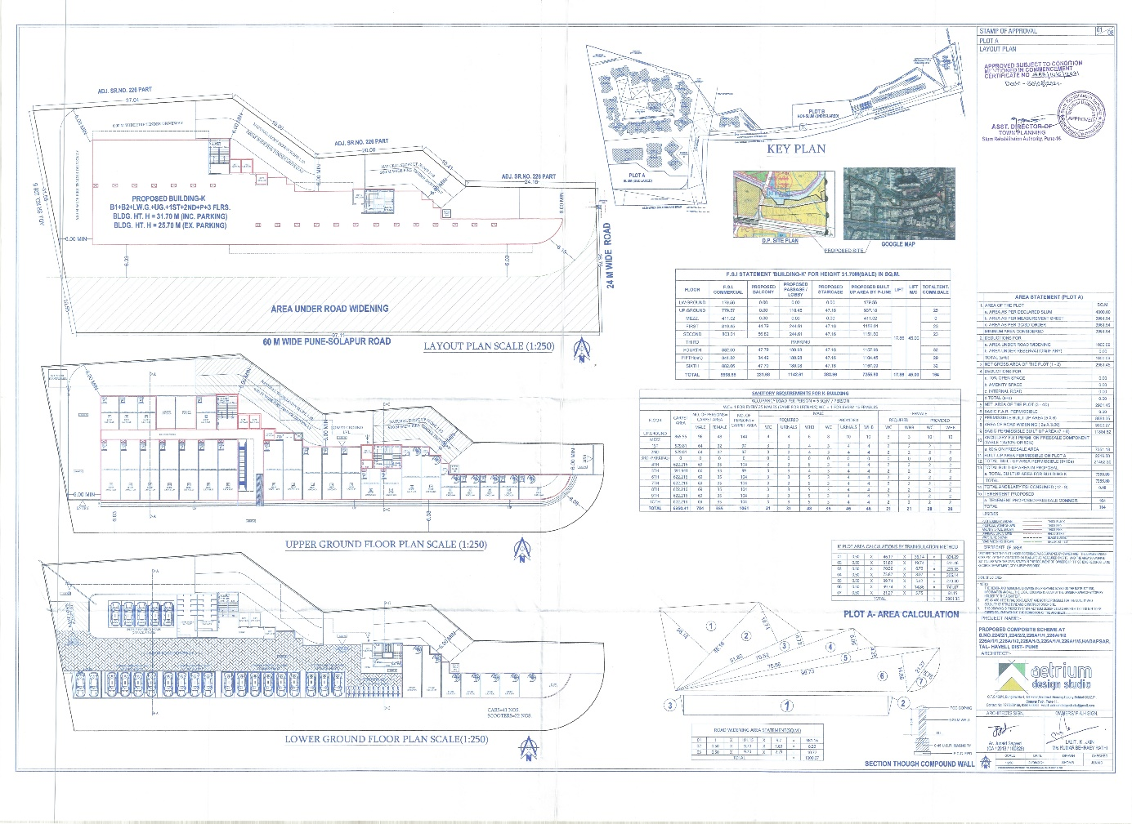
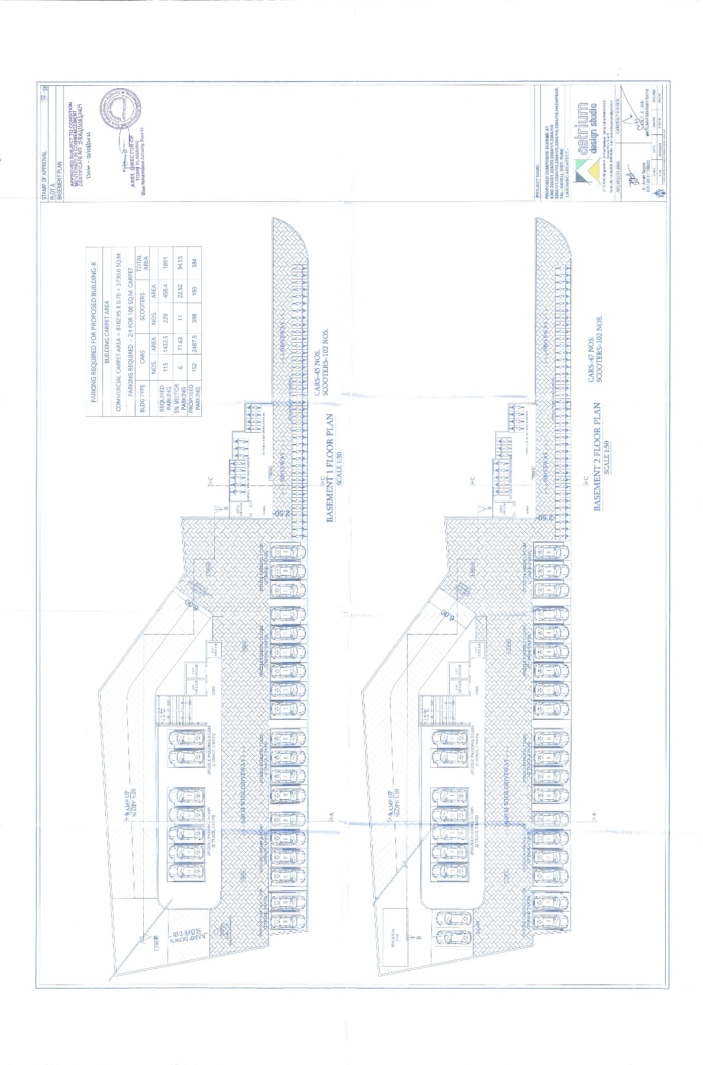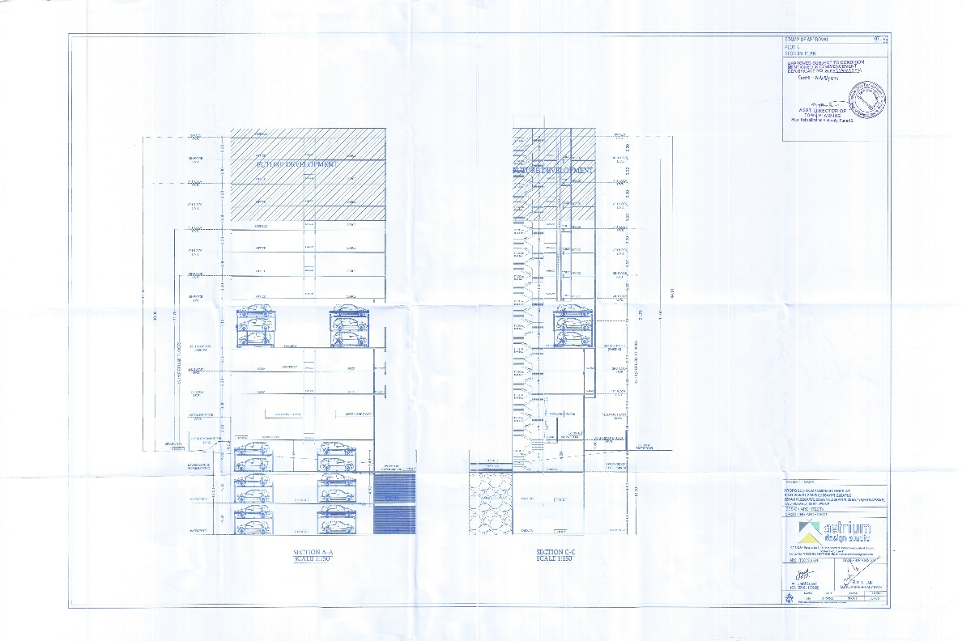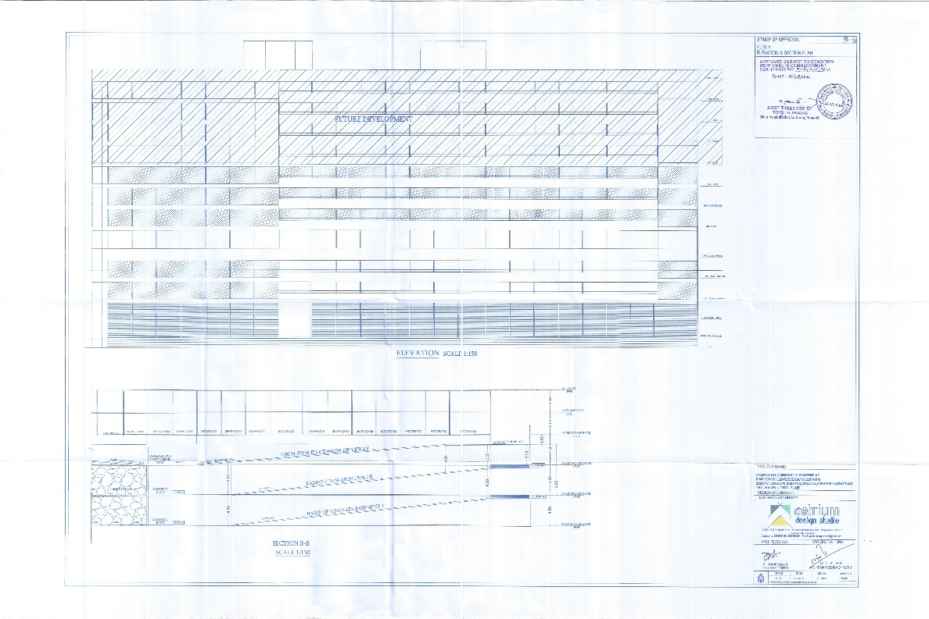

ANNEXURE –D
Commencement Certificate 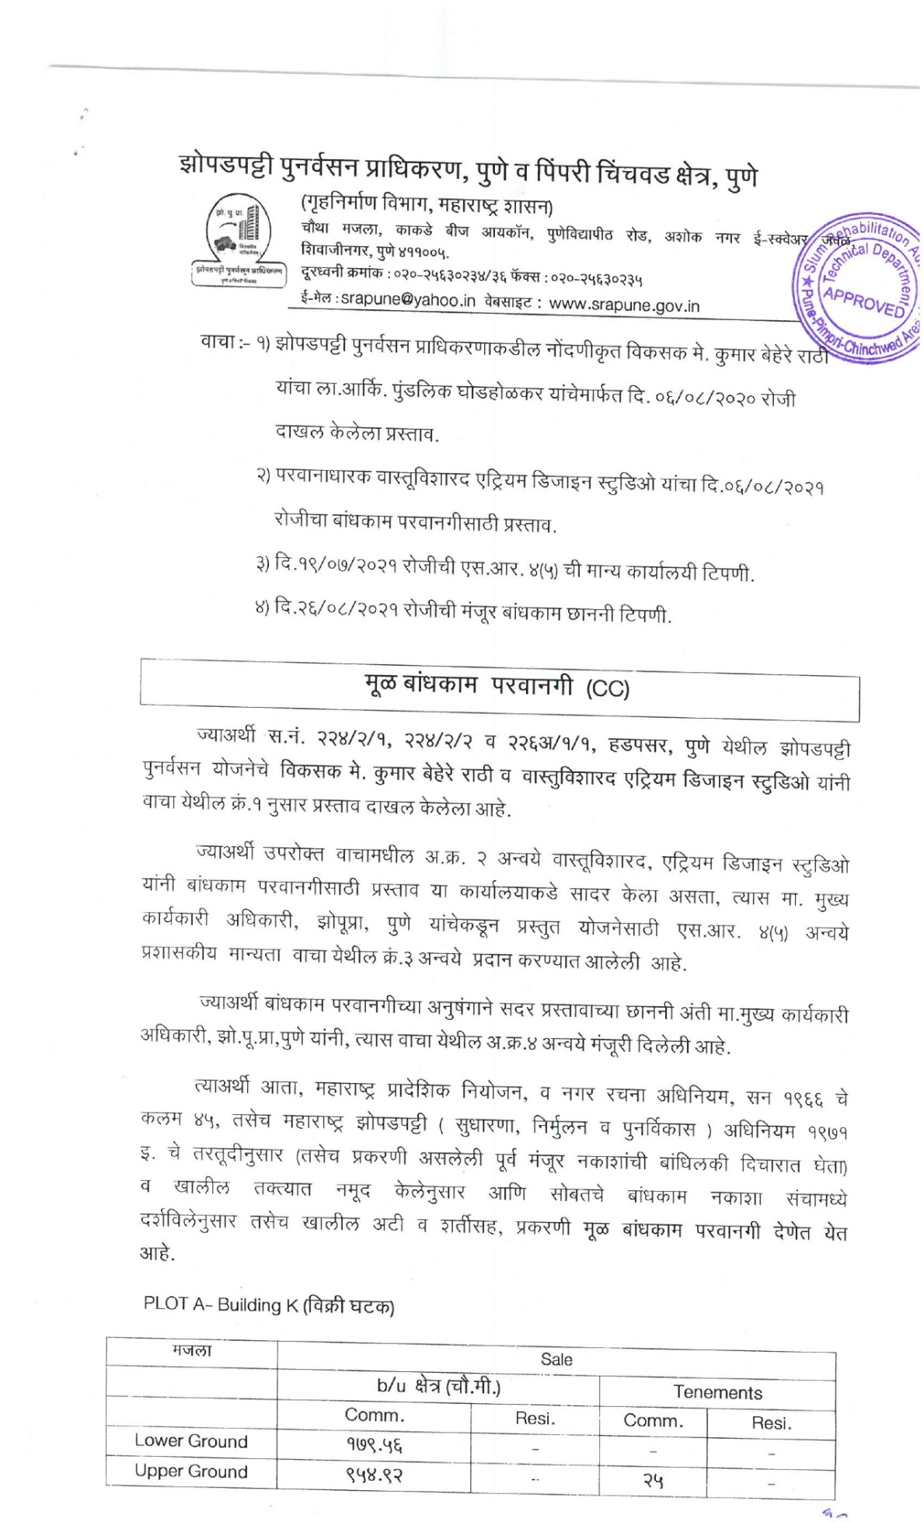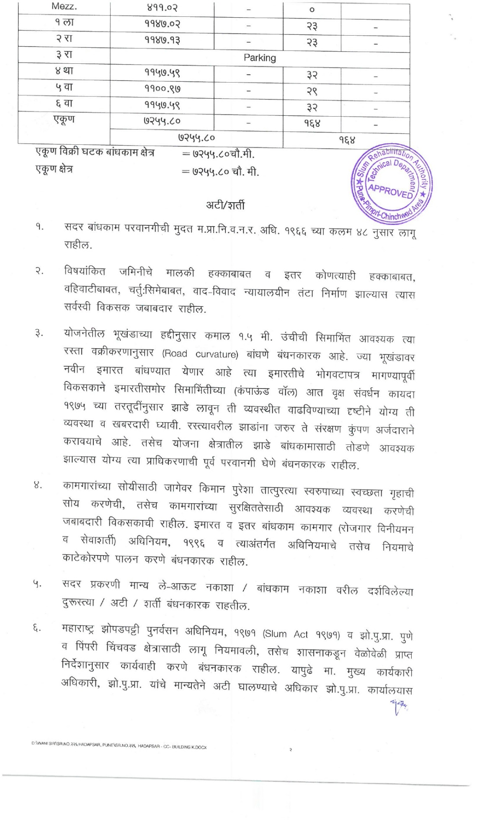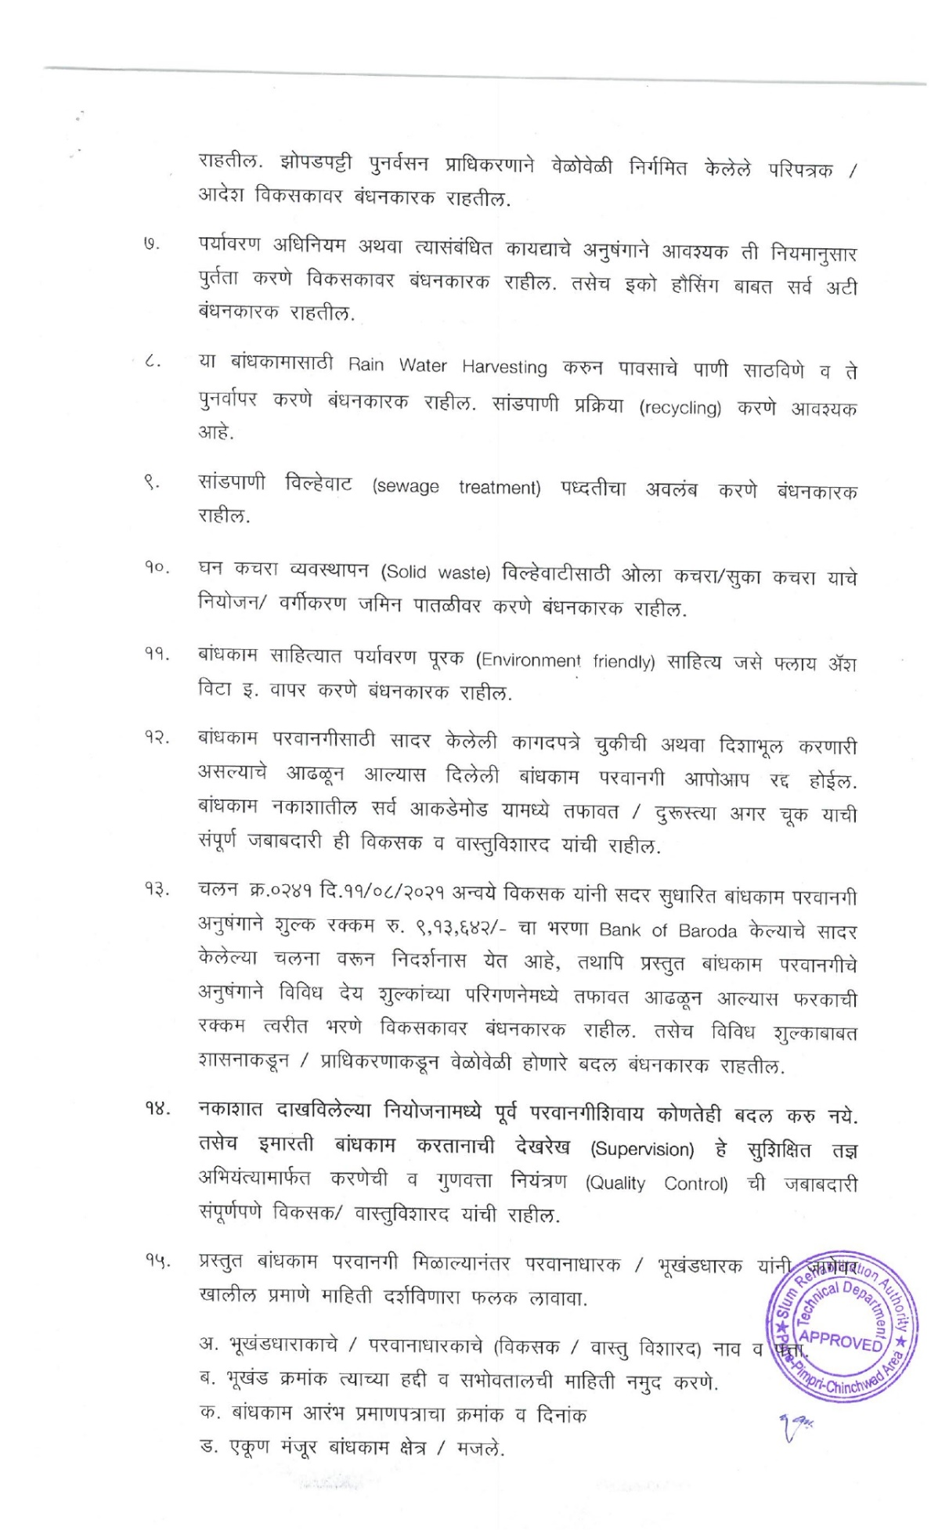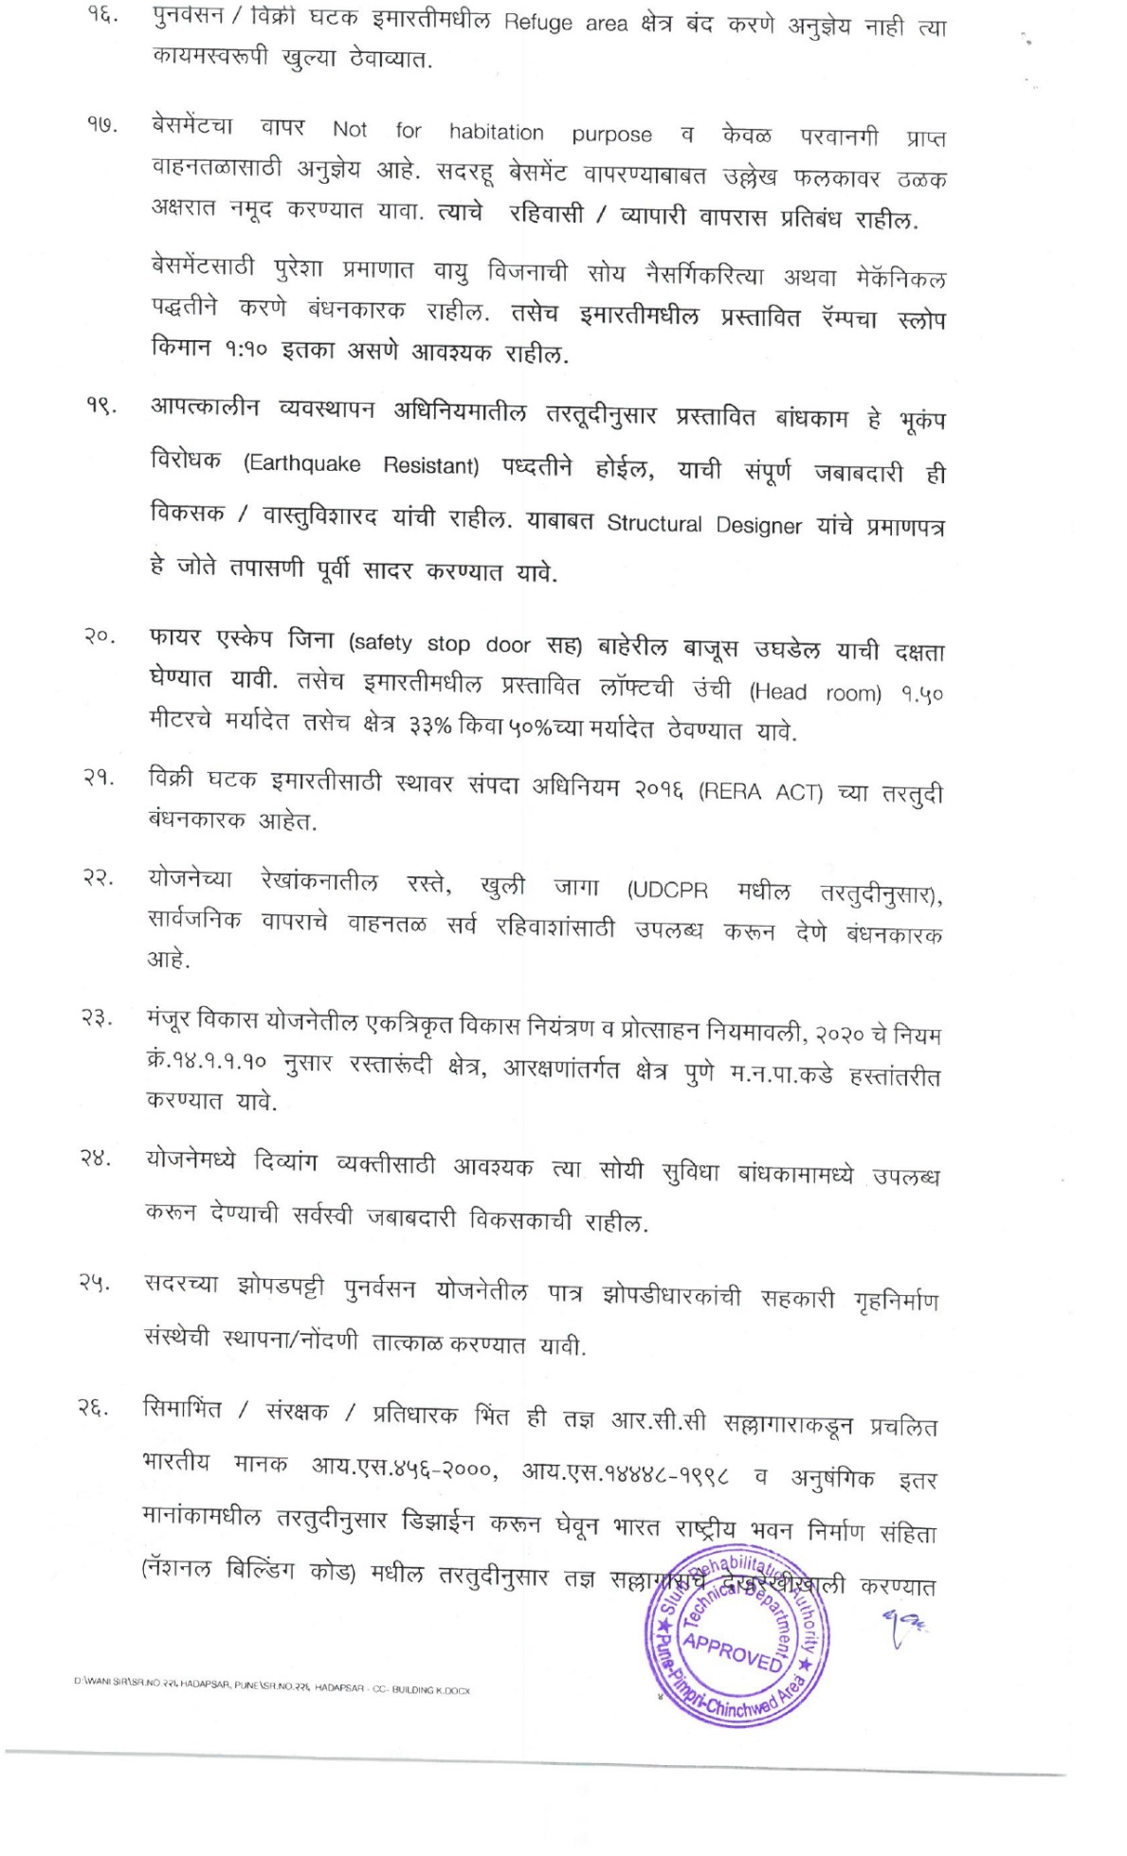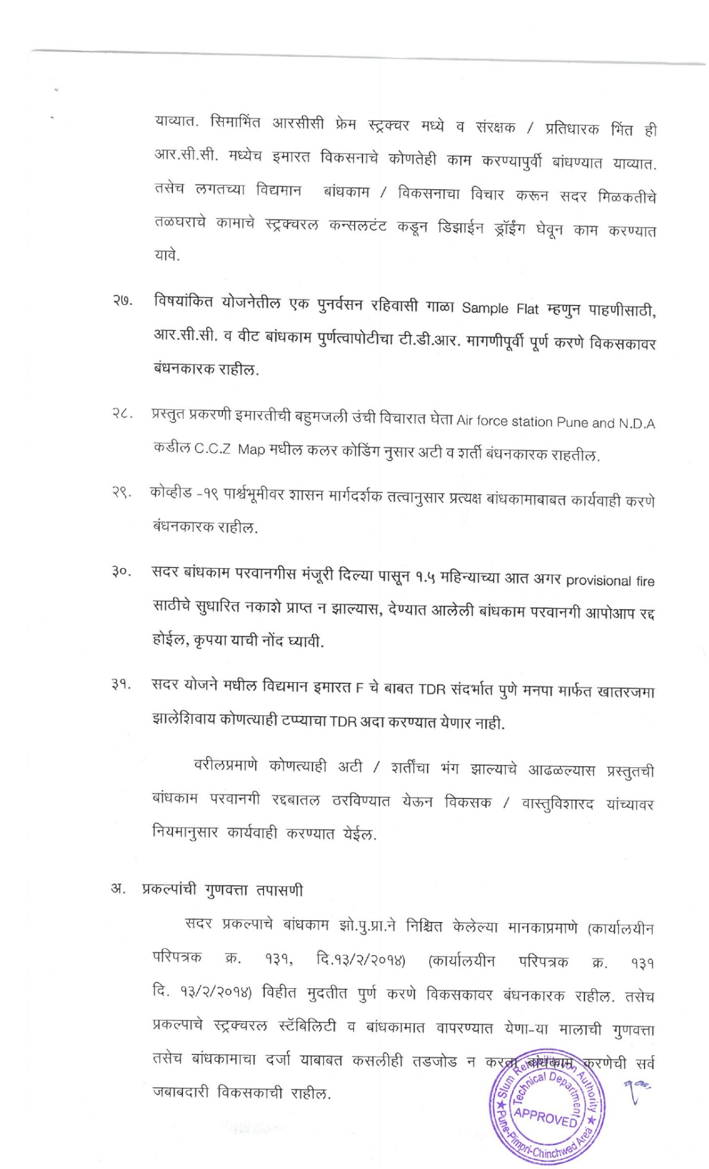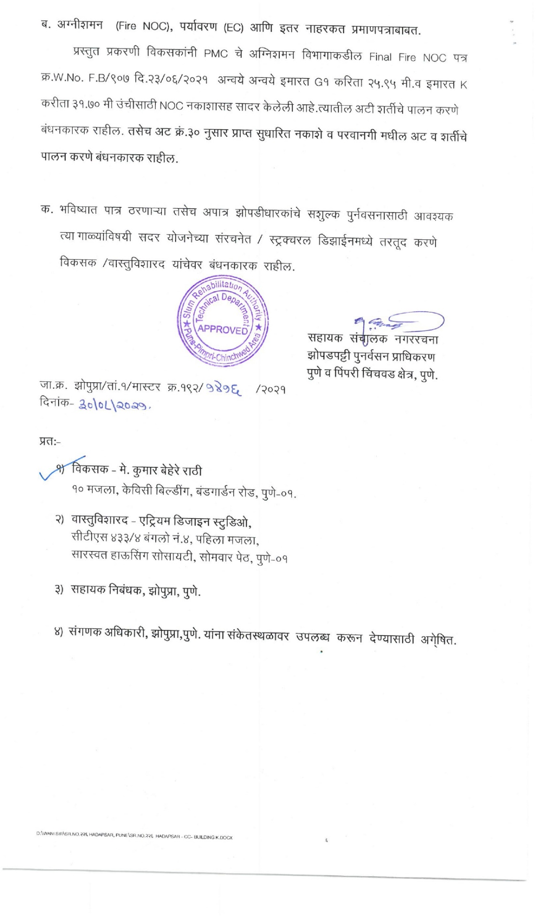

ANNEXURE –E
Non- Agriculture Order
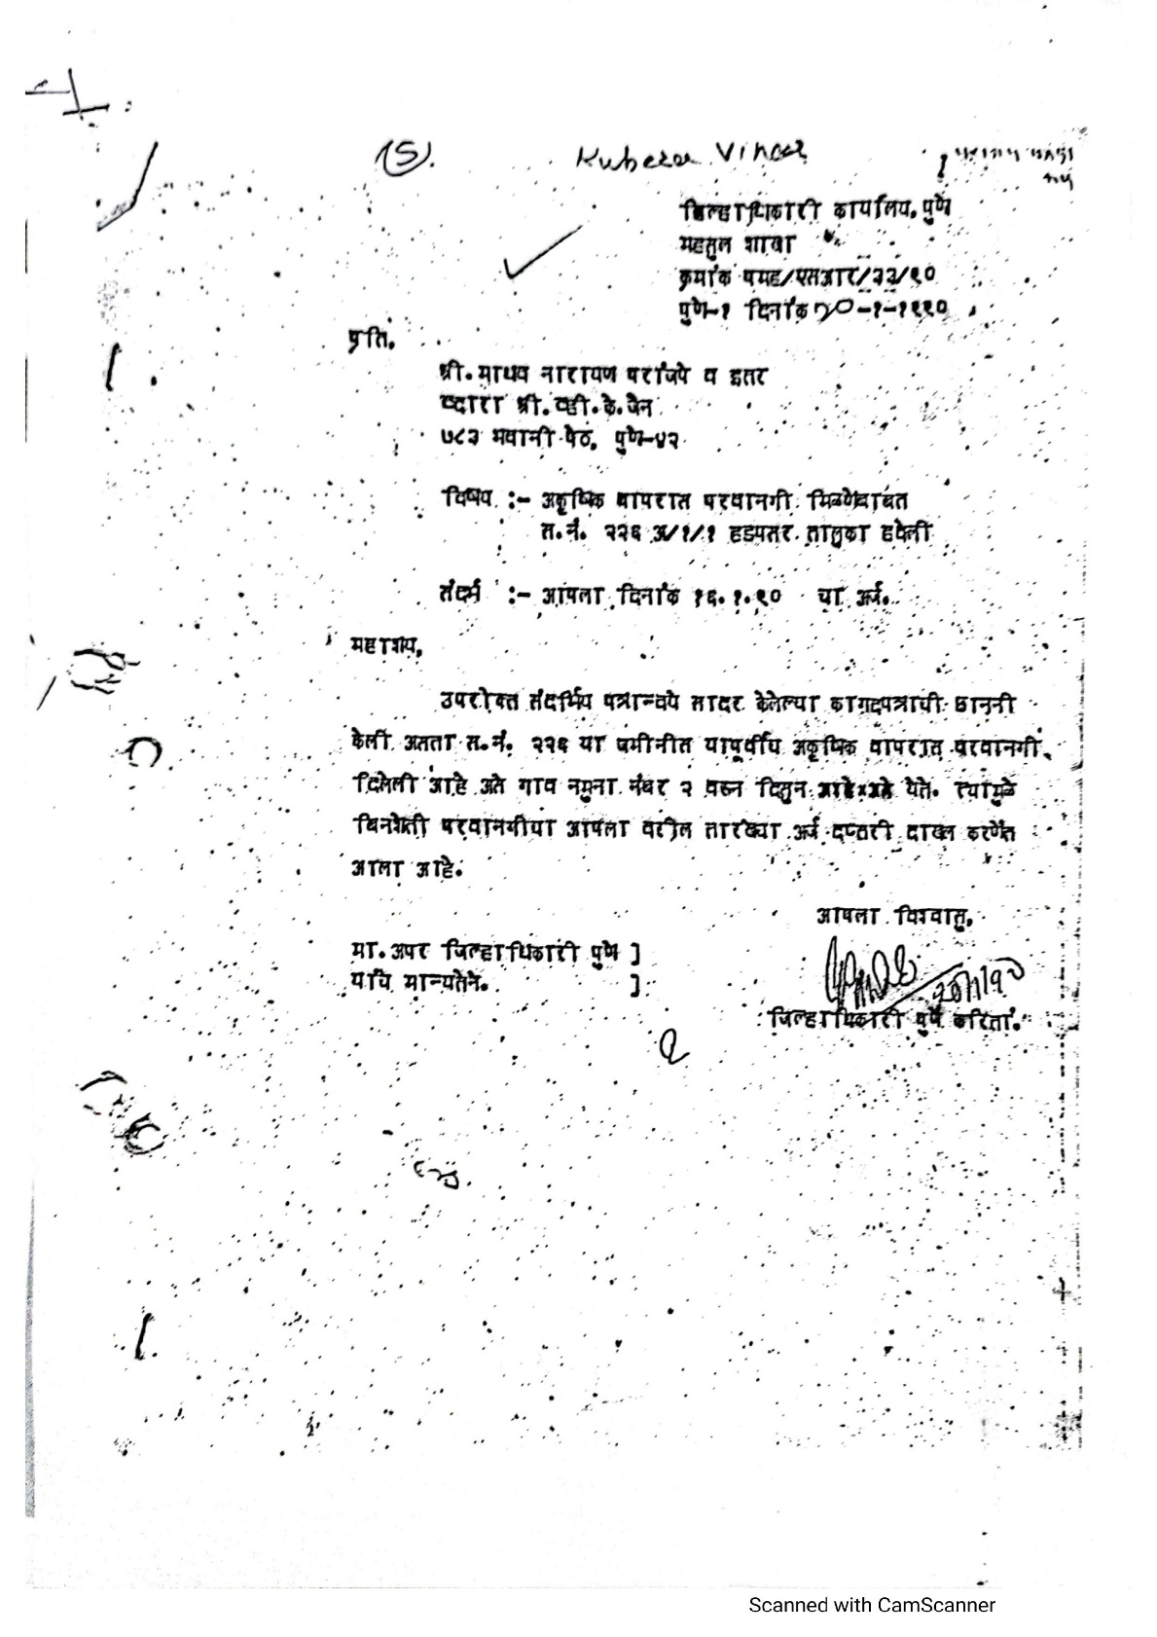
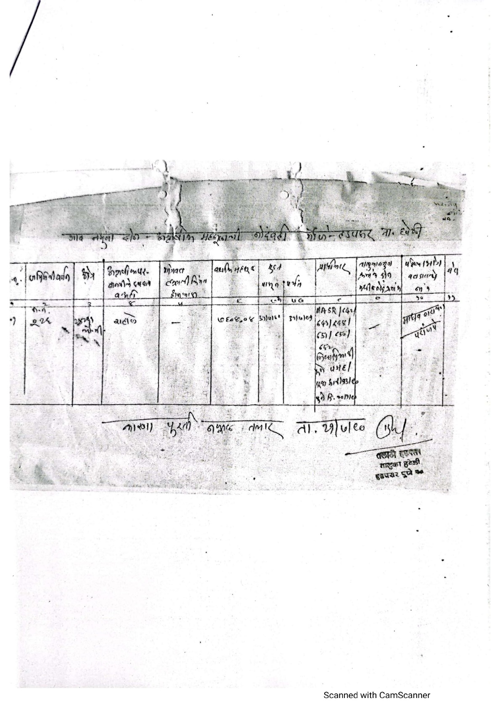
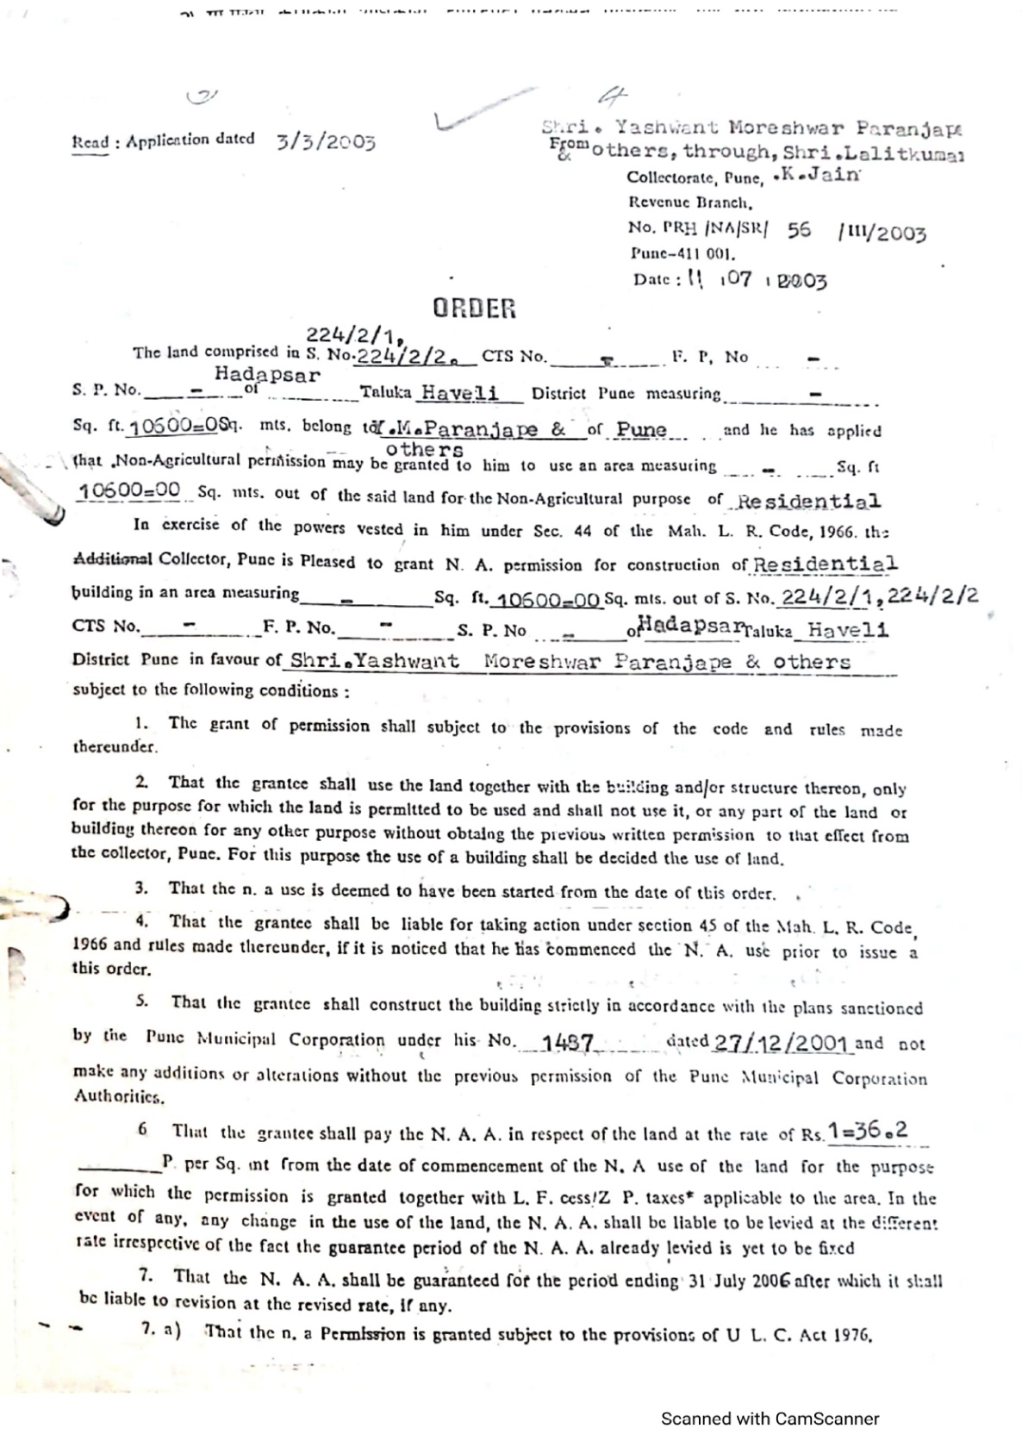

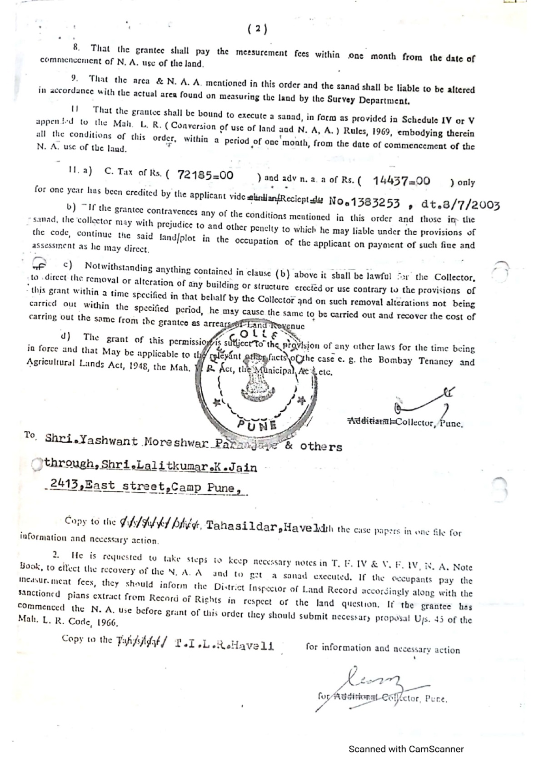

ANNEXURE –F
Building Plan showing the said Unit delineated in red colour boundary line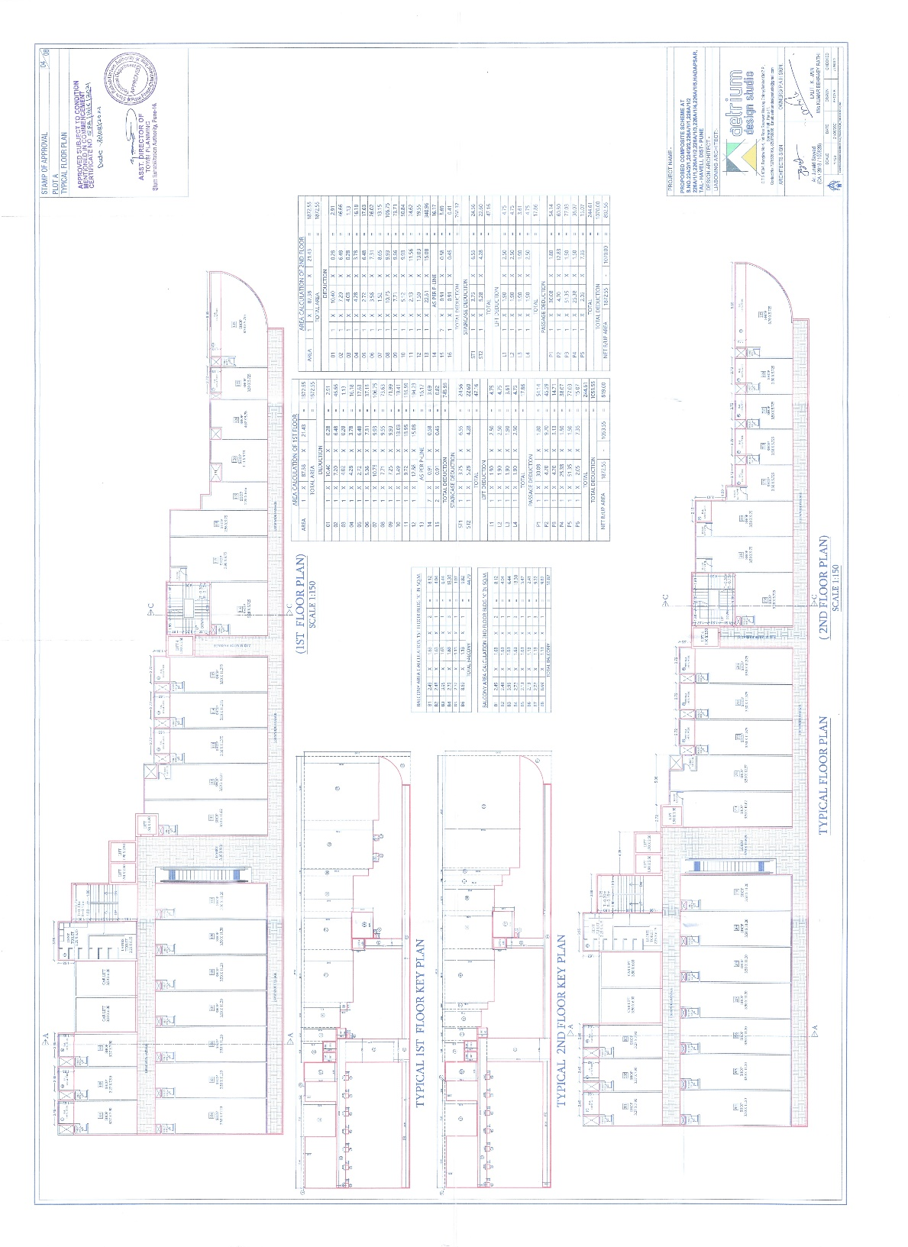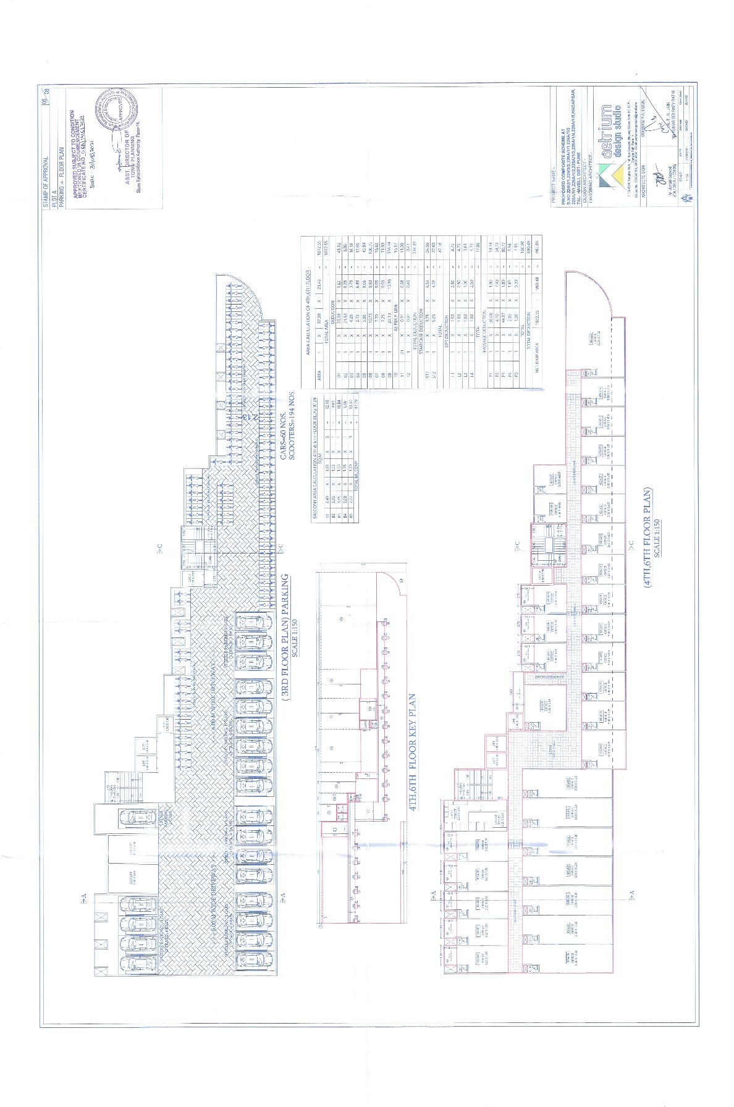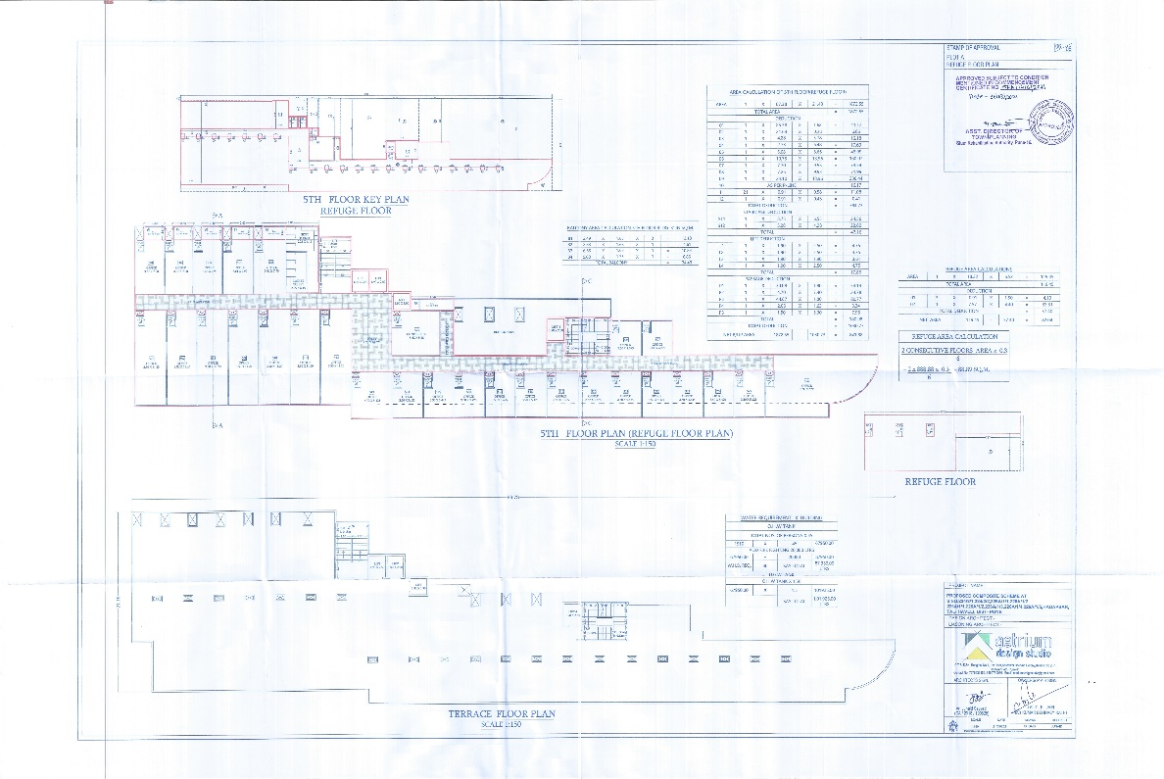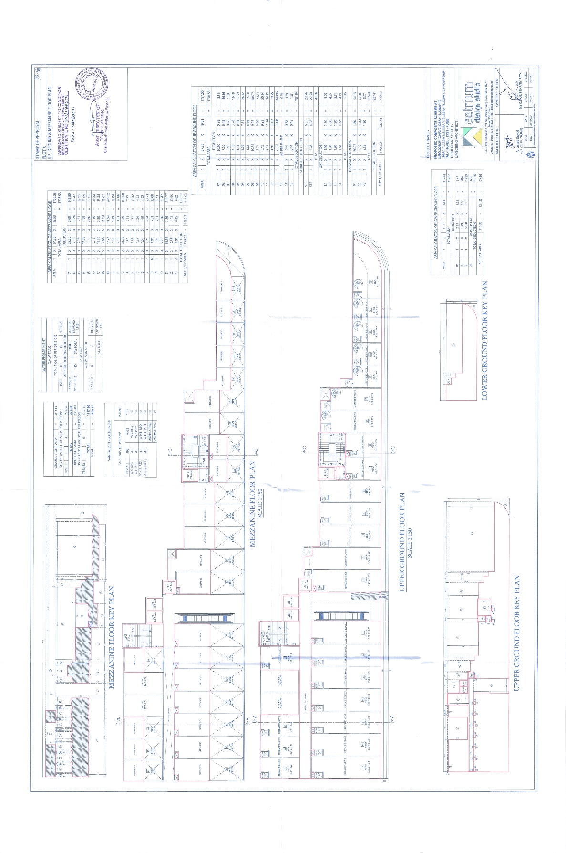

ANNEXURE – G
Amenities

Sr. No. | Particulars
1 | Smoke detectors
2 | Fire Alarm
3 | Sprinklers
4 | CCTV Coverage over Campus and Internal Areas
5 | Common Washroom on Dedicated Floors & Dedicated
6 | Washroom Provision for Shops & Offices
7 | Godown/Store for Retail Spaces*
8 | Loading & Unloading Corridor
9 | STP
10 | Complete Generator Backup (MSEB Permissible Load)
11 | Internal Tremix Concrete/Pavers for Driveway
12 | Top Parking Management System
13 | Top Housekeeping Management System
14 | 24*7 Security Guard
15 | Corpus Fund to Manage Your Building Lifetime
16 | Maintenance Management System
17 | Water Conservation - Water Level Controller with Auto Shut-off to Prevent Overflow and Wastage.
18 | Use of Aerated Blocks for Low Thermal Conductivity which Saves Electricity.
19 | Energy Conservation:
 | • Auto Shut-off Pumps
 | • Auto Shut-off Generator Backup
 | • Use of Led Lights in Common Areas to Reduce Energy Consumption
 | • Low Flow Taps in Common Washroom
 | • Motion Sensor Lights in Common Washroom
 | • OWC
20 | Rent Assistance*
21 | Logistic & Transport Assistance
22 | Pest Control Services
23 | Sanitisation Services
24 | House Keeping Services
25 | MDU Provider
26 | STP Operator
27 | Warranty After Possession (WAP)*
28 | 41 Cash Connect Programme

(Disclaimer: The above mentioned services are provided by the Developer with the help of third party providers.
However, warranty after possession is in accordance with the warranty provided by the manufacturer and is limited only to a few products installed and the developer cannot be held accountable for any discrepancies/commitments from 3rd party vendors.)

ANNEXURE – H
Maintenance

Sr. No. | Maintenance Includes
1 | Housekeeping
2 | Housekeeping supervisor
3 | Security
4 | Security Supervisor
5 | Garden
6 | Pest Control
7 | Lift for customer 4nos.
8 | Car lift 2 nos.
9 | Escalator
10 | CCTV maintenance & AMC
11 | DG maintenance & AMC
12 | STP maintenance & AMC
13 | Fire fighting AMC
14 | Common area electricity maintenance
15 | water tank cleaning
16 | Repairs & maintenance
17 | Technical Staff salary for attain the complaints  (a) Electrician  (b) Plumber

