II SHRI GAJANAN PRASANNA II

ARTICLES OF AGREEMENT

THIS ARTICLES OF AGREEMENT is made and executed at Pune on this ____ day of ___________ in the Year 2022.

BETWEEN

M/S. RAVIMA DEVELOPER PAN# AASFR5116L
A Partnership Firm, registered under the provisions of the Indian Partnership Act, 1932 and having its registered office at Office No.108, Jewel Square, Vasani Nagar, Koregaon Park, Pune – 411 001, Maharashtra, email id: legal@ravimaventures.com

Through its authorized partner:
MR. GAURAV RAVINDRA GADIYA PAN# AGGPG0272Q
Age: 39 Years, Occ: Business, Having Office at: Office No.108, Jewel Square, Vasani Nagar, Koregaon Park, Pune – 411 001, Maharashtra

Hereinafter referred to as “PROMOTER”, which expression shall unless it be repugnant to the context or meaning thereof shall mean and include the said Firm, its partners and partners for the time being and from time to time in future, their/his legal heirs, executors, successors, administrators and assignees etc.
…. PARTY OF THE FIRST PART

AND

M/S. REALITYWORLD INFRACON PAN# ABCFR8888A
a Partnership Firm registered under the provisions of the Indian Partnership Act, 1932 and having its registered office at: D 61, Chakan Industrial Estate Phase 2, Bhamboli, Khed, Pune 410501 Maharashtra,

Through its Partner MR. JIGARR JAYANT VYASS, PAN # ACQPV7344A
Age: 39 years, Occ: Business

Hereinafter referred to as “CONFIRMING PARTY No. 1”/ “LANDOWNER No. 1”, which expression shall unless it be repugnant to the context or meaning thereof shall mean and include the said Firm, its Partners and Partners for the time being and from time to time in future, their / his respective legal heirs, executors, successors, administrators and assigns.

…. PARTY OF THE SECOND PART
AND

1. MR. SANDIP POPAT PAWAR
Age: 43 years, Occupation: Business
Residing At : Tathawade, Taluka Mulshi, District Pune 411033

2. MR. AJIT POPAT PAWAR
Age: 38 years, Occupation: Business
Residing At : Tathawade, Taluka Mulshi, District Pune 411033

3. SMT. SUBHADRA POPAT PAWAR
Age: 63 years, Occupation: Business
Residing At : Tathawade, Taluka Mulshi, District Pune 411033

4. MRS. SHRAVANI SHRIKANT JAGTAP
Age: 41 years, Occupation: Business
Residing At : Hingne Khurd, Pune 411051

5. MRS. RUPALI VIJAY GALANDE
Age: 39 years, Occupation: Housewife
Residing At : Vadgaon Sheri, Pune 411014

6. MR. SUBHASH GHEVARCHAND JAIN MEHTA
Age: 40 years, Occupation: Business
Residing At : Chinchwad, Pune 411033

7. MR. PRASHANT DILIP SAPKAL
Age: 33 years, Occupation: Business
Residing At : Thergaon, Pune 411033

Nos. 1 to 7 (both inclusive), through their duly constituted Attorney –

M/S. REALITYWORLD INFRACON
through its partner(s) –

M/S. KEYS INFRA PROJECTS LLP
through its authorized partner
MR. JIGARR JAYANT VYASS
Age: 39 years, Occupation: Business

Hereinafter referred to as “CONFIRMING PARTY NO. 2”/ “LANDOWNER NO. 2”, which expression shall unless it be repugnant to the context or meaning thereof shall mean and include the said Firm, its Partners and Partners for the time being and from time to time in future, their/his respective legal heirs, executors, successors, administrators and assigns.

…. PARTY OF THE THIRD PART

(1) MISS/ MR. / MRS. Pawan Rajput___________________________________
Age: 0 years, Occupation: (PAN: ____________________)
email id :
residing at A1-602 Yellow Blossoms ,B.T.Kawade Road Ghorpadi Mundhawa Pune-411036

&
(2) MISS/ MR. / MRS.___________________________
Age: years, Occupation: , (PAN:
email id : ___
residing at ____________________________________________

Hereinafter referred to as the “Allottee(s)/Purchaser(s)” (which expression shall, unless it be repugnant to the context or meaning thereof, be deemed to mean and include, in the case of an individual or individuals, his, her or their respective heirs, legal representatives, executors, administrators, successors and permitted assigns, in the case of a body corporate, its successors and permitted assigns, in the case of a partnership firm, the partners from time to time of the partnership firm, the heirs, legal representatives, executors, administrators, and successors of its last surviving partner, its / his / her / their permitted assigns, in case of a Hindu Undivided Family, the Karta, co-parceners and members from time to time of the coparcenary and the survivors or survivor of them [party shall be represented by the Karta] and the heirs, legal representatives, executors, administrators, successors and permitted assigns of the last survivor of them, and in the case of a Trust, the trustees for the time being and from time to time of the Trust and the survivors or survivor of them and their successors and permitted assigns)
…..PARTY OF THE FOURTH PART

The Promoter and Purchaser shall hereinafter collectively be referred to as the “Parties” and individually as a “Party”.

In this Agreement unless: –

- The context otherwise implies, the below expressions shall have the respective meanings assigned to them;

- The singular shall include plural and vice versa;

- The masculine gender or reference made thereto, shall include both the other genders and references thereto, as the context may require;
- The titles to the clauses are only for reference purpose and shall have no bearing on the contents thereof or on the interpretation of the clauses;

- The recitals and Schedules written hereunder and the Annexures annexed hereto form an integral part of this Agreement.

- Reference to taxes whether specified or not includes all present and future taxes and levies.

- Unless the subject or context otherwise requires, reference to the word “include”, “includes” or “including” shall be construed as without limitation.

- Reference to the terms “herein”, “hereto”, “hereof”, or “thereof”, and any other similar terms refer to this Agreement and not to the particular provision in which the term is used, unless the subject or context otherwise requires.

- Reference to an “amendment” includes a supplement, modification, novation, replacement, or re-enactment, and the term “amended” is to be construed accordingly unless the subject or context otherwise requires.

- Bold typeface, headings and titles are used for convenience of reference only and shall not affect the construction of this Agreement, and/or limit, extend, or define any of the terms, conditions and provisions hereof.

- When any number of days is prescribed in any document, the same shall be reckoned excluding the first day and inclusive of the last day.

- Wherever the Allottee/s has confirmed, and/or accepted, and/or acknowledged, and/or agreed to, and/or given any undertaking in respect of, any act, deed, matter, thing, item, action, or term or provision of this Agreement, the same means, and shall be deemed to mean the irrevocable and unconditional confirmation, acceptance, acknowledgement, agreement, undertaking, declaration, representation and warranty on the part of the Allottee/s, in respect of and/or in relation to such act, deed, matter, thing, item, action, or provision.

- Time is of the essence in respect of the performance by the Allottee/s of all his/her/their/its obligations, including financial obligations. If any time period specified herein is extended in writing by the Promoter in its discretion, such extended time period shall also be of the essence;

- All aggregate payments shall be paid by the Allottee/s on or before the due dates for payment thereof, and/or as demanded by the Promoter, without any delay, demur, default, dispute, or deduction, whatsoever.

- References to recitals, articles, clauses, schedules and annexures shall be reference to the recitals, articles, clauses, schedules and annexures contained in or annexed to this Agreement, as the case may be.

- References to laws, rules or regulations, or to any provision/s thereof, shall include references to any such law, rules and regulations as they may, after the date hereof, from time to time, be amended, supplemented or re-enacted, and any reference to a statutory provision shall include any subordinate legislation, including rules or regulations, made from time to time under that provision.

WHEREAS, All that piece and parcel of land comprises of the following :-

- All that piece and parcel of land at Survey No. 137/3/1 totally admeasuring about 00 H 12 R, Village Tathawade, Taluka Mulshi, District Pune, within the limits of Pimpri Chinchwad Municipal Corporation
- All that piece and parcel of land admeasuring about 00 H 04 R out of Survey Nos. 137/3/2 totally admeasuring about 00 H 12 R, Village Tathawade, Taluka Mulshi, District Pune, within the limits of Pimpri Chinchwad Municipal Corporation
- All that piece and parcel of land admeasuring about 00 H 04 R out of Survey Nos. 137/3/2 totally admeasuring about 00 H 12 R, Village Tathawade, Taluka Mulshi, District Pune, within the limits of Pimpri Chinchwad Municipal Corporation
- All that piece and parcel of land admeasuring about 00 H 04 R out of Survey Nos. 137/3/2 totally admeasuring about 00 H 12 R, Village Tathawade, Taluka Mulshi, District Pune, within the limits of Pimpri Chinchwad Municipal Corporation
- All that piece and parcel of land at Survey Nos. 137/4 totally admeasuring about 00 H 24 R, Village Tathawade, Taluka Mulshi, District Pune, within the limits of Pimpri Chinchwad Municipal Corporation
- All that piece and parcel of land at Survey Nos. 138/2A totally admeasuring about 00 H 41 R, Village Tathawade, Taluka Mulshi, District Pune, within the limits of Pimpri Chinchwad Municipal Corporation

Hereinafter the aforementioned properties described at (A), (B), (C), (D), (E) & (F) shall be collectively referred to as said “said Land”, which are more particularly described in First Scheduled respectively, written hereunder.

WHEREAS, the Confirming Party No. 1 / Landowner No. 1 has acquired and is well and sufficiently entitled to the land described at Sr. No. (a), (e) and (f) of the recitals hereinabove; and the Confirming Party No. 2 / Landowner No. 2 has acquired and is well and sufficiently entitled to the land described at Sr. No. (b), (c), and (d) of the recitals hereinabove.

AND WHEREAS, the Confirming Party No. 1 / Landowner No. 1 has acquired and is well and sufficiently entitled to the development rights to the land described at Sr. No. (b), (c), and (d) of the recitals hereinabove;

AND WHEREAS, the Promoter hereto has entered into a Joint Development Agreement, which is registered with the office of the Joint Sub-Registrar of Assurances at Haveli No. 23 under Reg. No. 21770/2021 with the Confirming Party hereto with respect to the said Land described at (A), (B), (C), (D) (E) and (F) and the Promoter and the Confirming Party have decided to develop the said Land together, in terms whereof the Confirming Party is entitled to receive as consideration including the said amount of land cost from the Joint Development represented by Area share of the Owner in the saleable area of residential Units proposed to be developed and constructed on the said Land in accordance with the terms and conditions of the Joint Development Agreement .

AND WHEREAS, the Confirming Party along with the aforesaid Joint Development Agreement have also executed Irrevocable Power of Attorney which is registered in the office of Sub-Registrar Haveli No. 23 at Serial No. 21772 /2021 with respect to the said land.

AND WHEREAS, in the circumstances as aforesaid, the Promoter became seized, possessed and absolutely entitled to cause development over the said Land and that the Promoter herein shall be completely entitled to retain and/or sell the said area to its entitlement to any third party at its sole discretion.

AND WHEREAS, being well and sufficiently entitled to cause development and being in possession of the said Land, the Promoter herein have obtained sanction for development of said Land relating to amalgamation plus layout of building vide Commencement Certificate bearing No. B.P./ Tathawade/ 87/2021 dated 13/10/2021, which has and the Pimpri Chinchwad Municipal Corporation has sanctioned the layout of the said Land, hereinafter referred to as “Sanctioned Layout”, (which will be subject to further revisions as per the applicable laws, rules, regulations, bye-laws etc. in order to entitle the Promoter herein to develop the said Land to its complete potential in a phase wise manner for which informed consent is hereby accorded by the unit purchasers) and part sanctioned the plans for construction of wings C & D comprising of parking floors plus Twelve (12) upper floors comprising of Residential tenements/Apartments of the said Land hereto more particularly described in the First Schedule hereunder written (hereinafter referred to as the `said Land’). The Promoter has accordingly commenced construction of the Phase I of the said Project (as defined here in below) in accordance with the Sanctioned Layout. It is further clarified that the Promoter shall construct more additional floors in the said Phase I of the said Project by loading and utilizing thereon Transferrable Development Rights (TDRs), Slum TDR, additional /fungible/ premium FSI etc., i.e. Phase I of the said Project shall comprise of wing C & D comprising or parking floors plus Twelve (12) upper floors comprising of Residential Unit/ tenements / Apartments, lift room and the stair cases and also erection of facilities and amenities being developed for the entire Project i.e. common for phases in the said Project.

AND WHEREAS, after deducting from the area of the said Land [admeasuring 8900 sq.mtrs] the areas of the following are as follows:
        - Area under D P Road – 570.00 sq.mtrs.

After the deductions of the aforesaid areas from the total land, the net area of the said Land is 8330.00 sq.mtrs. and such net area is hereinafter referred to as “the said Land” and is more particularly described in the First Schedule hereunder written;

AND WHEREAS, at the time of sanctioning the said plans concerned local authority and/or Government has laid down/shall lay down certain terms, conditions, stipulations and restrictions which are/will to be observed and performed by the Promoter and the Unit Purchaser/s/Allottees while developing and using the said Land and the said Building and upon due observance performance of which only the completion certificate in respect of the said Building shall be granted by the concerned local authority.
AND WHEREAS, the promoter has purchased and proposes to procure / make available FAR (FSI) by way of purchase of “Transferable Development Rights”, FSI, premium or TDR generated in the scheme by handing over the road area out of the total land for Road Widening, “Paid FSI”, premium, or FSI available as incentive FSI by implementing various schemes as mentioned in the Development Control Regulations or based on expectation of increased FSI which may be available in future on modifications to the existing Development Control Regulations which are applicable to the said project and to consume such additional FSI by constructing sanctioned additional floors.

AND WHEREAS, the said building and the areas, facilities and common to all the Project and the said Land more particularly described in the Third schedule herein under written.

The Owner/Promoter shall construct the said Project in vertical phases as follows:

No. | Phase | Construction Stages
 | I | Wing C - Residential Building - comprising of parking floors and Twelve (12) upper Floor of residential tenements/apartments, lift rooms, stairways plus such further floors as may be permissible as per Development Control Regulations.
 | I | Wing D - Residential Building - comprising of parking floors and Twelve (12) upper Floor of residential tenements/apartments, lift rooms, stairways plus such further floors as may be permissible as per Development Control Regulations.

AND WHEREAS, the Promoter is entitled and enjoined upon to construct building in the phase wise manner by distributing the same in vertical phases on the said Land in accordance with the recitals hereinabove and the Promoter is in possession of the said Land.

AND WHEREAS, the Allottee/s has/have applied and/or agreed to purchase from the Promoter the Apartment that is described under Clause 5 of this Agreement and under Third Schedule hereinbelow.

AND WHEREAS, the Promoter has entered into a standard Agreement with an Architect registered with the Council of Architects and such Agreement is as per the Agreement prescribed by the Council of Architects. However, the Promoter shall have the right to remove and substitute the Architects until the said entire project shall be completely developed.

AND WHEREAS, the Promoter has obtained RERA Registration bearing No. P52100031983 dated 03/12/2021 in respect of the said Residential Building to be known as “NEWTON HOMES TATHAWADE PHASE I” from the Maharashtra Real Estate Regulatory Authority under the provisions of Section 3 of the Real Estate (Regulation and Development) Act 2016 (hereinafter referred to as “the said Act”) and the Rules and Regulations made thereunder; a copy of the said Certificate is annexed hereto as Annexure “A”;

AND WHEREAS, the Promoters have entered into a standard Agreement with Patil & Bugade Associates, Pune who is registered with the Council of Architects and such Agreement is as per the Agreement prescribed by the Council of Architects and the Promoters have appointed STS Consultant LLP for the preparation of the structural design and drawings of the said Building and the Promoters accept the professional supervision of the said Architect and the said Structural Engineer till the completion of the project provided however, that the Promoters reserve the right to change the said Architect and Structural Engineers at any time before the completion of the Project;

AND WHEREAS, by virtue of the said Joint Development Agreement, the Promoter has sole and exclusive right to sell the Apartments in the said building/s to be constructed in Phase wise manner by the Promoter on the said Land and to enter into Agreement/s with the Allottee of the Apartments and to receive the purchase price in respect thereof;

AND WHEREAS, on demand from the Allottee, the Promoter has given inspection to the Allottee of all the documents of title relating to the Project Land and the plans, designs and specifications prepared by the Promoter's Architects and of such other documents as are specified under the Act and the Rules and Regulations made there under. The Allottee has got the same independently verified and is duly satisfied with the same.

AND WHEREAS, the authenticated copies of Certificate of Title issued by the Attorney at Law or advocate of the Promoter, Commencement Certificate/s, authenticated copies of Property card or extract of Village Forms VI and VII and XII or any other relevant revenue record showing the nature of the rights of the Promoter to the said Land on which the Apartments are constructed or are to be constructed have been annexed hereto and marked as Annexure 'B', ‘C’ and ‘D’, respectively. The same is hereby independently verified to the satisfaction of the Allottee, acknowledged and confirmed by the Allottee.

AND WHEREAS, the authenticated copies of the plans of the Layout as approved by the Municipal Corporation of Pimpri Chinchwad / local plan sanctioning/ development authority have been annexed hereto and marked as Annexure “E”.

AND WHEREAS, the authenticated copies of the plans of the Layout as proposed by the Promoter and according to which the construction of the buildings and open spaces are proposed to be provided for on the said project have been annexed hereto and marked as Annexure “F”.

AND WHEREAS, the authenticated copies of the plans and specifications of the Apartment agreed to be purchased by the Allottee, as sanctioned and approved by the local authority have been Scheduled Three.

AND WHEREAS, the Promoter has got some of the approvals from the concerned local authority/ies to the plans, the specifications, elevations, sections and of the said building/s and shall obtain the balance approvals from various authorities from time to time, so as to obtain Building Completion Certificate or Occupancy Certificate of the said Building.

AND WHEREAS, while sanctioning the said plans concerned local authority and/or Government has laid down certain terms, conditions, stipulations and restrictions which are to be observed and performed by the Promoter while developing the Project Land and the said building and upon due observance and performance of which only the completion or occupancy certificate in respect of the said building/s shall be granted by the concerned local authority.

AND WHEREAS, the Promoter has accordingly commenced construction of the said building/s forming part of “Newton Homes Tathawade Phase I” in accordance with the said sanctioned plans.

AND WHEREAS, the Parties, relying on the confirmations, representations and assurances of each other to faithfully abide by all the terms, conditions and stipulations contained in this Agreement and all applicable laws, are now willing to enter into this Agreement on the terms and conditions appearing hereinafter;

AND WHEREAS, after the Purchaser/s enquiry, the Promoter requested the Purchaser/s to carry out independent necessary search by appointing his/ her/ their own Advocate and to ask any queries, he/she/they had regarding the title and the nature and title of said property, Plans and Specifications and the Purchaser/s has/have satisfied himself/ herself/ themselves about the marketable title and rights of the Promoter in respect of said i.e. Schedule I property and thereof, agreed to purchase Residential Unit (Apartment) and with Parking more particularly described in Schedule III (if any) written hereunder and hereinafter for the sake of brevity and convenience referred to as "the SAID RESIDENTIAL UNIT/APARTMENT" and the Unit Purchasers have got satisfied with the same.

AND WHEREAS, the Allottee has full knowledge of the terms and conditions contained hereinabove and in the documents, recited herein. The Promoter has made full disclosure to the Allottee as per law. The Allottee is aware of the fact that save and except the building, construction whereof is presently proposed, the scheme of development is subject to change and/or modifications, as desired by the Promoter and the Allottee has no objection to the same.

AND WHEREAS, the Purchasers/s is/are aware of the fact that, the construction is undertaken by the Promoter/s in a phase wise manner and the Purchaser/s accorded its consent to the Promoter to revise plans either by way of amalgamation of land and/or subdivision without causing any prejudice to the Unit agreed to be sold to the Purchaser/s herein. Furthermore, the Purchaser/s herein has also accorded its irrevocable consent for transfer and/or assignment of rights of the Promoter herein in favour of any third party, subject to no prejudice being caused to the Unit agreed to be sold to the Purchaser/s herein.

AND WHEREAS, the Purchaser/s herein prior to/at the time of the execution of these presents has/ have paid to the Promoter being the part payment of the Sale Price of the Unit agreed to be sold by the Promoters to the Unit Purchaser/s. Along with the offer to purchase the Apartment from the Promoter, the Allottee has requested to treat the monies paid in terms of the offer letter as a part payment of the purchase price of the Apartment agreed to be sold by the Promoter to the Allottee as advance payment or Application Fee (the payment and receipt whereof the Promoter both hereby admit and acknowledge) and the Allottee has agreed to pay to the Promoter the balance of the purchase price in the manner hereinafter appearing.

AND WHEREAS, under section 13 of the said Act the Promoter is required to execute a written Agreement for sale of said Apartment with the Allottee, being in fact these presents and also to register said Agreement under the Registration Act, 1908.

AND WHEREAS, in accordance with the terms and conditions set out in this Agreement and as mutually agreed upon by and between the Parties and the Allottee, having fully understood all the disclosures made by the Promoter, the Promoter hereby agrees to sell and the Allottee hereby agrees to purchase the Apartment and the proportionate rights in the common areas for the Phase.

NOW THEREFORE THIS AGREEMENT WITNESSETH AND IT IS HEREBY AGREED BY AND BETWEEN THE PARTIES HERETO AS UNDER:

- The Parties hereto agree, acknowledge and consent that the recitals contained hereinabove, schedules, annexures etc. attached with the present Agreement shall at all times be read together with and form an operative part of this Agreement as being reproduced herein verbatim.

- DEFINITIONS:

  - “Act of God” or “Force Majeure” shall include but not be restricted to any natural calamity, act of legislature, restrictions by Courts or any governmental or legislative authority, man-made calamity like riots, wars, civil commotion, accidents, structural damage, epidemic or other natural disaster, calamity or changes in law, regulations, rules or orders issued by any court or government authorities and acts beyond the control of the Promoter.

  - “Apartment” or “Unit” or “Said Unit” or “said Apartment” shall mean the Apartment agreed to be purchased by the Allottee with carpet area of the Apartment, carpet area of the balcony and proportionate share in the Common Areas, which is more particularly described in Third Schedule hereunder.

  - “Association” shall mean an organization being a society / association / condominium or a limited company formed for the Project at the discretion of the Promoter. It is clarified that, as the Project is proposed to be developed in multiple phases, each phase could have an independent Association.

  - “Carpet area of the Apartment” shall mean the net usable floor area of an Apartment, excluding the area covered by the external walls, areas under services shafts, exclusive balcony appurtenant to the said Apartment for exclusive use of the Allottee or verandah area and exclusive open terrace area appurtenant to the said Apartment for exclusive use of the Allottee, but includes the area covered by the internal partition walls of the Apartment. The method of calculating the carpet area has been clarified by the Government of Maharashtra vide Circular dated 4/2017 dated 14 June 2017. In the event of any methodology, being required, is changed leading to a changed area, such a change shall have no bearing on the consideration so long as the said Apartment is constructed as per the sanctioned plans and sale plans annexed herewith.

  - “Carpet Area of balcony” shall mean the area of the balcony, which is appurtenant to the net usable floor area of an Apartment, meant for the exclusive use of the Allottee. When the balcony is enclosed, the carpet area shall be measured from the line of the Apartment as per the sanctioned plan till and excluding the external walls, however, in case of any internal walls between balconies or rooms, the area of such internal partition walls shall be included in the carpet area of the balcony.

  - “Carpet area of Terrace” shall mean the area of the terrace, which is appurtenant to the net usable floor area of an Apartment, meant for the exclusive use of the Allottee. The area of the terrace shall be calculated till the outer edge/s of the terrace slab i.e. it shall include the railing.

  - “Carpet area of Utility” shall mean the area of utility, which is appurtenant to the net usable floor area of an Apartment, meant for the exclusive use of the Allottee. The area of the utility shall be calculated till the outer edge/s of the terrace slab i.e. it shall include the railing or till the inside of the parapet wall, as the case may be.

  - “Common Area Maintenance” or “CAM” shall mean the management, upkeep and maintenance of the Common Areas of the Project and includes but is not limited to cleaning/housekeeping, security (including electronic security cameras), STP, Firefighting system, underground and overhead water tank, all maintenance of transformer, water pumps, DG (Diesel charges for running the common areas), and other electrical equipments, artificial ventilation system, mechanize car parking, sanitation, upkeep of all common areas and peripheral areas of the Building, upkeep of elevators, escalators, basements, Revenue Charges, insurance etc. It also covers proportionate charges of insurance of Genset, Escalator etc.

  - “Common Area Maintenance Charges” or “CAM Charges” shall mean the charges payable towards the CAM, ground rents, taxes, water charges and costs payable to any authority. It shall include local taxes, betterment charges or such other levies by the concerned local authority and/or Government water charges, insurance, common lights, repairs and salaries of clerks, bill collectors, gardens, security (including electronic security cameras), chowkidars, sweepers and all other expenses necessary and incidental to the management and maintenance of the Entire Plot and said Project, salaries, wages, of the people engaged for the ultimate body, electricity charges, water charges, all annual maintenance charges and maintenance costs of all equipment and machineries, including STP, elevators, DG set, amenities on podium floor / top floor or any other area of Project (as decided by Developer) and all other expenses of and incidental to the management and maintenance of the said project land and structure. CAM Charges shall always exclude costs of water procured by tankers and costs of diesel, which shall be borne at actuals proportionately by prospective purchasers/Allottees of the said Entire Project.

  - “Common Areas for the Phase” shall mean the common areas of building of Phase I, the total of which is to be conveyed to the association with proportionate title to the Apartment purchasers.

  - “Common Areas for the Project” shall mean areas, amenities and facilities within the Project, or within the Entire Plot, intended for the common use of, inter alia, Allottees, owners and occupants, from time to time of the Apartments, and more particularly described in the Seventh Schedule annexed hereto which is to be conveyed to the ultimate body with proportionate title to the Apartment Allottees.

  - “Default” shall mean any non-compliance of the terms and conditions of this Agreement and includes not making payments on or before the due date in terms of this agreement. A default is deemed to have occurred immediately upon the breach of any condition or missing the deadline for payment of any amount or installment due or delay may be on account stop payment /dishonor of any negotiable instrument (cheque) on its due date of representation which is issued in discharge of the legal liability of payment of consideration price as per agreed payment schedule by the Allottee unto the Promoter.

  - “Discretion of the Promoter”, or “Promoter’s discretion”, and any grammatical variations thereof, shall mean, and shall be deemed to mean, the sole, absolute and unfettered discretion of the Promoter, which irrevocably binds the Allottee/s and all other concerned persons, and which shall not be called into question and/or challenged and/or disputed in any manner, on any grounds whatsoever, by the Allottee/s and all concerned persons.

  - “Entitlement” of the Promoter, and/or the Promoter being “entitled”, and any grammatical variations thereof, the same shall mean and shall be deemed to mean, the full complete, absolute, exclusive and unfettered entitlement and liberty of the Promoter in its sole discretion, over and/or in relation to the act, deed, matter, or thing in question and it may include rights entrusted by the land owners unto the Promoter in lieu of Joint Venture/ Development Agreement and Power of Attorney thereby conferring absolute right of development by making construction on Schedule I land and thereby to sell units on it and execute final deed of conveyance in favour of the association of tenement holders.

  - “Entire Plot” shall mean the land more particularly described in the First Schedule to this Agreement. In the event any additional land is subsequently added by following the provisions of law, the meaning of the word “Entire Plot” shall automatically stand amended to include such additional land.

  - “Intent to terminate notice” or “cure notice” shall mean a Notice sent or required to be sent to the Allottee or the Promoter, as the case may be, by the other party, providing a period of 15 days to make good of the default. A Notice of default with a period to cure / make good the default shall automatically be considered as Intent to terminate notice or a cure notice.

  - “Liquidated Damages” shall mean the pre-estimated liquidated damages payable by the Allottee/s together with the brokerage/commission paid to the estate agent/s in relation to the allotment of the Apartment, which the Parties mutually confirm that they consider the same to be reasonable and not amounting to a penalty. The amount to be equivalent to 15% of the total purchase price of the said Apartment.

  - “Loft Area” shall mean an intermediary floor between two floors or a residual space in a pitched roof, above normal floor level, which is constructed and adopted for storage purposes.

  - “Notice” shall mean any communication by the Promoter to the Allottee. The said communication shall be by e-mail.

  - “Notice of default” shall mean a notice sent by the Allottee or the Promoter as the case may be to the other party describing the nature of any default that has taken place by the other party.
  - “Payment Plan/Schedule” shall mean the payment plan/schedule more particularly described in the Fifth Schedule to this Agreement. The time of payment or timely payment of each of the installments as per the Payment Plan/Schedule and/or any other payment due or payable under this agreement shall always be the essence of this Agreement.

  - “Permitted Assign” shall mean an assignee approved by the Promoter if assignment is to be done before the execution of the Deed of Apartment in favour of the Allottee.

  - “Phase/s” shall mean
- In case of Phase I, Wing C - Residential Building - comprising of parking floors and Twelve (12) upper Floor of residential unit/ tenements/ apartments, lift rooms, stairways plus or such further floors as may be permissible as per Development Control Regulations.
- Wing D - Residential Building - comprising of parking floors and Twelve (12) upper Floor of residential unit/ tenements/apartments, lift rooms, stairways plus or such further floors as may be permissible as per Development Control Regulations.
- In case the permission from the concerned Government or semi-government or local authority/ies for constructing the additional floor/s by loading future TDR or FSI or premium is acquired in more than one part and/or the sanction of the layouts have been or may be granted in parts, the Promoter shall, at its discretion, merge two or more such sanctions or treat each such sanction as a separate Phase.
- In this Agreement, unless specifically stated otherwise, shall relate to Phase II, as the case may be.

  - “Plans” shall mean the plans, drawings and layout as currently approved and sanctioned by the Municipal Corporation of Pimpri Chinchwad or any concerned development authority within Pune District and/or any other concerned Governmental Authorities in respect of the Project, and includes plans, drawings and layouts as may, from time to time, be submitted by the Promoter in its discretion, in respect of the Project, or any part thereof, and/or as may be sanctioned and approved from time to time; together with any amendments, alterations, modifications, additions, extensions, renewals, etc. in respect thereof as the Promoter may consider necessary and expedient, in its discretion and/or as required by any Governmental Authority.

  - “Purchase Price” shall mean the purchase price and consideration payable by the Allottee herein, to the Promoter herein, as stated in the Payment Schedule. However, the Purchase Price excludes Taxes, (consisting of tax paid and/or payable by the Promoter by way of Goods & Service Tax, and Cess and/or any other similar taxes in connection with the construction of and carrying out the Project payable by the Promoter), any other taxes up to the date of handing over the possession of the said Apartment to the Allottee, Stamp Duty and Registration.

  - “Project” shall mean project being constructed by the Promoter on the said Land;

  - “Said Building/ Wing” shall mean the Building wherein the said Apartment will be a part.

  - “Taxes” shall mean all present, future, and enhanced direct/ indirect taxes, imposts, dues, duties, impositions, fines, penalties, etc., by whatever name called, imposed/levied under any Applicable Law and/or by Governmental Authorities, attributable to and/or in relation to and/or arising from and/or imposed or levied upon, the Agreement for allotment and sale herein, and/or the Apartment and/or the Common areas and facilities and/or this Agreement and/or upon the Purchase Price and/or any or all of the other Payment/s referred herein, and/or upon the Ultimate body to be formed and/or in respect of the documents and writings to be executed in their favour, as contemplated herein and/or otherwise; and includes goods and services tax, education tax/cess, local body tax, property rates and taxes and cesses, stamp duty and registration charges, and any taxes, imposts, impositions, levies or charges, in the nature of indirect tax or in relation thereto, that is/are imposed or levied by any Governmental Authority.

  - “Terminable Default” shall mean a default, whereby the non-defaulting party is provided with the right to terminate this agreement including but not limited to the following cases:
- In the case of default not relating to payment is not cured or made good within the period mentioned in the Notice of Default;
- In the case of default in making payment as per the due date mentioned in any Notice of Default;
- In the case of default in making payment immediately upon the occurrence of a default being the fourth instance of a delay in payment where the previous three delays were cured as per the notice of default or where any previous delay/s though not cured during the notice of default, were condoned by the promoter.
- Default/ Delay in payment on account of dishonour of negotiable instrument issued by the Allottee in lieu of consideration price as mentioned above.

  - “Termination notice” shall mean the notice by which this Agreement stands cancelled pursuant to a Terminable Default taking place.

  - “The Act” shall mean the Real Estate (Regulation and Development) Act, 2016.

  - “Ultimate Body” shall be an entity consisting of the associations formed by the Promoter, for the management and maintenance of the common areas of the Project and to which the land may ultimately be transferred.

- NAME OF THE PROJECT

The development on the said Landof the said Project to be known as “NEWTON HOMES TATHAWADE” in phase wise manner as aforesaid shall always be known as defined in the Schedule I or by such other name as may be desired by the Promoter, this covenant shall be binding upon the successors in title of the Promoter and/or the Allottee including the Association of Allottees and the Ultimate Body (formed in the manner as provided hereunder) in perpetuity.
- DESCRIPTION OF THE PROPERTY

The Property / Land on which the said Project, more particularly described in the Second Schedule hereto, shall be developed, is more particularly described in the First Schedule hereto. The Promoter shall construct the said Project on the Project Land in accordance with the plans, designs and specifications as approved by the concerned local authority from time to time.
- DESCRIPTION OF THE UNIT/APARTMENT

The Allottee/s hereby agrees to purchase from the Promoter the Residential Unit admeasuring 0.00 sq. mtrs. carpet area and balcony 0.00sq. mtrs area of Flat/ Apartment bearing No. A-1202 to be situate on the 12 th Floor^{th} floor of Phase I in the Building / Wing No. of the said Project to be known as “Newton Homes Tathawade Phase I” to be constructed by the Promoter on the said Land (the said Unit) TOGETHER WITH One Covered Car Parking Space No. _______________________ and allotted in the Project” and whereas the said Unit/Apartment together with its said appurtenances are more particularly described in the Third Schedule hereunder.

- CONSIDERATION & PAYMENT SCHEDULE

  - The Parties hereby agree that the total price at which the Allottee shall purchase the Unit from the Promoter shall be Rs. 87,56,522.00/- (i.e. Rupees Eighty Seven Lakh Fifty Six Thousand Five Hundred Twenty Two only only), (hereinafter referred to as the “Purchase Price”).

  - The Allottee/s hereby agrees to purchase from the Promoter and the Promoter hereby agrees to sell to the Allottee/s the Apartment as described in the Third Schedule written hereunder at a consideration/Purchase Price more particularly detailed in the Fourth Schedule written hereunder.

  - The total consideration of the Apartment includes the proportionate price towards the common general areas which are more particularly detailed in the Fifth Schedule written hereunder.

  - The total Purchase Price amount referred to in the sub clause above payable by the Allottee/s to the Promoter is inclusive of: (i) Cost of the Apartment, (ii) Cost of Garage, and (iii) Society Formation, MSEDCL charges but excluding power supply and running costs, on lumpsum basis. The total price referred to in the sub clause above payable by the Allottee/s to the Promoter is exclusive of Legal & Administrative Charges and Incidental Charges which shall be paid by the Allottee/s over and above the total Purchase Price amount in the manner specified herein.

  - The total above is excluding taxes and any other amounts specifically mentioned herein as payable. Further it excludes (a) diesel and water procurement by tankers or otherwise and consumption charges till the final hand over (b) any other dues as herein otherwise contained all of which shall be payable as may be applicable. The amounts due shall be paid by the Allottee/s as and when due and called upon to do so by the Promoter in terms of this Agreement. It also excludes refundable deposits to be paid for the Apartment to any Authority/ies.

Provided the Allottee/s shall not be entitled to claim possession and/or allotment and/or transfer of the said Apartment until the Allottee/s has/have paid the full and complete dues and consideration payable to the Promoter under this Agreement or by a separate contract or otherwise.

  - The Promoter is entitled to merge or consolidate two or more installments in its sole discretion by simultaneously executing the contemplated work in the Payment Plan/Schedule.

  - The Total Price is escalation-free, save and except escalations/increases due to increase on account of development charges payable to the competent authority and/or any other increase in charges which may be levied or imposed by the competent authority/Local Bodies/Government from time to time and/or any Act of God or due to stoppage of work on account of a work stop order by any authority/ies or any strike or non-availability of labour or material which is beyond the control of the Promoter. The Promoter undertakes and agrees that while raising a demand on the Allottee/s for increase in development charges, cost, or levies imposed by the competent authorities etc., or for escalation as provided in this clause, the Promoter shall enclose the said notification/ order/ rule/ regulation published / issued in that behalf to that effect or supporting documentation authenticated by an Architect along with the demand letter being issued to the Allottee/s, which shall only be applicable on subsequent payments.

- MODE OF PAYMENT

  - The Promoter shall send a notice/ authorized mail to the Allottee/s intimating the Allottee/s the date the milestone mentioned in the Payment Plan is expected to be completed atleast 7 days prior to the milestone to being completed. The Allottee/s shall pay the amount due under the said installment within the time stipulated in the notice/ authorized mail and upon milestone being achieved.
  - All payments mentioned herein shall be made by NEFT or RTGS or account payee cheques or demand drafts or Bankers Cheques or Pay Orders payable at par on banks in Pune and not otherwise. The date of payment shall be considered as the date on which the payment is credited to the account of the Promoter in Pune. Bank charges for outstation cheques shall be borne by the Allottee.
  - The Allottee/s shall be obliged to pay to the Promoter interest at the same rate payable by the Promoter to the Allottee, as provided under the rules of the Act, on the amount of the installments and/or due/s in arrears for the period of the delay in payment of such installments and/or dues, without prejudice to the rights of the Promoter as provided herein below.
  - Any failure by the Allottee/s to make any payment/s on or before the due date shall be considered as a default or a terminable default, as the case may be.
  - The Allottee/s authorizes the Promoter to adjust/appropriate all the payments made by him/her/them under any head(s) of dues against lawful outstanding, if any, in his/her/ their name/s, as the Promoter may in its sole discretion deem fit, and the Allottee/s undertakes not to object/demand/direct the Promoter to adjust his payments in any manner.

- TAXATION:

- The consideration herein is exclusive of taxes. The Allottee/s hereby agree/s that in the event of imposition of any additional new tax or revision in taxes by Government of India or State of Maharashtra or Gram Panchayat/ Zilla Parishad/ Collector/ Authority / Municipal Corporation (presently Pimpri Chinchwad Municipal Corporation) which will affect development of the lands construction, purchase, sale of property then in that case, the Promoter shall be entitled to claim the same from the Allottee/s on pro rata basis, if such tax is required to be paid then, such tax or burden will be calculated by the Chartered Accountant and project Architect. The calculations of such tax calculated by Chartered Accountant and project Architect will be provided to the Allottee/s and the Allottee/s shall be bound to pay the same. If such tax is levied before the possession of the said Apartment is given, then in that case the Allottee/s shall pay the same as due before taking possession and in case possession of the said Apartment is given then in that case within 15 days from demand of such amount by the Promoter. So also, if the tax is levied after possession, the Allottee/s shall be liable to pay his/her/its/their share of the same without demur.

- The Allottee/s hereby further agree/s that in the event of any amount not already referred to herein by way of premium or deposit payable to the Central or State Government or betterment charges or development charges or development tax or any other amounts or charges or taxes payable to any body or authority for grant of any permission/NOC/license or connection or installation of any services or any other tax or statutory liability or payment of a similar nature, being demanded from the Promoter, the same shall be reimbursed by the Allottee/s to the Promoter in proportion to the area of the aforesaid Apartment, agreed to be acquired by the Allottee/s and in determining such amount, the decision of the Promoter shall be conclusive and binding upon the Allottee/s. In addition to the consideration and other amounts also payable by the Allottee/s, the Allottee/s shall be liable to pay to the Promoter the sum calculated at the rate and on the basis prescribed and payable as and by way of Works Contract Tax, if payable to the Government of Maharashtra, GST and/or other dues to the State or Centre by means of taxes or otherwise before handing over the possession of the said Apartment as aforesaid.

- Amounts due from the Allottee/s shall automatically create a charge of the Promoter on the said Apartment.

- It is further clarified that the Promoter shall be solely entitled to claim set-off for GST recovered from the Allottee/s and the Allottee/s shall not claim any set-off against GST paid against the said Apartment agreed to be sold to the Allottee/s.

- In addition to the above, the Allottee/s agree, acknowledge and consent that liability of the Allottee/s for contributing towards property taxes against the said Apartment shall commence immediately upon levy of such property taxes on the said Apartment by the Municipal Corporation of Pimpri Chinchwad.

- EVENT OF DEFAULT IN PAYMENT AND INTEREST IN CASE OF DEFAULT

- Without prejudice to the right of the Promoter to charge interest in this Agreement, the Allottee/s on committing any default in payment of any amount due from the Allottee/s, under this Agreement on the due date, shall be considered a default or a terminable default, as the case may be.
- The word amount in this sub clause shall mean any dues due from the Allottee under any head in this Agreement.
- Any condonation or leniency shown by the Promoter or delay or extension in timely raising of bill or invoice by Promoter in this case shall not mean a waiver and shall not affect the right of the Promoter to terminate this Agreement in terms of this clause.

- FIXTURES, FITTINGS AND SPECIFICATIONS

The fixtures, fittings and specifications of the apartment to be provided by the Promoter in the said Apartment as are set out in the Third Schedule hereto. The Allottee/s hereby agrees, declares and confirms that save and expect the fixtures, fittings as mentioned in the said Third Schedule, the Promoters shall not be liable, required and/or obligated to provide any other fixtures, fittings, materials in the said Apartment.

- OPTIONS OF SPECIFICATIONS

Notwithstanding the fact that as defined in the Third Schedule hereto, where the choice of specifications lies with the Promoter, it is agreed to between the Promoter and the Allottee/s that in the event of the Promoter choosing to offer any options and the Allottee/s choosing any of the alternative options offered by the Promoter in the said Apartment to be purchased by him/her/it/them, the Promoter shall provide the same, provided that the Allottee/s agree/s to pay and pays the extra costs involved in advance and that provided the options so selected, are communicated in writing to the Promoter sufficiently in advance within the time limit as decided by the Promoter and not thereafter. Options once selected shall be binding on the Allottee/s and shall not be changed for any reason whatsoever.

- POSSESSION

DATE OF POSSESSION
- The Promoter shall give possession of the Apartment to the Allottee/s as per the date mentioned in the Sixth Schedule hereto.

- In the event the Allottee/s is served with a notice to take possession, but does not do so within 30 days of the receipt or deemed receipt thereof, the Allottee/s shall be liable to pay the Promoter a sum as mentioned in the Fourth schedule as holding charges, which include the charge for looking after the Apartment, replace any fitting/s that may get stolen and to provide the Apartment in a proper condition when the Allottee/s comes to take possession thereof. This holding charge shall be applicable from the date the Allottee/s is being invited to take the possession till the date of possession.

- This holding period shall not exceed 60 days and if the Allottee/s does not take possession for a period in excess of 60 days, he shall be deemed to have committed a terminable breach of the Agreement and the Promoter may terminate this Agreement by issuing a termination notice. The consequence of termination shall ipso facto follow.

- The Allottee hereby agrees and confirms that it does not have any objection with regard to receiving the possession of the Apartment at such early date from the Promoter and, as such, hereby admits and undertakes to make full purchase price in respect of the Apartment and all other amounts payable by the Allottee in respect of the Apartment at such early date, in the event the Promoter is able to expedite the development of the project and handover the possession of the Said Apartment at such early date. It is clarified that in the event the Promoter provides the possession of the Apartment to the Allottee at such early date, then such early date on which the Promoter offers the possession of the Apartment shall be construed as the Possession Date under this Agreement. Provided however that the aforesaid Possession Date, is subject to extension as per the dates provided at the time of registration of the project as per the Act.

- PROCEDURE FOR TAKING POSSESSION

- The Promoter on its behalf shall offer the possession to the Allottee/s in writing upon receiving the completion / occupancy certificate of the Project (part / full) and after the Apartment is certified for the Allottee/s occupancy.

- The Promoter shall invite, the Allottee shall inspect the Apartment and take possession. The Allottee/s may exercise his/her/their right to inspect, measure, and confirm that he/she/they is/are satisfied with the Apartment. Upon the Allottee/s taking possession, it shall be deemed to be to the satisfaction of the Allottee/s. No objection thereafter shall be raised on these issues.

- Upon written request by the Allottee/s, the Promoter shall confirm the final carpet area that has been allotted to the Allottee/s after the construction of the Building is complete and the occupancy certificate or completion certificate is granted by the competent authority. In the event of any variation in the carpet area, the Promoter shall furnish details of the variation, subject to a maximum of three percent - it may vary up to 3% due to plaster, tiling, skirting, ledges and structural members etc. The total price payable for the carpet area shall be recalculated upon confirmation by the Promoter. If there is any reduction in the carpet & usable area within the defined limit then the Allottee/s shall deduct the proportionate amount and make the final possession installment. If there is any increase in the carpet area allotted to Allottee/s, the Promoter shall demand additional amount from the Allottee, and the Allottee shall make this payment before taking possession of the Apartment. All these monetary adjustments shall be made at the same rate per square meter as agreed in this Agreement and the square meter rate shall be derived therefrom.

- In the event the carpet area is less by over 3%, the Allottee/s shall have the option to claim a refund for the shortfall area from the Promoter, subject to mutual agreement and independent verification of the carpet area by the Promoter. In the event the carpet area is more by over 3%, the Promoter shall have the option whether to provide a refund of the amounts paid and cancel the Apartment purchase by issuing a termination notice to the Allottee/s or claim the proportionate extra amount for the extra area. In case either party exercising their right to terminate the process as per the termination and the consequences of termination herein shall be followed.

- In case the customer has any dissatisfaction in respect of the Apartment, the customer shall intimate the Promoter in writing within 15 days from the date of receiving the intimation/ offer from the Promoter to take possession of the Apartment. After the expiry of the said period of 15 days it shall be presumed that the Allottee/s is/are fully satisfied with the said Apartment/s and the development.

- If the Allottee/s requests the keys to the Apartment for fit outs/ furniture/ fixtures purposes, the same would be handed over only on the receipt of the balance consideration towards the entire Purchase Price; however, this shall not mean handing over of possession. If for whatsoever reasons the Allottee/s occupy the Apartment/s before issuance of occupancy certificate by concerned authorities and if it/they (Authority/ies) charge compounding fees known as “Tadjod” for the said pre-occupation of the said Apartment by the Allottee/s then the Allottee/s will be solely liable at his/her/their own cost to pay the said fee or any other charges thereto for his/her/their own Apartment and proportionate share to common areas and the Allottee/s shall keep the Promoter indemnified for the same.

- The Allottee shall take possession of the Apartment within 15 days of the written notice / through authorized mail from the Promoter to the Allottee intimating that the said Apartment/s is/are ready for the use and occupancy.

- Promoter shall give possession of the Apartment/s to the Allottee/s as per the provisions of this Agreement. In case the Allottee/s fails to take possession within the time provided, the Allottee/s shall nevertheless be liable to pay maintenance charges and all outgoings payable in respect of the Apartment (utilities charges, taxes, etc.) as applicable 15 days after the date of receipt of notice by the Promoter to take the possession of the said Apartment.

- DEPOSITS AND PAYMENTS DUE AT THE TIME OF POSSESSION

All amounts due under all heads whatsoever, including deposits, shall be paid by the Allottee/s prior to the possession being handed over.

- DELAY IN HANDING OVER POSSESSION

- If the Promoter fails to abide by the time schedule for completing the Project and handing over the Apartment to the Allottee/s as defined in the Sixth schedule hereto, the Promoter agrees to pay to the Allottee/s, provided the Allottee/s does not intend to withdraw from the Project, interest as specified in the Rules of the Act, on all the amounts paid by the Allottee/s, for every month of delay, till the handing over of the possession.

- If the Promoter fails or neglects to give possession of the Apartment to the Allottee/s on account of reasons beyond its control and of its agents by the aforesaid date then the Promoter shall be liable, on demand, to refund to the Allottee/s the amounts already received by it in respect of the Apartment with interest at the same rate as charged to the Allottee/s for delayed payment from the date the Promoter received the sum till the date the amounts and interest thereon is repaid.

- Provided further that the Promoter shall be entitled to an extension for a period of 6 months and such further reasonable extension of time for giving delivery of Apartment on the aforesaid date, as may be granted by, on such terms and conditions and on payment of such fees as may be prescribed by, the concerned authority/ies, if the completion of building in which the Apartment is to be situated is delayed on account of any Force Majeure Event or any such event as follows –

  - War, civil commotion
  - Act of God;
  - Any notice, order, rule, regulation, notification or directive of the Government and/or other local or public or private body or competent authority/court/tribal/any quasi-judicial body or authority;
  - Any prohibitory order of any court against the development of the building/land;
  - Flood, drought, cyclone, fire, earthquake, or any other calamity caused by the nature affecting the regular development of the real estate project;
  - Non-availability of cement, steel or other building material, water or electric supply/connection or drainage/sewerage connection or labours etc.; or
  - Delay on account of the following:
  - Minor or major Fire or explosion or accident at the site not caused due to any negligence by the Promoter; or
  - Strikes or agitation by the workers, employees or laborers of the Promoter or the contractors or suppliers; or
  - Government seizures of the equipment and/or plant of the building
  - Any judgment of a competent court or any legislation or regulation or statutory or regulatory change of a governmental entity prohibiting the performance of this Agreement;
  - Delay in issue of the occupation certificate and/or grant of any no objection certificate, permission, approval, sanction, license and/or order as may be required in respect of the Said Apartment for reasons not attributable to the Promoter.
  - Act of interference or action by civil or military authorities, act of terrorism, or act of a public enemy, acts of belligerents or foreign enemies, riots, blockages, civil disturbance, revolution, rebellion or insurrection, exercise of military or usurped power.
  - The Promoters shall, wherever it is necessary, intimate the authority in this regard.
  - The Promoter shall not be liable to pay any compensation to the Allottee/s for delay on any account of the abovementioned reasons & or situations or conditions.

- DEFECT LIABILITY

If within a period of five years from the date of handing over the Apartment to the Allottee, the Allottee brings to the notice of the Promoter any structural defect in the Apartment or the building/Phase in which the Apartment is situated, except for regular cracks in walls, natural wear and tear etc., then, wherever possible such defect/s shall be rectified by the Promoter (Builder/Developer) at its own cost and in case it is not possible to rectify such defect/s, then the Allottee shall be entitled to receive from the Promoter compensation for such defect in the manner as provided under the Act.
Provided the Allottee shall not carry any change in use or change original state and/or make any alteration of whatsoever nature in the said Apartment and/or in the building and/or Phase in which the said Apartment is located, which shall include, but shall not be limited to, columns, beams, etc. and/or carry out any alteration in any of the fittings, pipes, water supply connections or any erection or alteration in the toilet and kitchen, change of nature or state of things of items, fixtures, fittings, pathways/ run outs, breaking/ hammering on walls/ tiles, slabs, column, beams projections, section, elevations, entrances, plumbing, structural design, alteration specifications, civil work of Apartment, plans, material alteration, flow, connectivity, dismantling, replacement of joints, snatching of fixed material or things, heaving loading which will jeopardize RCC, Structure, walls, etc. which may result in the seepage of the water, cracks in the walls, without the prior written consent of the Promoter. If any of such works are carried out without the prior written consent of the Promoter, the defect liability shall automatically become void and the Allottee shall be liable for the consequences thereof used therein or any unauthorized change in the construction of the said building/phase/Apartment. Further, if due to the Act of the Allottee, there is a leakage of damage in the Apartment/s of the other/other Allottee/s, the responsibility and costs of the repairs, etc. of such other Apartment shall be of the Allottee and not of the Promoter.
In view of the above, the Allottee hereby acknowledges that any loss/damage occasioned or caused due to breach in the covenant of the Allottee not to do core cutting or puncturing activities with respect to the slabs, beams, columns etc., which shall be at the sole costs, risks and consequences of the Allottee and shall amount to waiver of the claims of the Allottee with respect to defect liability period, as any such defect arising in case thereof shall be deemed to have occasioned solely on account of negligence with respect to the use of the Apartment by the Allottee.
The word defect here means the manufacturing and workmanship defects in the structure caused on account of willful neglect on the part of the Promoter (Builder/Developer) and shall not mean defect/s caused by normal wear and tear but defect caused by negligent use of Apartment by the occupants, vagaries of nature etc. It shall also not include damage caused to the Apartment due to an act of another Allottee in the Building/s. Provided further that it is agreed that the described defect liability period under the Act shall be deemed to have commenced from the date of obtaining the handing over of the possession or from the date on which the Promoter has given the necessary intimation under this clause, to take possession of the Said Apartment, whichever is earlier. In such an event, the dispute will be required to be resolved between the Allottee and the person so concerned.
It shall be the responsibility of the Allottee to maintain his/her/their Apartment in proper manner and take all the care needed including but not limiting to take care that the joints in the tiles in his Apartment are regularly filled with white cement/epoxy to prevent water seepage. Additionally, the Allottee agrees, acknowledges and undertakes not to change or vary the location of the safety equipment’s, installations including but not limited to fire sprinklers, smoke detection machines, if any etc. and shall in no event be covered or cause to be damaged, by the Allottee.
Further where the manufacturer warranty, as shown by the Promoter (Builder/ Developer) to the Allottee, ends before the defects liability period and such warranties are covered under the maintenance of the said building/phase and if the annual maintenance contracts are not done/renewed by the Allottee, the Promoter (Builder/Developer) shall not be responsible for any defects occurring due to the same.
The said Phase as a whole has been conceived, designed and constructed based on the commitments and warranties given by the Vendors/Manufacturers that all equipments, fixtures and fittings shall be maintained and covered by maintenance/warranty contracts so as it to be sustainable and in proper condition to continue warranty in both the Apartments and the common areas for the Phase wherever applicable.
The Allottee has been made aware and that the Allottee expressly agrees that the regular wear and tear of the building/phase includes minor hairline cracks on the external and internal walls excluding the RCC structure, which happens due to variation in temperature of more than 20⁰ C and which do not amount to structural defects and hence cannot be attributed to either bad workmanship or structural defect. The Allottee agrees not to hold the Promoter (Builder/Developer) and the Promoter liable for the same.
It is expressly agreed that before any liability or defect is claimed by or on behalf of the Allottee, it shall be necessary to appoint an expert who shall be a nominated surveyor who shall survey and assess the same and shall then submit a report of its findings to state the defects in material used in the structure built of the Apartment/phase and in the workmanship executed, keeping in mind the aforesaid agreed clauses of this Agreement. It is further agreed that in the event any damage is caused to the Apartment of another Allottee in the building due to an act of the Allottee, the Allottee herein shall alone be responsible to make good such damage/s.
Defect liability is subject to assured, implied warranties and guaranties given by the manufacturer, maker as after delivery of possession to the Apartment holder/ Allottee, the Allottee shall be presumed to be stepping into the shoes of Promoter in lieu of benefit of any warranties and guaranties provided by such third party manufacturers, which shall be enforced by the Allottee against the said third party manufacturers without any recourse to the Promoter herein. Accordingly, the Allottee is under obligation to do needful acts, deeds and things and/or make renewal in lieu of implied warranties and guaranties or to improve, maintain quality, performance, efficiency, workout of any guaranteed items, things etc. under warranty. In default whereof the defect liability of such things will be revoked, termed non est or cancelled.
- COMMON AREAS & AMENITIES

- The common general areas and the common parking areas, as described in the Seventh Schedule hereto, shall constitute the common areas and which shall ensure for the more beneficial use and enjoyment (in common with one another) of the holders, for the time being, of the various Apartments comprised in the said Project. Barring what is stated in the Seventh Schedule hereto, the Promoter shall not be required to provide any further amenities, facilities, equipment etc. for the common general areas. The Allottee/s shall have no claim whatsoever in the common areas which will remain the area of the Promoter until the Conveyance is done and until the charge is handed over to the Ultimate body. The common areas and facilities as stated above shall be for the common use of all the Apartment holders.
- The Allottee/s has/have requested that his/her/their, along with the other Allottees, proportionate undivided share in the common parking area be shown on the ground. This would make parking of the vehicles convenient for all concerned. The Allottee/s shall permit the Ultimate body to rework such allocation in terms of the byelaws attached to the documentation pertaining to the Ultimate body.
- The confirms and agrees that the Common Areas & Amenities for the Project are to be shared by all the allottees/occupants of the Units of the Project, subject to payment of all amounts payable thereof (including the CAM Charges, Incidental Charges, etc.) mentioned in this Agreement. Further, the Allottee confirms and agrees that the Common Areas & Amenities will be completed upon the full completion of all phases of the Project; and certain Common Areas & Amenities may not be available for use or enjoyment of the Allottee till such time as all the phases of the Project is completed, and hence the Allottee shall not raise any claims, actions or objections against the Promoter in respect of the same.
- The Allottee hereby acknowledges and agrees that there may be certain circumstances due to which the Promoter may take further time in completing the allotment / handover of the parking space in respect of the Unit and until the Promoter completes the processes for the allotment of the parking space in respect of the Unit, the Promoter may make temporary arrangement for provisional space in the Project for the parking of vehicles for the units/ unit owners in the Project. Hence, the allotment / handover of the parking space for the Unit, to the Allottee, will be completed only upon the full completion of all phases of the Project; and such parking space may not be available for use or enjoyment of the Allottee till such time as all the phases of the Project is completed. The Allottee hereby agrees that he/she/ it shall not raise any claims, actions or objections against the Promoter in respect of the same.
- The Allottee hereby acknowledges and agrees that the Promoter shall be entitled to undertake the necessary revisions to the Project (specifications, common areas and amenities, internal passages, etc.) as the Promoter may deem fit, without affecting the Apartment agreed to be sold hereunder to the Allottee. The Allottee hereby accepts and irrevocably consents to the aforesaid and undertakes not to raise any objections, actions, claims, proceedings, etc. in this regard against the Promoter.

- COMMON AREA MAINTENANCE (CAM)

- The Allottee hereby agrees that notwithstanding and irrespective of the date on which the Allottee receives the possession of the Apartment or the date on which the Occupancy Certificate/ Completion Certificate for the Apartment is received, the CAM Charges for each and all the Apartments of the Project shall be leviable and payable from the date of the which the first possession of a unit of the Project is being handed over to the concerned allottee (hereinafter referred to as the “First Possession Date”). Hence, the Allottee hereby acknowledges that the CAM Charges for the Allottee’s Apartment shall be leviable and payable for from the First Possession Date and the Allottee hereby agrees to pay the same from the First Possession Date.

The Allottee hereby agrees that the Allottee shall on the date of receiving possession of the Apartment or from the date of Completion Certificate/ Occupancy Certificate of the Apartment (whichever is earlier), advance to the Promoter the amount specified under the Fourth Schedule hereinbelow towards Advance Maintenance Charges for such period as specified in the Fourth Schedule hereinbelow.

- The Allottee/s is/are informed that the concerned authority will provide piped water supply in due course and the Allottee/s agree to pay for tanker/bore well water until the water is made available and thereafter in case of any shortfall in the water supply. The Promoter is not required to pay for water for individual Apartment Allottee/s or common area requirements.

- The amounts collected under the Fourth Schedule will be used along with the interest accrued for the CAM and to shall cover all costs related to CAM Charges and all other expenses of and incidental to the management and maintenance of the said project land and structure(s). The Allottee/s hereby indemnifies and keep indemnified the Promoter against the aforesaid payments and charges. It is agreed that the Allottee/s shall pay the Allottee’s proportionate share of the aforesaid charges to the Promoter.

- The Advance Maintenance Charges payable to the Promoter and/or his nominee will be paid on a lump sum basis in advance as mentioned in the Fourth Schedule The actual call for payment of the maintenance pursuant to the exhaustion of the Advance Maintenance Charges paid by the Allottee, will be computed by the Promoter based upon the actual expenses incurred by the Promoter and will be demanded by the Promoter accordingly and the Allottee agrees to pay the same without any demure or protest and without claiming any breakups related to this from the Promoter.

- During the period, the Promoter is managing the Common Area Maintenance, the Promoter shall be responsible for cost of billing, collections, accounting and book keeping, banking formalities and managing the affairs of the common areas of the Project. The Allottees agree to reimburse the Promoter for the aforementioned responsibility by paying a lumpsum amount calculated at the rate of 15% of all CAM charges. The Promoter (Builder/Developer) or the Promoter is not expected to bear the cost for paying wages to tradesmen such as plumbers, carpenters, masons, painters, electricians etc from this amount and in the event the same is payable, it shall be paid by the Allottee separately.

- The Allottee hereby authorizes the Promoter to collect the amount directly from CAM Charges account on a yearly basis (or as is required from time to time). The Allottee shall not object to any such amounts that will be charged and collected towards such CAM Charges.

- In the event a facilities manager / third party agency is appointed for the day to day management of the Project, the salary for such facilities manager / third party agency shall be paid from the CAM charges collected and such salary amount paid thereform.

- The Allottee hereby acknowledges that it has been informed that in case there any issue or delay or failure in supply of water, drainage, working / usage of STP, electricity, OWC, utilities, etc. in respect of the Project by the Corporation/ concerned authority, then the Allottee shall not hold the Promoter responsible or liable and shall not bring any action, complaint, case, proceedings, claim, etc. against the Promoter or the Corporation/ concerned authority. In such situation as the aforesaid, the Allottee shall pay, at actuals, for the costs/ expenses/ charges towards procuring the aforesaid supply / utility (viz. water tankers, etc.) so as to enable the arrangement of the same from any other source.

- In addition to the CAM charges, the Promoter may collect amounts from time to time to be spent towards the cost of purchasing water by tankers and diesel for the generator and for additional expenses like carpentry, masonry, painting, etc. These amounts will be spent as required by the Promoter and the Allottee agrees that he/she/it shall not object to the same. The Promoter shall provide receipts for payments of the same (along with any balance amounts available) at the time of handing over of the common areas for the Phase/s to the Association and Common areas for the Project to the Ultimate Body, as the case may be.

- If the Allottee fails to pay the outstanding CAM Charges, maintenance charges or any other charges as per the agreement, to the Promoter then it will be treated as charge of the Promoter on the said Apartment and the Promoter shall have the right to treat the non-payment as a breach of this agreement and may lead to consequence, including termination, as stated hereinabove. On the other hand, at the entire discretion of the Promoter, the Promoter shall have the right to restrict or prohibit the Allottee from using any of the facilities, utilities or common areas, in case such Allottee has not paid his/her/their CAM Charges or other such charges towards maintenance.

- PROVIDED however that such management by the Promoter shall automatically cease and the liability of the Allottee to pay the management fee to the Promoter as mentioned herein above shall cease as soon as the handing over of the Common Areas for the Phase to the Association and Common Areas for the Project to the Ultimate body of the said Project Land is in possession, management and control of the Association and the Ultimate Body respectively as regards the Phase and the Project respectively takes place as envisaged herein. However, if the Allottee is in arrears, the arrears will need to be paid to the Association and/or the Ultimate Body. The Promoter shall not be accountable or liable for any acts done in due course of such management. Arrears with respect to the same, by any Allottee, at the time of handing over of charge to the Association and/or the Ultimate Body shall be shown as receivable in the books of accounts and the responsibility to collect the same shall be of the Association and/or the Ultimate Body, as the case may be, upon taking over the management of the Phase or the Project, as the case may be.

- In the event of the Association and the Ultimate Body being formed or registered before the sale or disposal by the Promoter (Builder/Developer) of its share of allocation of their share of allocation, of all the Apartments in the said Phase and the Project Land respectively, or before the construction of additional storey/s / structures / Apartments / etc. which may be constructed by the Promoter (Builder/Developer) on the entire Project Land and/or Project Land and/or any Part thereof, subject to the approval of the concerned authorities, as the case may be, the powers and authorities of the said Association and the Ultimate Body so formed by the Allottee and the Allottee of the other Apartments in the entire Project Land and/or any part thereof shall be subject to the overall control of the Promoter. The Promoter shall have absolute authority and control, as regards the disposal of the unsold Apartments including Apartment of which the agreements are cancelled at any stage for some reason or other or the additional Apartment to be constructed on the entire Project Land and/or any other part thereof and/or on contiguous or adjoining lands proposed to be acquired by the Promoter (Builder/Developer) and acquired and merged following the provisions of the law and the disposal thereof, and all the Allottees of such Apartments shall be admitted as constituents of the Project, without any reservation or conditions whatsoever and subject to payment only of their contribution of the share moneys, the outgoings etc., on the basis and in the same proportion as may be payable by the other constituents thereof. Taxes, if any, shall be paid by the Promoter (Builder/Developer) and/or the Co-Promoter, as the case may be, in respect of the said unsold Apartment on account of the same being unoccupied and further that in the event of such refund of the Local Taxes, in respect of such unsold Apartment, shall be to the credit of the Promoter (Builder/Developer) and/or the Co-Promoter, as the case may be, alone.

- GST (or any other tax) as applicable will be paid separately by the Allottee at the time of payment of the same.

- RECREATION FACILITIES

- The recreation facilities shall be available to and enjoyed by the Allottee/s of the Apartment/s in the entire Project, subject to payment of CAM charges or any other utility charges / levies in respect thereof. The same shall be usable by the Allottee/s in the Project, including, the Allottees of Apartment/s in the Building/s to be constructed, on the additional land, if any.

- The Promoter has informed the Allottee/s of the following facts, matters and circumstances that shall pertain to the recreation facilities which the Allottee/s has fully read, understood, accepted and agreed to unreservedly, that is:

- The recreational facilities will be constructed and respectively have the one-time installation of equipment, amenities and facilities as the Promoter may deem fit and appropriate to install and provide therein;

- There may be recreational, social and other related events, performances, activities, parties, gatherings, etc. (hereinafter referred to as “the Events”), held by the Promoter, Ultimate body or one or more of the Allottee/s of the Apartments, subject to the permission of the Promoter and/or the Ultimate body, as the case may be, and in accordance with the applicable laws, rules, regulations and formalities which have been formulated by the Promoter and/or Ultimate body in respect of the same.

- FORMATION OF THE ULTIMATE BODY

- Once more than 51% of the Apartments in the building have been booked, the Promoter shall form the Ultimate body as defined in clause 21.

- The Ultimate body formed shall be named as defined in clause 21.

- All related costs for the registration of the Ultimate body as referred to hereinabove shall be borne on a pro rate basis by all Allottees. If any amount is paid by the Promoter, the same shall be reimbursed by the Allottee to the extent of his/her/their share.

- CONVEYANCE

- The conveyance deed shall be drawn up by the Advocate of the Promoter and shall contain such provisions and covenants (which shall be so framed that the burden thereof shall run with and be binding upon the said Apartment/s hereby agreed to be sold into whose hands whomsoever the same may come) as maybe necessary for giving effect to the stipulations and restrictions mentioned or referred to herein. It shall also include covenants by the Allottee/s to indemnify and keep indemnified the Promoter against all actions, costs, proceedings, claims and demands in respect of the due observance and performance of such stipulations and restrictions The said Conveyance deed shall include the necessary provisions pertaining to the use of the common parking areas so as to assist in peaceful and harmonious use of the common parking areas by the Allottees.

- The said Conveyance deed shall also include provisions whereby Allottee/s shall not be entitled to any easement or right of light or air which would restrict or interfere with the free use of any neighboring or adjoining Apartment/s of the Promoter for building/s or other purposes and a declaration that the access and user of light and air to and for the said Apartment purchased by the Allottee/s is enjoyed under the express consent of the Promoter.

- The timeline for completion of the conveyance and procedure to be followed shall be as per clause 21.

- The costs, charges and expenses in connection with the permissions for formation of the aforesaid Ultimate Body, and/or sanctions under the Income Tax Act, 1961 and/or any other law/s for the time being in force and premium, if any, payable therefore shall be borne and paid proportionately by all the Allottees of their respective Apartments in the said Project Land. The Promoter shall not contribute anything towards such expenses. The proportionate share as determined by the Promoter of such costs, charges and expenses payable by the Allottee/s shall be paid by him/her/it/them immediately on demand.

- The Advocates for the Promoter shall engross and approve all documents, which are to be or may be executed in pursuance of this Agreement.

- The Purchaser hereby agrees and acknowledges that there will be more than one common organization in the said building or project, which is being implemented in the phase-wise manner, the purchase shall not raise any objection for the same. In any such event the developer/shall be entitled to execute and register separate conveyances/ transfer deeds separately in favour of such common organization only upon completion of the entire project being developed in phase wise manner. Furthermore, it is hereby clarified that the promoter shall in its absolute discretion be entitled to consolidate or amalgamate all or any of such common organizations or form any apex common organization.

- The Purchaser further agrees, acknowledges and undertakes that in the case of a building or a wing of a building in a Layout, the Promoter shall (subject to his right to dispose of the remaining Apartments, if any) execute the conveyance of the structure of that building or wing of that building (excluding basements and podiums) within three (3) months from the date of issue of occupation/completion certificate.

- It further agreed that the promoter shall be entitled to retain one or more unsold apartment and shall continue to have full and absolute rights or disposal thereof without any objection, hindrance or claim from the purchaser and/or the ultimate common organization and in any such case such common organization shall not be entitled to claim any compensation, contribution, transfer fee from the developer, or from the transferee/assignee/acquirer from the developer. Further it is also agreed and declared that no maintenance or common charges are payable by the promoter for such unsold apartments/units. The ultimate common organization or members thereof shall not claim or demand any contribution from the promoter with regard to such unsold apartments. The promoter further shall be entitled to consume and utilize or take advantage of any balance/residual /additional FSI/TDR and /or construction as may be permitted or granted by the concerned authorities without any objection and/or claim and/or hindrance from the purchaser or the ultimate common organization.

- In case any land or portion of the land described in above is acquired by any authority and/or additional FSI is granted before execution of the final conveyance, then the promoter alone shall be entitled to take the compensation for the same or get FSI in lieu of compensation.

- It is further submitted that the entire undivided or inseparable land underneath all buildings/ wings along with structures of basements and Podiums constructed in a Layout by (subject to the right to utilize the balance development potential of the said Layout), the Promoter shall execute the conveyance of the entire undivided or inseparable land underneath all buildings jointly or otherwise within one month from the date on which the Apex Body or Federation is registered or, as the case may be, the association of the allottees is duly constituted or within three months from the date of issue of occupation certificate to the last of the building or wing in the Entire Proposed Layout, whichever is earlier.

- TRANSFER BEFORE CONVEYANCE TO ULTIMATE BODY

In the event the Allottee/s wishes to transfer or assign his/her/their rights under this Agreement to a third party, the Promoter shall act as a Confirming/Consenting party to the transfer and all rights and obligations of the Allottee/s as stated in the agreement between the Allottee/s and the Promoter shall be conferred upon the transferee for which the Promoter shall receive a processing and acquiescence fee for written confirmation, record changes, etc. as defined in the Fourth Schedule . Notwithstanding the above, the Promoter shall retain the right to refuse a transfer till the completion of the Development without assigning any reason.

- RIGHT OF PROMOTER FOR SIGNAGE/TOWER

The Promoter reserves its rights to place signage and/or tower on such areas of the Project as the Promoter deems fit.
- LEGAL & ADMINISTRATIVE CHARGES, INCIDENTAL CHARGES, ETC.

In addition to the consideration herein mentioned, the Allottee shall pay to the Promoter a lump sum as mentioned in Fourth Schedule for meeting all legal and administrative costs charges and expenses. The same includes but is not limited to, professional costs of the Attorney-at-Law/Advocates of the Promoter in connection with formation of the said Ultimate body and for preparing its rules, regulations and bye-laws and the cost of preparing and engrossing the conveyance and also costs for paperwork, documentation, billing, use of the mobile application till the time of handing over of the possession of the Apartment and paperwork and facilitation of registration of conveyance documents. The aforementioned amount is payable prior to or at the time of taking possession and shall be paid on a lump sum basis and no account or breakup of the same shall be required to be provided. The amount mentioned in this clause excludes any amounts that may arise as mentioned in other clauses above
The Allottee shall pay the Promoter the amount specified under the Fourth Schedule of this Agreement, towards the Incidental Charges (if and as applicable), at the time of the execution of this Agreement. The Allottee agrees that the Incidental Charges are towards the specific requirements/ preferences of the Allottee for the Apartment and hence, the Allottee shall not raise any claims, actions, proceedings, etc. in respect of the same or ask for any break up from the Promoter for the same, in any manner whatsoever.
- The Promoters shall be entitled to grant lease or licence of any portion of the said Land to any Government/ Semi-Government or Local or Municipal Body or Authority or to the M.S.E.D.C.L. or to any Private Party or Parties for setting up any installations for providing services such as electricity, telecommunication services, dish antennae etc. and the Allottee/s herein shall not be entitled to raise any objection to such grant of lease or licence. Conveyance of the said Land and Building/s thereon in favour of the Society/Condominium to be formed of all the Allottees of Units in “NEWTON HOMES TATHAWADE PHASE -I” shall be expressly subject to the rights created under any such Lease or Licence mentioned in this Clause.

- The said Apartment is agreed to be sold subject to:

- Any scheme or resolution affecting the said Project Land or any part or parts thereof made or to be made by any authority concerned including the terms covenants stipulations and conditions contained in the hereinbefore- recited Agreement/s.
- Its present use for residence and any other permissible use/s as permitted by the prevailing laws.
- Any relevant and necessary covenants as may be stipulated by the Promoter for the more beneficial and optimum use and enjoyment of the said Project Land (i.e. the said Project Land together with the building/s thereon) in general and for the benefit of any class of holders of any Apartment and other premises, as the case maybe, or any part thereof.
- All rights of water, water drainage, watercourse, light and other easements and quasi or reputed easements and rights of adjoining owners (if any) affecting the same and to any liability to repair or contribute to the repair of roads, ways, passages, sewers, drains, water lines, gutters, fences and other like matters. The Promoter shall not be required to show the creation of or define or apportion any burden.
- The Allottee/s having been made aware that the Promoter and/or its sister/ associate concerns holds and/or intends to enter into arrangement whereby the Promoter and/or its sister/associate concerns shall become entitled to hold other land/s with/without buildings thereon, in the vicinity or proximity of the said Project similar to the other Project being developed or to be developed on the said Project Land.
- All the covenants and conditions for the benefit of the Promoter, orders of layout, order of NA use, agreement/s made in respect of the Apartment/s comprised in building/s to be constructed on and/or in respect of the potential of the other holding/s of the Promoter and all terms and conditions stipulated or to be stipulated by the Promoter in respect of the common areas to be provided for the benefit of the said Project Land or other land/s (contiguous or adjoining thereto) or any part/s thereof.
- The use for the aforesaid purpose and all purposes of and incidental thereto and/or for the more beneficial and optimum use and enjoyment of the portions of the said project land and/or any other land/s contiguous/ adjoining the same and/or any parts thereof of the Promoter and/or their sister/associate concerns in such manner as may be desired by them, the Promoter shall be entitled to grant over, upon or in respect of any portion/s of the said land all such rights, benefits, privileges, easements etc. including right of way, right to draw from or connect to all drains, sewers water, electricity, telephone, T.V, internet connections and/or installations and other services in the said Project Land and/or building and/or any other land/s contiguous/adjoining the said Project Land and/or any part/s thereof right of use and enjoyment of all amenities and facilities provided and/or agreed to be provided in the said Project Land and optimum use and enjoyment thereof in such manner as may be desired by the Promoter.
- The Allottee/s hereby agrees to the irrevocable right of the Promoter to complete the project as also the other schemes and phases referred to hereinabove through professional persons/concerns and/or agencies of the Promoter’s choice and said irrevocable rights will not be challenged by the Allottee/s under any circumstances whatsoever regardless of who the Promoter may appoint and the Promoter may change or discontinue the services of any appointed professional, at the sole discretion of the Promoter;
- It having been made expressly clear that the ultimate transfer deed/s in respect of the said Project Land viz. said project and/or any other lands contiguous/adjoining the said Project and/or any part/s thereof with building thereon shall contain such provisions which shall be accordingly framed and the burden thereof shall run with the plot/ land/other phases/ lands and shall be binding upon all the persons who are the holders of their respective Apartments as the Promoter may reasonably require for giving effect to and/or enforcing the said restrictions covenants and stipulations.
- The Promoter shall not be held responsible for any delay or inability on the part of the Gram Panchayat / Zilla Parishad / Collector / Authority/ Municipal Corporation to provide external road, streetlights and other facilities to the said project land. The facilities to be provided by the Gram Panchayat / Zilla Parishad / Collector / Authority/ Municipal Corporation are not a subject matter (and are outside the purview) of this Agreement and for which the Allottee/s cannot make any demand or claim against the Promoter.
- In the event of a time lag between completion, handing over possession to owners and /or handing over the management to the ad hoc body or to the Ultimate Body, the Promoter will not be obliged to do any type of rework of the Building, Apartment /s constructed on the said Project Land which was already carried out by the Promoter (such as external painting, external tiling, etc.) and/or the Promoter will not make any replacement of equipment installed by the Promoter before and after the handing over the management of the said Building to the Ultimate body. The Allottee/s shall not be entitled to insist that the Promoter do rework of any kind which was already carried out by the Promoter and/or replace equipment installed by the Promoter.
- The right of the Promoter to surrender the common areas and to surrender or develop the Future Project Land in the said Project and/or from other projects of the Promoter and/or of the sister concerns of the Promoter, to the authorities concerned and thereby acquire and load the FSI acquired (by means of a DRC certificate or otherwise, by the such surrender) on the land more particularly described in the land of the project.

- REPRESENTATIONS, WARRANTS AND DUTIES OF THE PROMOTER

The Promoter hereby represents, warrants and makes itself duty bound to the Allottee/s as follows:
- The Promoter has relied on the assurance of title provided by its advocate and states that its title to the land is clear and marketable title as declared in the title report annexed to this Agreement and has the requisite rights to carry out development upon the Project Land and also has actual, physical and legal possession of the Project Land for the implementation of the Project;

- The Promoter has lawful rights and requisite approvals from the competent authorities to carry out the development of the Project and shall obtain requisite approvals, from time to time, to complete the development of the Project;

- There are no known encumbrances, including boundary disputes and/or any right, title, interest or claim of any party in or over the said Project Land except those disclosed in the title report, so as to assign, convey, transfer and vest the portions of said Project Land unto the said Ultimate body with such title on the execution of the final transfer deeds of the said Project Land and/or the building;

- There are no known litigations pending before any Court of law with respect to the Project Land or Project except those disclosed in the title report;

- All approvals, licenses and permits issued by the competent authorities with respect to the Project, Project Land and said building/wing are valid and subsisting and have been obtained by following due process of law. Further, all approvals, licenses and permits to be issued by the competent authorities with respect to the Project, Project Land and said building/wing shall be obtained by following due process of law and the Promoter has been and shall, at all times, remain to be in compliance with all applicable laws in relation to the Project, Project Land, Building/wing and common areas;

- The Promoter hereby agrees to observe, perform and comply with all the terms, conditions, stipulations and restrictions if any, which may have been imposed by the concerned local authority/ies at the time of sanctioning the said plans or thereafter; and shall, before handing over possession of the Apartment to the Allottee/s, obtain from the concerned local authority occupancy and/or completion certificates in respect of the Apartment.

- The Promoter shall abide by the time schedule for completing and handing over the Apartment to the Allottee after receiving the occupancy certificate / the completion certificate, as the case may be.

- The Promoter has the right to enter into this Agreement and has not committed or omitted to perform any act or thing, whereby the right, title and interest of the Allottee/s created herein, may prejudicially be affected;

- The Promoter has not entered into any Agreement for Sale and/or Development Agreement or any other agreement / arrangement with any person or party with respect to the Project Land, including the Project and/or the Apartment which will, in any manner, affect the rights of Allottee/s under this Agreement;

- The Promoter confirms that the Promoter is not restricted, in any manner whatsoever, from selling the said Apartment to the Allottee/s in the manner contemplated in this Agreement;

- At the time of execution of the Deed of Apartment, upon the Board of Managers being appointed or elected as per the terms and conditions of the Deed of Declaration, the Promoter shall handover the lawful, vacant, peaceful, physical possession of the common areas of the structure to the Board of Managers on behalf of the Allottees;

- The Promoter has duly paid and shall continue to pay and discharge undisputed governmental dues, rates, charges and taxes and other monies, levies, impositions, premiums, damages and/or penalties and other outgoings, whatsoever, payable with respect to the said project to the competent Authorities;

- No notice from the Government and/or any other local body or authority and/or any legislative enactment, government ordinance, order, notification (including any notice for acquisition or requisition of the said property) has been received or served upon the Promoter in respect of the Project Land and/or the Project except those disclosed in the title report.

- RIGHTS, DECLARATIONS, REPRESENTATIONS, COVENANTS AND OBLIGATIONS OF THE ALLOTTEE

- It is expressly clarified, agreed and understood that strict observance, performance and compliance of the terms, conditions, covenants, stipulations and provisions of this clause shall be of the essence of this Agreement. On the basis of the declaration, agreement, undertaking, covenant, confirmation and assurance made/given by the Allottee/s, the Promoter has entered into this Agreement. Non-compliance by the Allottee/s shall amount to a breach.

- The Allottee/s hereby unconditionally agrees that the Promoter is entitled to implement the scheme of development in respect of the said building / wing / phase and shall be entitled to construct any additional buildings and structures in said Project in accordance with the sanctions and approvals obtained or to be obtained from the local authorities inter alia the Collector/ Zilla Parishad/Gram Panchayat/ Municipal Corporation of Pimpri Chinchwad from time to time and by consuming the said entire development potential of the said Entire Land including on the additional land if acquired, as specified in the preceding clauses, and the Allottee/s having satisfied himself thereof, acknowledges, accepts, understands and agrees that the Promoter is fully entitled to carry out and implement the development of the said building/wing/phase and to carry out any alteration, variation, amendment and modifications thereof and in the layout, plans and specifications thereof and for making construction, as may be deemed necessary by the Promoter without any dispute, protest or objection from the Allottee/s, but subject to at least 2/3rd of the Allottees having consented to the same. The Allottee/s, either as Allottee/s in respect of the said Apartment or as member of the Ultimate Body, agree/s not to raise any dispute or objection to the Promoter and/or its nominees in implementing the scheme of development of the said building/wing/phase and/or making and effecting construction on the said Project Land on any ground whatsoever, including that of any actual or perceived nuisance or annoyance etc. The Allottee/s further agree/s to extend all co-operation and assistance to the Promoter in respect thereof at all times hereafter, even after taking possession of the said Apartment and the Allottee/s, as member of the Ultimate Body, as the case may be, shall not raise any dispute or obstruction or interfere with the benefits, rights, powers, discretions and authorities of the Promoter, in relation to the said entire Development Potential of the Project Land and with the utilization, consumption and/or transfer thereof, including the right of the Promoter to deal with or dispose of the same, in such manner as the Promoter may deem fit, in their sole, absolute and unfettered discretion. The Allottee/s hereby further agree/s that even after formation and registration of the Ultimate body and at all times thereafter, the Allottee/s in his/her/their individual capacity and as member of the Ultimate body, shall not create any hindrance or obstacle for the Promoter in exercising its rights to carry out construction and development of the said building/phase/wing in accordance with the scheme of development, including any variations, amendments and/or modifications therein, and shall not raise any obstruction or interfere with its rights in relation thereto.

Provided that the Promoter shall have to obtain prior consent in writing of the Allottee/s in respect of variations or modifications which may adversely affect the Apartment of the Allottee/s except any alteration or addition required by any Government authorities or due to change in law.
- The Promoter shall be entitled to develop or construct any other phase, if any, with the right to utilize and/or avail the power and water supply and/or draw from other service / utility connections, lines or storage tanks and all other facilities and amenities, conveniences and services in the said Project and other conveniences and amenities for the aforesaid purposes and the Allottee/s hereby expressly accepts and consents to the same.

- The Allottee/s shall use the said Apartment and permit the same to be used only for the purpose of residence and as allowed by the concerned authorities and shall use the said car parking space/s and permit the same to be used only for the purpose of keeping and parking his own light motor vehicle/s. The Allottee/s agrees to park light motor vehicle/s and/or two wheelers only at his designated place/s and not elsewhere in the said building/wing/phase. The Allottee/s shall not use and/or permit to use the said Apartment or any part thereof as guesthouse or service Apartment or to house therein any person as a part of commercial arrangement or for any illegal or immoral purpose. The Allottee shall not park or permit to be parked any commercial vehicle in the parking area/s.

- The Allottee/s or himself/themselves, with intention to bring all persons into whosoever hands the Apartment may come, hereby covenants with the Promoter as follows: -

  - The Allottee/s agrees in perpetuity not to carry out any structural changes or to increase the size of the Apartment/s in any manner including covering of terraces, balconies, etc or by means of any kind of extension, amalgamation etc. without the explicit permission of the Promoter in writing. Also Allottee/s agrees not to alter the external elevation of the building and/ or to fix grilles of non-standard or non-uniform design, in no circumstances whatsoever at no time after taking over the possession.

  - The Allottee/s is aware that the Promoter has implemented and/or shall implement the scheme of development of the said building/phase/wing, as specified herein. The Promoter has informed the Allottee/s that for the speedy completion of the scheme of development of the said building/phase/wing, it is required to and shall be entitled at all times, to carry out construction and/or any other allied work, including completion work of the structures in the said building/phase/wing, and the Allottee/s shall, not only as the Allottee/s of the said Apartment/s, but also as a member of Ultimate Body, as the case may be, not at any time raise any objection or obstruction on any ground whatsoever, notwithstanding that there shall or may be any perceived or actual nuisance, annoyance and inconvenience that could arise during the construction and/or any other allied work, including completion work of the structures in the said building/phase/wing. The Allottee/s shall not interfere with the rights, powers and authorities of the Promoter in respect of implementing the scheme of development of the said building/phase/wing. The Allottee/s hereby acknowledges, accepts and irrevocably consents to the aforesaid and the Allottee/s does hereby undertake to co-operate with and render all assistance to the Promoter, in respect of the development of the said building/phase/wing;

  - The Allottee/s has seen, gone through, read and understood all the sanctions, approvals and permissions and agrees to abide by the same including to pay such deposits and amounts as may be required by the respective authorities, at the appropriate time and/or as and when called upon by the Promoter. The Allottee/s, for himself/ herself/ themselves / itself and as member of the Ultimate body, hereby specifically agrees to pay and/or reimburse, proportionately with other members of the Ultimate body or otherwise, as the case may be, Operation and Maintenance Cost in respect of Environment Management Facility, and also to replace/reimburse, at the time when the management and administration of the Ultimate body shall be handed over by the Promoter to such Ultimate Body, such deposits, bank guarantee and/or any other amounts which may have been paid by the Promoter and kept with the respective authorities during the development of the said building/phase/wing in compliance of the terms and conditions contained in the environment related approvals and consents, and which will be required to be retained with such respective authorities in compliance and/or continuation of such environment related approvals and consents;

  - To maintain the said Apartment/s at the Allottee’s own costs and expenses in good and tenantable repair and condition from the date when possession of the said Apartment/s is offered and shall not do or suffer or permit to be done anything in or to the said Building in which the said Apartment/s is situated, or to the staircases, landings, lobbies, passages, lifts or other common areas, amenities and facilities therein or pertaining thereto, which may be against the rules, regulations or bye-laws of the Ultimate Body, or of the Promoter or the concerned government, local or public or private bodies or authorities. The Allottee/s shall also not change, alter or make any addition in or to the said Apartment/s or to any part of the said Building. In the event of the Allottee/s contravening any of the aforesaid provisions, the Allottee/s shall be responsible and liable for the consequences thereof; in the event of any damage to the structure of the Apartment of the Allottee/s or other Allottee/s or the building is caused due to an act of the Allottee/s, he/she/they/it alone shall be responsible for the same and indemnifies the Promoter in this regard.

  - To carry out permissible alterations in the said Apartment/s only after submission of plans and specifications thereof to the Promoter and the ultimate body and/or the local authorities (whosesoever required) including the said PMRDA, as the case may be, and obtaining their prior written approval in respect thereof. If any alteration is carried out in the Apartment/s of the purchase and the same leads to a leakage or damage to the neighboring Apartment/s or the Apartments above or below or any other part of the building, the responsibility of repair and restoration of such other Apartment/s shall be of the Allottee/s alone; Any such alteration shall be carried out by the Allottee/s of the Apartment/s only after a certification of an Architect and Structural Engineer and under professional supervision and after obtaining permission from the authorities concerned and without consuming any FSI or TDR and after permission in writing from the Promoter and the ultimate body.

  - In the event, the Allottee/s carries out any unauthorized changes / construction/ modification in the said Apartment/s, or causes any damage to or permits / suffers any decay of/to the same, then the Allottee/s shall rectify and make good all defects, decays, want of repairs and unauthorized changes/construction/modification within 7 (seven) days from the date of receipt of a written notice from the Promoter, the ultimate body, and/or from the concerned government, local or public or private bodies or authorities in that regard;

  - To carry out, at his own cost, all internal repairs to the said Apartment and maintain the Apartment in the same condition, state and order in which it was delivered by the Promoter to the Allottee/s and shall not do or suffer to be done anything in or to the building in which the Apartment is situated or to the Apartment, which may be contrary to the rules and regulations and bye-laws of the concerned local authority/ies or other public authority/ies. In the event of the Allottee/s committing any act in contravention of the above provision, the Allottee/s shall be responsible and liable for the consequences thereof, to the concerned local authority/ies and/or other public authority/ies.

  - To bear and pay proportionately or otherwise, as may be required, all amounts including increases in rents, rates, taxes, cesses, assessments, water charges, insurance and other levies, if any, which are or may be imposed by or payable to the concerned government, local or public or private body/ies or authority/ies, the insurance company and/or any other person/s in respect of the said Building and/or the said Project Land and/or structures thereon. However, if any such increases are imposed on account of or arise due to any change made or permitted to be made in the user of the said Apartment/s , i.e. user other than the user stipulated herein, then the Allottee/s shall be solely liable to bear and pay the entire amount of such increase/s;

  - To observe, perform and comply with all the rules, regulations and bye- laws which the Promoter may specify and those which the Ultimate Body, may adopt or frame at its/their inception and the additions, alterations or amendments thereto that may be made from time to time, including those for protection and maintenance of the said Building and other structures in the said Project and the Apartment/s and other premises therein, and for the observance, performance and compliance of the building rules, regulations and bye-laws for the time being of the concerned government, local and public or private body/ies and authority/ies. The Allottee/s shall also observe, perform and comply with all the stipulations, rules, terms and conditions laid down by the Promoter and/or Association, as the case may be, regarding the use of all common areas, amenities and facilities in the said Project and the Allottee/s shall pay and contribute regularly and punctually, towards all the rents, rates, taxes, cesses, assessments, levies, expenses and all other outgoings in accordance with the terms and conditions of this Agreement;

  - To co-operate with and give and render all assistance and facilities to the Promoter, as the case may be, and to do and perform all acts, deeds, things and matters, as may be required by the Promoter, from time to time, and at all times hereafter, including to sign, execute and admit execution of all necessary writings and documents as may be required by the Promoter within 7 (Seven) days of their respective intimations thereof and to attend its office in this regard, for the purpose of enabling the Promoter’s exercising and enjoying and effectuating its authorities, powers, rights, benefits and interests in respect of and/or relating to the said Project Land and/or the said Project, including, as mentioned in this Agreement, and for enforcing and putting into complete effect, the terms, conditions and provisions of this Agreement and all related or incidental documents and writings including the said Agreement and so as to enable the Promoter to carry out and complete the development of the said Project in the manner that may be desired and deemed fit and as envisaged by the Promoter, as mentioned in this Agreement;

  - If the Allottee/s is/are obtaining a loan from any bank or financial institute for purchase of the said Apartment/s, then it will be the sole responsibility of the Allottee/s to complete the formalities to obtain the loan and the Promoter is not concerned for any reason whatsoever with such a procedure/formalities as well as the Promoter shall not be responsible for any loan amount, installment, interest, charge, etc. or any kind of dues arising out of such loan or loan proposal or compensation for losses sustained by the Allottee/s on any account or for whatsoever reasons. The Allottee/s may obtain the loan from bank or financial institute at his/her/its/ their own risk and cost with prior written knowledge of the Promoter.

  - To install split air-conditioner/s or wall A.C. in the Apartment/s only in the designated space/s provided in the said Apartment/s for the same and shall not install air-conditioner or wall air-conditioner/s or any other type in any part of the Apartment/s which will protrude/project substantially outside the said Apartment/s, or be required to be affixed/installed outside the said Apartment/s;

  - To make suitable arrangement for removal of debris arising out of any interior decoration, renovation and furniture making or any other allied work in the said Apartment/s. In case such debris is not removed by the Allottee/s, the Allottee/s shall pay/reimburse to the Promoter, the cost incurred by the Promoter in removal of such debris;

  - To permit, until the Deed/s of Conveyance is/are executed, the Promoter and its architects, engineers, surveyors, contractors, agents and employees, with or without workmen and others, at all reasonable times, to enter into and upon the Project Land, the said Building, the said Apartment/s or any part thereof, to view and examine the state and condition thereof and/or for the purpose of making, laying, installing and/or affixing additional, new and other fixtures, fittings, utilities, conveniences, amenities, facilities and services in, through, over or outside the said Apartment/s for the benefit of the said Building or other building and in the said Project, as also for the purpose of disconnecting or cutting off supply of water and electricity to the said Apartment/s and/or any other residential and/or other premises in the said Building in respect whereof, the Allottee/s herein and/or the owner/s or occupier/s of such other Apartments and other premises, as the case may be, shall have made delay/default in making payment of his/her/their/its share or contribution of the water and electricity charges and/or any other amount/s or outgoing/s. The Allottee/s shall not obstruct or hinder the Promoter, or its architects, engineers, surveyors, contractors, agents and employees, with or without workmen and others, in carrying out their duties;

  - Not to do or carry out any painting, decoration or other work to the exterior of or outside the Apartment/s, without the prior written permission of the Promoter and the Ultimate Body;

  - Not to affix/install any sign, name or display boards, or any hoardings or neon lights in or outside the Building and/or in any part of the said Project (except the Allottee’s name plate at the designated place and not exceeding the size suggested by the Promoter/ Ultimate body), without the prior written permission of the Promoter and the Ultimate Body;

  - Not to cover or enclose in any manner whatsoever, the open terraces / garden, the open balcony/balconies or other open space/s (if any) forming part of or appurtenant to the said Apartment/s as also the said car parking space/s. If the Allottee/s would desire to affix/install grills to the windows, or grill/s or safety door/s to the main door/s of the said Apartment/s, then the Allottee/s shall obtain the prior written permission of the Promoter to do so and in order to maintain aesthetic / architectural elevation, the Allottee/s shall ensure that the designs and position thereof would be strictly in accordance with the stipulated designs and specifications and permission given by the Promoter in that regard;

  - Not to hang clothes, garments or any other thing in the windows, balcony / balconies or the terraces/garden of or appurtenant to the said Apartment/s;

  - To take connection for Television from the Common DISH Antennas only.

  - Not to do or permit or suffer to be done any act, deed, matter or thing which may render void or voidable any insurance of the said Building and/or the other structures on the Project Land or any part/s thereof, or whereby or by reason whereof any increased premium shall become payable in respect of the insurance, and, in case of breach, the Allottee/s shall reimburse the additional premium which may be charged or become payable or which may be claimed by the insurance company/ies, if the same would be directly or indirectly attributable or due to any violation or breach of the aforesaid condition on the part of the Allottee/s;

  - Not to do or perform, or cause/permit to be done or performed, any act, deed, matter or thing which may or is likely to cause nuisance, disturbance or annoyance to the owners or occupiers of any other Apartments, premises, and/or car parking space/s in the said Building or in the said Project and/or to the owners or occupiers of any adjacent, contiguous or adjoining property/ies;

  - Not to construct/erect any brick or masonry wall/partition in the said Apartment/s or to make any other structural additions or alterations of a temporary or permanent nature therein without the prior written consent of the Promoter;

  - Not to demand partition of the Allottee’s interest in the said Project Land. It being expressly agreed, understood and confirmed by the Allottee/s that his/her/their/its interest therein is impartible, and he/she/they/it shall not demand any sub-division of the said Project Land or of the said Project or any part thereof;

  - Not to store in the Apartment any goods which are of hazardous, combustible or dangerous nature or are so heavy, as to damage the construction or structure of the building in which the Apartment is situated or storing of which goods is objected to by the concerned local or other authority and shall take care while carrying heavy packages, which may damage or likely to cause damage, the staircases, common passages or any other structure of the building in which the Apartment is situated, including entrances of the building in which the Apartment is situated and in case any damage is caused to the building in which the Apartment is situated or the Apartment on account of negligence or default of the Allottee/s or any person working on behalf/ under the instructions of the Allottee/s, in this behalf, the Allottee/s shall be liable for the consequences of the breach.

  - Not to demolish or cause to be demolished the Apartment or any part thereof, nor at any time make or cause to be made any addition or alteration of whatever nature in or to the Apartment or any part thereof, nor any alteration in the elevation and outside colour scheme of the building in which the Apartment is situated and shall keep the portion, sewers, drains and pipes in the Apartment and the appurtenances thereto in good tenantable repair and condition, and in particular, so as to support shelter and protect the other parts of the building in which the Apartment is situated and shall not chisel or in any other manner cause damage to columns, beams, walls, slabs or RCC, Pardis or other structural members in the Apartment without the prior written permission of the Promoter and/or the Association.

  - Not to throw dirt, rubbish, rags, garbage or other refuse or permit the same to be thrown from the said Apartment in the compound or any portion of the project land and the building in which the Apartment is situated.

  - In case post possession if Allottee/s commits default in payment of any amount of maintenance charges or any other amounts payable to the Promoter then such a default shall be considered as a breach of this agreement and is liable for termination of this Agreement by following the provisions of the notice, etc. as hereinabove stated and the Promoter can repossess the Apartment from Allottee/s.

  - Not to advertise, market, make promotion of any day to day activity/ business/ product or paste/ stick any pamphlet, bills, advertisement or anything or hook hoarding or put any display boards in the commons passages or area, Lobby, Open spaces, glass facade, railings of the complex, common amenity space in the project, pathways etc.

  - The Allottee/s shall not let, sub-let, transfer, assign or part with interest or benefit factor of this Agreement or part with the possession of the Apartment until all the dues payable by the Allottee/s to the Promoter under this Agreement are fully paid up and prior written consent has been obtained from the Promoter.

  - The Allottee/s shall observe and perform all the rules and regulations which the Association may adopt at its inception and the additions, alterations or amendments thereof that may be made from time to time for protection and maintenance of the said building and the Apartments therein and for the observance and performance of the Building Rules, Regulations and Bye-laws for the time being of the concerned local authority/ies and of Government and other public body/ies. The Allottee/s shall also observe and perform all the stipulations and conditions laid down by the Ultimate Body / Association regarding the occupancy and use of the Apartment in the Building and shall pay and contribute regularly and punctually towards the taxes, expenses or other out-goings in accordance with the terms of this Agreement.

  - Till a conveyance of the structure of the building, in which Apartment is situated, is executed in favour of the Association, the Allottee/s shall permit the Promoter and their surveyors and agents, with or without workmen and others, at all reasonable times, to enter into and upon the said buildings or any part thereof to view and examine the state and condition thereof.

  - Till a conveyance of the project land on which the building in which the Apartment is situated is executed in favour of the Ultimate Body/Association, the Allottee/s shall permit the Promoter and its surveyors and agents, with or without workmen and others, at all reasonable times, to enter into and upon the project land or any part thereof to view and examine the state and condition thereof.

  - Not to raise any objections for utilization of premises for permissible uses including but not limited to use for the purposes of IT offices, housing of servers, hostels, service apartments, cafes, clinics, pathology labs, restaurants, lodging hotels etc.

- Nothing contained in these presents shall be construed to confer upon the Allottee/s any right, title or interest of any kind whatsoever into or upon the said Project or and/or any parts thereof and/or the building to be constructed thereon. Such conferment, subject as aforesaid, shall take place only upon the execution of the Deeds of Apartment or assurances mentioned herein in favor of the said Association/Ultimate Body.

- The Apartment hereby agreed to be sold is intended and shall be used for permissible residential purposes only and the Allottee/s undertake/s that the said Unit shall not be used by the Allottee/s for any other purpose whatsoever than mentioned herein.

- This Agreement is on the express condition that certain of the premises comprised in the said Project Land to be constructed/developed have or are being sold and/or allotted, subject to the mutual rights of such other Allottee/s /Allottees with regard to their respective Apartment/s and/or rights for use of the covered car parking/terraces/ open space as aforesaid and that the user of each of such Apartment/s and the rights in relation thereto of each Allottees shall be subject to all the rights of the other Allottee/s in relation to their respective Apartments. None of the Allottee/s of the said remaining Apartments shall have any right whatsoever to and shall not use and/or occupy the said Apartment/s, open space or covered car parking space or any part thereof of other Allottee/s. Correspondingly the Allottee/s covenants that the Allottee/s shall exercise the Allottee's rights consistently with the rights of the other Allottees and shall not do anything whereby the Allottee/s of the other Apartment/s are prevented from using or occupying or enjoying exclusively and/or jointly as the case may be their respective Apartment/s including the open space, covered car parking space or whereby the rights of the other Allottee/s are in any manner affected to prejudiced.

- The Allottee/s for himself/ herself/ themselves/ itself and as member of the Ultimate Body, shall not at any time claim or be entitled to or claim any right to insist on sub-division of any portion of the said Project Land and/or amalgamation thereof with any other land contiguous, adjacent or adjoining thereto.

- USE OF FSI/FAR/TDR

- The Promoter has declared that the Floor Space Index available as on date in respect of the project land and has planned to utilize additional permissible Floor Space Index by availing of TDR or FSI available by surrendering the Future Project Land in the said project to Municipal Corporation Pimpri Chinchwad or on payment of premiums or FSI available as incentive FSI by implementing various scheme as mentioned in the Development Control Regulation or FSI available based on expectation of increased FSI which may be available in future on modification to Development Control Regulations, which are applicable to the said Project. The Allottee/s has agreed to purchase the said Apartment/s based on the proposed construction and sale of Apartments to be carried out by the Promoter by utilizing the proposed FSI and on the understanding that the declared proposed FSI shall belong to the Promoter only. To the extent of use of such additional FSI/loading of such TDR, the Allottee/s give/s his/her/its/their irrevocable consent.

- It is possible that the FSI (including by loading of TDR) increases and the Promoter alone shall be entitled to the benefit thereof and shall be entitled to load the same on the said project or in case the available FSI is unused before the conveyance, then the same shall belong to the Promoter and the Promoter can take it as TDR or floating FSI or compensation as permitted by the DC Rules.

- The Promoter shall at all times hereafter including before or after transfer of the said land have the unfettered and unrestricted right to avail of the F.A.R. and rights for use of TDR or FSI as may be permissible for the said Project Land.

- SEPARATE ACCOUNT

The Promoter shall maintain a separate account in respect of sums received by the Promoter from the Allottee/s as advance towards the common area maintenance as per clause 18 and shall utilize the amounts only for the purposes for which they have been received.
- NO GRANT OR DEMISE

Nothing contained in this Agreement is intended to be nor shall be construed as a grant, demise or assignment in law, of the said Apartments or of the said Plot and Building or any part thereof. The Allottee/s shall have no claim save and except in respect of the Apartment hereby agreed to be sold to him/her/them/it and all open spaces, covered parking spaces, lobbies, staircases, terraces recreation spaces, will remain the property of the Promoter until the said structure of the building is finally transferred in terms of this Agreement.
- PROMOTER SHALL NOT MORTGAGE OR CREATE A CHARGE

After the Promoter executes this Agreement, and so long as this agreement is not cancelled, it shall not mortgage or create a charge on the Apartment and if any such mortgage or charge is made or created then notwithstanding anything contained in any other law for the time being in force, such mortgage or charge shall not affect the right and interest of the Allottee/s who has taken or agreed to take such Apartment.
- BINDING EFFECT

Forwarding this Agreement to the Allottee/s by the Promoter does not create a binding obligation on the part of the Promoter or the Allottee/s until, firstly, the Allottee/s signs and delivers this Agreement with all the schedules along with the payments due as stipulated in the Payment Plan within 30 (thirty) days from the date of receipt by the Allottee/s and secondly, the Allottee/s appears for the registration of the same before the concerned Sub- Registrar as and when intimated by the Promoter. If the Allottee(s) fails to execute and deliver to the Promoter this Agreement within 30 (thirty) days from the date of its receipt by the Allottee/s and/or appear before the Sub- Registrar for its registration as and when intimated by the Promoter, then the Promoter shall serve a notice to the Allottee for rectifying the default, which if not rectified within 15 (fifteen) days from the date of its receipt by the Allottee/s, application of the Allottee/s shall be treated as cancelled and all sums deposited by the Allottee/s in connection therewith including the booking amount shall be returned to the Allottee/s without any interest or compensation whatsoever.

All such agreements entered into by the Promoter with any persons in respect of any Apartment/s comprised in the said Project land and/or other lands and/or the building/s thereon shall be binding on the Allottee/s and all other Allottee/s of the other premises comprised therein to be developed by the Promoter and that the Allottee/s shall not be entitled to raise any objections or do anything which would result in a breach of terms and conditions of the Agreements which are or may be entered into by the Promoter with other persons with regard to such premises as aforesaid.

- ENTIRE AGREEMENT

This Agreement along with its schedules and annexures, constitutes the entire Agreement between the Parties with respect to the subject matter hereof, which supersedes all documents, brochures and writings whatsoever (if any) executed or exchanged by and between the parties hereto prior to the execution hereof. The parties hereto hereby confirm, agree and acknowledge that this Agreement represents and comprises the entire contract between them in respect of the subject matter hereof. The Allottee/s hereby expressly admits, acknowledges and confirms that no terms, conditions, particulars or information, whether oral, written or otherwise given or made or represented, including those contained or given in the informative material or in any correspondence or other writing or document, by the Promoter, as the case may be, and/or their respective agents to the Allottee/s and/or his agents, other than such terms, conditions and provisions as are contained or incorporated in this Agreement, shall be valid.

- RIGHT TO AMEND

This Agreement may only be amended through written consent of the Parties.
- PROVISIONS OF THIS AGREEMENT APPLICABLETO ALLOTTEE / SUBSEQUENT ALLOTTEES

It is clearly understood and so agreed by and between the Parties hereto that all the provisions contained herein and the obligations arising hereunder in respect of the Project shall equally be applicable to and enforceable against any subsequent Allottee/s of the Apartment, in case of a transfer, as the said obligations go along with the Apartment for all intents and purposes.
That the Allottee/s and the assigned Allotte/s agree/s that they shall not object to any easement rights that need to be given to any person in and around the said project and shall neither object to any such proceedings of land acquisition undertaken by any Government Agency/ies including any compensation/benefit given to the Promoter in turn for which no conveyance has occurred to the Ultimate Body expressly stated in this agreement and for which no consideration is specially dispensed by the Allottee/s to the Promoter for the same. Save and except his/her/their/it right to enjoy and used the Apartment purchased by him/them and any other right given by the Promoter to the Allottee/s for which consideration is paid.
- SEVERABILITY

If any provision of this Agreement shall be determined to be void or unenforceable under the Act or the Rules and Regulations made there under or under other applicable laws, such provisions of the Agreement shall be deemed amended or deleted in so far as reasonably inconsistent with the purpose of this Agreement and to the extent necessary to conform to Act or the Rules and Regulations made there under or the applicable law, as the case may be, and the remaining provisions of this Agreement shall remain valid and enforceable as applicable at the time of execution of this Agreement.
- SAFETY AND DISCIPLINE

- It is agreed and understood by the Allottee/s that during the period of construction, the Allottee/s and/ or his/her/their family member/s or any other person/s on his/her/their behalf shall not enter the site and/ or building(s) till 30 days before the expected date of completion and any visit during this period by the aforesaid person/s shall be solely at the risk of the Allottee/s and the Promoter shall not be responsible and/ or liable for any untoward incident or accident. Also Promoter’s project staff is not accountable to respond to Allottees’ enquiries during the visit as the staff is expected to focus primarily on timely and quality construction.

- No verbal assurances/commitments given by any person shall be considered to be a commitment/ assurance made by the Promoter and only the written commitments/ assurances as recorded in this agreement shall be considered as have been made by the Promoter

- METHOD OF CALCULATION OF PROPORTIONATE SHARE WHEREVER REFERRED TO IN THE AGREEMENT

Wherever in this Agreement it is stipulated that the Allottee/s has/have to make any payment/s, in common with other Allottee/s in Project, the same shall be in proportion to the carpet area of the Apartment to the total carpet area of all the Apartments in the Project.

- FURTHER ASSURANCES

Both Parties agree that they shall execute, acknowledge and deliver to the other such instruments and take such other actions, in additions to the instruments and actions specifically provided for herein, as may be reasonably required, in order to effectuate the provisions of this Agreement or of any transaction contemplated herein or to confirm or perfect any right to be created or transferred hereunder or pursuant to any such transaction.

- EVENT OF DEFAULT

- In the event of default, the non-defaulting party shall issue a cure notice to the defaulting party.
- In the event the defaulting party completely cures the default within the stipulated period, the default shall then cease to be a default.
- In the event the defaulting party fails to completely cure the defect as per the default notice, the default shall be treated as a terminable default in such case or in any other terminable default. The non-defaulting party may without further notice proceed with termination as provided herein.

- TERMINATION AND CONSEQUENCES OF TERMINATION

- Notwithstanding anything contained above, upon termination of this Agreement by the Promoter in event of default by the Allottee/s, the Promoter is entitled to forfeit 10% of the amount as liquidated damages for breach of the terms of the agreement and also interest amounts and other charges paid under the payment scheme above and refund the balance amounts (if any – in the manner set out below) to the Allottee/s without any interest, compensation or claim for any damage or costs, charges and expenses whatsoever.
- Upon termination of this Agreement, the Parties shall execute and register a Deed of Cancellation. The refund amount set out above shall be made by the Promoter to the Allottee/s within 30 days from the date of termination of this Agreement, subject to the execution and registration of the Deed of Cancellation in favour of the Promoter.
- Further, in the event of the price agreed to be received on such transfer/sale of the Apartment in favour of a third party is less than the total price of the Apartment specified above, and the termination is caused due to a breach of the Allottee/s or by the Allottee/s with no fault of the Promoter, the Promoter shall have the right to recover the differential amount from the Allottee/s, or adjust the same against the amounts refundable to the Allottee/s as above in the sub clause of this clause. However, in the event of the consideration to be received by the Promoter on transfer/sale of the Apartment in favour of a third party is more than the consideration price of the Apartment charges to the Allottee/s, the Allottee/s shall not be entitled to stake any claim in respect of such excess consideration received by the Promoter and the same shall belong to and be appropriated solely by the Promoter. Keeping this in mind, an amount equivalent to 10% of the purchase consideration agreed upon shall be retained by the Promoter till the Apartment is finally sold to another Allottee/s. The said retained amount shall be held without interest and shall be refunded within 8 days of the transfer/entering into any agreement with a new Allottee/s subject to deduction as aforesaid. In the event the new Allottee/s agrees to a figure larger than the consideration agreed upon, the entire retained amount as aforesaid shall be refunded within the said period of 8 days. If however no new Allottee/s is found within 180 days of the termination, and retention as aforesaid, the Promoter shall refund the entire retained amount within 8 days thereof.
- The Parties agree and confirm that the forfeiture amount and any differential amount estimated after transfer of the Apartment in favour of a third party recovered and/or adjusted from the amounts refundable to the Allottee/s shall be construed as pre-estimated liquidated damages and Allottee/s shall not at any time hereafter raise objections , claims or dispute the same.
- The Allottee/s agrees that upon termination of this Agreement as aforesaid, the Promoter shall be released and discharged of any and all liabilities and obligations under this Agreement and the Allottee/s hereby irrevocably authorizes the Promoter to dispose off and sell the Apartment and all rights incidental thereto to such person or persons at such price and on such terms and conditions as the Promoter may deem and think fit in its absolute discretion and the Allottee/s shall not be entitled to raise any objection to the same and this Agreement (and related documents, if any) shall be deemed to stand cancelled and the Allottee/s shall cease to have any right title interest claim demand of any nature whatsoever against the Apartment (including rights incidental thereto) or any part thereof and/or against the Promoter.
- The Promoter (if the cancellation is caused due to a fault of the Allottee/s or the Allottee/s cancels the agreement without a breach by the Promoter) shall not be liable to pay to the Allottee/s any interest, compensation, damages, costs or otherwise. In any event the Promoter shall not be liable to reimburse to the Allottee/s any government charges, stamp duty, registration fees, taxes etc. The amount specified above shall be accepted by the Allottee/s in full satisfaction of all his/her/its/their claim under this Agreement and/or in or to the Apartment.
- It is agreed between the Parties hereto, that in case of termination of this Agreement by the Promoter, the notice of termination itself would be treated as cancellation of this Agreement without there being any necessity of execution of any such separate document for cancellation of this agreement. However, this does not absolve the obligation of the Allottee to execute and register the cancellation agreement as stated hereinabove, and the Allottee’s refund, if any, shall be subject to the cancellation being registered. The stamp duty and registration charges for such cancellation shall be borne by the Allottee/s.
- No interest shall be payable if the termination is due to the breach of the Allottee/s which is not cured in spite of a notice.
- Without prejudice to whatever stated in this clause, none of the other rights, remedies, contentions, compensation and claims available to the Promoter against the Allottee/s on facts and in law and/or as a result of such termination, shall however, be adversely affected or prejudiced.
- The refund shall be subject to a deduction of 10% of the consideration of the Apartment, which shall be forfeited by the Promoter as liquidated damages. The refund shall be strictly restricted and shall not include any amount paid towards stamp duty, registration charges, LBT, electricity charges, deposits paid to any body / or authority, GST, or any other tax whatsoever, or any amount not received by the Promoter towards the consideration of the said Apartment payable to and paid to the Promoter and retained by them.
- The Allottee confirms that he/she/they will not be entitled to terminate this Agreement for any reason whatsoever, other than on account of Promoter's failure to handover possession of said Apartment within the stipulated period in this Agreement.
- Upon the execution and registration of the aforesaid Deed of Cancellation, the Promoter shall provide the Allottee with a letter of authority to enable the Allottee to claim and collect the refund of stamp duty or any other government taxes paid under this Agreement (as applicable). In the event the Allottee delays in coming forth for the registration of the aforesaid Deed of Cancellation, no interest shall be payable for such delayed period. Further, keeping in mind the fact that the delay in executing the cancellation agreement creates an encumbrance on the Apartment, the entire delayed period shall be reduced from the interest payable period and the interest payable shall be on the period left after such reduction.
- In case refund for the amounts paid such as government charges, stamp duty, GST, LBT, registration fees etc. shall have to be claimed directly by the Allottee/s from the concerned authority. The Promoter shall not be liable to pay any compensation to the Allottee/s on any account or for whatsoever reason.
- In the event there is a dispute whether there is a legitimate delay or not, the same shall be referred to the Mediator as mentioned in this agreement.

- NOTICE OR DEMANDS ORINTIMATION

That all notices, demands, intimations, etc., to be served on the Allottee and the Promoter as contemplated by this Agreement shall be deemed to have been duly served if sent to the Allottee or the Promoter by email at the below authorized email ids specified in the name clause above : : legal@ravimaventures.com

The Allottee/s and the Promoter shall keep each other informed on any change in the above email address. In case the Allottee/s or the Promoter changes his/her/their email address subsequent to the execution of this Agreement and fails to inform the other party in writing by Registered Post, then dispatch to the old email address of the other party shall be deemed to have been received by the Promoter or the Allottee and the same shall be considered valid and binding.

- JOINT ALLOTTEES

That in case there are Joint Allottees all communications and / or any notice/s shall be sent by the Promoter to the Allottee whose name appears first and at the address given by him/her which shall for all intents and purposes to consider as properly served on all the Allottees.
- CONFIRMATION OF THE ALLOTTEE/S

The terms and conditions herein so far as the same apply to the Allottee/s and no further or other, shall bind the Allottee/s and in confirmation thereof the Allottee/s has/have subscribed his/her/their signature or through their duly authorized signatory.
- WAIVER

Any delay or indulgence by the Promoter in enforcing the terms of this Agreement or any concession or giving of time to the Allottee/s shall not be construed as a waiver on the part of the Promoter of any breach of or non- compliance of any of the terms and conditions of this Agreement by the Allottee/s nor shall the same in any manner prejudice the rights of the Promoter.
- INTEREST

The Allottee agrees to pay to the Promoter, interest as specified in the Rules, on all the delayed payment which become due and payable by the Allottee to the Promoter under the terms of this Agreement from the date the said amount is payable by the Allottee/s to the Promoter.
- STAMP DUTY AND REGISTRATION

The charges towards stamp duty, Registration charges and all other levies like LBT, GST if any, for this Agreement as well for any other document/s including the Deed of Apartment, if favour of the Allotte/s in furtherance hereof, inter alia, the conveyance/s and / or any Deed of Cancellation shall be borne / shall be proportionately borne by the Allottee/s alone. The Allottee/s shall also share his/her/their proportionate share of expenses for the preparation, execution and registration of the Deed of Declaration.
- PLACE OF EXECUTION & REGISTRATION

The execution of this Agreement shall be complete only upon its execution by the Promoter through its authorized signatory at the Promoter’s Office, or at some other place, which may be mutually agreed between the Promoter and the Allottee/s, and after the Agreement is duly executed by the Allottee/s and the Promoter. Hence this Agreement shall be deemed to have been executed at Pune.
The parties hereto shall, immediately after the execution of this Agreement, but in any event prior to expiry of 3 (three) months from the date hereof, at the Allottee’s own initiation, cost and expenses, present and lodge this Agreement for registration with the Sub-Registrar/Joint Sub-Registrar of Assurances having jurisdiction and admit execution of the same. The Promoter undertakes to make itself available for the registration. The original of this agreement is handed over to the Allottee/s and the responsibility of getting an appointment for registration is of the Allottee/s alone. If the Allottee/s fails or neglects to present and lodge this Agreement for registration and admit execution thereof within the aforesaid time for any reason whatsoever, the Promoter will not be liable or responsible for the non-registration of this Agreement and for the consequences arising therefrom, nor shall the Promoter be liable to pay any penalty for their late attendance to complete the registration formalities. The consequences of not lodging this agreement for registration shall be that of the Allottee/s exclusively and the Promoter is hereby indemnified against any consequences arriving out of the non-registration of this agreement. The Allottee/s also hereby undertakes to pay the Stamp Duty and LBT, if any, as may be applicable and any increase or decrease shall be solely to the account of the Allottee/s and the Promoter shall in no way be liable or concerned with the Stamp Duty liability and any consequences of non-payment of correct Stamp Duty or delayed payment as the same shall be exclusively that of the Allottee/s.
The Promoter is only facilitating the Allottee in payment of Stamp Duty, LBT and registration charges. The amount may be received in the Promoter’s Account for such facilitation. The same does not mean receipt thereof by the Promoter. In fact, the Promoter is not charging any service charges for this facilitation.
- DISPUTE RESOLUTION

- Any dispute between parties shall be first tried to be amicably settled through mediation of a sole mediator, jointly appointed by the parties hereto and the decision of such mediator shall be followed by the parties hereto. In the event, for any reason, if no common mediator can be arrived at, each of them shall appoint one mediator each and the two mediators so appointed, shall undertake the mediation proceedings. The mediation shall be in the English language and shall be held only in Pune. The cost of the mediation shall be borne by parties in equal proportion.
- In case of failure to settled the dispute amicably, the dispute, or unresolved part thereof, shall be referred to the Authority as per the provisions of the Real Estate (Regulation and Development) Act, 2016, Rules and Regulations, there under. No other forum is envisaged.
- This agreement is on principal to principal basis between the Allottee/s and Promoter and hence at all times will remain so and any differences between the parties hereto will be resolved on the basis of the process mentioned in this agreement. The Promoter is not obliged to respond to any group of Allottees prior to the formation of the Ultimate / Body to which the Promoter shall respond only for all matters excluding issues pertaining to Allottee’s Apartment. For responding to any individual issues, the Promoter shall only respond to the Allottee/s named herein or a duly constituted authorized representative of the Allottee/s empowered to take all decisions in the matter being addressed.

- NON-OBSTANTE

Notwithstanding anything contained anywhere in this agreement, the Allottee/s hereby declares, confirms and agrees that the Promoter has reserved all its rights to amalgamate and/or sub-divide the said Property and/or any other abutting /adjoining piece of land or otherwise, for which, the Allottee/s hereby accorded his irrevocable consent and no objection to the Promoter subject to provisions of the Act and any other law.

- ALLOTTEE/S AS AN INVESTOR

Even though the purchase by the Allottee/s of the said Apartment is a capital asset, the Allottee/s is an Investor (within the meaning described to the said word under Maharashtra Stamp Act, 1958), the Allottee/s therefore reserves the right to claim stamp duty set off/adjustments of the stamp duty paid by the Allottee/s on these presents in terms of Article 5 (g-a) (ii) of schedule I to the Maharashtra Stamp Act, 1958 upon the Allottee/s assigning the benefit of this agreement and his/her/its/their interest in the said Apartment to a subsequent Allottee/s

- OBSERVING OF ALL CONDITIONS IMPOSED BY STATE GOVERNMENT AND LOCAL AUTHORITY

The Promoter hereby agrees to observe and perform and comply with all the terms and conditions, stipulations and restrictions, if any, which may have been imposed by the concerned local authority/ies. In the event of there being any change in the zoning that may directly or indirectly affect the development as a result of something beyond the control of the Promoter, the Promoter shall not be held liable.

- GOVERNING LAW

That the rights and obligations of the parties under or arising out of this Agreement shall be construed and enforced in accordance with the laws of India for the time being in force.

The Promoter shall comply with the directions and stipulations contained in The Real Estate (Regulation And Development) Act, 2016 (the Act) and the Rules therein contained as amended from time to time and shall also comply with the notifications and circulars there under. The Allottee/s shall also accordingly be bound by the same. All terms and conditions herein which are contrary to the Act and the rules made there under shall be deemed substituted by the said Act and Rules.

FIRST SCHEDULE
Description of said Land

        - All that piece and parcel of land at Survey No. 137/3/1 totally admeasuring about 00 H 12 R, Village Tathawade, Taluka Mulshi, District Pune, within the limits of Pimpri Chinchwad Municipal Corporation and which land is bounded as follows :
On or towards East : By property of Survey No. 137/4
On or towards South : By property out of Survey No. 129
On or towards West : By property of Mr. Sandip Popat Pawar out of
Survey No. 137/3/2
On or towards North : By property out of Survey No. 137 Part

        - All that piece and parcel of land admeasuring about 00 H 04 R out of Survey Nos. 137/3/2 totally admeasuring about 00 H 12 R, Village Tathawade, Taluka Mulshi, District Pune, within the limits of Pimpri Chinchwad Municipal Corporation and which land is bounded as follows :
On or towards East : By property of Survey No. 137/3/1
On or towards South : By property of Survey No. 137/2
On or towards West : By property of Survey No. 137/3/2
On or towards North : By property out of Survey No. 137 Part

        - All that piece and parcel of land admeasuring about 00 H 04 R out of Survey Nos. 137/3/2 totally admeasuring about 00 H 12 R, Village Tathawade, Taluka Mulshi, District Pune, within the limits of Pimpri Chinchwad Municipal Corporation and which land is bounded as follows :
On or towards East : By property of Survey No. 137/3/1
On or towards South : By property of Survey No. 137/2
On or towards West : By property of Survey No. 129
On or towards North : By property of Survey No. 137/3/1

        - All that piece and parcel of land admeasuring about 00 H 04 R out of Survey Nos. 137/3/2 totally admeasuring about 00 H 12 R, Village Tathawade, Taluka Mulshi, District Pune, within the limits of Pimpri Chinchwad Municipal Corporation and which land is bounded as follows :
On or towards East : By property of Survey No. 137/3/1
On or towards South : By property of Survey No. 137/2
On or towards West : By property of Survey No. 137/3/2
On or towards North : By property of Survey No. 137/3/2

        - All that piece and parcel of land at Survey Nos. 137/4 totally admeasuring about 00 H 24 R, Village Tathawade, Taluka Mulshi, District Pune, within the limits of Pimpri Chinchwad Municipal Corporation and which land is bounded as follows :
On or towards East : By Survey No. 138/2A
On or towards South : By Survey No. 129 Part
On or towards West : By Survey No. 137/3
On or towards North : By property out of Survey No. 137 Part

        - All that piece and parcel of land at Survey Nos. 138/2A totally admeasuring about 00 H 41 R, Village Tathawade, Taluka Mulshi, District Pune, within the limits of Pimpri Chinchwad Municipal Corporation and which land is bounded as follows :
On or towards East : By Survey No. 138/2B
On or towards South : By Survey No. 129 Part
On or towards West : By Survey No. 137/4
On or towards North : By property out of Survey No. 137 Part
FIRST SCHEDULE
Description of the Project Land and all other details

All that piece and parcel of amalgamated land or ground admeasuring 8900 sq.mtrs being a portion out of the sanctioned Layout in respect of said Land admeasuring 8900 sq.mtrs Ares bearing Survey No. 137/3/1, 137/3/2, 137/4, 138/2A situate, lying and being at Village – Tathawade, Taluka Mulshi, District Pune and within the Registration Sub-District of Taluka Pune City, District Pune and outside the limits of the Municipal Corporation of Pimpri Chinchwad and which portion admeasuring 8330.00 sq.mtrs. out of the said sanctioned Layout is bounded as follows:
On or towards North : By Survey No. 137 Part
On or towards East : By Survey No. 138 Part
On or towards South : By Survey No. 129
On or towards West : By Survey No. 137 Part

SECOND SCHEDULE
Description of the Project
“NEWTON HOMES TATHAWADE”

The project is to be developed on the land described hereinabove and consists of a building with Four wings being Wing C and D comprising of Residential tenements / Apartments from 1st Floor till 12th Floor. The project contains residential tenements. The specifications of the apartments shall be as described in the Third Schedule. There may be further revisions in the sanctioned plans for further phase wise development as illustrated hereinabove. The Project shall have common areas as described in the Seventh Schedule.

THIRD SCHEDULE
DESCRIPTION OF THE APARTMENT

The proposed Apartment bearing No. A-1202 , on 12 th Floor^{th} floor, of the Building/Wing No. along with one covered parking space No. ____________ .
The details of the area of the Apartment is as under:
- Carpet area of the Apartment is 0.00 square meters (i.e. 0.00square feet)
- Usable area of balcony is 0.00square meters (i.e. 0.00 square feet)

DESCRIPTION OF THE SPECIFICATIONS OF THE APARTMENT
Key Specifications – Apartment

- GENERAL SPECIFICATIONS:
  - RCC Framed Structure.
  - Internal and external walls as per structural requirement

- Plastering and Painting
  - Internal walls with Gypsum/POP finish
  - Internal painting Oil bond Distemper
  - External wall with Sand Plaster with Acrylic Paint

- Doors and Windows
  - Molded / decorative doors with S. S. finished fittings and locks
  - Powder coated aluminum window with safety grills and with Mosquito mesh
  - Glass Railings upto 1.2 mtr. Height
  - Flush door with wooden door frame in all rooms
  - Bathroom and WC door frames in granite

- Kitchen
  - Granite kitchen otta with sink
  - Electrical Provision for water purifier
  - Electrical Provision for Exhaust fan
  - Separate electrical points as per electrical layout
  - Additional SS Sink in the dry balcony with granite top
  - Service counter with granite top

- Bathroom fittings and accessories
  - Concealed plumbing with glazed tiles up to lintel level in all bathrooms
  - CP fittings and Sanitary Ware of reputed make

- Electrical
  - Provision for TV, Telephone
  - Electrical modular switches
  - Light points and power sockets in the kitchen for various appliances like chimani point and washing machine point in dry balcony etc.
  - Provision for A.C. point in master bedroom
  - Telephone points in the living room & master bedroom
  - Loft for provision of inverter in the lobby area
  - Provision for Geyser point for master bathroom and common bathroom

- Flooring
  - Vitrified flooring in living room, dining, kitchen, bedroom and passage.
  - Ceramic / Matt flooring in terrace, dry terrace and toilet.

- Fire Safety
  - Fire fighting system as per PCMC norms for building

- Lift
  - Lifts of reputed make

- Video door bell for security

NOTE: For all Electronic/ Mechanical/ any fitting/ equipment the warranty as provided by the original manufacturer shall be applicable for the customer to avail directly.

FOURTH SCHEDULE
- CONSIDERATION PAYABLE:

The Allottee hereby agrees to purchase from the Promoter and the Promoter hereby agrees to sell to the Allottee Apartment No. A-1202 and Building/Wing No. more particularly described in the Third Schedule for the Purchase Price of Rs. 87,56,522.00 /- (Rupees Eighty Seven Lakh Fifty Six Thousand Five Hundred Twenty Two only only) plus government taxes as applicable.

The same is inclusive of:
Proportionate price towards Common Area

- AMOUNTS PAYABLE TOWARDS THE ADVANCE MAINTENANANCE / CHARGES ETC:

The amounts payable in terms of clause hereinabove shall be lumpsum of Rs. 75,000/- (Rupees Seventy Five Thousand Only) plus government taxes, as applicable for an initial period of 2 years or such period till the said amount is exhausted towards CAM Charges, whichever is earlier, towards Advance Maintenance / CAM Charges and thereafter, such further sums as may be determined by the Promoter or Ultimate Body or Association for the said phase of the Project.
- AMOUNTS PAYABLE TOWARDS INCIDENTAL CHARGES / INFRASTRUCTURE CHARGES

The amounts payable towards the Incidental Charges / Infrastructure Charges shall be Rs. __________________________________________ (Rupees _________only) (inclusive GST) (location preference, floor preference, etc.).

FIFTH SCHEDULE
Payment Plan or Payment Schedule for Residential

Sr No | Stage | Payment (%)
1 | Application Fee | 10%
2 | After Registration of agreement | 10%
3 | Commencement of Building | 10% | Excavation
4 | Commencement of Building | 10% | Foundation for Basement
5 | Commencement of Building | 5% | Plinth
6 | Commencement of Floor Slab | 5% | 1st Slab
7 | Commencement of Floor Slab | 5% | 3rd Slab
8 | Commencement of Floor Slab | 5% | 5th Slab
9 | Commencement of Floor Slab | 5% | 7th Slab
10 | Commencement of Floor Slab | 5% | 9th Slab
11 | Commencement of Internal Plaster | 5% | In Your Unit
12 | Commencement of Kitchen Otta | 5% | In Your Unit
13 | Commencement of Flooring | 5% | In Your Unit
14 | Commencement of Window/Grills | 5% | In Your Unit
15 | Commencement of 1st coat of Painting | 5% | In Your Unit
16 | Arch & Civil Completion of Apartment | 3%
17 | Occupancy Certificate by PCMC | 2% | On or Before
 | Total | 100%

SIXTH SCHEDULE
POSSESSION DATE

The Promoter shall give possession of the Apartment to the Allottee, after obtaining occupation certificate (part or full) from the concerned authority, proposed date of completion 30.04.2025, subject to terms contained hereinabove and subject to the Promoter having received the full purchase price in respect of the Apartment and all other amounts payable by the Allottee in respect of the Apartment.
SEVENTH SCHEDULE
COMMON GENERAL AREAS
Key Specifications – Common General Areas

Sr. No | Location | Specifications
1. | Common general areas –  Flooring/Painting | The entire structure excluding the individual apartments that is the common lobbies, common passages with ceramic tile flooring and oil bound distemper finish on walls and ceiling, common staircases (including fire staircases and excluding area earmarked for Promoter), overhead water tank, foundations, columns not considered in the carpet area.
2. | Common driveways | Common driveways with interlocking pavers or other finish as per the choice of the Promoter and street lighting.
3. | Recreational open space | Recreational open space along with landscaping area
4. | Entrance gate | Entrance gate and guard room
5. | Underground Water Tank | Underground water tanks with pumps and water plumbing network.
6. | Electrification | Electrification for the common areas as per electrical consultant.
7. | Equipments | Equipment provided including  - Diesel Generator, with capacity to run common lights, fire pumps,  - Fire protection systems as per the Fire NOC
8. | Compound Wall | Compound wall of height of 1.2 meters.  NOTE 1. The promoter may at his discretion increase/improve the specifications provided herein above, however shall in no case dilute the same.  Detailed specifications shall be as advised by the respective consultants and the decision of the Promoter shall be final.
9. | Finishes and materials | The finishes and materials used for the common areas shall be as per the discretion of the promoter and any marketing representation is purely for the purpose of understanding the spatial aspects of the areas shown and not as a commitment of the finishes and specifications.

NO OBJECTION LETTER BY THE ALLOTTEE/S

I/We do hereby accord my/our irrevocable consent to the Promoter to carry out any changes, revisions, renewals, alterations, modifications, additions etc. in the said Sanctioned Layout and Building Plans in respect of the land and the Project.

I/We hereby further accord my /our “no objection” to the Pimpri Chinchwad Municipal Corporation or any other concerned planning authority to accordingly pass such layout/s and/or building plans as may be submitted by the Promoter (including for the building plans, project plans, specifications, internal passages, common areas and amenities, etc.).

It is however clarified that such variations or modifications in such Layout/ Building Plans shall not modify/alter the said Unit hereby agreed to be purchased by me/us from the Promoter.

Date:
Place:

____________________

Allottee/s.

IN WITNESS WHEREOF THE PARTIES HERETO HAVE HEREUNTO SET AND SUBSCRIBED THEIR RESPECTIVE HANDS AND SEALS ON THE DAY MONTH AND THE YEAR FIRST HEREINABOVE WRITTEN.
SIGNED, SEALED AND DELIVERED by the within named Promoter, i.e. ‘M/S. RAVIMA DEVELOPER, through its authorized Partner,
Sign | Photo | Thumb Impression
Sign:-  SHRI. GAURAV RAVINDRA GADIYA | 
Promoter
SIGNED, SEALED AND DELIVERED by the within named Confirming Party No. 1 / Landowner No. 1, i.e. ‘M/S. REALITYWORLD INFRACON, through its authorized Signatory,
Sign | Photo | Thumb Impression
Sign:- MR. JIGARR VYASS | 
SIGNED, SEALED AND DELIVERED by the within named Confirming Party No.2 / Landowner No. 2, through their constituted Attorney -
1. MR. SANDIP POPAT PAWAR
2. MR. AJIT POPAT PAWAR
3. SMT. SUBHADRA POPAT PAWAR
4. MRS. SHRAVANI SHRIKANT JAGTAP
5. MRS. RUPALI VIJAY GALANDE
6. MR. SUBHASH GHEVARCHAND JAIN MEHTA
7. MR. PRASHANT DILIP SAPKAL

through their duly constituted Attorney – M/S. REALITYWORLD INFRACON, through - MR. JIGARR VYASS
Confirming Party/Owner
SIGNED, SEALED AND DELIVERED by the within named Purchaser/s
Sign | Photo | Thumb Impression
- Mr. Pawan Rajput

2) Mrs.

Purchaser/s
WITNESS NO. 1 | WITNESS NO. 2
Sign:  Name: Mr. Rahul Vahadane  Add. : Sadashiv Peth, Pune 411030 | Sign:  Name: Mr. Vivek Kaulwar  Add.: Bibvewadi, Pune 411037

ANNEXURE A
RERA CERTIFICATE
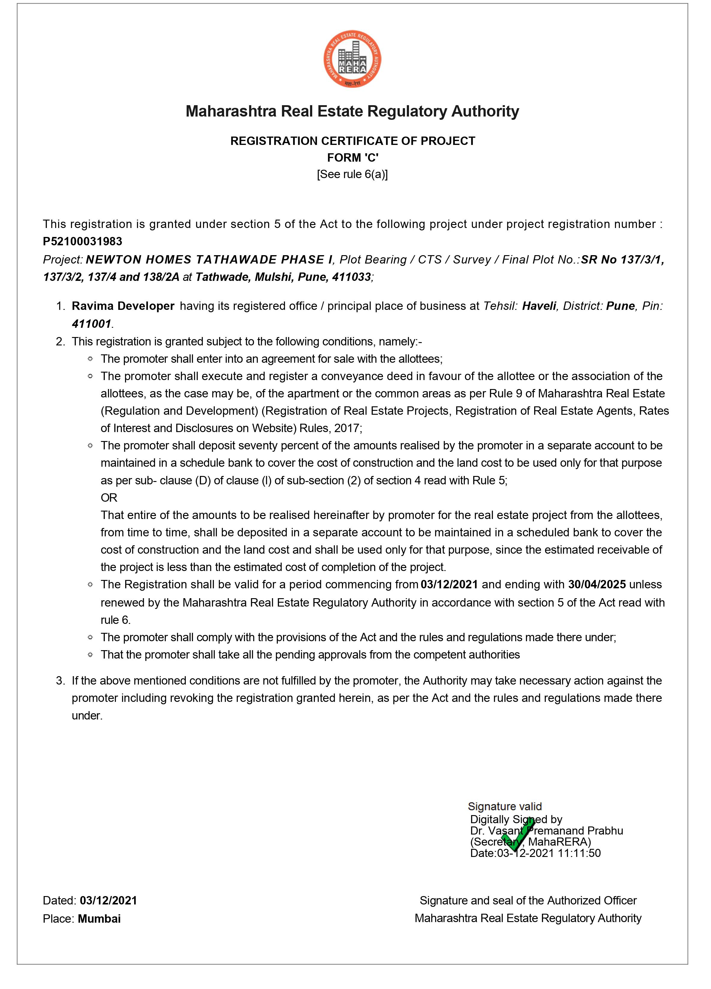

ANNEXURE B
TITLE CERTIFICATE

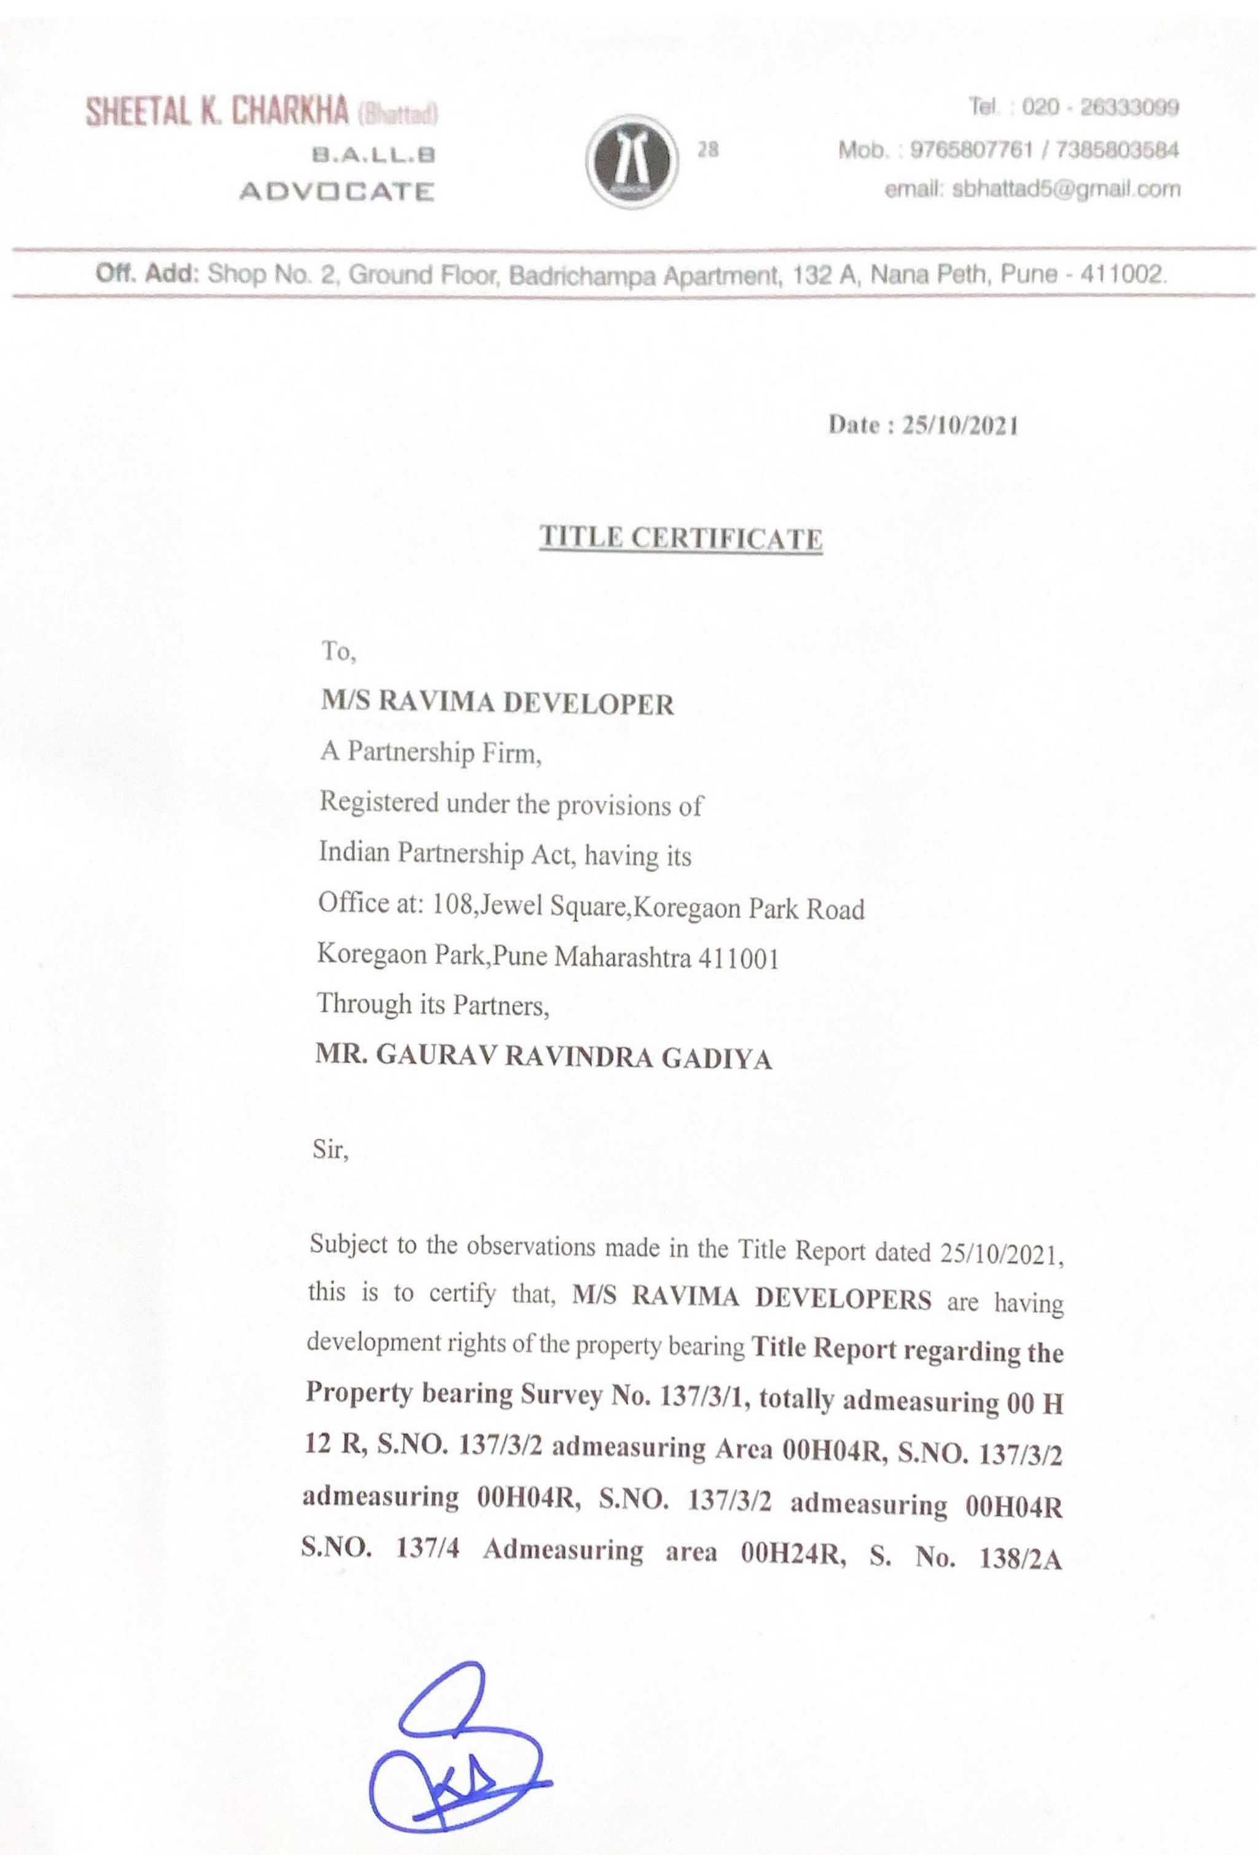
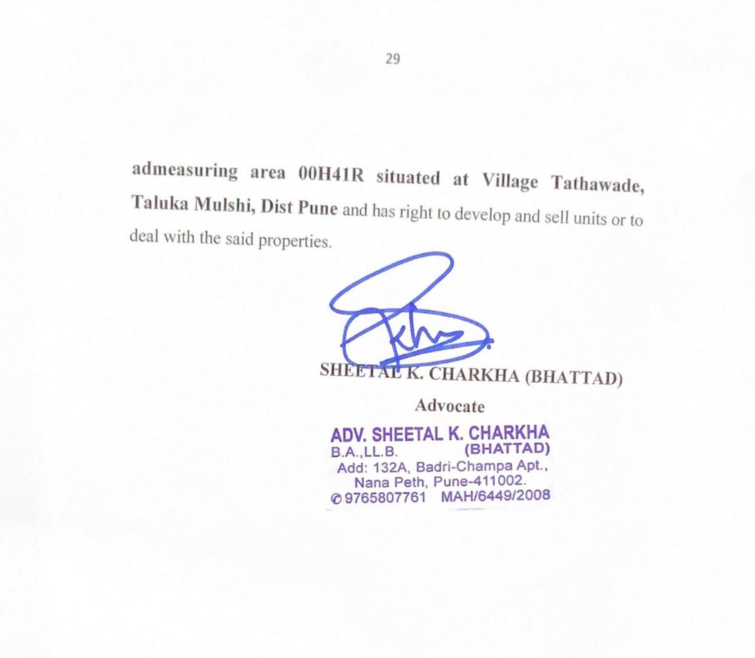
ANNEXURE C
COMMENCEMENT CERTIFICATE
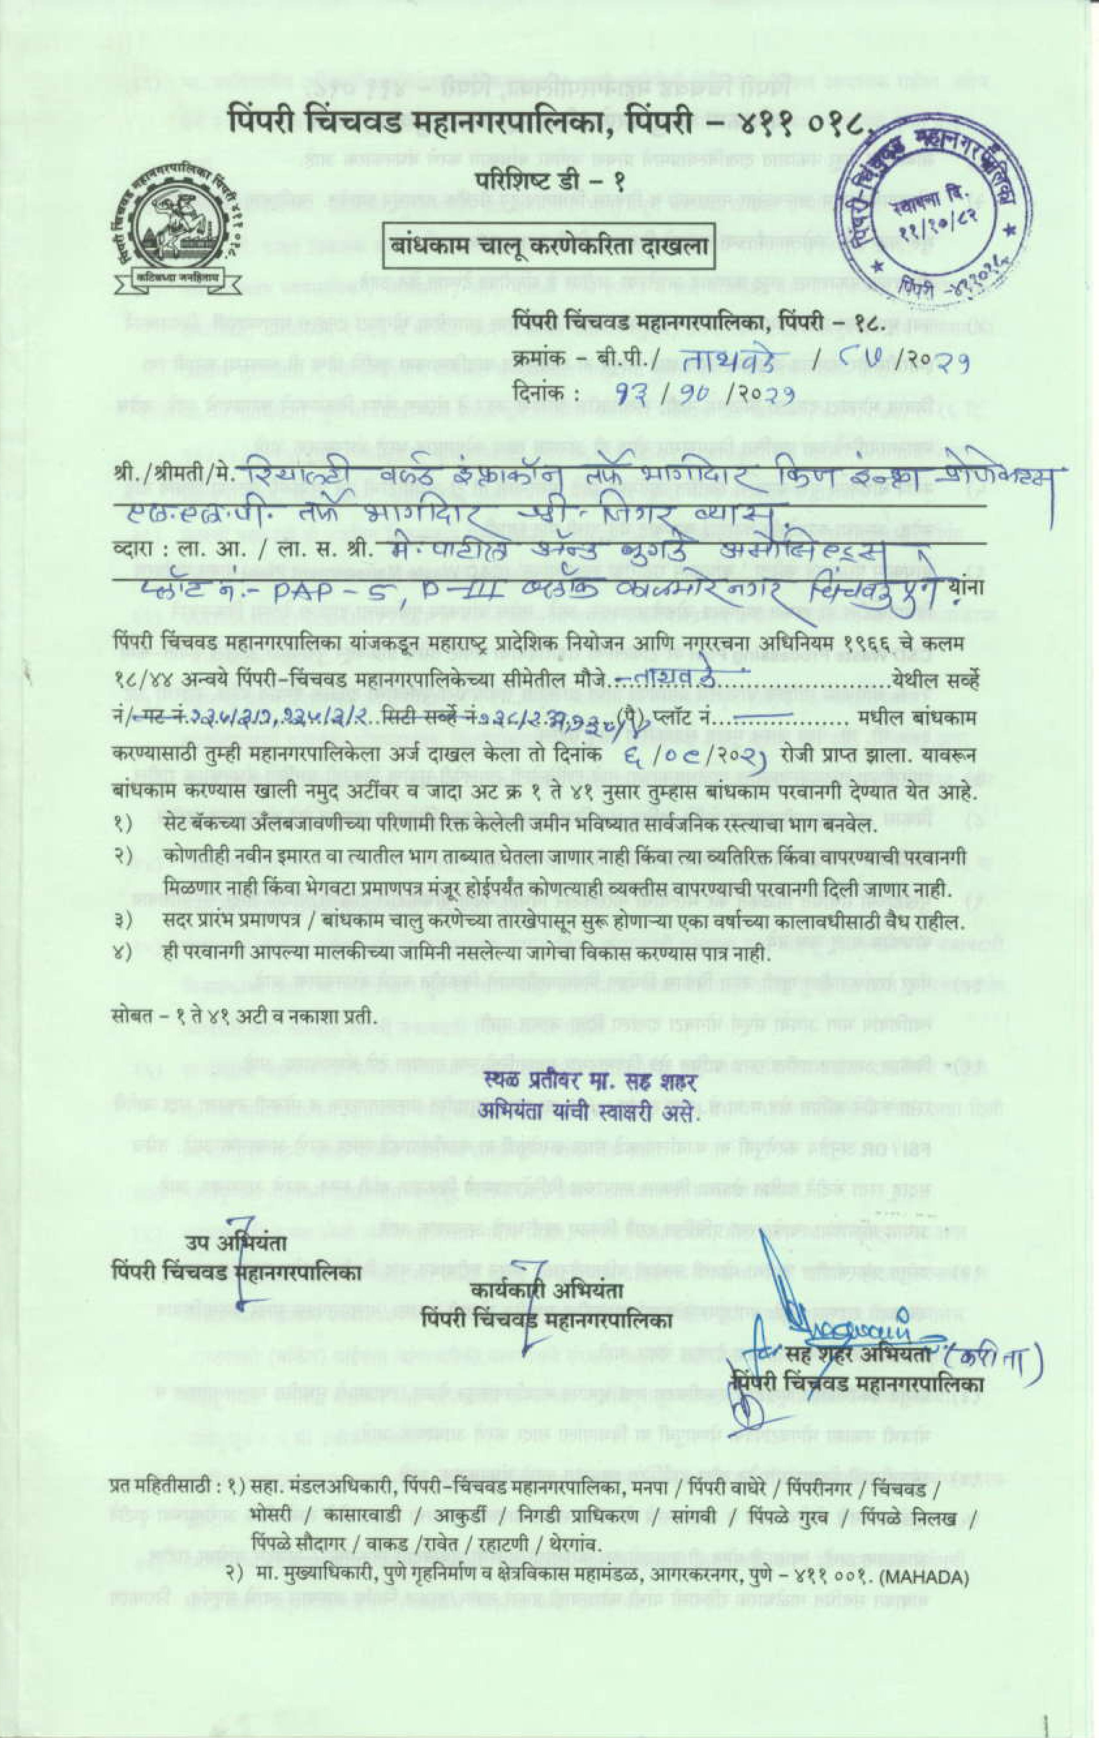

ANNEXURE D
7/12 EXTRACT OF THE SAID LAND
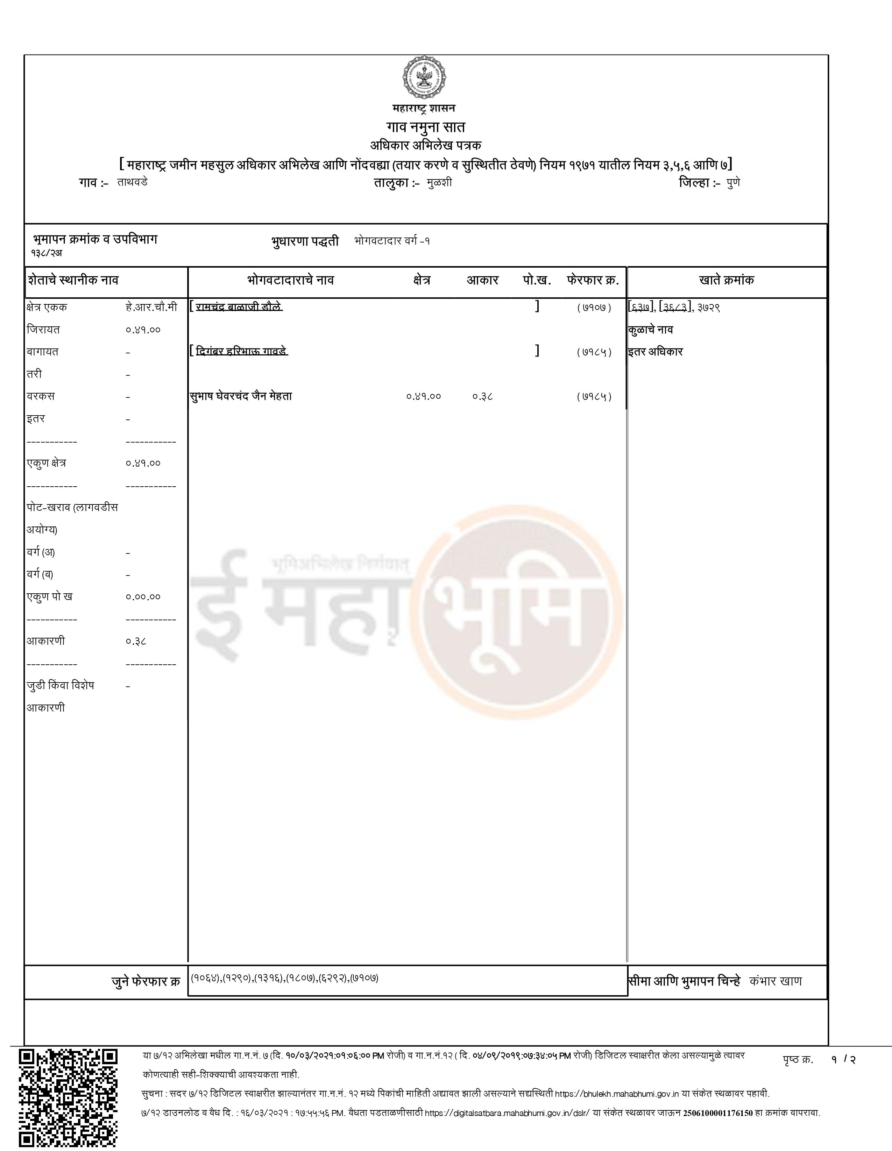

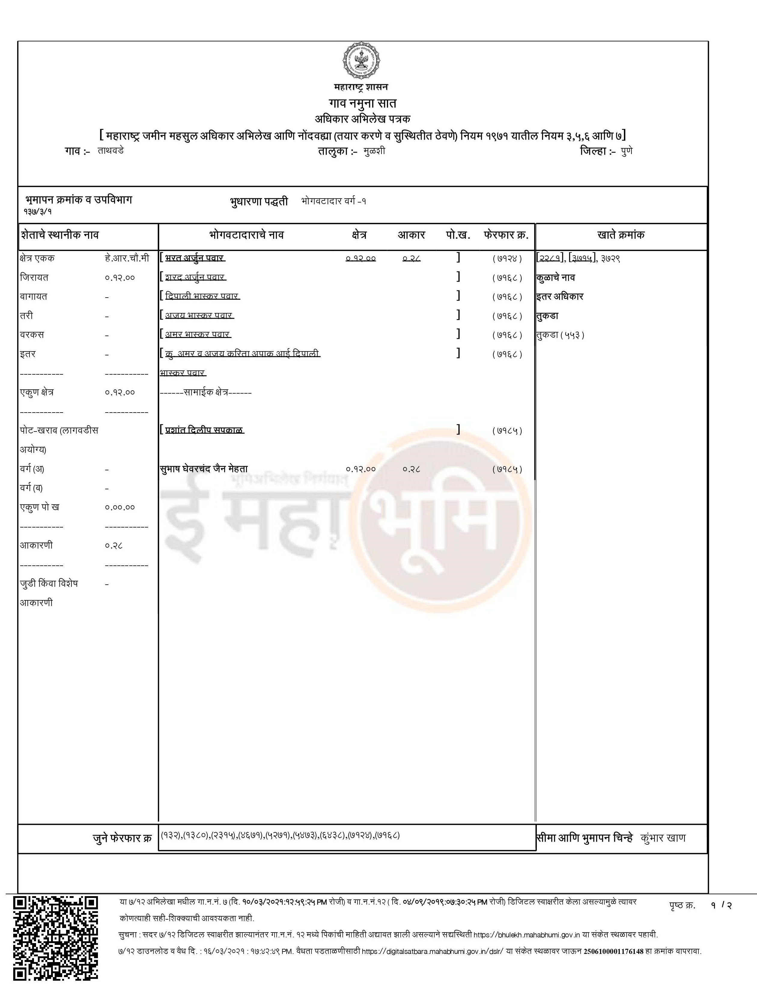
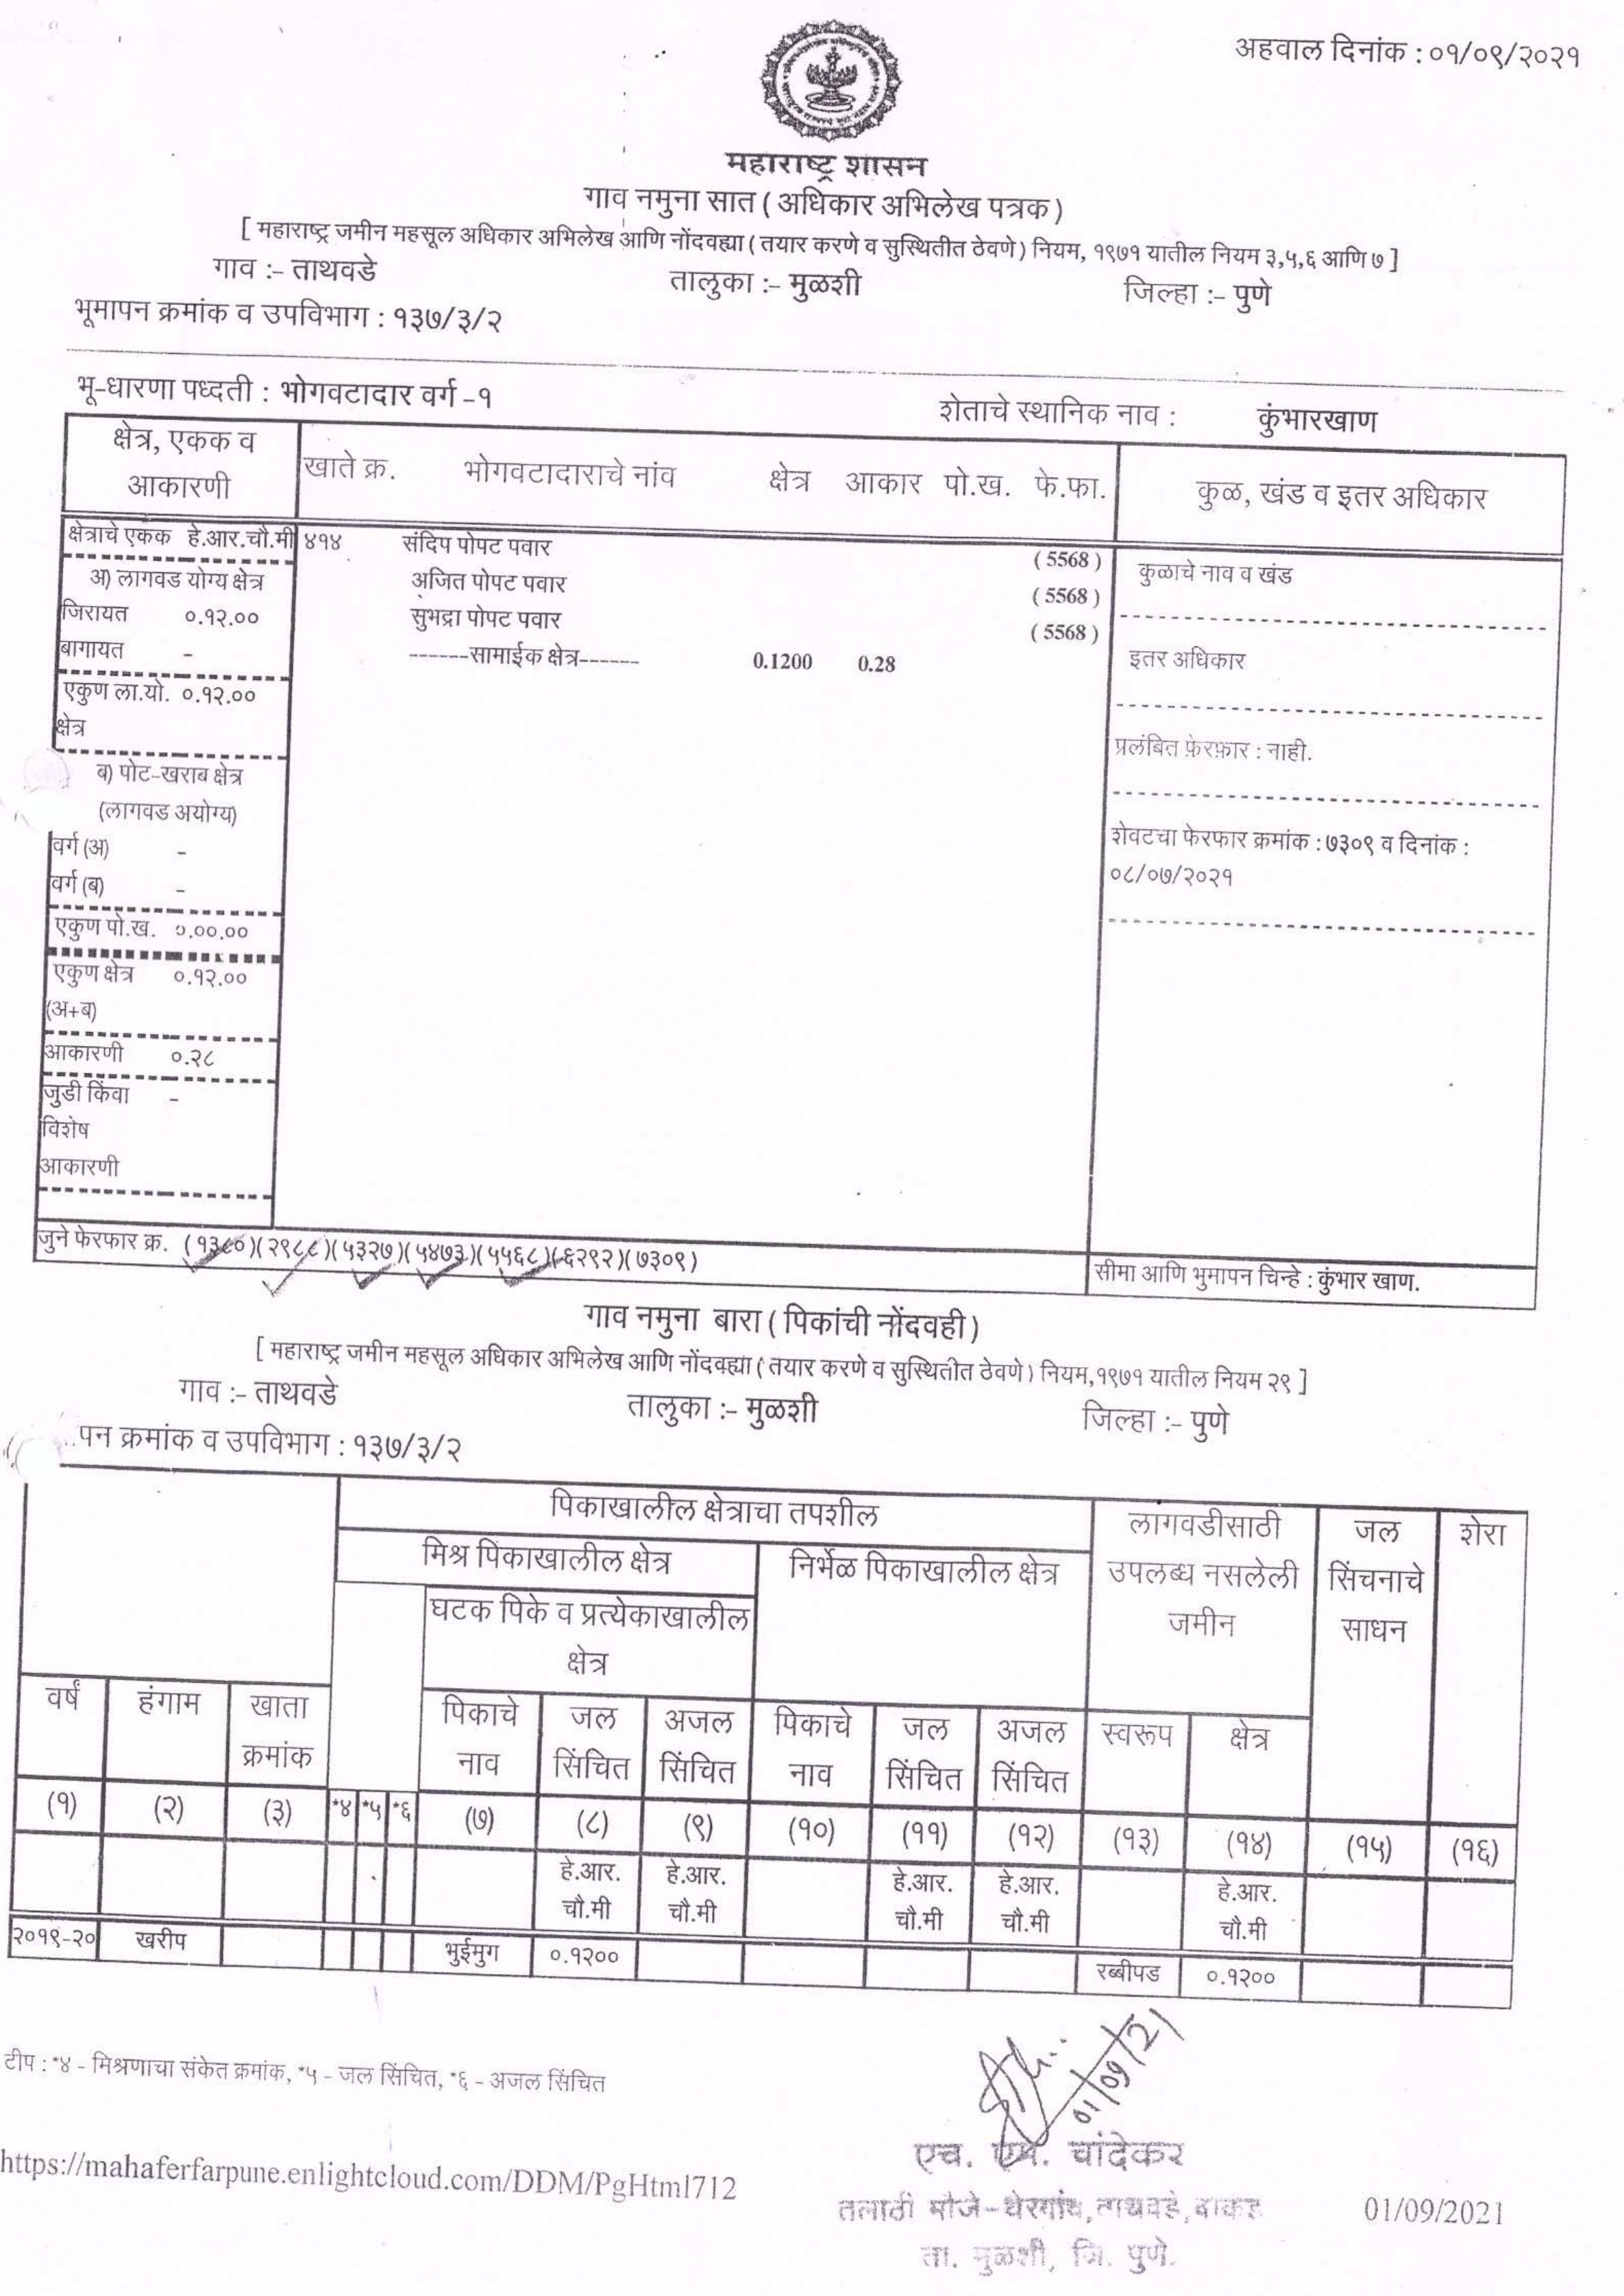
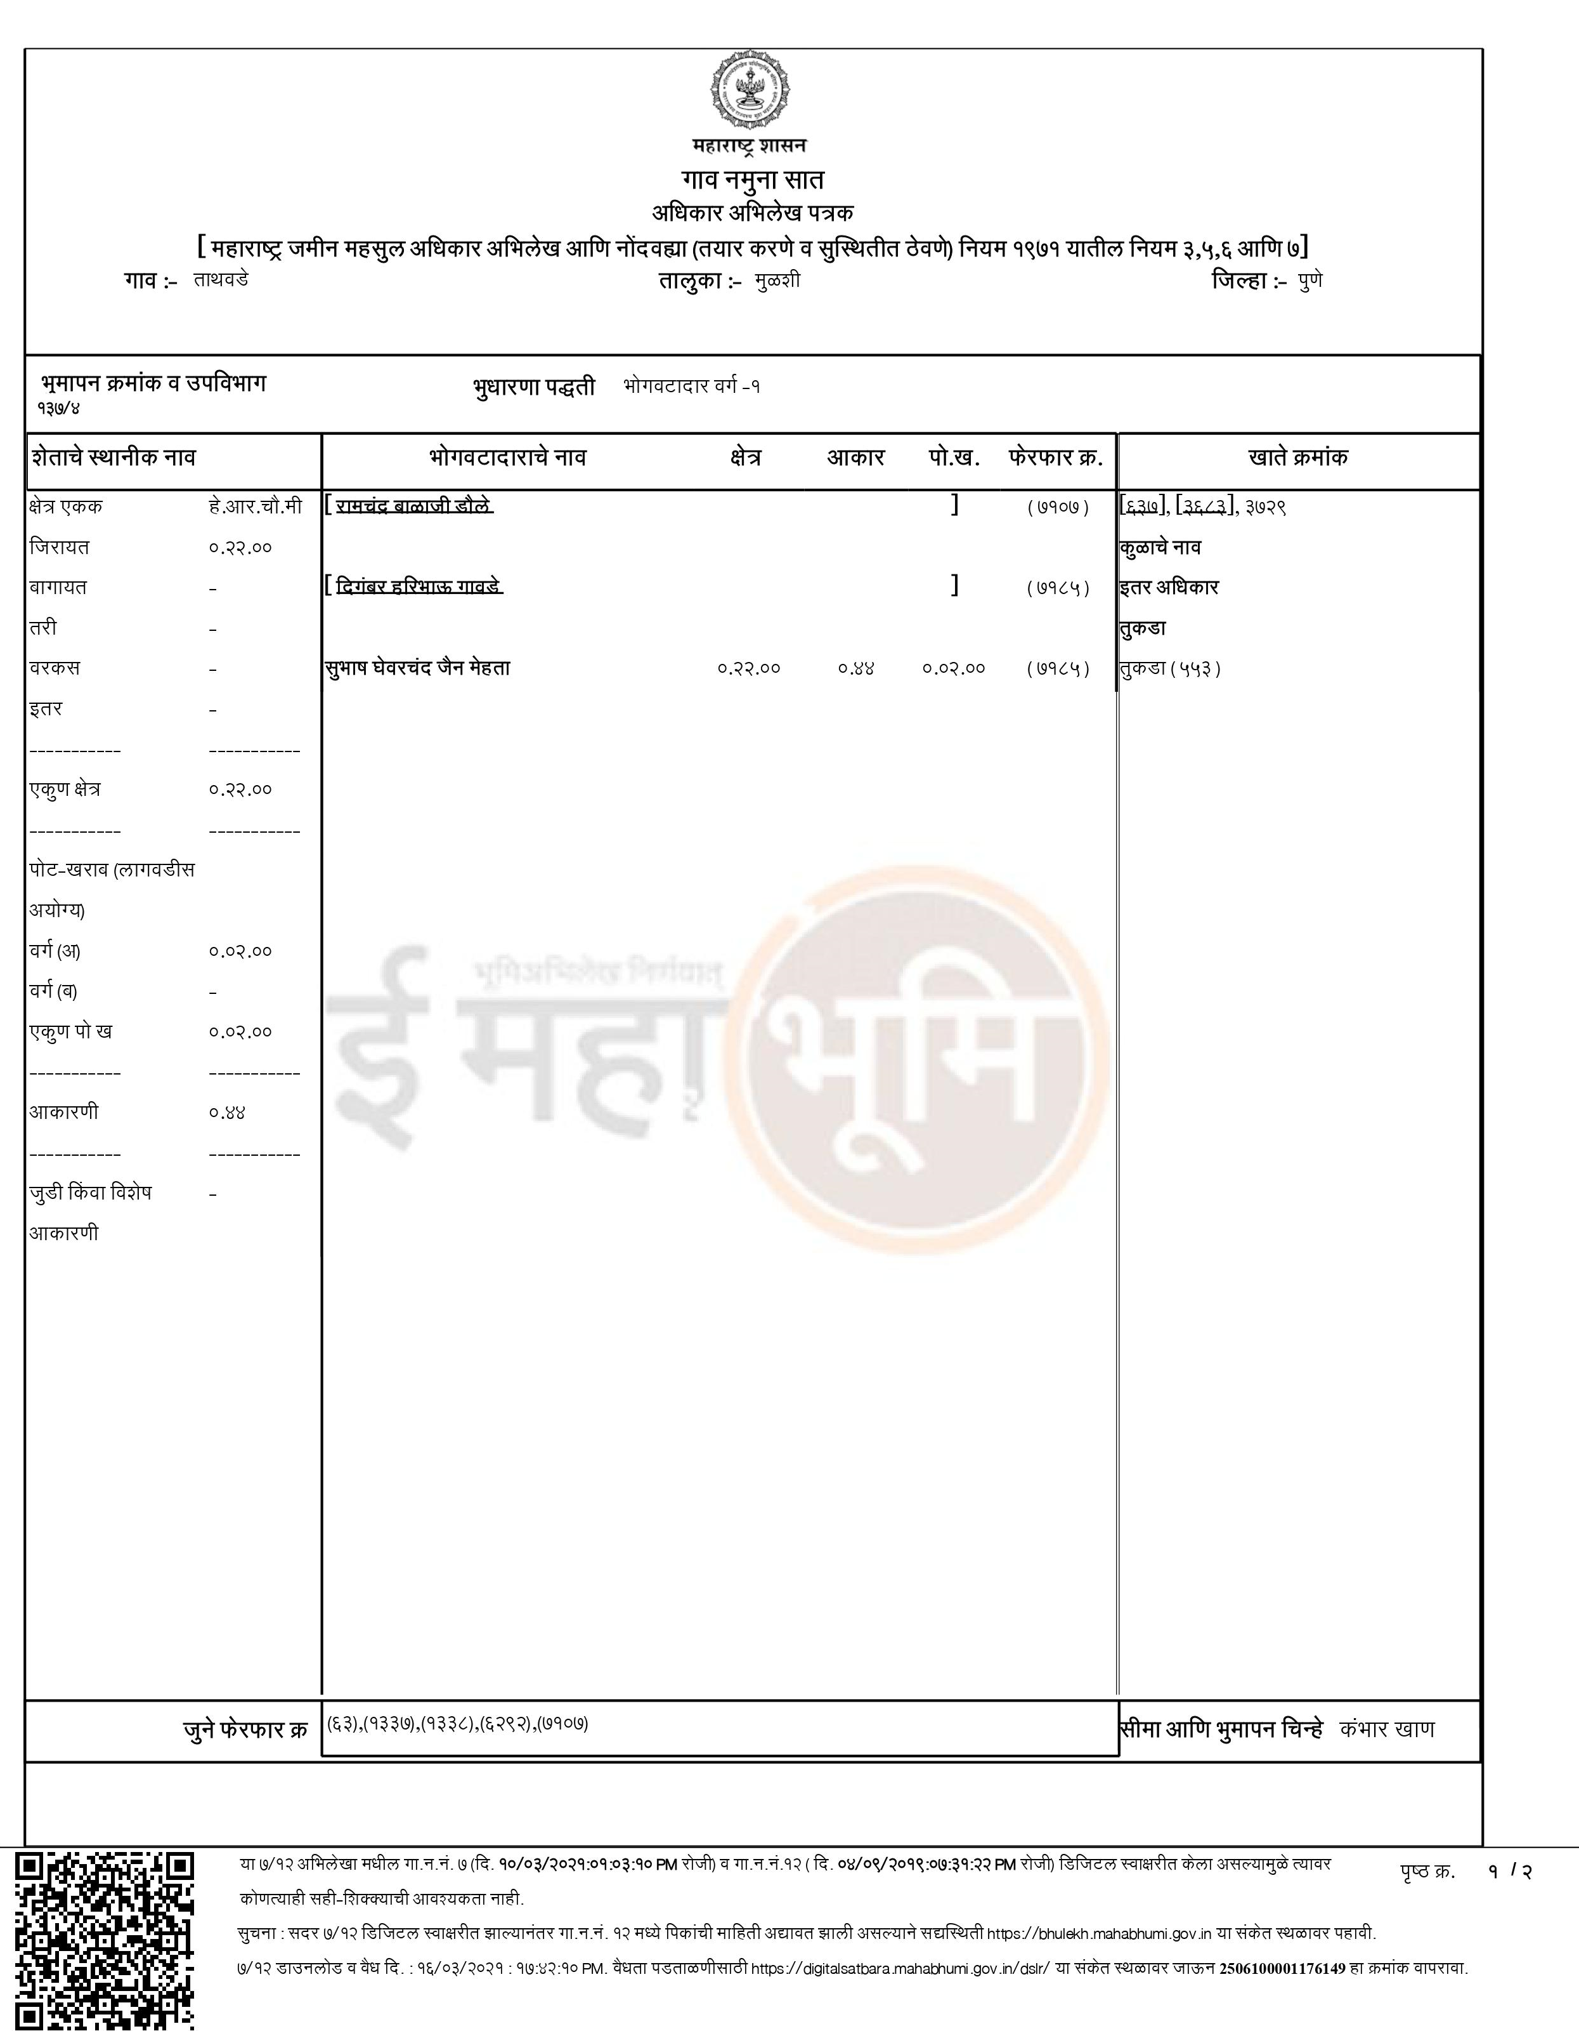

ANNEXURE E
SANCTION PLAN OF THE UNIT

ANNEXURE F
LAYOUT PLAN
